S-52 Presentation Library Draft Edition 4.0.3
Response on Alvaro’s comments - from Hannu
Hi Alvaro, - I looked your comment form about cases which may need update on ECDIS Chart 1 screen plots;
 | AU | 16.2 |  | te | ‘Port features (F)’. Symbol OBSTRN11 does not display as expected, Drawing instructions may be corrupted in the ECDIS used to get the screenshot for the S-52 plot.  The symbol displays correctly in the ECDIS used at the AHO. | Amend symbol display and replace plot.
Thank you for good catch. The drawing of symbol OBSTRN11 can be fixed for the plot, see fixed plot below:
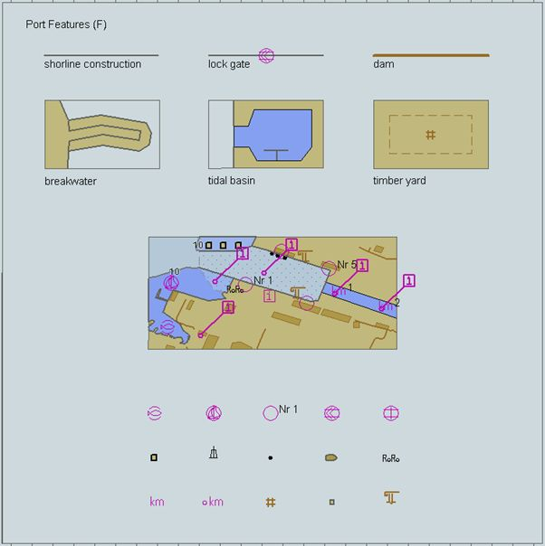

 | AU | 16.2 |  | te | ‘Seabed, obstructions, pipelines, etc (J,K,L).  The screenshot used for this S-52 plot does not reflect the latest changes to ENCA AC1JKL. These changes include amendments to the encoding of all the OBSTRN line features on the top right corner of the image. | Load latest version of AAC1JKL and generate new screenshot.  We also recommend (to avoid encoding duplication with the second object from the top - ‘Line obstruction, shallower than Safety depth’) editing the bottom OBSTRN line feature text from ‘Dangerous line obstruction’ to ‘Line obstruction, unknown depth’ and changing VALSOU from 7m to ‘Unknown’.
It is clear that the current plot is for the older version of AAC1JKL than in current draft for ed 4.0.3 (the plot below has the four examples of line obstruction as in current draft). This part of the plot can be fixed.
Your recommendation to avoid duplication (i.e. 2nd and 4th example are in current draft same) on AAC1JKL propose a change for the 4th example of obstruction line (inside red box in my screen sample below), but your submitted ENC chart file AAC1JKL.000 does not yet include your proposed change. Please submit AAC1JKL.000 with your proposed change to creation of new screen plot.
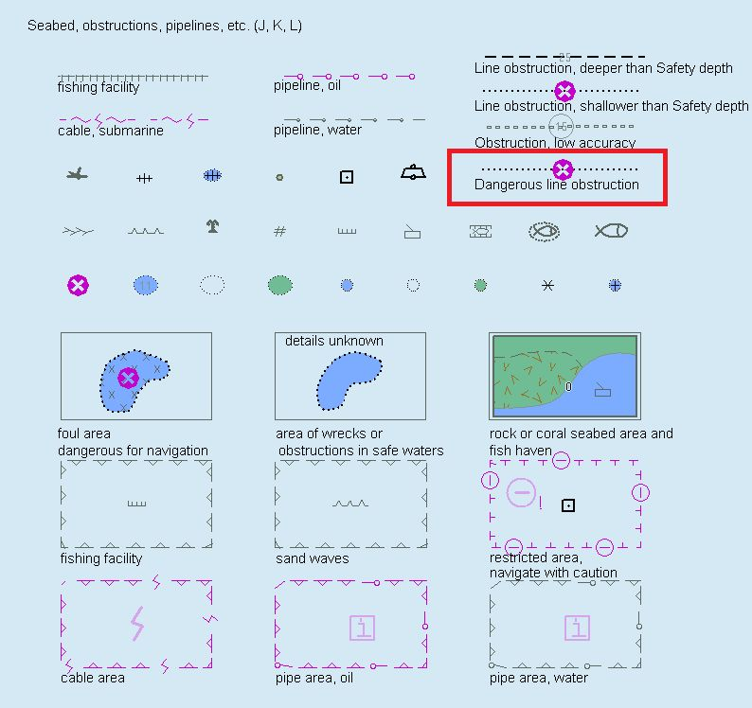
Best regards, Hannu

