Comments on Draft S-52 PL Edition 4.0.3

From: "Sazhnov, Nikolay" <nikolay.sazhnov@wartsila.com>
As per below clarifications of S-52 Presentation Library Edition 4.0(.3) depth contour value has been amended from 30 to 10m.

PresLib Ed. 4.0(.3) Clause | Clarification | Justification
16.2 Information about Chart display plot “Depths, currents,etc.(H,I)“. | Depth contour value has been amended from 30 to 10m. Shown on image “Depths, currents, etc. (H,I)“. | Existing Plot did not reflect S-52 requirement as the depth contour had an incorrect value.

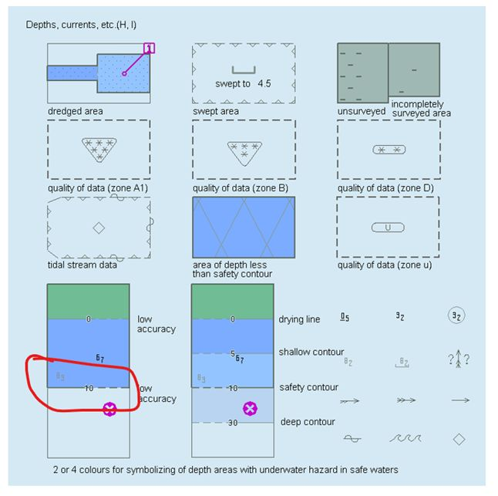

However, on the general picture of ECDIS Symbols the depth contour still retain 30 m. See below picture (H,I) .

