ENC STANDARDS MAINTENANCE WORKING GROUP
(ENCWG)

[A Working Group of the Hydrographic Services and Standards Committee (HSSC)]

Chairman: Thomas MELLOR
United Kingdom Hydrographic Office
Admiralty Way
Taunton, TA12DN
United Kingdom
Telephone: +44 (0)1823 337900
Facsimile: +44 (0)1823 284077
E-mail:Thomas.Mellor@ukho.gov.uk

Date 17/03/2022

Ref: ENC updates to Group 1 features and ECDIS display issues

Dear OEM,

I am writing to provide you an update on the issue relating to the incorrect display of isolated dangers and other point features resulting from underlying group 1 features being modified via an ENC update.
Firstly, thank you for your time and cooperation in testing and reporting your systems results for the apparent rendering issue against the provided test script, exchange set and online survey provided.
Unfortunately, results from the survey have indicated your ECDIS are rendering ENC information incorrectly.
The IHO would like to work with you and understand how you plan to resolve and distribute fixes to affected vessels ECDIS and in what timeframe.
Presently IHO member states are mitigating the risk of this issue by modifying their data, however this is only a temporary measure to provide you with a timeframe in which to resolve the affected ECDIS.
Please could you contact the IHO with your proposed timelines, rollout plan and method to fix the issue.
Thank you for your continued support on this issue.

Yours sincerely,
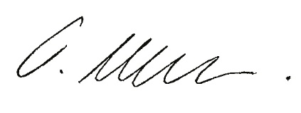
Thomas Mellor
IHO ENCWG Chairman

