ENC STANDARDS MAINTENANCE WORKING GROUP
(ENCWG)

[A Working Group of the Hydrographic Services and Standards Committee (HSSC)]

Chairman: Thomas MELLOR
United Kingdom Hydrographic Office
Admiralty Way
Taunton, TA12DN
United Kingdom
Telephone: +44 (0)1823 337900
Facsimile: +44 (0)1823 284077
E-mail:Thomas.Mellor@ukho.gov.uk

Date 17/3/2022

Ref: Skin Of Earth ECDIS Display Issue

To All ENC Producers,

I am writing to provide an update on the issue relating to the incorrect display of isolated dangers and other point features in ECDIS resulting from the underlying group 1 features being modified via an ENC update.
To better understand the scale of the ECDIS display issue across the industry the ENCWG have been engaged in surveying all S-63 scheme participants. Comprehensive test data, test scripts, and an online survey were disseminated to all OEMS and other chart display manufacturers registered within S-63.
The ENCWG have received a substantial number of responses to the survey and unfortunately, we have been made aware of the following ECDIS systems having this error present within their drawing engines:
OEM | System Version
CherSoft Ltd. | WENDIS Viewer 4.9
Furuno | FMD 5.05
Sperry Marine | VisionMaster FT 12.4
Wartsila Voyage | NaviPlanner/Sailor 4000

The ENCWG will work with the affected OEMs and urge them to get vessels ECDIS upgraded to fix the underlying problem and report on progress. In the meantime, please continue to follow the guidance in ENCWG letter dated ENCWG Letter 2_2021. I will provide an update on the issue and OEM plans to fix ECDIS software at the next ENCWG 7 in November 2022.
Thank you for your continued support on this issue.
Yours sincerely,
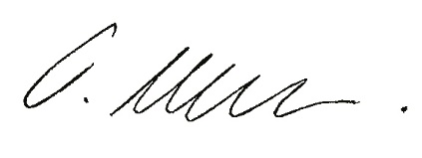
Thomas Mellor

