HSSC14-05.3B
Paper for Consideration by HSSC14
Request to approve S-128 for edition 1.0.0
Submitted by: NIPWG
Executive Summary: NIPWG has concluded that S-128 Product Specification is now in a condition where it is beneficial to release the product specification as version 1.0.0. since this will enable testing in the next phase of development and contribute to answering outstanding questions regarding stakeholder responsibilities with regards to S-128 services.
Related Documents: S-128
Related Projects: S-100
Introduction / Background
NIPWG is developing the S-128 product specification as a Catalogue of nautical products in accordance with F.8.1.5 of its work plan. The development has reached a sufficiently mature stage that a candidate package for going to Edition 1.0.0 can be submitted for HSSC approval. The work has in a large degree been supported by the Republic of Korea and Korean Hydrographic and Oceanographic Agency (KHOA) who is leading the development work. The success in bringing S-128 development to this stage has only been possible with their support.
Analysis/Discussion
The development process has included several rounds of review by the working group members and expert contributors who have contributed with valuable proposals and comments. Since the development began, the scope of S-128 has changed from a pure catalogue of products to both a catalogue of products and a service to provide a machine readable way to verify the up-to-dateness of the SENC. The current draft has made more progress in the original scope and need further testing and development to fully meet the extended scope. Comments received to the draft have been categorized into those that improve on the original scope and those that are extensions into the new scope. The latter have mainly been placed on hold pending version 1.0.0 of the product specification.
S-128 contains three basic product types; nautical product, electronic chart, and paper chart. It may be necessary to classify each S-1xx product into one of these categories of product type, and this type of classification should be done harmoniously to avoid any confusion. NIPWG has started work on drafting a proposal for how this classification can be done.
The candidate Product specification documents for edition 1.0.0 is attached to this input paper as Attachment A – S-128 Package.

S-128 Scope Extension
The extended scope comes with an extended responsibility placed on data producers and may in fact move the production of S-128 from optional to mandatory to fully provide the data consumer with the services needed to give an accurate report of up-to-dateness of the onboard data holding. WENDWG12 discussed possible ways on how to provide the S-128 files to the end users (on board systems and port state control officers), and NIPWG was recognized that there are several outstanding questions about S-128 use for dissemination of S-1XX products before S-128 services can be set up. There are further potential implications that must be answered regarding the responsibility of stakeholders in producing and distributing S-128, and during NIPWG 2022 VTC01 some discussions were held on identifying the most important questions will need to be answered. The input paper NIPWG-VTC01-4.6.3A was used to facilitate these discussions. A number of questions that NIPWG consider important to answer regarding S-128 were collected and these are found in Annex A to this document. Given the potential far reaching implications of these questions and since they are mainly regarding the operation of S-128 services, NPIWG think it is important to seek HSSC guidance on how to best address them. A preliminary conclusion from those discussions at NIPWG 2022 VTC01 was that it is necessary to have S-128 edition 1.0.0 to hold testbeds that can facilitate the necessary tests to answer the identified questions.
Recommendation
NIPWG has concluded that S-128 Product Specification is now in a condition where it is beneficial to release the product specification as version 1.0.0. This would allow NIPWG to continue development and test assumptions made and further enhance the S-128 product specification to meet the requirements place upon it by the extended scope. It is therefore recommended that the S-128 package in Attachment A be approved as Edition 1.0.0.
It is also recommended that HSSC consider the optimal way of addressing the questions raised in Annex A, as the answers to these questions are important for the further development of S-128.
Action required of HSSC
The HSSC is invited to:
- note the paper
- approve S-128 for Edition 1.0.0
- consider if the optimal way of addressing the questions raised in Annex A is within NIPWG or a wider group should be involved.
- Invite stakeholders to establish S-128 testbeds and share experiences with NIPWG

Annex A - S-128 service provision implications

Background
Acknowledging that S-128 is an essential part of S-100 ECDIS, WENDWG12 discussed possible ways on how to provide the S-128 files to the end users (on board systems and port state control officers). It was realized that the IHB (INToGIS in particular) may not be able to act as a reliable and always up to date S-128 repository, although IHB will be processing S-128 date as well. S-128 may also be a product catalogue for S-100-based services by organizations that are not under IHO membership; such as WMO and IALA.

Questions identified by NIPWG that need investigation.
- S-100 ECDIS needs a machine-readable way to determine up-to-dateness of system electronic navigational data. S-128 is intended to provide this function. Does this means that all S-100-based data services need to be combined with an S-128 service for the paradigm to work? There were suggestions that real-time data and need a separate mechanism, does this hold true in all scenarios?
- Is it necessary to draft example S-128 distribution scenarios which describe the role and responsibilities of each participant?
  - This would need to consider scenarios where a data producer is not a member of a RENC.
  - The role of S-128 in the Maritime Services in the context of e-Navigation must be described.
  - A start of such scenarios has been drafted in Figure 1A below.
- Is it necessary to create mechanisms that make it so that S-100-based navigational data services cannot operate without a S-128 service?
- Do we need one aggregator for up-to-dateness S-128?
  - If yes, Where and How? How will the ECDIS find the S-128 service?
  - Is there a need for a national catalogue in each country? Or should it be each producer responsible for creating S-128 catalogues? or is a super catalogue for whole world the best goal?
Note: It has been suggested that the aggregation of catalogue files by RENCs and VARs will give the flexibility to deliver services that meet user needs. VARs are seeing significant growth in the number of users obtaining their data over the Internet, with the benefit that they can access much more up-to-date data than was possible in the past. S-100 is expected to further enable this. However, bandwidth at sea remains limited. The growth in data volumes being exchanged for a wide range of purposes, including the spectrum of S-1XX products that will be available, means that bandwidth will continue to be under pressure for the foreseeable future. Users will want to access just the data that they need and not be restricted to downloading entire national datasets or, in this case, catalogues.

RENCs (and VARs for non-RENC members data) carry out quality assurance process which sometimes requires issues with datasets to be resolved before they can be issued. If the RENCs and VARs are not able to put their own catalogue files together, end users will be expecting updated data that isn't yet ready for release. They'll also be at risk of being expected to carry the updated data by Port State Control, when that data hasn't yet been released in service. This issue doesn't exist under the process shown on slide 5 because the RENC or VAR will only include the updated catalogue record when the S-1XX data is released into service. Synchronising nationally-produced catalogue files with the release of data from RENCs and VARs will be very difficult to achieve.
Such an option is not expected to prevent Port State Control having access to full catalogue files for the purposes of understanding how up-to-date a vessel should be. This may be a separate use case which may mean a different service.
- Do we need to think two main categories of S-128 service?
  - The two categories could be a catalogue for navigational purpose and a catalogue for others usages. Considerations in such a scenario would be;
    - What are the implications of such a service in light of S-100’s intended universal use?
    - What are the added workload implications on service providers?
- S-128 service will be an essential part of Port State Control. PSC officers have to check that the vessel conforms to carriage requirement: SOLAS V/27 : Nautical charts and nautical publications, such as sailing directions, lists of lights, notices to mariners, tide tables and all other nautical publications necessary for the intended voyage, shall be adequate and up to date. Therefore, S-128 service is not only of up-to-dateness verification of products on board.
  - Is there a need for a definition/description of a S-128 service that Port State Control officers will access to evaluate the update status of the onboard products?
  - Should each VAR provide this information to them individually? How? PSC owned and operated repository? Is this service description a IHO responsibility?
  - We could also say that IHO/HOs provide the data/content. The packing of the container, the transport, the unpacking and the last mile is not IHO/HO remit. Will this position be accepted by the maritime community? Some are of the opinion that SOLAS V, regulation 9, prescribe that contracting Governments must provide data management arrangements to support service and therefore HOs are responsible.

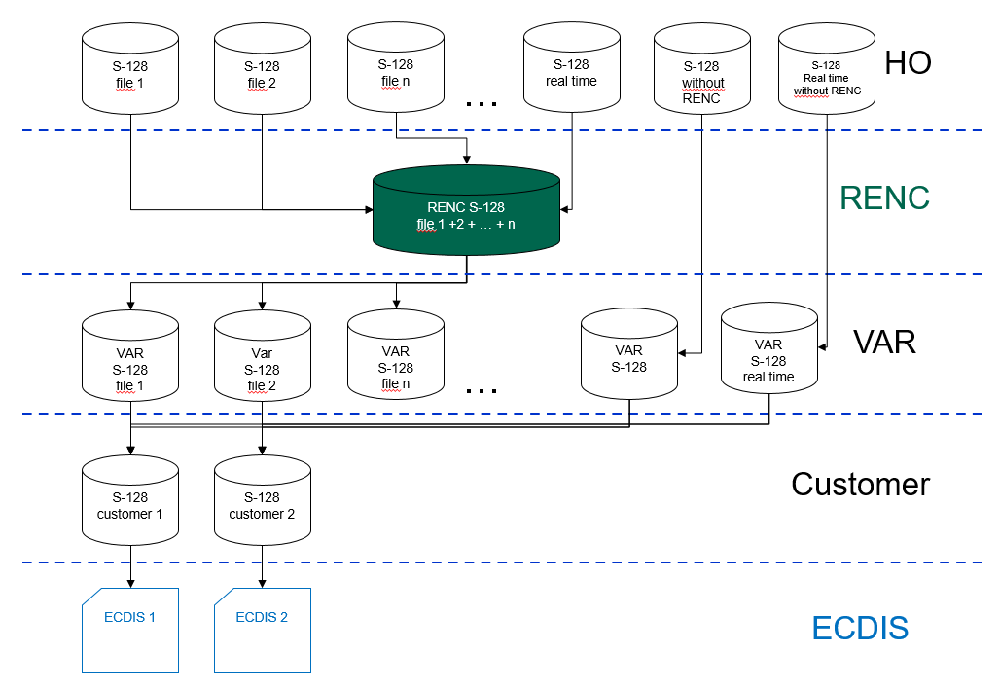
Figure 1A - Potential WEND view of S-128 service for navigational data.
Diagram notes to consider;
- The exchange of S-128 data between the different stakeholders will most likely be at a machine to machine level, and humans may not be involved beyond setting up the rules.
- Non-Member States are missing.
- Non-HO data producers are missing.
- The RENC concept had many challenges in the beginning.
- HOs or any other data provider may produce 1..n S-128 files.
- The provision of real-time data must be considered.
- Direct end user distribution of S-128 should be considered as an option.
- S-128 products may be provided to the responsible RENCs or forwarded directly to the VARs. The latter case happens if a data provider is not part of the RENC distribution system.
- The RENCs compile the individual S-128 into one big data package noting that real time data might be provided differently.
- The VARs grab the full producer S-128 product package and the S-128 provided directly, merge them to one integrated S-128 product and split its dataset afterwards into individual products, which will be forwarded to individual users and their ECDIS systems. Real time data might need to be provided differently.

