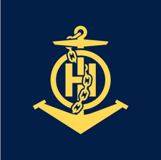
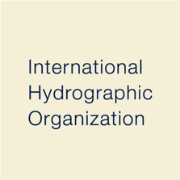
S-65
Published by the
International Hydrographic Organization
4b quai Antoine 1er
Principauté de Monaco
Tel: (377) 93.10.81.00
Fax: (377) 93.10.81.40
info@iho.int
www.iho.int
Annex A

High Density (HD) ENC Production and Maintenance Guidance

Edition 1.1.0 – October 2024

© Copyright International Hydrographic Organization 2024
This work is copyright. Apart from any use permitted in accordance with the Berne Convention for the Protection of Literary and Artistic Works (1886), and except in the circumstances described below, no part may be translated, reproduced by any process, adapted, communicated or commercially exploited without prior written permission from the International Hydrographic Organization (IHO). Copyright in some of the material in this publication may be owned by another party and permission for the translation and/or reproduction of that material must be obtained from the owner.
This document or partial material from this document may be translated, reproduced or distributed for general information, on no more than a cost recovery basis. Copies may not be sold or distributed for profit or gain without prior written agreement of the IHO Secretariat and any other copyright holders.
In the event that this document or partial material from this document is reproduced, translated or distributed under the terms described above, the following statements are to be included:
“Material from IHO publication [reference to extract: Title, Edition] is reproduced with the permission of the IHO Secretariat (Permission No ……./…) acting for the International Hydrographic Organization (IHO), which does not accept responsibility for the correctness of the material as reproduced: in case of doubt, the IHO’s authentic text shall prevail. The incorporation of material sourced from IHO shall not be construed as constituting an endorsement by IHO of this product.”
“This [document/publication] is a translation of IHO [document/publication] [name]. The IHO has not checked this translation and therefore takes no responsibility for its accuracy. In case of doubt the source version of [name] in [language] should be consulted.”
The IHO Logo or other identifiers shall not be used in any derived product without prior written permission from the IHO Secretariat.

Document History
Version Number | Date | Author | Purpose
0.0.1 | May 2019 | ENCWG | Draft document for discussion (S-101PT4)
0.0.2 | August 2019 | ENCWG | Draft document for WG approval
0.0.3 | November 2019 | ENCWG | Revised draft document for WG review
0.0.4 | January 2020 | ENCWG | Final draft for WG approval
1.0.0 | January 2020 | ENCWG | Publication of Edition 1.0.0
1.1.0 | October 2024 | ENCWG | Removed table taken from an old edition of IHO S-44; minor editorial amendments and clarifications made throughout

Contents
1 Overview 1
1.1 Introduction 1
1.2 References 1
1.3 Definitions 1
2 Bathymetric Surveys for HD ENCs 2
3 HD ENC Cell Creation 2
3.1 Existing cells 3
3.2 New cells 3
4 Cell Size 4
5 Quality of Bathymetric Data 4
5.1 HD ENC validation checks 4
6 Automatic Generation of Depth Contours and Sounding Selection 5
7 Application of SCAMIN 5
7.1 SCAMIN on contours 5
7.2 SCAMIN on soundings 5
8 Managing Shoals and Deeps 5
9 Testing 6
10 Maintenance of HD ENC Data 6

Overview

Introduction
When Electronic Navigational Charts (ENCs) were first introduced most HOs used their paper chart series as the source for this new vector product. Unfortunately, while enabling the relatively quick creation of ENC data, it has also led to some more unforeseen issues. One of the principle advantages of using ECDIS for navigation is that the system enables the setting of a safety contour, differentiating the safe and unsafe water. This can only accurately be achieved if the data within the ECDIS includes higher density contour intervals than those traditionally shown on the paper chart. Many of our ENCs today only contain the standard series of contour lines mirroring the paper chart as specified in IHO Publication S-4 - Regulations of the IHO for International (INT) Charts and Chart Specifications of the IHO, section B-411. This results in some vessels having to navigate in waters indicated on the ECDIS as dangerous, when in reality the vessel is still safe and has not reached the minimum permitted water depth.
There is also an emerging requirement for ENC covering commercial ports to include significantly larger scale and higher bathymetric content levels than included in the corresponding paper chart portfolio. This requirement is driven by:
- The increasing size of vessels in relation to ports, and their channels and confined waters;
- Reduced under-keel depth margins as more vessel sailings are required within each tidal window;
- A fundamental shift in the way these vessels are navigated and a change in user expectations.
The preference is to meet these requirements through official S-57/S-63 ENC rather than unofficial ‘closed’ proprietary formats. There is a concern that use of a proprietary format creates a situation whereby the ship’s Pilot has a considerably different view of the navigation situation compared to the vessel’s Master, leading to ineffective Bridge Resource Management, confusion and increased safety risk. In contrast, exclusive use of S-57/S-63 ENC allows for access and use of the same information by all parties.
With advances in the processing of high-resolution bathymetry it is now possible to automatically create sets of supplementary contours that can directly feed into the creation of high density (HD) ENCs. This Annex will provide HOs with survey capture, processing and production guidance to enable the effective creation of HD ENCs.

References
IHO S-4 Regulations of the IHO for International (INT) Charts and Chart Specifications of the IHO, Edition 4.8.0, October/November 2018
IHO S-44 Standards for Hydrographic Surveys, 5th Edition, February 2008
IHO S-57 Transfer Standard for Digital Hydrographic Data – Appendix B.1 – ENC Product Specification, November 2000.
IHO S-58 ENC Validation Checks, Edition 6.1.0, September 2018

Definitions
High Density ENC (HD ENC)
An ENC product that includes bathymetry depicted with depth area intervals of 1 metre or closer within the depth range of relevance, focussed on a physically constrained waterway. The additional bathymetric information is incorporated in the base ENC dataset. The product may also include more detailed port infrastructure. Under the current IMO ECDIS Performance Standards, this product is suitable to be displayed and operated on any type-approved ECDIS and consequently it can be used to fulfil the IMO’s chart carriage requirements.

Bathymetric Surveys for HD ENCs
HD ENCs are considered to be of maximum benefit to the Mariner in areas where there are areas of minimal under-keel clearance and/or vessel manoeuvrability is restricted.
Careful consideration must be given when planning surveys, so that the resulting data can be used to compile areas of HD bathymetry where a requirement is identified. Hydrographic offices should consult with ports, pilots etc. regarding surveys, maintenance, accuracy of infrastructure, target vessel type(s) and any other characteristics of the area of interest that may influence the structure and content of a HD ENC.
Hydrographic surveys to be used in the compilation of HD bathymetric areas will in the majority of cases need to meet IHO S-44 Special or Exclusive Order survey requirements. For full survey specification requirements please see the IHO S-44 Standard.
In cartographic terms, HD bathymetric data should be depicted in areas where there is sufficient data density to safely interpret additional contouring in areas categorised as CATZOC A1 and/or A2. Where the HO has sufficient confidence in the bathymetric data density it is also permissible to use data from areas categorised as CATZOC B.

The exception to the above is where the bottom quality is mud/silt and the water column is holding significant amounts of sediment. Given these environmental conditions multibeam as a survey technique is not suited when acquiring depth information. In this situation other survey techniques may be used.
It is recommended that charting authorities consider the following criteria when developing HD ENCs:
a. Ability for larger vessels to access the port.
b. Improvement to routes to avoid areas of environmental risk.
c. Improvement to routes to improve traffic flow.
d. Is it practical to maintain the cells once produced?

HD ENC Cell Creation
There are two options for creating HD ENCs:
- Incorporating HD ENC information in existing published ENC cells.
- Creation of dedicated new HD ENC datasets.
In order for RENCs or other service providers to identify a HD ENC for catalogue service purposes, the text string "HD ENC" should be included in the “Comment” [COMT] subfield of the “Data Set Identification” [DSID] field of the ENC Data Set General Information record.

Existing cells
HD bathymetric data can be included in any navigational purpose so long as the product is the largest scale ENC available in the area. The area of the data coverage of the ENC cell to be covered by HD ENC information should, for reasons of economy and maintenance, be restricted to the area of interest for the target vessel classes for the HD ENC information; with the remainder of the area of data coverage containing the more “traditional” level of bathymetric detail. In general, the area of interest for HD ENC data coverage will include (but is not restricted to) shipping channels (including dredged areas), anchorages, emergency escape channels, waiting areas, vessel manoeuvring areas (for example turning basins) and berths. In some cases these areas will require a larger compilation scale (using the S-57 meta object M_CSCL) to support the extra detail provided and the way the end user will use the ENC.
Standard ENC ENC containing HD bathymetric data
Figure 3.1 – Standard ENC and ENC containing HD information – comparison
The images above show the impact on the available safe water when additional contours are included.

New cells
New ENC cells containing only HD ENC data must be the largest Navigational Purpose ENC data covering the area. Where ENC data already exists at the Harbour (Navigational Purpose 5) band, the Navigational Purpose band 6 (Berthing) may be used. It is expected that the majority of HD bathymetric data will be included in new cells created in the Berthing Navigational Purpose. This approach is preferred as it simplifies the updating process.
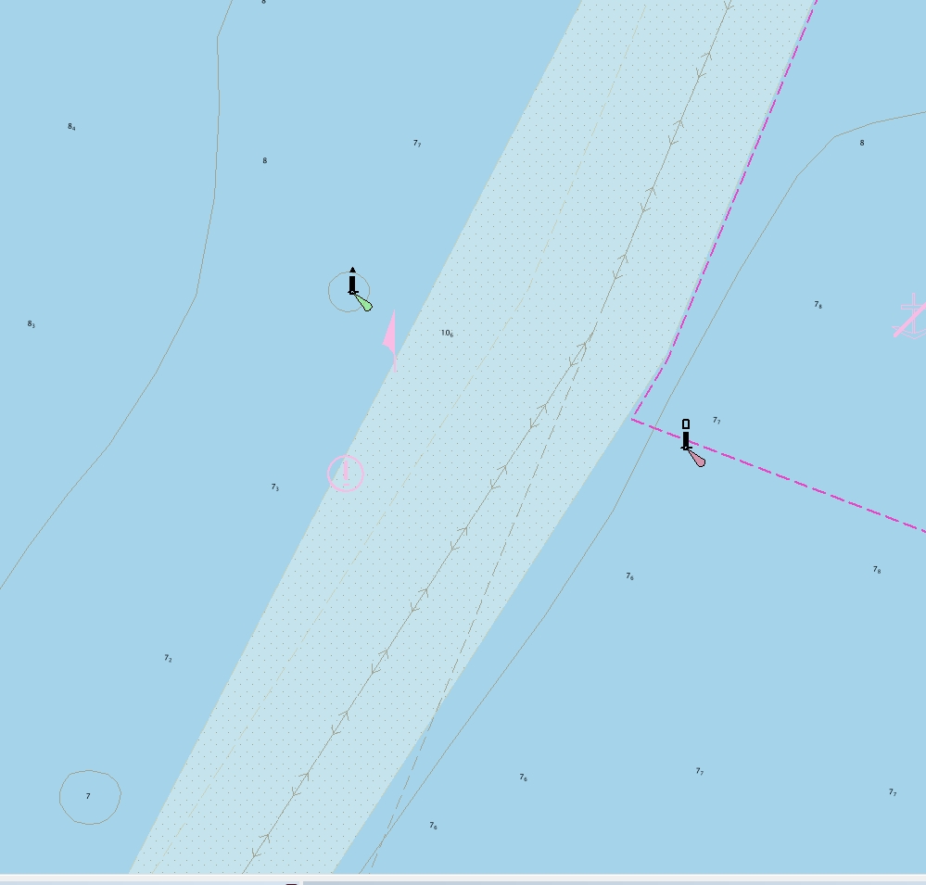
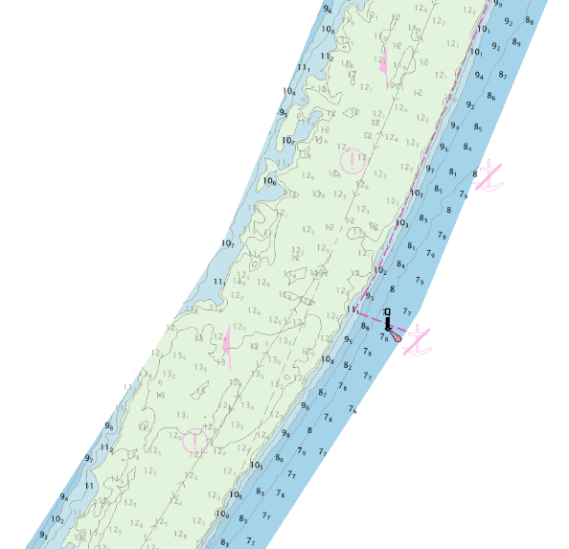
Classic Navigational Purpose 5 ENC view
HD ENC view
Figure 3.2 – Standard ENC and new HD ENC cell – comparison

Cell Size
An ENC dataset containing HD bathymetric data should contain no more than 5 Megabytes of data. Appropriate scheming of the area of interest, for instance consideration of multiple cells in lieu of a single large sized cell, should be considered; particularly if it is considered important that the 5 Megabyte data limit is to be retained.

Quality of Bathymetric Data
To ensure the mariner has access to all the metadata related to the bathymetric survey the meta object M_QUAL must be used, in accordance with S-57 Appendix B.1, Annex A – Use of the Object Catalogue for ENC. However for HD bathymetric data the use of the attribute value CATZOC = 6 (Unassessed) is prohibited.
It is strongly recommended that the attributes POSACC, SOUACC, SUREND and TECSOU are used on the M_QUAL where possible to relay important information about the quantitative accuracy of the source surveys and the survey technique of sounding measurement, taking into account the guidance on the use of these attributes as included in S-57 Appendix B.1, Annex A, clause 2.2.3.1.
The quality of source survey used to compile HD bathymetric data should only be of sufficient data density to safely interpret additional contouring in areas categorised as CATZOC A1, A2 or B (see clause 2).

HD ENC validation checks
ENC cells containing HD bathymetric data must conform to S-58 – ENC Validation Checks, noting however the allowance to exceed to 5 Megabyte data content limit (see clause 4 above).

Automatic Generation of Depth Contours and Sounding Selection
Hydrographic Offices are free to determine density of contours. It is recommended that a contour interval of 1m is used as this represents the most useful contour interval for the end user, although there has been HD bathymetry data produced with a 0.1m contour interval.
For use in ECDIS HD bathymetric data does not need to extend in the whole 0m – 50m depth range; the most useful depth range for surface navigation is between 5m to 30m. Hydrographic offices should consider factors such as the nature of the topography, area to be covered and classes of vessels for which the data is intended when determining the depth range within which to compile HD bathymetry.
For reasons of economy, it is considered that the cartographic quality of contours auto-generated and smoothed by modern production software tools is sufficient for use of HD bathymetry in ECDIS. Cartographic intervention should only be applied when matching the “standard” depth contours to adjoining data and in the depiction of isolated shoals and deeps (see clause 8).
The use of denser sounding patterns (50-100m ground spacing) may be beneficial to support the navigation of large vessels that may still require higher accuracy than the recommended 1m contour interval. In these cases, an evenly spaced sounding pattern (production software automated sounding suppression/selection (shoal biased) routine) is preferred. With modern production software, such an automated process is very quick and reliable taking into account the additional contours to be supported, noting that with such higher density data there is no expectation that the mariner may sail ‘from sounding to sounding’ as is common practice when navigating on traditional charts. It is important to remember that soundings are not part of the S-52 ‘Standard’ display and they can be turned off at any moment.
Note: When dredged areas (S-57 object class DRGARE) exist within the area of HD bathymetry the use of ‘supplementary’ contours matching the design depth of the dredged area is highly recommended (for example 7.6m). HOs may decide to replace dredged areas with full bathymetry, in which case the limit of the dredged area and the dredged depth should be indicated using a fairway (S-57 object class FAIRWY).

Application of SCAMIN

SCAMIN on contours
SCAMIN must be applied to the “standard” contours (0, 2, 5, 10, …) such that they match the SCAMIN values of the corresponding contours outside and adjoining the area of HD bathymetry. This ensures that the “standard” depth contours will appear and disappear at the same time irrespective of whether they sit within or outside the HD bathymetry area.
To avoid excess clutter within the ECDIS it is recommended that SCAMIN is applied to the intermediate (non-standard) contours within the HD bathymetry area so they are either not visible or only visible at the compilation scale of the HD bathymetry. The decision depends on the sea bottom topography and on how close together the contours are at compilation scale. Related S-58 checks (1553) can be ignored where the decision is to apply SCAMIN such that the intermediate contours disappear from ECDIS display at the compilation scale.

SCAMIN on soundings
Soundings must have SCAMIN applied in accordance with the general accepted practice for the Hydrographic Office.

Managing Shoals and Deeps
The automated contouring process may generate contours that are too small to easily be displayed at HD ENC compilation scale. It is recommended that no isolated shoal or deep area should be smaller than 2.75mm across any dimension at the compilation scale of the HD ENC. Appropriate automated contour generation algorithms so as to avoid the creation of small shoals should be investigated.
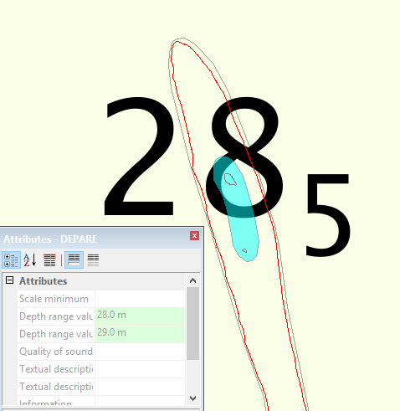
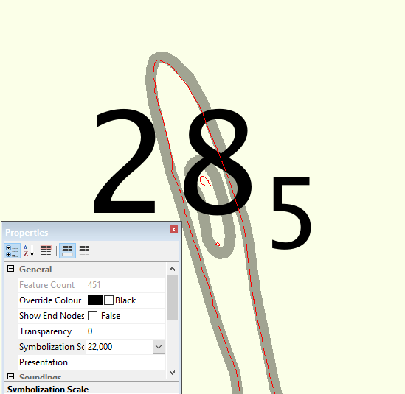
Small isolated deeps may be filtered out of the HD ENC data.
Figure 8.1 – Generalisation and enlarging of contours – example

Testing
Prior to publication, it is recommended that HD ENC datasets be supplied to harbour/port authorities and pilots for testing and feedback. If possible, consideration should also be given to supplying HD ENC datasets to local ship simulator training facilities for evaluation, testing and feedback.

Maintenance of HD ENC Data
HD ENCs should be maintained at a minimum as is done for the regular ENC maintenance regime, however where there is a requirement to release the data more regularly this would be possible with the agreement of the RENCs.
For post-dredging surveys the Hydrographic Office should consider processing the data and releasing an updated HD ENC dataset as soon as possible.
In all cases where the continued reliability of a HD ENC may be questioned (for example changed circumstances in ability to resurvey in areas of changeable seabed or in dredged areas; consequences of natural disaster), a course of action should be determined in full consultation with the key stakeholders. This may include, for HD ENC datasets having full HD bathymetry coverage, a decision to cancel the cell pending resolution of the issue. Such action should commence as soon as it is considered that the CATZOC for the HD bathymetry within the dataset has degraded in relevance and accuracy beyond the recommended CATZOC A1, A2 or B level required such that it cannot sufficiently support additional contouring.

