6th NCWG MEETING REPORT FINAL
VTC 3-4 November 2020
Contents:
- Report
- Annexes:
A Agenda
B List of Conference documents (Note: actual documents are available on IHO website including any presentations)
C List of Participants in NCWG6
D NCWG6 Actions
E NCWG Work Plan (updated for NCWG6)
F List of Acronyms and Abbreviations used at NCWG6

REPORT: (Note: The paragraph numbering is the same as in the agenda.)
1.Welcome, introductions and administrative arrangements
Docs: NCWG6-01A List of Documents (on website)
NCWG6-01B List of Registered Meeting Participants
NCWG6-01C List of NCWG Members

Keynote speaker comments:
Commander José María Bustamante Calabuig from Instituto Hidrográfico de la Marina opened the meeting and welcomed members. The Commander stated that it was good to see all of the members again and hoped that they and their families are well during this pandemic.

Chairman comments:
The chair thanked Commander José María Bustamante Calabuig for his comments and thanked Instituto Hidrográfico de la Marina for their earlier efforts in making arrangements to host the meeting in Spain. The Chair commented that the VTC meeting was planned to last 3hrs as a result of the differences in time zones and this was the best time for the majority of members. The Chair stated that not many papers had been submitted for this meeting which was probably a good thing due to the shorter meeting time. The Chair stated that during the meeting members will need to discuss if it would be beneficial to hold further separate VTC meetings in the future to concentrate on specific work items. The NCWG needs to look to how it intends to proceed with both new and old work items.

Apologies were received from Belgium.

2.Approval of Agenda
Docs: NCWG6-02A Agenda

The agenda was approved without any amendments.

3.Status of Actions from NCWG5
Docs: NCWG6-03A Status of Actions

The secretary provided a summary of the status of actions and questioned if certain actions could be completed. Members and the Chair provided updates and the following actions were closed as a result:

NCWG3
ACTION 3/15 CLOSED

NCWG4
ACTION 4/2 CLOSED
ACTION 4/10 CLOSED
ACTION 4/11 CLOSED
ACTION 4/12 CLOSED
ACTION 4/14 CLOSED
ACTION 4/15 CLOSED
ACTION 4/17 CLOSED
ACTION 4/19 CLOSED
ACTION 4/20 CLOSED

NCWG5
ACTION 5/1 CLOSED
ACTION 5/2 CLOSED
ACTION 5/3 CLOSED
ACTION 5/6 CLOSED
ACTION 5/7 CLOSED
ACTION 5/8 CLOSED
ACTION 5/9 CLOSED
ACTION 5/10 CLOSED
ACTION 5/11 CLOSED
ACTION 5/12 CLOSED
ACTION 5/13 CLOSED
ACTION 5/14 CLOSED
ACTION 5/15 CLOSED

4.Matters arising from HSSC
4.1 Notes from HSSC12
Docs: Presentation

The Chair provided a summary of HSSC12 feedback following their review of the NCWG report. The HSSC endorse our continued activity. All proposals recommended in the NCWG report were approved including the amended ToR, changes to S-4 and approval to proceed with a new work item on baseline symbology. The Chair explained that UKHO is publishing a new edition of the English language INT 1 that will be edition number 8, this is out of sequence with the exiting INT 1 published by Germany which is edition 9.
The HSSC have asked NCWG to continue monitoring the developments of Wing in Ground Effect craft (WIG) but do not want us to take any further actions at this time.

4.2 Actions from HSSC12

The chair provided a summary of the action items effecting NCWG from HSSC12.

- HSSC12/36 - Develop ways to enable or enhance HOs’ ability to produce paper charts or raster chart images directly from S-101. [The goal is to create a ‘Common IHO Baseline Symbology’ including basic symbol sets and rules.] This was discussed in meeting at agenda item 7.2A.
- HSSC12/41 - S-100WG, ENCWG, NCWG, and NIPWG to develop a harmonized portrayal process for S-98. This was discussed in meeting at agenda item 6.6.
- HSSC12/42 - HSSC endorsed the revision of S4 proposed by the NCWG for Ed. 4.9.0. NCWG Sec to provide IHO Secretariat with the corresponding red-line version of S-4, English version.

4.3 Report from S-100WG - Presentation
Docs: None
This item was skipped as part of the reduced agenda for the VTC meeting.

4.4 Report from ENCWG - Presentation
Docs: None
This item was skipped as part of the reduced agenda for the VTC meeting.

4.5 Report from NIPWG - Presentation
Docs: None
This item was skipped as part of the reduced agenda for the VTC meeting.

4.6 Report from DQWG - Presentation
Docs: None
This item was skipped as part of the reduced agenda for the VTC meeting.

5. NCWG Administration and Work Plan
5.1 Review of Terms of Reference and Detailed Procedures
Docs: None
This item was skipped as part of the reduced agenda for the VTC meeting.

5.2 Summary of progress, items completed (SEC)
Docs: NCWG6-05.2 work plan items completed

The secretary presented a progress review of the work plan items. No further comments were received from members.

5.3 Consideration of further VTC meetings
The Chair proposed that the group considers how to progress the new work items and discussed whether it would be useful to have additional shorter VTC meetings to focus on specific items.

The IHO Sec supported the idea and reminded the group that we would need to consider the phasing of these shorter meetings with the HSSC meeting. It is Important to make use of the VTC tools in the pandemic, but we also need to have a plenary meeting as well. There was wide support from members for the suggestion of holding smaller focused meetings using VTC.

6. S-4 Chart Specifications, New and revised symbology
6.1A Future of Paper Chart [Work item A16] (Future of paper chart SubWG)
Docs: None

The Chair showed a short presentation about the FOPNC that was presented to HSSC. The FOPNC survey provided a good overview of the current paper chart status around the world. There is still strong demand in certain areas for paper charts but generally the requirement is diminishing, and some members are changing their product portfolio and production methods as a result of this. Paper chart sales are going down and ENC cells are increasing, it is a very clear trend and effects some members more than others.

The Chair showed slides that explained the four approaches that members could take to improve efficiency:

- Optimise portfolio – Reduce the number of charts available.
- Optimise content – Reduce the number of features in each chart.
- Optimise portrayal – Reduce manual cartographic editing.
- Optimise production – Reduce duplicated work and parallel workflows

The Chair believed that the first option which is to optimise the portfolio, is probably a decision to be made at national or regional discretion. Regarding optimisation of content the Chair stated that S-4 usually gives options and some flexibility as most features are not mandatory. There are some S-4 items that need to be made clearer to understand what the mandatory minimum content is, but it is believed that simplification of charts can be achieved with S-4. The Chair suggested that this this option was also probably at national or regional discretion. However, the optimising portrayal option is something that is challenging due to the S-4 portrayal specifications. The issues effecting this option have been discussed by CARIS and ESRI at NCWG5 and we are aware that the lack of rulesets for S-4 are causing difficulty in automated charted solutions. The optimising production option is also affected by the portrayal challenges. There are very few members who have accomplished full automation, but the survey results show that this is a goal of several nations.

The Chair explained the recommendation to HSSC that NCWG should be tasked to develop ways to enhance or enable HO’s ability to produce paper charts or raster chart images directly from S-101 data. The goal is to create a common IHO baseline symbology including basic symbol sets and rules. The resulting baseline symbology may then be used for further development by the production software developers and by HO’s to provide simplified products.

The symbol set is not intended to be mandatory; the symbols would be a base to share with HO’s and developers in the first instance and then members could develop it further themselves if they considered it necessary. We are now tasked with developing a baseline symbology and we will need to start with the main symbols and the rules that need to accompany them.

The Chair invited comments from members and India made an observation that the ENC sales figures in the FOPNC needed to consider that one paper chart may have more than one plan and therefore may be equivalent to multiple ENCs and therefore that needed to be considered when looking at the sales data in the report. The Chair acknowledged the point raised by India and agreed that we needed to report on the trends that we can fully compare and not the absolute numbers in the graphs.

The US (NOAA) commented that they were not particularly happy with the ‘short shrift treatment’ that they believed was given to the US / Canada paper HSSC12-05.4C entitled ‘Unified S-100 symbology to enable direct paper chart output from Electronic Navigational Charts (ENC)’. The US wanted to note that this paper was not entirely addressed in the manner that the US had hoped for. They recognised that a backup or simplified specification may result from the work of the group. The Chair responded by stating that the paper [HSSC12-05.4C)] was not discussed but only referred to and mentioned instead.

6.1B Paper nautical chart from another perspective (ICA)
Docs: NCWG6-06.1B

This item was skipped as part of the reduced agenda for the VTC meeting; however, the ICA Commission on Marine Cartography have completed action 5/12 and provided a paper for members to review. This is available on the meeting website as document NCWG6-06.1B. We are grateful to the ICA for completing this review.

6.2 NtMs Versus subscription service (Chair/Canada)
Docs: Useful References: Doc. HSSC12-05.3D and Action HSSC12/35

Canada provided an overview of the paper that they submitted to HSSC12. They explained that they currently manage approximately 450 paper charts and update them by assessing source information that is received and comparing it against the existing products and issuing notice to mariners to update the charts. There are currently several challenges in preparing the textual content of the notice to mariners such as the need to include dual language and datum differences for example. They do not publish their own notices; this is done by the Canadian Coastguard and there is a delay of approximately 4 weeks from the internally produced notice and the notice issued by the coastguard. The Coastguard also have questions regarding the notices that they receive as they are not cartographers and sometimes do not understand the notice. Another concern that they currently have is the sales of the charts, they have tried to avoid issuing several new editions in a year so that the user did not have to keep paying for a new edition. The proposed subscription service would overcome this issue and allow the user to receive updated charts without the need to pay anything further. Every time there are changes to the chart the customer would receive a new copy, in a similar way that ENC customers currently do. The proposal also includes supplying the user with a pdf that would use red circle markers to show where the changes had occurred. The subscription model would simplify their process and avoid the writing of text, the changes could be generated straight out of the database.

The IHO Sec commented that further examples of the marked-up copies are available with the paper on the HSSC12 webpage. It was also mentioned that the last page of the HSSC12 presentation by NIPWG includes some comments relating to the Canadian paper and suggested that NCWG should consider the content in S-4. The IHO Sec stated that he welcomed the paper but believed that we needed to put this into context as mariners have a system for updating their products and monitoring navigational warnings and we need to consider this before amending S-4.

The Secretary asked if temporary and preliminary notice to mariners would be included in the updated charts or would they still be issued as separate textual NMs. Canada responded that their temporary notices are issued as Nav Warnings and follow a different updating mechanism and would not be added to the charts at the current time.

The Chair asked how would print on demand interact with this proposal. Canada confirmed that all of their products are currently print on demand and they do not hold a stock of paper charts. Their charts are all held as PDF files. Canada stated that the challenge is with distribution to customers and therefore the PDF format made this simpler. Sailing directions are also print on demand and are supported by printed notices to mariners but there is also an option to receive an updated PDF copy of the whole sailing directions book.

Australia questioned how the mariner would get access to the printed paper chart whilst at sea. Canada responded that they will ask colleagues regarding this and report back to the group. It is possible that users could open the PDF and identify the changes and mark them up on their version of the chart. Australia suggested that maybe the user could print the relevant update using an A3 printer and apply it to their copy of the chart.

Finland agreed that there was some merit in considering the Canadian paper further and explained that in Finland they do not issue notices to mariners for publications, instead they publish a revised PDF of the publication that is free to download. They make notices for charts but do not print copies of them, the user will do this instead if they require it. This may not be strictly to the guidance in S-4 section B600 regarding Notice to Mariner systems so there may be a need to review S-4 section B600 and liaise with NIPWG.

The UK requested clarification from Canada on whether this is something that they are exploring or is something that is being implemented. Canada confirmed that this is something that is currently being explored.

The IHO Sec reminded the group that we need to be careful when considering updating section B600 of S-4 as this is often a section that is scrutinised by marine accident investigators. The Chair agreed with the IHO Sec remarks but also believed that as it was a relatively new section of S-4, then it was right that it should be reviewed and updated to consider different practices that members may have.
ACTION 6/2: Provide detailed proposal of the subscription service regarding charts and nautical publications. Liaise with colleagues in NIPWG. CANADA

6.3 Future of S-4 [Work item A28] (Chair)
Docs: None

This agenda item was not individually addressed during the meeting but it was agreed by the Chair that this topic was covered by the discussions on baseline symbology which are closely related to S-4.

6.4 Protocol for considering portrayal requirements [Work item A26] Chair
Docs: None

The Chair reported that the protocol has been on the draft mode for a long time and it needed to be tested with a first case and then study the results. Nothing further to report.

6.5 Portrayal of S-124 – Navigational Warnings (Chair)
Docs: Useful References: Slides 11&12 in Doc. HSSC12-05.3A, Annex B to Doc. HSSC12-07.1B and Action HSSC12/31

Chair admitted that this has been overlooked as before the pandemic he had been in discussion with the lead of the S-124 work regarding their draft symbology. The Chair stated that he will contact the S-124 project lead to discuss further.

6.6 Develop a harmonised portrayal process for S-98 (Chair)
Docs: Useful Reference: Action HSSC12/41

S-98 is S-100 interoperability specifications. The Chair reported that there is a draft paper produced by the S-100WG that the Chair will circulate to members after the meeting to consider and provide their comments to the Chair or directly to the working group in December.
One of the core issues regarding S-98 is how two coordinate viewing two products in one display and it is likely that the NCWG will have a central role in coordinating this.

6.7 Swept Wrecks (Chair, Sec)
Docs: NCWG6-06.7A v2
The Chair briefed the group on the progress so far with this action item. It previously had several rounds of comments but no clear outcome and could not be closed at this time. The Chair noted that there was a recent new proposal submitted by the UK. The Secretary provided a summary of the comments that were received and included in document [NCWG6-06.7A v2] and provided an explanation of the new proposal submitted by the UK. The Secretary suggested that other working groups such as the DQWG should probably also consider the proposal by the UK. The UK believe that the mariner should not need to be concerned with the method employed to obtain a depth, they just need to be able to understand the level of uncertainty. They have proposed three categories of uncertainty (high, medium, low) for wrecks and obstructions. Australia agreed with the UK proposal and stated that it aligned with the proposals that they had also made. The Netherlands who raised this topic originally were also satisfied with the proposal made by the UKHO and agreed that this should now be passed to the DQWG for comment.
ACTION 6/3: UK to make a clean draft of Swept wrecks proposal and provide to Chair who will then submit it to the DQWG. UK

7. INT 1 / 2 / 3
7.1 Report from Secretary of INT1 subWG [Work item E1] (Sec)
Docs: NCWG6-07.1 Report from INT 1 subWG (Sec)
The Secretary provided an update of the work of the group and commented that there had been limited correspondence amongst members this year, possibly due to the pandemic. The main development that was reported is the UK taking over responsibility for the English language INT 1. The UK will publish their version of INT 1 in November 2020 and it will be called edition 8. This is out of sequence with the existing German version of INT 1 which is edition 9, the edition numbering difference is due to the UK national product having a different number to the existing INT 1. The content of the new INT 1 produced by the UK is limited to branding changes such as including the IHO seal and reference to INT1 in the title. Some other minor changes have been made in this edition to bring it in to closer agreement with the existing INT 1 versions, but some changes will be required at the next edition. There are no new symbols in this edition of INT1, these will be included in subsequent editions after the INT1 SubWG has considered further changes. The Secretary confirmed that the UK will receive and respond to requests for repromat. The Sec asked the group to approve some minor changes to the wording of the terms of reference for the SubWG to reflect the handover of responsibility from Germany to UK.
The Netherlands asked if the section V data quality indicators in the UK product would be submitted to the DQWG so that it can be considered for inclusion in INT official guidance. The Secretary replied that currently the Section V is part of UK national content and hasn’t been passed to the DQWG for further comment. The Secretary reminded members that INT1 Section V was still an ongoing work task [E9] for the group and therefore further discussions were needed to evolve it further.
The Chair asked if UK had received any user feedback on section V and Secretary informed the group that no feedback had been received in the previous 2 years that section V had been included in the UK national product, NP5011.

The IHO Sec asked if the new UK INT version should be locked when it is placed on the IHO website or should it be open to all? The UK believed that it would be kept locked but needed to confirm this and agreed to report back to the IHO Sec to advise on what to do. If members wanted to request repromat then the UK NCWG rep would make arrangements for this.

The US (NOAA) commented that they were interested in adapting section V which is currently the UK national content that it is included in the latest version of INT1, they asked if there would be any copyright issues and the UK agreed to find out and inform the US.

The UK, Sam Lerigo, introduced herself as the new UK rep on the INT1 SubWG and thanked Germany for their work on INT 1. Sam had been involved in the DQWG discussions comparing Section V to S-67 and confirmed that there were no conflicts between the products.

The IHO Sec requested that the group considers including a reference to S-67 in the title of section V for consistency.

The Chair reported a question from the VTC chat function regarding the ISBN number that was going to be used for the new INT published by the UK. The Chair asked if the ISBN number would remain registered as UK product because we are keeping our NP5011 number and just adding a reference to INT 1 on the front cover. The Secretary confirmed that yes this is still primarily a national product, it just includes some additional INT1 branding.

ACTION 6/4 – UK to confirm if section V of UK INT 1 can be released to US for modification in their publication or is there a copyright restriction. UK

7.2A Baseline Symbology to support automated chart production [E11] (CHAIR)
Docs: Useful References: Docs. HSSC12-05.4A , HSSC12-05.4C and Action HSSC12/36
The Chair started the discussion by asking the group to consider how we would like to approach this task, how will we work and what timeframes will we consider? It was stated that we do not have a project plan for this work yet and the plan for the meeting was to discuss this further. The Chair acknowledged that the US and Canada have already started this work and shared their views and he wanted to encourage other members to share their thoughts on how to proceed. The Chair highlighted the need for the group to consider the S-100 framework and what that might provide to our work on this task. The Chair also noted that we needed to consider SVG symbols and the rules relating to these in S-100.
7.2B .SVG Symbols (ESRI)
Docs: NCWG6-07.2B with symbols set and presentation included on NCWG website. (ESRI)

ESRI delivered a detailed presentation on Scalable Vector Graphic Symbols to Support Automation (slides available on NCWG6 webpage). As discussed previously at NCWG5 it is noted that one of the biggest obstacles to automation is the lack of universal symbology data set and data driven machine readable rules. S-4 is currently a graphics-based data specification and it was agreed at NCWG5 that we needed to create a standard set of portrayal rules to support symbolisation of ENC data.

ESRI provided some information related to S-100 SVG requirements in relation to the Tiny SVG 1.2 profile and displayed a SVG file in XML so that delegates could see how the coordinates and size of the feature were captured as well as details about the symbols pivot point (geographic location of symbol). The example also showed the title, description meta data and attributes associated with the SVG symbol. Unless removed by the S-100 standard anything should be valid within the Tiny SVG 1.2 profile. Clarification of S-100 is needed however as it is not clear if curves are supported and many symbols contain this. ESRI then provided some examples of post export modifications of SVG files in Inkscape [a free and open source vector graphics editor that’s main format is SVG]. ESRI explained some of the necessary CSS style sheet changes that needed to be manually edited in XML such as removal of stroke and fill and addition of line and fill class colour tokens.

The current symbol set that ESRI have provided does not meet the S-100 profile as it contains curves and the colour tokens are not defined since an INT chart stylesheet does not exist. ESRI asked a question regarding the need for SVG files to meet the S-100 standard, is this the goal? If this is the goal then further explanation is needed for the symbol builders.

The Chair thanked ESRI for the presentation and invited comments from the group.
Australia commentated that they didn’t see the need to follow S-100 unless we are intending to make a specification in S-100 to make a paper product. We are assisting the production of paper charts therefore do we need to tie in with S-100, it depends what we want to achieve in the longer term.

The US (NOAA) commented that they believe that having fewer specifications is better but if there is a good reason to use S-100 then we should follow that standard. They noted that the NCWG is not just responsible for paper charting symbols and may need to work with other groups symbology requests who are more focused on the S-100 profile. Therefore, to be efficient in working with the symbol requests for other groups it may be an appropriate for us to follow the S-100 profile. The Chair agreed that this was an important point to consider.

Canada was in agreement with the US and highlighted the fact that members were planning for a S-100 based future and were looking to produce many products out of one profile, S-100. Therefore, whilst basing the symbols on S-100 may be a lot of work in the short term it was likely to be beneficial in the longer term.

The UK suggested that as S-100 grows and more working groups become involved, it is likely that NCWG will find itself tasked with making a S-100 symbol set anyway. The Chair agreed that this was a good point and stated that if the IHO has defined a profile for SVG then we will need a good reason to deviate from it but if there was a need for development then we would need to consider discussing further and remember that the S-100 standards can be developed.

Australia questioned whether the intention is to use the SVG files already in the S-101 register or develop new paper chart specific symbols? The Chair commented that he believed that we could have different symbol sets using the same profile if needed and highlighted that S-52 already has two symbol sets to choose from, it would be ok to have a screen variant and a paper chart variant. ESRI remarked that the symbol set that they supplied is more focused on the paper chart and uses thinner line weights, it was also noted that some symbols do not convert well to ECDIS symbology as they are specific to the look of a paper chart.

The US (NOAA) agreed that paper chart and ECDIS symbols can be implemented differently but they believed that we needed to establish some principles for this project. They recommended that the NCWG should establish some principles such as whether we wanted to adopt simplified symbology based upon attribution or S-101 symbology etc. If paper charts are used increasingly as ECDIS backup, then should paper chart symbols be more unified with ECDIS as mariners are more familiar with them? This is a principle that the US believes needs to be either accepted or rejected as this project could unify the symbology between paper charts and ECDIS.

The UK queried the amount of effort to convert S-57 features to S-101, the Chair confirmed that many features will be simple to convert but there are approximately 400 features and attributes that are not straight forward to convert and will require additional effort.

The IHO Sec (Jeff Wootton) thanked ESRI for their presentation and confirmed that there are currently around 400 features that are different between S-57 and S-101 and require additional effort to convert. He reminded the group that S-101 is a product and not a database that we use to make other products from, therefore we needed to be cautious of making changes to S-101 simply to support another product. The IHO Sec stated that the SVG requirements that didn’t appear to be included in the S-100 profile (S-100 registry appendix 9C) were not yet being used and didn’t have a ‘use case‘ provided at this time. Therefore, if we want to move forward to use a S-100 profile of SVG then a proposal to the S-100 WG is needed and that is unlikely to be a problem. If the group is looking to make a new product then the best solution would be to create a new product specification using S-100 and the symbols would be placed in the IHO Geo-information registry. The symbols would then be maintained and held within this portrayal register by the NCWG, this would not be a problem and the infrastructure already exists. A ‘use case’ also already exists for proposals to S-100 and a new product specification therefore this would be a useful starting point.

The US (NOAA) mentioned that there is the S-57 conversion software to consider and wondered if that would be of help. They appreciated the points raised by the IHO Sec but stated that from a US perspective they would not want to maintain a separate database to make the paper product, they would only want to have S-57 or S-101 as an input and not need to have to work with a separate database. They questioned which ‘base’ do we intend to start with S-57, S-101, S-4? Would we just consider the ENC as a base to start from, in which case some of the ENC attribution is not currently supported by the S-4 specification. The US recommended that we needed to discuss this further. The Chair agreed that we need to consider this because if we included features that were not in S-101 then this may require a separate database, and this may not achieve the goal of have just having one database. The Chair believed that it may be possible to have one dataset that supports both ENC and paper and commented that Finland has a S-57 database that includes some additional content to support paper charts but the features are captured just once in the same database.

The Chair asked for views on how to proceed. The US (NOAA) stated that we needed to consider what our expectation is for the output, are we willing to make small compromises on the traditional aesthetic quality of a paper chart and how much effort are we willing to make to get a output to look like a traditional lithographic printed paper chart. The Chair believed that it may be possible to have symbol feature that has two levels of portrayal, a basic portrayal using S-101 and an enhanced portrayal solution that is modified for additional attributes.
Canada stated that they agree with developing an official single base of symbols that would be stored in a registry and maintained by the IHO. They would then be able to derive other products from their databases using the same official symbols. The Chair commented that at this point in our work we have the ability to consider all of the different needs and views and we should not close off the path to different needs at this point. The Chair then suggested that if we just used S-101 ENCs then we may limit ourselves and constrain what we are able to achieve, however if we considered using a S-101 dataset and then expanded it further we may have other opportunities. Australia commented that we may be mixing up several points at the same time in our discussion and suggested that the common problem that we have is a need for a standard set of symbols and a basic set of rules to accompany them.

[Day 1 of the meeting closed at this point and the discussion was continued as the first item on Day 2 of the meeting and a summary of the discussion is included below.]

The US (NOAA) reminded the group about the wording of the task from HSSC which was clear that the output should come from S-101 [HSSC tasked the NCWG to add a work item in its workplan to develop ways to enable or enhance HOs’ ability to produce paper charts or raster chart images directly from S-101. [The goal is to create a ‘Common IHO Baseline Symbology’ including basic symbol sets and rules.]]

The Chair stated that if we just focus on the S-101 product and had no interaction with other groups then many members may not see any benefit. The Chair believes that we need a solution that will support both the US and others. It was acknowledged that software manufacturers require a starting point and there are many different needs to consider. As we start to define how our work will progress we need to gather all of the needs and not exclude any of the benefits at this stage.

The UK stated that it supports the development of a single symbol set and is currently reviewing the provision of a UK symbol set, this discussion is in the early stages and UK rep will provide a progress update at a later date.

The Chair shared a diagram (Fig.1) to support his idea on how we could approach the task of automated paper chart production. The Chair proposed the possibility of a three-tier system that had different levels of added content and symbol complexity. It was suggested that we could start with tier 0 first which would have the minimum content needed for safe navigation, this may fulfil the request for information on back up and simplified charts possibly. We could potentially consider that Tier 0 would be directly obtained from S-101 without additional amendment. The diagram is just to support discussion. We need to consider what kind of modules would help us in this task.

Fig 1.
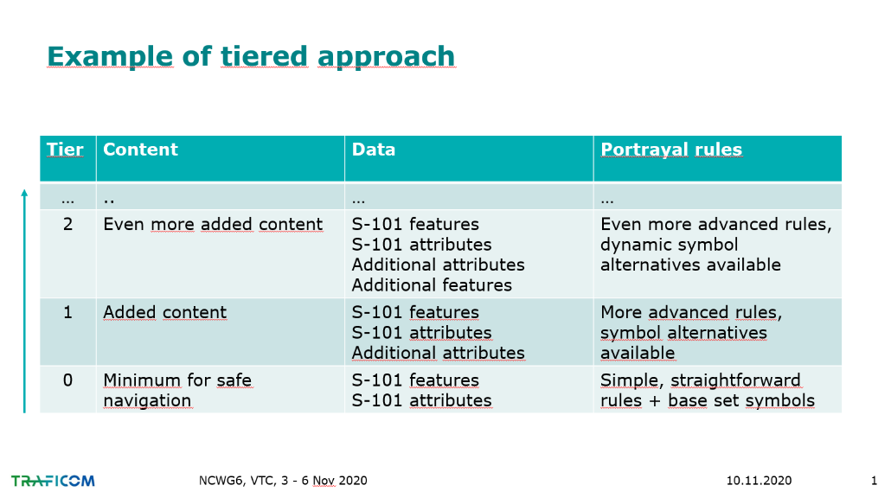

Australia commented that they considered the first task is to make the INT1 symbology into the SVG format and pass it to the IHO S-100 registry. It was noted that we would need to contact the S-100WG to inform them of the extra SVG attribute requirements that need to be included in S-100 profile to allow the symbols to be portrayed. Australia also suggested that the first task should include creating some basic rules to use as a starting point to develop other things. The Chair agreed with Australia and commentated that it may not be necessary to convert all INT 1 symbols to SCG format straight away, the most important ones could be done first and the less important symbols converted at a later date. Canada agreed with Australia’s comments but indicated that they would probably choose tier 0 as a starting point.

The IHO Sec stated that it was difficult to define the minimum content for safe navigation as it was dependent upon user need and location. The IHO Sec also recalled that the WENDWG had suggested a tiered approach in the past at the start of the S-10X work. He further commented that this approach may create more issues rather than solutions. Downgrading the existing paper chart standards presents the risk of causing confusion to mariners.

The US commented that because S-101 has a set of rules then that would probably be our starting point for developing symbols. However, we should also consider if certain features displayed in an ECDIS should not be included in the paper chart such as magenta isolated dangers, depth quality symbols and safety contours etc.

The Chair suggested that we probably needed a dedicated VTC meeting to this subject and that members with a high interest in joining that meeting should contact the Chair and then a date for the meeting can be arranged. This meeting will be open to other members who are interested in joining the discussion, but the main interested parties will be consulted to agree a suitable date.

The IHO Sec suggested that the first task that this new group would need to do is develop a mandate that clearly explained the aims of the group. This would then allow members to understand the issues and task better and help them to consider their opinion.

Action 6/1 – Members interested in joining baseline symbology VTC meeting should contact the contact chair, then subsequently arrange a meeting date and develop a mandate.

8. S-11 Part A
Docs: None
This item was skipped as part of the reduced agenda for the VTC meeting.

9. Liaison with other working groups
9.1 S-101 Portrayal (Chair)
Docs:

We are aware that there is an overdue task for missing portrayal items. Finland and Germany are working on this and it was originally planned to be completed by May but this had been delayed by the pandemic. The Chair confirmed that he will continue to liaise with the S-101 project team regarding this work.

9.2 Invitation to membership of the ICA Commission on Marine Cartography (ICA)
Docs: NCWG6-09.2A

Professor Lysandros provided a short presentation and paper inviting members to consider applying for membership of the ICA Commission on Marine Cartography. The members of NCWG have the background and technical expertise in Nautical Cartography and that is why the ICA is inviting them to become members. The MOU between IHO and ICA also supported close working relations and sharing of knowledge for the benefit of both organisations and the international cartographic community.

Australia asked for clarification on how to become an individual member if the organisation that people belong to is not a member, they also queried how much it costs.

Professor Lysandros suggested that they address the request to their national body that is a member of the ICA but agreed to discuss with ICA colleagues and report back to Australia.

The Chair welcomed the interest from members and stated that he is personally a member of the Cartographic Society of Finland who are a member of ICA and he is able to become a member as a result of this relationship. The Chair noted that this may vary between countries.

10. Lessons learned from Marine Incidents
Docs: None

This item was skipped as no new reports were received for discussion. The Chair encouraged everyone to keep monitoring incident reports that may be of interest to the charting community and requested that members share the reports at the time that they occur.

11. Review of Actions and Work Plan

11.1 Review of meeting actions

The US (NOAA) requested ACTION 6/4 for the UK to respond regarding permission to use and modify Section V as they believed that it was missed. The secretary has included this request as ACTION 6/4 under agenda item 7.1.

11.2 New Item's for work Plan

The Chair recommended that we consider adding a new work plan item regarding the NM Subscription Service proposal.

The Chair confirmed that 6 members are currently interested in joining the group discussion on baseline symbology as detailed in ACTION 6/1.

The IHO Sec asked if the FOPNC SubWG could now be disbanded? The Chair asked the group and members agreed that the FOPNC SubWG could be disbanded.

The IHO Sec then asked if we could confirm the name of the new SubWG that would look at baseline symbology. The Chair responded that this is too early to decide on whether to make a new SubWG and this will need to be discussed at the next meeting which will be dedicated to this topic.

Australia asked if we had missed agenda item 6.3 regarding the future of S-4. The Chair responded that this was taken as part of the bigger discussion on baseline symbology which will affect S-4 and we didn’t take this as a separate item. Australia asked how we planned to progress the discussion of the future of S-4 and the Chair stated that this is not clear at this stage but it is closely related to the bigger discussion on portrayal symbology, it depends on how we proceed. Australia suggested that this needs further clarification at the next meeting. The Chair agreed and stated that we need to have discussions with the S-101 project team. The IHO Sec stated that we needed to remember that the goal of S-4 is to improve chart content.

DECISION: Future of Nautical Paper Chart SubWG has now been disbanded and this group can be removed from the membership list as a separate SubWG.

12. INF papers, reports and Any Other Business

12.1 Election of Chair, Vice Chair and Secretary

The IHO Sec co-ordinated the election of the Chair and Vice chair roles. Mr Mikko Hovi confirmed that he was happy to continue as Chair and no further nominations were received when asked during the meeting. Mrs Jacqueline Barone (US NGA) stood down from the role of Vice Chair at this meeting and will be leaving the group, she thanked everyone for the friendships that she had made within the group during the past 10 years. Mr Nick Rodwell (UK) was successful in applying for the post of Vice Chair and no other nominations were received. Mr James Timmins (UK) stepped down from the role of Secretary and will be leaving the group also. The IHO Sec made a request for volunteers to become the new secretary and Mr Edward Hands from Norway volunteered and was appointed to the role, no other volunteers came forward.

DECISION: Mr Mikko Hovi (Finland) will remain as Chair. Mr Nick Rodwell (UK) has become the new Vice Chair. Mr Edward Hands (Norway) has become the new Secretary.

12.2 Any other Business
No further matters were raised.

13. Date and Location of next meetings

NCWG7– 2021 - Cadiz, Spain (potential hybrid meeting if travel restrictions continue), 9-12 November 2021 tbc
NCWG8- 2022 – Australia

The Chair asked the group to consider the possibilities of hybrid meetings in the future where some members would travel to the meeting and others would attend via VTC due to travel restrictions.

14. Closing remarks

The Chair thanked everyone for their contributions and commented that it was good to see interest in new work items. No further comments were received from members. The Chair wished the members well and hoped that they stay fine, and that the pandemic situation remains stable wherever members are. The Chair encouraged everyone to keep in mind the new skills that we have been learning (VTC) and make use of them.

ANNEX A
Meeting VTC Event
3-4th November 2020

AGENDA AND TIMETABLE
Notes: a/ Potential presenters of papers shown in brackets ().
b) Please refer to the NCWG-6 List of Documents to check the latest version of the documents. NCWG6-XX Rev n means that a new version of document NCWG6-XX has been made available but that it does not affect the draft agenda and timetable.
c) All time slots given below in UTC time.

Tuesday  3 November | NCWG-6 PLENARY DAY 1
1000 -1015 | 1. Welcome, Introductions and Administrative Arrangements (Chair, Instituto Hidrográfico de la Marina, NCWG Secretary)
Skipped, Docs refer | Docs: NCWG6-01A List of Documents (IHO Sec.)  NCWG6-01B List of Participants (IHO Sec.)
1015 | 2. Approval of Agenda
1020 | 3. Status of Actions from NCWG5
 | 4. Matters arising from HSSC
1025 | 4.1. Notes from HSSC12 (Chair)
1035 | 4.2. Actions from HSSC12 (Chair)
Skipped, Docs refer | 4.3. Report from S-100WG (Chair)  Docs: HSSC12-05.1A REV3
Skipped, Docs refer | 4.4. Report from ENCWG (Chair)  Docs: HSSC12-05.2A REV1
Skipped, Docs refer | 4.5. Report from NIPWG (IHO Sec)  Docs: HSSC12-05.3A REV4
Skipped, Docs refer | 4.6. Report from DQWG (DQWG Chair)  Docs: HSSC12-05.5A REV1
 | 5. NCWG Administration and Work Plan
Skipped | 5.1. Review of Terms of Reference and Detailed Procedures (Chair)
1040 | 5.2. Summary of progress, items completed (Sec)
1045 | 5.3 Consideration of further VTC meetings (Chair)
1100 | BREAK 10 MINUTES
 | 6. S-4 Chart Specifications, New and revised symbology
1110 | 6.1.A Future of Paper Chart [Work item A16] (Chair)
Skipped, Docs refer | Docs: NCW6-06.1B Paper Nautical chart from another perspective (ICA – Commission on Marine Cartography)
1130 | 6.3. Future of S-4 [A28] (Chair)
1215 | 7.2A Baseline symbology to support automated chart production [E11] (Chair)  Docs: HSSC12-05.4A and Action HSSC12/36 (former HSSC11/47)  7.2B .SVG symbols (ESRI)  Docs: NCWG6-7.2B .SVG symbols (ESRI)
1300 | END OF DAY 1

Wednesday  4 November | NCWG-6 PLENARY DAY 2
 | 6. S-4 Chart Specifications, New and revised symbology contd. (note: items 6.1 and 6.3 discussed on day 1)
1000 | 6.2 NtMs versus subscription service (Chair / Canada)  Docs: HSSC12-05.3D and Action HSSC12/35
1100 | COFFEE BREAK 10 MINUTES
1110 | 6.4. Protocol for considering portrayal requirements [A26] (Chair)
1115 | 6.5 Portrayal of S-124 – Navigational Warnings (Chair)  Docs: HSSC12-05.3A and action HSSC12/31
1120 | 6.6 Develop a harmonized portrayal process for S-98. (Chair)  Docs: Action HSSC12/41
1125 | 6.7 Swept Wrecks (Chair/ Sec)
 | 7. INT 1 / 2 / 3
1135 | 7.1. Report from Secretary of INT1 subWG [E1] (Sec)  Docs: NCWG6-07.1 INT1 SubWG report
 | Note :7.2A Baseline symbology to support automated chart production and 7.2B .SVG symbols are being discussed on day 1 as part of agenda item 6.
Skipped | 8. S-11 Part A
 | 9. Liaison with other working groups
1140 | 9.1. S-101 Portrayal (Chair)
1145 | 9.2. Invitation to membership of the ICA Commission on Marine Cartography. (ICA)
Skipped | 10. Lessons learned from Marine Incidents
 | 11. Review of Actions and Work Plan
1155 | 11.1. Review of Meeting Actions
1210 | 11.2. New items for Work Plan
 | 12. INF papers, reports and Any Other Business
1230 | 12.1. Election of Chair, vice Chair and Secretary
 | 13. Date and location of next meetings
1245 | NCWG7 - November 2021 – Australia (tbc)  NCWG8 - November 2022 (tbd)
1300 | CLOSURE OF MEETING

ANNEX B

NCWG6-01B | List of Participants
NCWG6-01C | HSSC - List of Contacts
NCWG6-02A | Draft Agenda and Timetable ( .doc , .pdf )
NCWG6-03A | Status of NCWG5 Actions at 30 October 2020 ( .doc ; .pdf )
NCWG6-04.1A | Report of NCWG at HSSC12 - Presentation
NCWG6-04.1B | Report on the Future of the Nautical Paper Chart endorsed at HSSC12 - Presentation
NCWG6-04.2A | Outcome of HSSC-12 ( .pdf )
NCWG6-05.2A | NCWG Work Plan Progress ( .doc )
NCWG6-06.1B | Discussion on the Future of the Paper Nautical Chart from another perspective
NCWG6-06.2A | NtMs versus subscription service Useful References: Doc. HSSC12-05.3D and Action HSSC12/35
NCWG6-06.5A | Portrayal of S-124 - Navigational Warnings Useful References: Slides 11&12 in Doc. HSSC12-05.3A , Annex B to Doc. HSSC12-07.1B and Action HSSC12/31
NCWG6-06.6A | Development of a Haronized Portrayal Process for S-98  Useful Reference: Action HSSC12/41
NCWG6-06.7A | NCWG Letter 01/2020 Consolidated Response Form regarding Swept Wrecks
NCWG6-07.1A | Report of INT1 subWG
NCWG6-07.2A | Baseline symbology to support automated chart production  Useful References: Docs. HSSC12-05.4A , HSSC12-05.4C and Action HSSC12/36
NCWG6-07.2B | Scalable Vector Graphic Symbols to Support Automation (SVG .zip)  Presentation
NCWG6-09.2A | Invitation to Membership of the ICA Commission on Marine Cartography
NCWG6-12.1A | Election of Chair, Vice-Chair and Secretary- Application and bio of Mr Nick Rodwell, for the position of Vice-Chair

ANNEX C
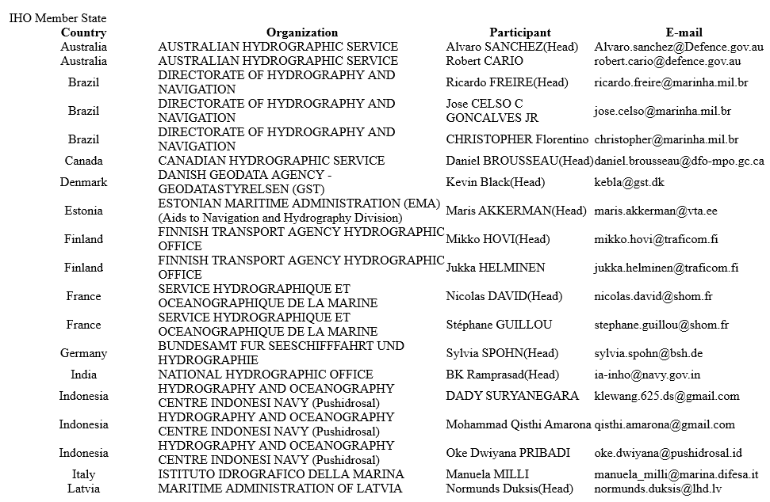
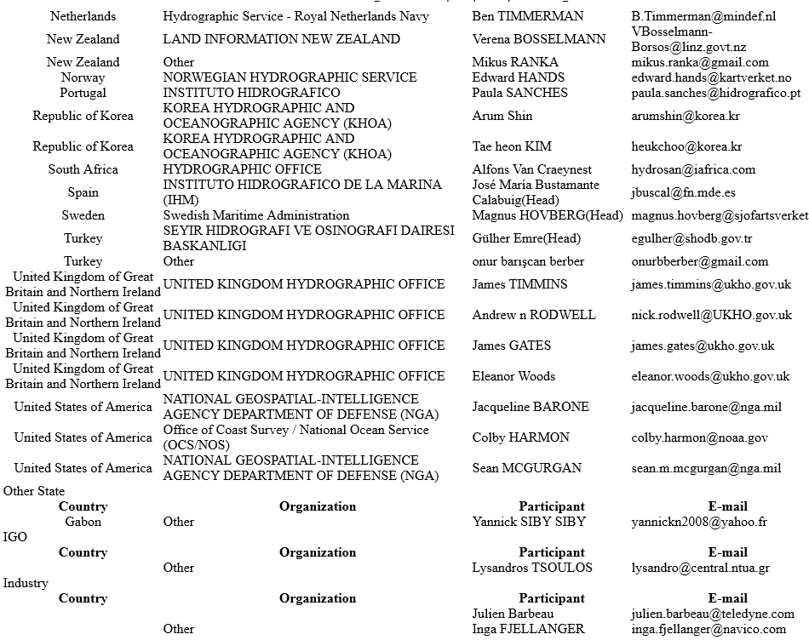
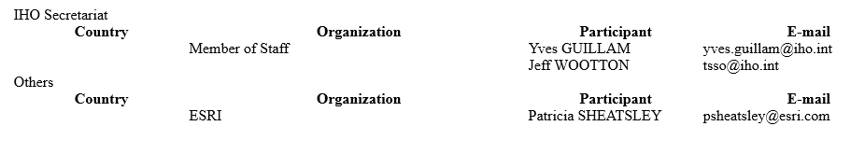
ANNEX D
RETAINED NCWG2 ACTIONS
No | NCWG2  Agenda item | NCWG2 Action | Delegate | Status
2/20 | 8.6 | Chair to discuss DQ options with Ron Furness (ICA) | Chair | Ongoing
2/24 | 8.9 | Chair to propose changes to definitions for seagrass and seaweed in S-32 to HDWG (and consider whether any related definitions, such as kelp, need adjusting).  Note from NCWG3: Additionally, to monitor HDWG’s processing of NCWG2/4 on the agreed revised definitions of height, elevation and altitude. | Chair | Ongoing

RETAINED NCWG3 ACTIONS
No | NCWG3  Agenda item | NCWG3 Action | Delegate | Status
3/3 | 3 | Chair to share list of possibly required symbols for S-101 among volunteers (IT, TR, DE, FI, US-NOAA, US-NGA) and to check latest S101 data quality model is included in the list. | Chair | Ongoing
3/6 | 4.4 | Secretary, Chair and IHO (Sec) to review all IHO Resolutions associated with NCWG activities with a view to cancelling them, or absorbing them into the appropriate standard. | Secretary, Chair, IHO(Sec) | Ongoing

Retained actions from NCWG4
No | NCWG 4  Agenda item | NCWG4 Action | Delegate | Status
4/1 | 4.6 | Discuss and agree a new S-101 symbol for QOBD (Quality of Bathymetric Data) as part of missing symbols work. Inform S-101 project team when considering alarms and indications. | Chair | Ongoing
4/3 | 6.6 | Nations using Satellite Derived Bathymetry (SDB) should share their practices with the UK. The UK will then prepare a consolidated report to identify any common SDB practices and share their findings back to the nations using SDB. If further wording in S-4 required then submit a new paper. | UK and all members who use satellite derived bathymetry | Ongoing
4/5 | 6.8 | Considering discussions had NL to send paper NCWG4-06.8A to S100WG | NL | Ongoing
4/7 | 6.9 | Draft a plan regarding pilot boarding area (and other) boundary symbols and a centralised symbol alternative if boundary symbols not permitted. Submit plan to S-100WG and ENCWG. | UK and FI | Ongoing
4/8 | 6.10 | Review S-4 guidance at B400 so that it is more product neutral. Identify areas that effect ENCs then contact AUS and member states. | Secretary | Ongoing – is this superseded by future of S-4 task?
4/9 | 6.12 | Contact IALA to discuss FFl and draft proposal for S4 depending upon their view. Also consider S-101. | Secretary and NGA | Ongoing
4/16 | 12.5 INF5 | Further consider issue of distinguishing between obstructions and foul ground, propose changes for S-4. | FR, AU | Ongoing
4/18 | 7.2 | INT1 SubWG to continue work with section V and confirm if it will be included in INT1. | INT1 SubWG | Ongoing

Retained NCWG5 ACTIONS
No | NCWG5  Agenda item | NCWG5 Action | Delegate | Status
5/4 | 6.4 | UK to update S-4 (A204.8) and diagram with footnotes and positions of limits of charting regions D and E. (UK) | SEC, UK | In progress
5/5 | 6.7 | NL to re-draft proposed S-4 wording for swept wrecks based upon the comments received. | NL | Included in letter 1 of 2020
5/16 | 12.7 | KR to provide update on S-100 portrayal project | KR | Ongoing

NCWG6 ACTIONS
No | NCWG6  Agenda item | NCWG6 Action | Delegate | Status
6/1 | 7.2 | Members interested in joining baseline symbology VTC meeting should contact the chair, then subsequently arrange a meeting date and develop a mandate. | All | Open
6/2 | 6.2 | Provide detailed proposal of the subscription service regarding charts and nautical publications. Liaise with colleagues in NIPWG. | CA | Open
6/3 | 6.7 | UK to make a clean draft of Swept wrecks proposal and provide to Chair who will then submit it to the DQWG. | UK | Open
6/4 | 7.1 | UK to confirm if section V of UK INT 1 can be released to US for modification in their publication or is there a copyright restriction. | UK | Open

ANNEX E
(updated to 4 November 2020 following NCWG6 and HSSC12)
Tasks
A | Maintain and extend Publication S-4 'Chart Specifications of the IHO & Regulations of the IHO for INT Charts' (IHO Task 2.2.1)
B | Maintain and extend Publication S-11 Part A ‘Guidance for the Preparation and Maintenance of INT Chart schemes’ (IHO Task 2.2.2)
D | Development of new (and revised) symbology (IHO Task 2.2.1)
E | Maintenance of S-4 supplementary publications INT 1, 2 & 3 (IHO Task 2.2.1)
G | Conduct meetings of NCWG (IHO Task 2.1)
H | Provide technical assistance to other IHO working groups and support regarding the implementation of S-100 (IHO Task 2.3)

Work items
* Allowing for approval via HSSC (in accordance with Resolution 2/2007) before MS and publication.

No | Work item | Priority  H-high  M-medium  L-low | Next Milestone | Start  Date | End  Date | Status  P-Planned  O-Ongoing  C-Completed | Contact Person(s) | Affected Pubs/Standard | Remarks
A26 | Portrayal subWG | H | Agree protocol for seeking advice from NCWG | 2016 |  | O | Chair NCWG |  | HSSC7 Action 18  NCWG2 Actions 5, 22, 30-32  Attendance at NIPWG Visualization workshop May 2017.  NCWG3 Action 15
A28 | Future of S-4 | H | NCWG6 – discuss future of S-4 and agree work tasks | 2020 | 2022 | O | Chair NCWG | S-4 | NCWG3 Agenda 7.4: waiting on progress with A16
E1 | Maintain official INT 1s |  | UK to take over English INT 1 from DE and publish new edition |  |  | O | UK: Sam Lerigo  DE: S Spohn  FR: S Guillou  ES: J. Bustamante | INT 1 | DE INT 1 edition 9 published August 2018  ES INT 1 edition 6 published April 2018  FR INT 1 edition 7 published in 2019  UKHO plan to publish new edition of English version before end of 2020.
E9 | Develop new section V for INT1 for ‘data quality’ | M | Draft under consideration by INT1 subWG | 2014 | 2021 | O | Chair NCWG  INT1 subWG | INT1 | CSPCWG10 Action 35  NCWG3 Agenda 11.2: Transferred to UK  NCWG4 – Action 4/18 ongoing
E10 | Symbol library | L | UK to confirm freedom to use UK's symbol set | 2016 |  | O | UK (N Rodwell)  US (C Harmon) | S-4, INT1 | NCWG Actions 45, 46  NCWG3 Agenda 3: Not required to progress at this time.
E11 | Develop baseline symbology to support automated chart production | H | NCWG6 – discus and agree work tasks | 2020 |  | P |  | INT1, S-4 | New proposal by NCWG at HSSC12
Meetings (Task G)

Date | Location | Activity
5-8 November 2019 | Stockholm, Sweden | NCWG5
3-4 November 2020 | VTC | NCWG6
9-12 November 2021 | Cadiz, Spain tbc | NCWG7

Chairman: Mikko Hovi (FI) Email: mikko.hovi@traficom.fi
Vice Chairman: Nick Rodwell (UK) Email: Nick.Rodwell@UKHO.gov.uk
Secretary: Edward Hands (NO) Email: Edward.Hands@kartverket.no

ANNEX F
LIST OF ACRONYMS AND ABBREVIATIONS USED AT NCWG6

AU | Australia
BR | Brazil
CA | Canada
CATZOC | Category of Zone of Confidence
CL | Circular Letter (of IHO)
CO | Colombia
CSPCWG | Chart Standardization and Paper Chart WG (of HSSC)
DE | Germany
DK | Denmark
doc | NCWG4 document or paper associated with the meeting
DQ | Data quality
DQWG | Data Quality Working Group (of HSSC)
E110 | IALA standard for rhythmic characters of lights on aids to navigation
ECDIS | Electronic Chart Display and Information System
ED | Existence Doubtful
EN | Explanatory note
ENC | Electronic Navigational Chart
ENCWG | Electronic Navigational Chart Working Group (of HSSC)
ES | Spain
ESRI | Environmental Systems Research Institute
FI | Finland
FOPNC | Future of Nautical Paper Chart
FR | France
HAT | Highest astronomical tide
HDWG | Hydrographic Dictionary Working Group (of HSSC)
HO | Hydrographic Office
HQ | Headquarters
HSSC | Hydrographic Services and Standards Committee (of IHO)
IALA | International Association of Lighthouse Authorities
IBSC | The FIG/IHO/ICA International Board on Standards of Competence for Hydrographic Surveyors and Nautical Cartographers
ICA | International Cartographic Association
ICPC | International Cables Protection Committee
ID | Indonesia
IHA | International Hydrographic Assembly
IHO | International Hydrographic Organization
IHO(Sec) | Secretariat of the IHO (based in Monaco)
IHO(TSSO) | Technical Standards Support Office of the IHO
IMO | International Maritime Organization
IN | India
INF | Information paper associated with the meeting
INT | International
INT1 | Symbols, Abbreviations, Terms used on Charts
INT3 | Use of Symbols and Abbreviations - standard reference chart
IRCC | Inter-Regional Coordination Committee
JP | Japan
MARPOL | International Convention for the Prevention of Pollution from Ships (MARPOL)
M_QUAL | Quality of data
MS | Member State (of IHO)
NCWG | Nautical Cartography Working Group (of HSSC)
NGA | National Geospatial-Intelligence Agency (US)
NIPWG | Nautical Information Provision Working Group (of HSSC)
NL | Netherlands
NO | Norway
NOAA | National Oceanic and Atmospheric Administration (US)
NM | Notice to Mariners
NP 5011 | Nautical Publication 5011, symbols and abbreviations used on Admiralty paper charts, published by UK.
OEMs | Original equipment manufacturers for ECDIS
PDF | Portable document format
(P)NM | Preliminary Notice to Mariners
PPT | Microsoft PowerPoint
PSC | Port State Control
Res. | Resolution (of the IHO)
Rev | Revision (of a paper)
S-4 | Chart Specifications of the IHO and Regulations for International (INT) Charts
S-11 | Guidance for the Preparation and Maintenance of International Chart Schemes and Catalogue of International (INT) Charts
S-32 | Hydrographic Dictionary
S-52 | Specifications for Chart Content and Display Aspects of ECDIS
S-57 | IHO Transfer Standard for Digital Hydrographic Data
S-100 | IHO Geospatial Standard for Hydrographic data
S-100WG | S-100 Working Group (of HSSC)
S-101 | ENC Product Specification
S-122 | Marine Protected Area Specification
SCAMIN | The SCAMIN value of an object determines the display scale below which the object is no longer visible on an Electronic Chart Display and Information System (ECDIS).
SE | Sweden
Sec | Secretary
SOLAS | The international convention for Safety of Life at Sea
SubWG | Sub-working group (of relevant HSSC WG)
T&P | Temporary and Preliminary (NMs)
TIF | Tagged Image File
(T)NM | Temporary Notice to Mariners
TOR | Terms of Reference
UK | United Kingdom of Great Britain and Northern Ireland
UOC | Use of Object Catalogue for ENC
US | United States of America
WIG | Wing in Ground
WG | Working Group (of IHO)

