7th NCWG MEETING REPORT [DRAFT v0.1]
VTC 24-25 November 2021
Contents:
- Report
- Annexes:
A Agenda
B List of Conference documents (Note: actual documents are available on IHO website including any presentations)
C List of Participants in NCWG7
D NCWG7 Actions
E NCWG Work Plan (updated for NCWG7)
F List of Acronyms and Abbreviations used at NCWG7

REPORT: (Note: The paragraph numbering is the same as in the agenda.)
1. Welcome, introductions and administrative arrangements
Docs: NCWG7-01A List of Documents (on website)
NCWG7-01B List of Registered Meeting Participants
NCWG7-01C List of NCWG Members

The Chair opened the meeting and welcomed all participants. It was noted that the virtual icebreaker held the previous day had been a success and it had been good to see so many members attending. The Chair outlined the administrative arrangements and relevant protocols for the meeting.

2. Approval of Agenda
Docs: NCWG7-02A Agenda

The agenda was approved without any amendments.

3. Status of Actions from NCWG6
Docs: NCWG7-03A Status of Actions

The secretary provided a summary of the status of all current NCWG actions. Members and the Chair provided additional updates and the status of actions was updated accordingly

NCWG2
ACTION 2/20: It was considered that this action was time expired and could be reactivated if required. - CLOSED

ACTION 2/24: It was considered that this action was time expired. CLOSED

NCWG3
ACTION 3/3: It was considered that this action had been taken over by the work of the S-101 Portrayal SubWG - CLOSED

ACTION 3/6: This is an ongoing action involving a regular review of IHO resolutions. The IHO Sec noted that there is an overarching action on the HSSC related to a proposal made by the Republic of Korea at the second session of the IHO Assembly. A review of M3, which contains all the IHO resolutions, is planned and it is believed that this action can be embraced within this review as led by the IHO Secretariat. - OPEN

NCWG4

ACTION 4/1: It was agreed that this has been overtaken by the work of the S-101 Portrayal SubWG -CLOSED

ACTION 4/3 this action relates to guidance in S-4 for Satellite Derived Bathymetry (SDB). The UK submitted a paper in 2019 noting that even though a common practice had been agreed on in S-4 there were still differing approaches to its use among different HO’s. The IHO Sec noted that following a quick review of S-4, there was not one single mention of SDB and cautioned against closing this action as some work was still needed. It was agreed that additional work was required and the UK agreed to collect SDB practices from the relevant HO’s and provide a consolidated report a the next meeting - OPEN

ACTION 7/1 Information on SDB practices to be provided to UK by HO’s. UK to prepare a consolidated report for presentation at NCWG 8

ACTION 4/5: This related to a paper on offshore solar parks and NL submitted to S-101 PT team in 2019 and S-4 was updated accordingly - CLOSED

ACTION 4/7: This action related to pilot boarding areas and the confusion that is generated when the symbol in an area feature auto-centralises and moves when users over zoom. The UK agreed to lead on the collection of information from former mariners and liaise with FI before reporting at the next meeting. - OPEN

ACTION 7/2 UK to request additional information on pilot boarding areas and liaise with FI and report back to NCWG 8

ACTION 4/8: OPEN

ACTION 4/9: The NGA have provided guidelines from IALA no draft yet – OPEN

ACTION 4/16: This was discussed at NCWG 5 existing wording to be retained with no further action required - CLOSED

ACTION 4/18: Work on Section V is ongoing. A report of progress will be given at NCWG 8 -OPEN

NCWG5
ACTION 5/4: This was done in the S-4 Version 4.9 published March 2021 - CLOSED

ACTION 5/5: This was superseded by action 6/3 - CLOSED

ACTION 5/16: OPEN

NCWG 6
ACTION 6/1: CLOSED

ACTION 6/2: CA noted that an update on subscription services for charts and nautical publications would be given on day two - CLOSED

ACTION 6/3: Information has been submitted to DQWG - CLOSED

ACTION 6/4: UK confirmed that work this issue is ongoing - OPEN

4. Matters arising from HSSC
4.1 Notes from HSSC13
Docs: Presentation

The Chair provided a summary from HSSC13. The meeting was held virtually in May 2021 and included discussions on the S-100 roadmap and duel-fuel ECDIS. Many of the S-100 based product specifications will be nearing maturity in the upcoming years and there is a target to start producing S-101 ENC’s in 2025. It was noted that there is still work to be done on defining the guidance and requirements for how to define how ECDIS will handle the duel-fuel transition period when both S-57 and S-101 ENCs’ will coexist.

The IHO is trailing the ISOS 9001 quality assurance principles and for the HSSC the S-101 project is acting a test case with a project team established to do some ISO 9001 compliant screening on the project.

Two project teams were established by HSSC:
- S-130 PT: which will work on the product specification for the polygonal demarcation of global sea areas. This represents a development of the former S-23. It is not intended to completely replace S-23 but is intended to be more of an area subdivision without the names.
- MASS PT- Which was given a two year mandate to identify and define the navigational requirements for the future of autonomous shipping.

It was noted that the Baseline Symbology PT was not included on this list as the NCWG is responsible for establishing this. The HSSC noted that the NCWG was in the process of formally establishing this PT and expressed support for the work.

The IHO Sec took the opportunity to remind members that the priority given by HSSC and Council is that this group can support the automation of paper charts from S-101. In addition, the existence of the permanent task for the group to prepare an annual report based on the recommendations raised in the future of the nautical paper chart report was emphasised. The Chair acknowledged the permanent action to report to both HSSC and Council and noted that the first report to the Council had indeed already been submitted.

4.2 Actions from HSSC13

The Chair provided a summary of the action items relevant to the NCWG from HSSC13.

ACTION HSSC 13/06 – NCWG recommendation for INT chart coordinators to focus on ENC schemes rather that paper charts reported by HSSC to IRCC-13. Agreed –COMPLETED.

ACTION HSSC13/43 – HSSC welcomed the establishment of a Baseline Symbology PT and requested NCWG to submit a project plan for this work as soon as possible following NCWG 7. The Chair noted that this item would be discussed further under agenda item 6.7.

ACTION HSSC13/44 – HSSC 13/44 reminded NCWG of the pending action to provide feedback regarding the portrayal issues in S-124. The Chair thanked all members who provided responses to NCWG Letter 02/2021 and noted that a consolidated response was prepared and forwarded to the Chair of the S-124 PT. – COMPLETED.

ACTION HSSC13/44 – HSSC tasked NCWG to consider the proposal made by CA on subscription-based services to provide updates to navigational products. The Chair noted that this item would be discussed further under agenda item 6.8 and that an update will be provided to HSSC next May.

ACTION HSSC13/46 – HSSC noted the adoption of Edition 4.9.0 of S-4. It was noted that both the English and French language versions are now available – COMPLETED.

An update on the status of the Spanish language version of S-4 was requested. ES noted that this update would be provided during day two of the meeting.

4.3 Report from S-101PT
The Chair noted that this was a place holder on the agenda and that there was nothing specific to report on here.

The IHO Sec commented that the S101 PT which met earlier in 2021. It was noted that it was essentially a reporting meeting for all of the subgroups that fall within the remit of the PT. It was approved at the meeting to publish DCEG version 1.0.1 which subsequently resulted in version 1.0.1 of the S-101 Feature Catalogue. There has been significant work ongoing within the Portrayal subWG. Several further subgroups were established at the meeting. The next S-101 PT meeting will take place on the 6th and 7th December 2021 and this will be an important meeting with the aim of starting to set S-101 up towards the publication of edition 1.1.0 of S-101 which is to be aligned with editions 5.0.0 of S-100 which will be published at the end of 2022.

The Chair noted that the NCWG will continue to monitor S-101 issue and acknowledged his intention to correspond with the Chair of the S-101 PT.

5. NCWG Administration and Work Plan
5.1 Summary of progress, items completed (SEC)
Docs: NCWG7-05.1A_Work_plan_Progress

The Secretary presented a progress review of the work plan items.

Item A26: Portrayal subWG – This relates to an ongoing action for the NCWG to provide portrayal advice. It was agreed the NCWG will continue to provide feedback on portrayal matters but that agreement of a specific protocol for seeking NCWG advice as it was originally planned is no longer necessary. This will be reported to HSSC 14.

Item A28: The Future of S4 – There is currently no open action on restructuring or rewriting S-4. It was noted however that Issues might emerge in the future based on the work of both the S-101 Portrayal PT and the Baseline Symbology PT. The Vice Chair reminded members of the previous calls from OEMs and software manufactures to make S-4 more prescriptive to assist with machine learning and translation. It was noted that such requests have not been forgotten but that NCWG does not have the capacity to do a full re-write of S-4. It was suggested that perhaps the OEMs could provide a list of priority areas for NCWG to look at. The Chair took the opportunity to remind everyone that if there are parts of S-4 that are not considered to work it is possible to raise these with the NCWG for further evaluation and potential amendment. As part of the future of the nautical paper chart proposals it was decided not to freeze S-4 and it will be kept up to date and developed further.

The US - NOAA commented that if attempts were to be made to modernize S-4 to make it more useful for automation the approach of starting over would be preferable to attempting to rebuild the existing S-4 into something more compatible and machine readable.

Item E1: Maintain official INT 1’s – The UK have now taken over responsibility for the English language version of INT 1 from Germany. The most recent edition 8 was published in November 2020. This is a permanent ongoing action and the three official language version will continue to be updated and maintained by the relevant HOs

Item E9: Develop new section V for INT 1 for ‘Data Quality’- Section V was originally published as national guidance in the English version of INT 1, The INT 1 subWG is working to progress this item but requested an extension til the end of 2022.

Item E10: Symbol library- The UK to confirm freedom to use UK’s symbol set. This item is ongoing and the Vice Chair noted that progress was underway.

Item E11: Develop baseline symbology to support automated chart production- it was noted that some work had been done to establish a PT and that the issue would be discussed further at agenda item 6.7.

5.2 Consideration of further VTC meetings

The Chair reported that there has been one intersessional VTC meeting in connection with the Baseline Symbology PT and that this has been successful and additional VTC meeting to discuss specific topics could be arranged as necessary. It was noted that the group should also consider the role of VTC meetings in the post Covid world and how they can benefit the work of the group.

6. S-4 Chart Specifications, New and revised symbology

6.1 Information describing users and uses of paper charts
Docs: NCWG7-06.1A_UKHO Insight on Paper Chart Use and Sales.

The Vice Chair presented information gathered by the UKHO that was considered to align closely with the action to monitor and define the future of the paper chart. The investigation looked at who was still using paper charts and what they were using them for. The first part of the investigation looked at the different market segments that were using paper charts and it was shown that paper charts were being used on both SOLAS and non SOLAS vessels including the non-mandated ECDIS section. The ECDIS-mandated sector of the market used to be the core market for paper chart but this was shown to now be heavily focused on digital products. The aim was to try to determine how much of the non-mandated sector were using paper charts and whether they are using them for more than situation awareness and planning. The research was conducted between October and November 2020. With regards to the question of who was using paper chats and for what purposes, the results showed a difference between the answers given by the fleet masters and the mariners themselves.

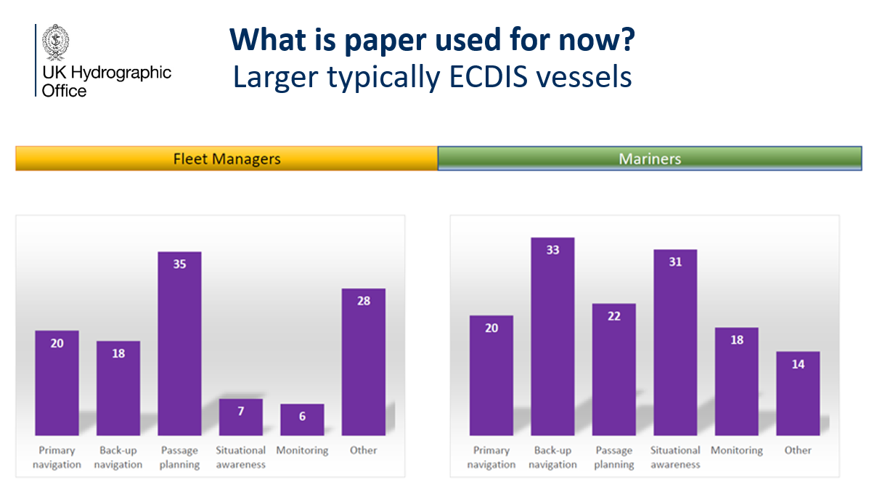

A summary was given of the main findings of the study

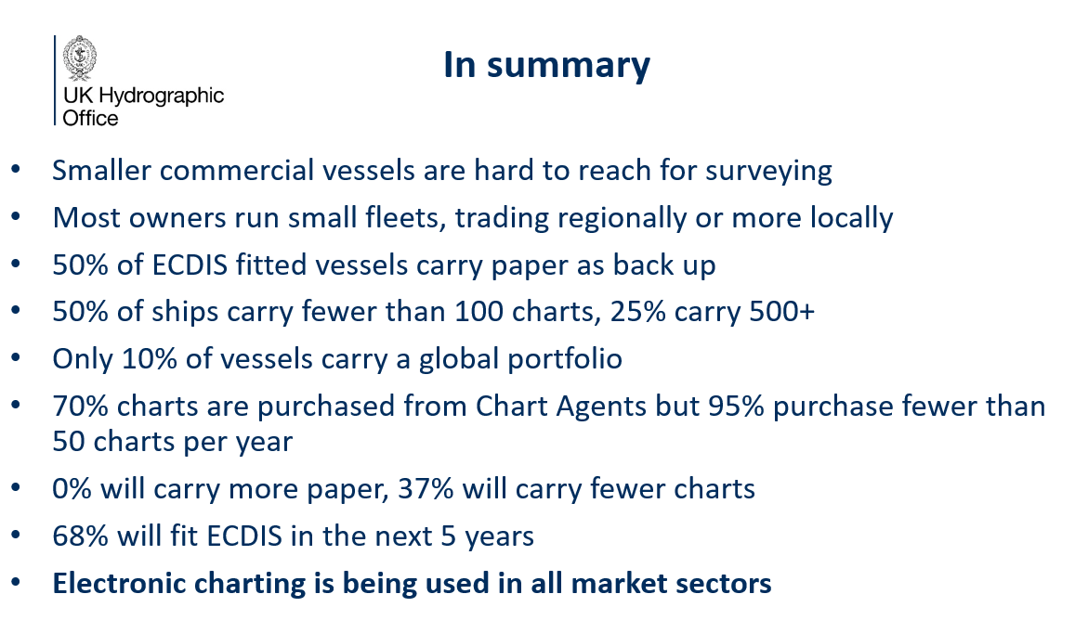

Further information was provided on sales research that showed paper chart sales falling by around 20% per year. Change in the proportion of new editions versus underlying sales had been influenced by print on demand and print to order. It is no longer necessary for distributors and sales agents to maintain stock but are rather relying on print on demand services to meet the need of the users as required. This has reduced the observed sales peak observed when new editions are published and highlights a move to a purchase to requirement culture that we've moved to.

The IHO Sec sought clarification on the sample size used in the survey and questioned whether there were any port state control habits or practice on the use of backup paper charts required by SOLAS. The Vice Chair noted that he would confirm answers to both issues and distribute them after the meeting. US - NOAA enquired if there had been any study of the different use of scales with perhaps electronic sources more prominent in larger scale usage and whether there had been any notable differentiation by usage where by users where more likely to use paper in one scenario and electronic for another. NL noted that the first slide had differentiated between SOLAS and Non SOLAS vessels including leisure craft but that I appeared that the leisure craft segment had not been further investigated in the rest of the survey. The Vice Chair commented that it had been much more difficult to obtain actual feedback from the leisure market beyond a general understanding of how paper charts were used generally.

The Chair encouraged all members to continue to share finding regarding paper chart usage to enable the group to monitor the situation and highlight any significant changes.

6.2 The Future of S-4
Docs: None

This item was addressed when discussing the work plan and there was no further comments were received.

6.3 Position Approximate/Doubtful abbreviations on paper charts.
Docs: NCWG7-06.3A Merging of PA and PD abbreviations in paper charts

FR reported on the decision taken by the S-101 PT for the quality of horizontal measurement in S-101 ENCs and its potential impact on S4. It was noted that at S-101 PT6 a paper was presented that discussed the allowable values for quality of horizontal measurement in S-101 and the recommendation was made to remove seven of the nine possible values and thereby reduce the allowable values to just two, 4: approximate and 5: position doubtful.
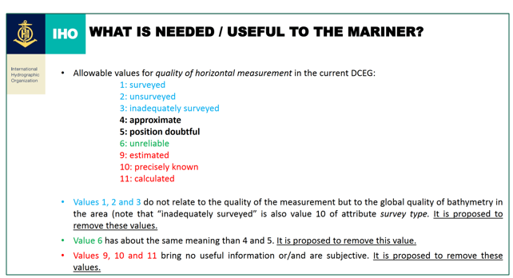

It was not considered that this proposed restriction of values would have a direct impact on S-4 however it was noted that many HO’s produce paper charts from S-57 databases. Therefore France proposed an amendment to S-4 in order to reinforce the importance of populating the S-57 attribute QUAPOS (Quality of position). A proposal was made to add the following additional sentence to B-424:

“On modern cartographic production systems, abbreviations ‘PA’ and ‘PD’ on paper charts can be derived from the qualitative attribution (i.e. QUAPOS) on the corresponding S-57 features. In order to support future ECDIS route planning and route monitoring functionalities, it is strongly recommended to also include quantitative information by populating all relevant S-57 attributes (e.g. POSACC).”
The second topic addressed related to a proposal to merge the abbreviations PA (position approximate) and PD (position doubtful). It is impossible for the mariner to evaluate any degree of uncertainty from either PA or PD. In both case the mariner might well come to the obstructions true position when attempting to avoid it. It was therefore proposed to merge PA and PD into the same abbreviation PA and update S-4 Accordingly. If approved it was also proposed to submit a paper to the S-101 PT to inform them and consider a replacement of attribute Quality of Horizontal Measurement in S-101 with a Boolean attribute Position Unreliable (True/False).

CA noted that they have been struggling with this specific specification for years and following a grounding in the Arctic they took the decision to stop using PA, PD, ED, or SD but have instead been using S-4 B-424.5 Reported Shoal or other danger with a year of reported. Canada were in agreement with the proposal put forward by France.

With regards PD the UK questioned whether in the S-101 environment, it would be possible to add some sort of value to the quantity of uncertainty when you have more than one reported position and you can't differentiate between them.

The IHO Sec enquired as to whether FR had experimented with the proposed merging in existing products to see if there were any impacts on the current products based on the database they have. FR confirmed that no experimentation with the proposal had yet taken place.

The IHO Sec raised concerns with the additional wording proposed to S-4 which was considered to constitute essentially encoding guidance for ENC’s. It was highlighted that in
S-57 there is already guidance recommending that data producers populate the quantitative attributes (POSACC) to represent accuracies rather than the qualitative attributes (QUAPOS). In addition in S-101 Positional accuracy (POSACC) and Sounding accuracy (SOUACC) have been mandated for all depth information shoaler than 30m. Therefore in terms of S-101 the last sentence of the proposed additional wording would not be required. Support was given for highlighting that the population of PA and PD or ED on paper charts can be derived from the qualitative attribution. In situations where the positional accuracy quoted for a feature in S-57 or S-101 is worse than the overall quality indicated by CATZOC then the data producers should consider using a PA or PD. In association with that depth on the chart.

The inclusion of encoding guidance in S-4 raises questions regarding the future of S-4. If it is agreed to start including encoding guidance then it will be necessary to start looking at that sort of information for everything described in S-4 and there was concern raised about this type of cross over.

CA highlighted problems for training new cartographers and the difficulty reconciling between the information contained in the UOC/DCEG and the S-4.

IN commented that we have been increasing the size of S-4 over the years and this might be a good starting point to begin reducing the size of the document.

The Chair summarized the discussion by noting that in general the group approved the main principle but that additional work was required to agree on more suitable wording and the following action was taken.

ACTION 7/3: Additional work to be conducted informed by the paper submitted by FR on quality of horizontal measurement in S-101 ENCs (FR, IHO Sec (JW), NCWG Chair, NCWG Sec)

6.4 Depth Resolution in Charts
Docs: NCWG7-06.4A Depth Resolution in Charts_V1

The IHO Sec presented a paper relating to the depth resolution in charts prepared in collaboration with the Danish Geodata Agency. The paper submitted is stage one of a three stage process resulting from and ENC WG action on DK and the IHO Sec to address some inconsistencies in the resolutions of depths in S-57. The intention of the paper was to reaffirm that the standard unit for depths must be meters and decimetres as is stated in B-130 in S-4 and further qualified by rounding rules in S-412. In S-57 there is a statement relating to the sounding multiplication factor which describes what soundings are converted to within the data. The sounding multiplication factor is set to 10 therefore data cannot be stored to any greater accuracy than the level of a decimetre and this aligns with S-4. However inconsistencies were highlighted in the S-57 attribute Value of sounding where the unit of measurement is defined in meters and decimetres by the format enables encoding of soundings to more than one decimal place of a meter contrary to S-4.
In S-101 the corresponding subfield to the sounding modification factor in S-57 is the CMFZ value and in the current version of S-101 it states that this must be set to 100 which means depths can be captured to centimeter accuracy in ENCs which is no longer compliant with S-4. Furthermore in the value of sounding attribute in S-101 the resolution has been changed to two decimal place and this also does not comply with S-4. It was highlighted that a number of other attributes (including depth range minimum, value of contour, sounding accuracy) can only be encoded to decimeter accuracy.
The NCWG were requested to reconfirm that the units of measurement for depths on charts must be in meters and decimeters as quoted in S4-B-130 in order to facilitate further discussions with the S-101 PT.
A number of suggested amendments to S-4 were proposed to strengthen the guidance and to address some inconsistencies found in the cross referencing.
CA stated their agreement for the reconfirmation that the units of measurement should be meters and decimeters. US (NOAA) noted that depths would never be portrayed to two decimal places on paper charts or ECDIS however the information might still be beneficial in the calculation such as UKC calculations. There is a need for clear differentiation in S-4 between portrayal and data storage. The Chair noted that there are some cases in Finland of regulatory drafts in which accuracies of less than 1 decimeter are important. This can currently be shown on paper chart but not in an ENC. A decision was made to reconfirm that the units of measurement for depths on charts must be in meters and decimeters as quoted and endorsed the paper submitted to the S-101 PT. It was agreed that the proposed redline changes to S-4 would be addressed in the intersessional period and the following action was recorded:
ACTION 7/4 Proposed red line amendments to the relevant S-4 clauses relating to the rounding and depiction of depths on charts to be submitted to members for comment/approval.

6.5 Charted Depiction of Decommissioned oil/gas platform jacket structural remains
Docs: NCWG7-06.5A Charted Depiction of Decommissioned Oil and Gas Platform Jackets

The UK presented a paper relating to an issue that is increasingly being experienced where an oil platform has been removed above the surface or below the sea surface, but protrude above the seabed. In some cases the remains extend up to 50m from the seabed. S-4 states that these should be portrayed as obstructions and it was questioned whether such features could be portrayed differently to draw greater attention them. The group discussed the options with a number of different options being suggested. There was some agreement that this might constitute a special case of obstruction worthy of its own form of portrayal. The UK were tasked with preparing a follow up paper to discuss the issue in greater depth.

ACTION 7/5 UK to expand on the ideas presented in their paper related to the charting of decommissioned oil and gas platform jackets and provide a formal paper.

6.6 Nautical Cartography Surgery
Due to time constraints it was proposed to move this item to day two of the meeting.

[Day 1 of the meeting closed at this point]

6.7 Baseline Symbology Project Team (E11)
Docs: NCWG7-06.7A NCWG Baseline Symbology Project Team Terms of Reference and Procedure.
NCWG7-06.7B_Recommendations_for_Baseline_Symbology_Project Team.
Ref Docs: NCWG7-06.7C_Minutes_of_Baseline_Symbology_VTC_Meeting_1_March21.
The Chair provided a recap on the Baseline Symbology PT noting that it was an issue discussed at the NCWG 6 meeting and that a VTC meeting had been held in March 2021 to discuss how to take the work forward. The decision was made to establish a PT and CA had agreed to take the role of project lead. The proposal to establish a project ream was presented and endorsed at HSSC 13.
CA provided an update on the current status. Following the meeting in March 2021 CHS contacted Caris to consider a symbol converter to SVG from the existing catalogue of production symbols. CHS are looking to adopting the IHO standard and not use their national variations.
It was noted that TOR for the PThad been drafted shorlty following the meeting in March but that these had yet to be formally adopted and that work to complete these would be given high priortiy. The IHO sec higlighted that reference was made to the creation of paper chart back ups in the current draft TOR, however there are currently no product speciaificaitons defining what a paper chart back up is. CA agreed with the point raised and confirmed that the TOR would be amended to reflect this.
The Chair reinterated that as a result of the of the work on the future of the paper chart it had been agreed that there was no requirement for a specific back-up chart specification. There is no active work on creating a separate international specification for back-up charts, however HOs are at their liberty to create their own back-up products. The primary aim of this work would not be to replace any existing products, rather to focus on the creation a machine readblie symbol library which can help support improved automation of paper chart creation from ENC data. CA commented that what had been decided that paper chart content is important so the exisiting paper chart will not be simplified. The key goal will be to reduce the amount of cartographic work that goes into producing a paper chart.
AU supported the conversion of S-4 symbols into SVG to support the creation of paper charts in a standardised way and suggested there could be two approached to this. The first is simply to automate existing processes for deriving a paper chart from an ENC using standardised and machine readable symbols and portrayal rules. But AU also support the concept of back-up charts and the use of automation and a standard to clearly define what that backup chart should contain is considered to be important. AU wish to discontinue paper charts by 2025 and move entirely to a product-on-demand service. Feedback from mariners has demonstrated a preference for the symbology to reflect S-52 symbols and not S-4 symbols. If there is no international back-up specification, AU noted their intention to move forward on their own as they are invested in developing a back-up product. US - NOAA supported the comments made by AU. The US is in a very similar position and although they do not necessarily advocate for a formal specification they are carefully considering what would be required for a backup paper chart.
The Chair commented that this work related to an action assigned to the NCWG from HSSC and that two requirements from HSSC were relevant to the current discussion. Firstly was the decision that there would be no separate backup specifications. If the consensus is that this is an item that needs to be revisited then the NCWG will need to demonstrate how the current S-4 is unable to cater for those HO’s wishing to produce a simplified paper chart product. The option to reconsider certain cases within S-4 that are considered too demanding for this purpose is always open the NCWG. If however this is not sufficient and the view is that a separate specification is required then the group must demonstrate clearly why S-4 is insufficient. The second issues of note was that the NCWG were tasked with creating and delivering both symbols and portrayal rules and in order for the portrayal rules to work they need to be linked to data. HSSC mandated that this should be S-101 data. Although the decision to include S-57 as well may be taken it is S-101 that is required by the task assigned to NCWG and it is not possible to deviate from this without HSSC approval.
US - NOAA made a couple of comments relating to the draft TOR for the PT and requested that the proposed two week interval between meetings be extended slightly and suggested some changes to the mandate and objectives of the PT to focus the work more effectively. CA acknowledged that the issues raised had already been addressed in a revised version of the terms of reference. A question was raised regarding the procedural issues relating to the approval of the TOR and the work of the PT. The Chair confirmed that at the first meeting of the PT the TOR should be amended and finalised and submitted to the NCWG for approval and work should begin on the project plan.
US - NOAA presented a proposal jointly submitted by the US (NOAA) and KR (KHOA). It was noted that there is an opportunity for HO’s to take advantage of new technology to automate much of the creation of paper charts. The Baseline Symbology PT was encouraged to move forward with its work in an expedient manner, building upon automation progress that's already been made by some industry partners and aim to present a prototype at the next NCWG meeting in 2022. The need to move forward quickly and with renewed purpose was highlighted. It was proposed that the PT should be flexible and open to new ways in which data might be presented on automated ENC-based paper charts. Automated paper charts and baseline symbology created to support them should be familiar to paper chart users. Although it could be argued that it should be more familiar to ECDIS users if it’s used as backup. It was noted that there are features for which the traditional S-4 symbology or portrayal might be difficult to automate. There could be different equally comprehensible representations that are certainly acceptable that should be considered. So we shouldn't hold fast necessarily to existing symbology as there may be an opportunity to provide something that is more intuitive. Moving forward, tradeoffs must be considered between the nostalgia for the beauty of the traditional paper charts versus the efficiency of automation and the process to create an equally functional product.
It was also suggested that the PT should be pragmatic and take advantage of S-57 ENC data and S-57 related automation efforts. It was advocated that the automation of S-101 ENC’s should certainly be considered as this has been mandated by HSSC. However it was noted that challenges remain for HO’s with regards the conversion of existing S-57 data and the creation of S-101 data directly. These are still obstacles that have to be overcome to enable efficient use of S-101 data versus the S-57 data that already exists. There is currently already worldwide coverage of S-57 at different scales suitable for automation prototyping, conversely very little if any S-101 currently exists and the earliest operational data is not expected to be available until 2025. If we want to be able to have a robust data set to experiment with, S-57 is available and S-101 is not in a robust way. It is considered that a reliance solely on S-101 data will delay the usefulness of the PT. It was proposed that NCWG should move forward to support automatic paper chart production based on the already available S-57 data, and this will provide valuable lessons for the eventual automation of S-101 ENC data when it becomes available.

The IHO Sec agreed with the arguments given for the development of national strategies but noted that the proposal presented appears to be an attempt to change the strategy approved by HSSC and the Council only six months ago to prioritise and allocate resources to S-101 development and subsequently the automated production of paper charts from S-101 data. At the IHO level caution must be exercised and if deemed necessary by the NCWG a recommendation would need to be submitted to HSSC to approve any change of strategy.

US - NOAA noted the comment but noted that the proposals were not advocating that work towards automating S-101 be abandoned but rather that using S-57 as a baseline could potentially make success with S-101 even faster as we will be able to use some existing data to prototype how things will look and what problems we may have as we move forward.

The Chair reminded members of a decision taken at NCWG 3 that all new S-4 symbology must be automation proof and that there were no barriers preventing the group from revisiting existing symbology to remove unnecessary complexity. One of the tasks of the PT identify problematic symbology that is difficult to automate and report it back to the wider group so that changes can be made as necessary.

SE noted that requesting that HSSC revise the strategy already approved in order to include S-57 might actually delay progress and Sweden supports the approach already agreed on by HSSC and later confirmed by the Council.

CA provided a demonstration of switching between different symbology in the production system to highlight the fact that we are not too far away from the desired goal and that many of the tools for automation are already present. US – NOAA noted that they are very close to having an automated solution to most of the symbology, although labels and annotations are a little but further behind. It was also highlighted that we now have the possibility to use newer technology that was not available before that might facilitate automation. US- NOAA noted that when we're looking at a dual fuel and the conversion process S-57 will for many member states be here for some years to come. The Chair agreed and noted that we cannot afford to forget S-57 entirely. We need to consider the anticipated life of S-57, but need to consider if is it worth investing in producing a conversion from S-57 which will be superseded by S-101. However is was also accepted that not all HOs will be first adopters of S-101.

The Chair discussed the best ways to move the work of the PT forward and noted that the first tasks would be to finalise the TOR and prepare a project plan to be approved and submitted to HSSC 14 and the following actions were agreed.
ACTION 7/6 Baseline Symbology PT to convene and finalise TOR and submit to the group for approval.
ACTION 7/7 Baseline Symbology PT to convene and finalise project plan (including consideration of S-57) and to submit to the group for approval.

6.8 NtM Versus subscription service

CA confirmed that there had been no recent evolution on the concept presented at HSSC. The key aim is to simplify the production of the NtM and move towards presenting the information in a more graphical way to the mariner and to develop an automated system. The main goal is to modernise the delivery system to the mariners and there is interest in finding out how other HO’s are dealing with this issue.

AU shared information pertaining to the Australian E-Notices Service in which the user can register the charts they are interested in and then receive a text message with details about the notices that affect only the charts that they subscribe to.

The Chair noted that he would report back to HSSC that the NCWG has noted the Canadian concept and discussed the topic and but that no further action is required at this stage.

6.9 Portrayal of S-124 – Navigational Warnings
This item related to the proposals from the S-124 PT that were circulated via NCWG letter 2/2020 for comments during the summer. The Chair thanked all those who provided responses in relation to this and noted that all response had been consolidated and forwarded to the S-124 PT lead. It is expected that the NCWG will be consulted on further S-124 portrayal issues in the future but there was no further action required at this time.

6.10 S-4 Proposed wording for Swept Depths and Wrecks

The Secretary confirmed that details had been passed on to the DQWG Chair and this action could be closed for the NCWG. The paper will be considered in terms of DQ by the DQWG at their next meeting in February 2022. It was not considered likely to generate any additional changes to S-4

6.6 Nautical Cartography Surgery

This item was moved from the agenda for day 1 due to time constraints. The Chair introduced the concept of the surgery as a forum for members to raise any small cartographic questions they were having trouble within their respective HO’s in order to seek advice or determine if the topic was worthy of a full paper in its own right.

Two topics were presented, voluntary no anchor areas and buoys with variable adjustable light intensity. Both attracted a good degree of engagement and discussion from members with many suggestions being proposed for portrayal. No further actions were required and no papers were proposed.

7. INT 1 / 2 / 3
7.1 Report from Secretary of INT1 subWG [Work item E1] (Sec)
Docs: NCWG7-07.1A INT1 SubWG report
The Secretary provided an update of the work of the INT1 subWG. The main development was that the UK had now taken over responsibility of the English language version of INT1 and the new edition 8 was published in November 2020. The TOR of the subWG were updated accordingly to reflect this change and were included as an annex to the report. The UK is aware of a minor error in the English language version relating to a reference in the general index to retro-reflected material, which is no longer in the main text. However, it is not considered that corrective action is required at this stage and it will be corrected in the next edition.
The secretary acknowledged that the development of section V was an ongoing work item and that further discussions were required to evolve it further. It was proposed to address this during the intersessional period and report back on progress at NCWG 8. The following action was captured:
ACTION 7/8 Progress development of section V for INT1 for data quality.
FR noted that there were no plans for a new French language version of INT 1
ES noted that a new version of the Spanish language version of INT 1 was planned for early 2022 depending on the nature of the changes required.
AU commented that the latest edition of INT 3 is from 2011 and enquired whether there had been any active analysis of new symbols being proposed or whether it was frozen. The UK confirmed that INT 3 was not frozen but that no updates are not currently being considered. The printed version are not likely to be produced in the future but would be available as PDF as required.
AU suggested that INT3 could serve as the first test case challenge for the Baseline Symbology PT, digital files for the INT3 panels could be created and maintained and made available as PDF or even GeoPDF.

7.2 Retiring Stump Symbology
Docs: NCWG7-07.02A Retiring Stump Symbology
DE presented a paper proposing that version 1 of INT1 symbol K43.1 (set of stump symbols grouped together) and K43.2 be discontinued and enquired if any other HO’s were using these symbols.
SE noted that Sweden was still using symbol K43.2 but would be happy to review its use if required.
EE noted that they were also still currently using this symbol but there are only two instances in the database. Attempts were made to change them but when assigning category of obstruction as foul area partly submerged it appeared on paper charts as a dolphin. DE confirmed that they had experienced the same issue and offered to assist EE outside of the meeting.
FR use these symbols but they could easily be converted to obstructions. ES also confirmed that they use K43.2.
The Vice Chair raised a question regarding the use of the symbols on charts adopted from other HO’s and what the retroactive work was expected to be if the symbol was retired.
The proposal to retire the symbols was supported in principle and it was noted that a full paper outlining all the changes necessary to S-4 and INT 1 should be prepared by DE with support of the NCWG Sec.
ACTION 7/9 Draft proposed changes to S-4 regarding the removal of stump symbols and submit to group for approval.

8. Liaison with other working groups
8.1 IBSC Recruitment

Professor Lysandros representing the International Board on Standards of Competence for Hydrographic Surveyors and Nautical Cartographers made a presentation urging NCWG members to consider becoming members. It was noted that a CL would be provided from the IHO further explaining this opportunity and it was suggested that those interested should contact the Chair of the Marine Cartographic Commission.

9. Review of Actions and Work Plan

9.1 Review of meeting actions

The Secretary provided a review of the actions captured during the meeting

US - NOAA acknowledged that the Baseline Symbology PT should follow the task given by HSSC to use the S-101 symbols for its work on automated paper chart production. However formal acknowledgement was sought for the proposal to consider the conversion of the existing S-57 symbols as a parallel effort that would constitute a beneficial path for facilitating the PT progress. The Chair suggested that the PT would first need to assess their capabilities in this matter and highlighted the difficulties of agree to give the PT additional work before the project plan has been finalised. In response US - NOAA suggested an action of the PT to consider the inclusion of S-57 when formalising the project plan. AU suggested that the PT consider this issue as part of the TOR prior to circulation to NCWG member for approval.

The Chair reiterated that the use of S-101 data is the primary goal required in the action from HSSC and recommended that a final decision on the inclusion of a consideration of S-57 be left up to the PT to decide. If the PT feels that they have the necessary resources and capability to consider S-57 in addition this can be included in the project plan.

9.2 New Item's for work Plan

No comments on new items were proposed and the Chair confirmed that a review would be conducted off line ahead of the next meeting.

10. INF papers, reports and Any Other Business

10.1 Mapping for a sustainable World
Docs: NCWG7-10.1A_Mapping for a Sustainable World Info

DE presented a booklet entitled ‘Mapping for a Sustainable World’ that was presented at the UN-GGIM meeting in August and developed by the International Cartographic Association together with the United Nations Geospatial Information Section. This booklet covers several Sustainable Development Goals. It is proposed that the IHO gets involved in the next edition, when planned, in order to encompass marine cartography, ocean mapping and hydrography. The IHO Sec acknowledged the benefits of this proposal and suggested that this item be kept open on the agenda of NWCG and that suitable actions be taken as necessary.

10.2 A.O.B

11. Date and Location of next meetings

A request was received to try and ensure that future meeting dates do not coincide with any major holidays and this was acknowledged by the Chair however the problems inherent of arranging international meetings were noted.

ES Stated that they were no longer in a position to host the next meeting.

AU indicated that they were willing to host but were unable to make a firm commitment at this time due to the continued complication caused by the COVID 19 pandemic.

Traditionally, the meeting is in the first full week of November and in 2022 the meeting would be between the 8 -11. It was recommended that a Go-no-date be agreed to give clarity for dates and enable travel arrangement to be made. It was agreed that a decision on the date, location and format of the next meeting would be made during the intersessional period and that all members would be informed in good time to make the necessary arrangements.

ACTION 7/11: Decisions on the date, location and format of the next meeting to be taken and disseminated to all NCWG members at least six months before the proposed meeting.

12. Closing remarks

The Chair thanked everyone for their contributions and commented that it was good to see interest in new work items. No further comments were received from members and the meeting was closed.

ANNEX A
7th NCWG Meeting VTC Event
24th-25th November 2021

DRAFT AGENDA AND TIMETABLE

Notes: a) Potential presenters of papers shown in brackets.
b) Please refer to the NCWG-7 List of Documents to check the latest version of the documents.
c) All time slots given below are in UTC time.

Wednesday  24 November | NCWG-7 PLENARY DAY 1
1200 | - Welcome, Introductions and Administrative Arrangements (Chair, Sec)
1210 | - Approval of Agenda  Docs: NCWG7-02A_Draft Agenda version 0.2.
1215 | - Status of Actions from NCWG6  Docs: NCWG7-03A_Status of Actions from NCWG_06_Nov21.
 | 4. Matters arising from HSSC
1225 | 4.1. Notes from HSSC13 (Chair)  Docs: NCWG7-04.1A Report of NCWG at HSSC13.
1240 | 4.2. Actions from HSSC13 (Chair)  Docs: NCWG7-04.2A_Outcome of HSSC 13.
1250 | 4.3. Report from S-101WG (Chair)
 | 5. NCWG Administration and Work Plan
1300 | 5.1. Summary of progress, items completed (Sec)  Docs: NCWG7-05.1A_Work_plan_Progress.
1310 | 5.2 Consideration of further VTC meetings (Chair/Vice Chair)
 | BREAK 10 MINUTES
 | 6. S-4 Chart Specifications, New and revised symbology
1330 | 6.1. Information describing users and uses of paper charts (Vice Chair)  Docs: NCWG7-06.1A_UKHO Insight on Paper Chart Use and Sales.
1345 | 6.2 The Future of S-4 [A28] (Chair)
1400 | 6.3 Position Approximate/Doubtful abbreviations on paper charts (France)  Docs: NCWG7-06.3A Merging of PA and PD abbreviations in paper charts.
1420 | 6.4 Depth Resolution in Charts (Jeff Wootton)  Docs: NCWG7-06.4A Depth Resolution in Charts_V1.
1440 | 6.5 Charted Depiction of Decommissioned oil/gas platform jacket structural remains (Vice Chair)  Docs: NCWG7-06.5A Charted Depiction of Decommissioned Oil and Gas Platform Jackets
1500 | 6. 6 Nautical Cartography Surgery (Chair/Vice Chair)
1530 | END OF DAY 1

Thursday  25 November | NCWG-7 PLENARY DAY 2
1200 | 6.7 Baseline Symbology Project Team [E11] (Chair/Canada/NOAA)  Docs:  NCWG7-06.7A NCWG Baseline Symbology Project Team Terms of Reference and Procedure.  NCWG7-06.7B_Recommendations_for_Baseline_Symbology_Project Team.  Ref Docs:  NCWG7-06.7C_Minutes_of_Baseline_Symbology_VTC_Meeting_1_March21.
1250 | 6.8 NtMs versus subscription service (Chair / Canada)  Docs:
 | COFFEE BREAK 10 MINUTES
1330 | 6.9 Portrayal of S-124 – Navigational Warnings (Chair)  Docs: NCWG7-06.8A NCWG_Letter_02-2021 Consolidated Response Regarding Navigational Warnings.
1340 | 6.10 S-4 Proposed wording for Swept Depths and Wrecks (Chair/ Sec)  Docs: NCWG7-06.10A: Proposal for Revised Definition of Swept Wrecks.
 | 7. INT 1 / 2 / 3
1400 | 7.1. Report from Secretary of INT1 subWG [E1] (Sec)  Docs: NCWG7-07.1A INT1 SubWG report.
1410 | 7.2 Retiring Stump Symbol (Germany)  Docs: NCWG7-07.02A Retiring Stump Symbology
 | 8. Liaison with other working groups
1420 | 8.1 IBSC Recruitment (IBSC)
 | 9. Review of Actions and Work Plan
1430 | 9.1. Review of Meeting Actions
1450 | 9.2. New items for Work Plan
 | 10. INF papers, reports and Any Other Business
1500 | 10.1 Mapping for a sustainable World (Germany)  Docs: NCWG7-10.1A_Mapping for a Sustainable World Info
1510 | 10.2 A.O.B
1520 | 11. Date and location of next meetings
NCWG8 - November 2022 – Spain/Australia? (tbc)
NCWG9 - November 2023 (tbd)
1530 | CLOSURE OF MEETING

ANNEX B

NCWG7-01B | List of Participants
NCWG7-01C | HSSC - List of Contacts
NCWG7-02A | Draft Agenda and Timetable ( .doc , .pdf )
NCWG7-03A | Status of NCWG6 Actions at 12 November 2021 ( .doc )
NCWG7-04.1A | Report of NCWG at HSSC13
NCWG7-04.2A | Outcome of HSSC-13 ( .pdf )
NCWG7-05.2A | NCWG Work Plan Progress ( .doc )
NCWG7-06.1A | Insight on Paper Charts Use and Sales (UKHO)
NCWG7-06.3A | Merging of PA and PD abbreviations on paper charts  Presentation
NCWG7-06.4A | Depth Resolution on Charts (.doc ; .pdf ) - Presentation
NCWG7-06.5A | Charted depiction of decommissioned oil/gas platform jackets
NCWG7-06.7A Rev1 | TORs and ROPs of the Baseline Symbology Project Team
NCWG7-06.10A | Proposal for Revised Definition of Swept Wrecks.
NCWG7-07.1A | Report of INT1 subWG
NCWG6-07.2A | Retiring stump symbol
NCWG7-10.1A | Mapping for a Sustainable World

ANNEX C
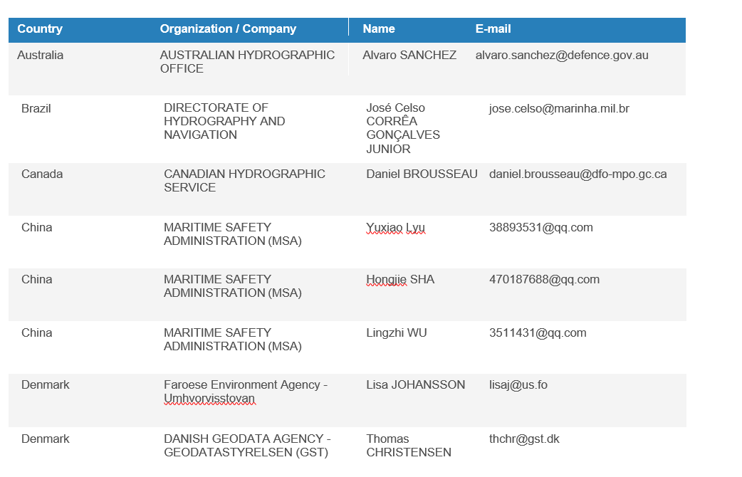
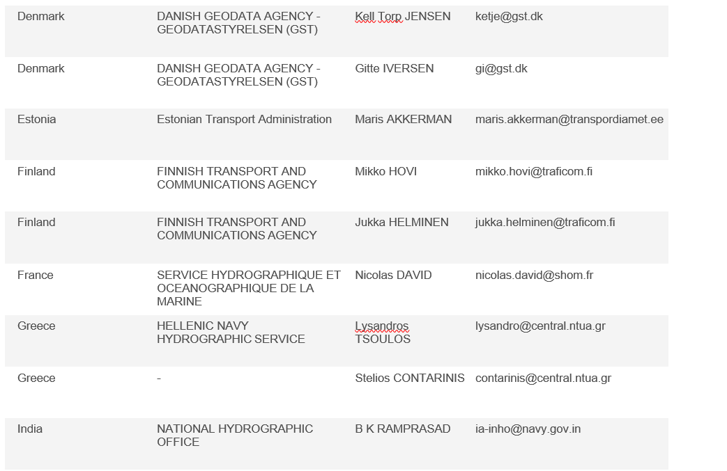
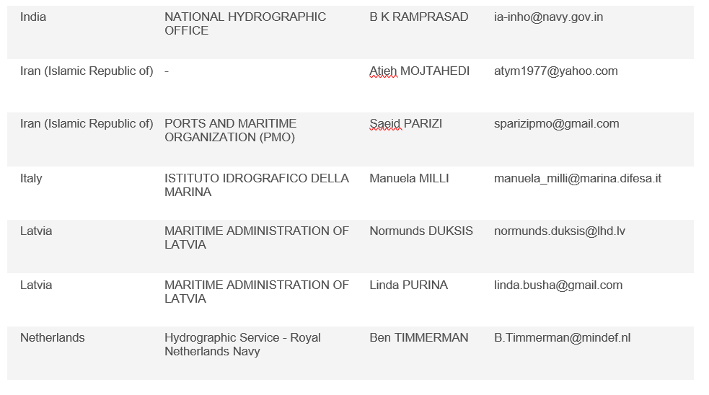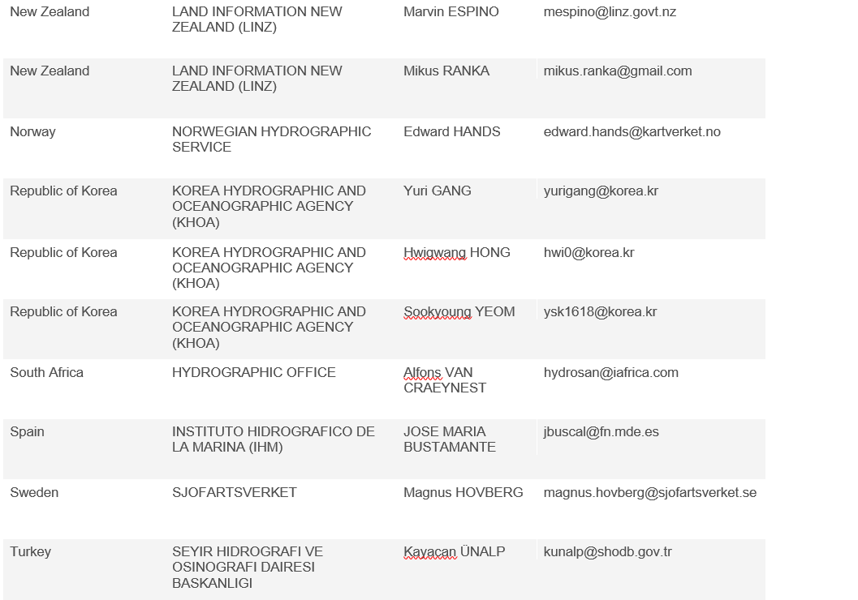
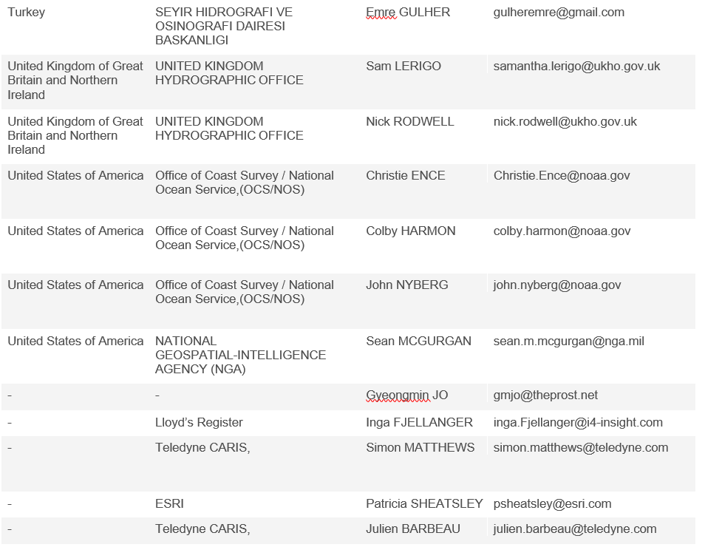 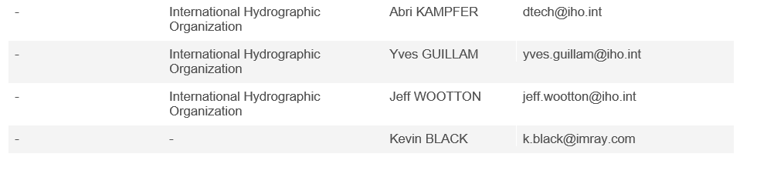
ANNEX D
Retained NCWG3 ACTIONS
No | NCWG3  Agenda item | NCWG3 Action | Delegate | Status
3/6 | 4.4 | Secretary, Chair and IHO (Sec) to review all IHO Resolutions associated with NCWG activities with a view to cancelling them, or absorbing them into the appropriate standard. | Secretary, Chair, IHO(Sec) | Ongoing
Retained NCWG4 ACTIONS
No | NCWG 4  Agenda item | NCWG4 Action | Delegate | Status
4/3 | 6.6 | Nations using Satellite Derived Bathymetry (SDB) should share their practices with the UK. The UK will then prepare a consolidated report to identify any common SDB practices and share their findings back to the nations using SDB. If further wording in S-4 required then submit a new paper. | UK and all members who use satellite derived bathymetry | Ongoing
4/7 | 6.9 | Draft a plan regarding pilot boarding area (and other) boundary symbols and a centralised symbol alternative if boundary symbols not permitted. Submit plan to S-100WG and ENCWG. | UK and FI | Ongoing
4/8 | 6.10 | Review S-4 guidance at B400 so that it is more product neutral. Identify areas that effect ENCs then contact AUS and member states. | Secretary | Ongoing
4/9 | 6.12 | Contact IALA to discuss FFl and draft proposal for S4 depending upon their view. Also consider S-101. | Secretary and NGA | Ongoing
4/18 | 7.2 | INT1 SubWG to continue work with section V and confirm if it will be included in INT1. | INT1 SubWG | Ongoing
Retained NCWG5 ACTIONS
No | NCWG5  Agenda item | NCWG5 Action | Delegate | Status
5/16 | 12.7 | KR to provide update on S-100 portrayal project | KR | Ongoing
Retained NCWG6 ACTIONS
No | NCWG6  Agenda item | NCWG6 Action | Delegate | Status
6/4 | 7.1 | UK to confirm if section V of UK INT 1 can be released to US for modification in their publication or is there a copyright restriction. | UK | Open

NCWG 7 ACTIONS
No | NCWG7  Agenda item | NCWG7 Action | Delegate | Deadline
7/1 | 3 | Information on SDB practices to be provided to UK by relevant HO’s. UK to prepare a consolidated report for presentation at NCWG 8 | UK | NCWG 8
7/2 | 3 | UK to request additional information on pilot boarding areas and liaise with FI and report back to NCWG 8 | UK | NCWG 8
7/3 | 6.3 | Additional work to be conducted informed by the paper submitted by FR on quality of horizontal measurement in S-101 ENCs | FR, IHO Sec, Chair, Sec | NCWG 8
7/4 | 6.4 | Proposed red line amendments to the relevant S-4 clauses relating to the rounding and depiction of depths on charts to be submitted to members for comment/approval. | Chair, IHO Sec, Sec | NCWG 8
7/5 | 6.5 | UK to expand on the ideas presented in their paper related to the charting of decommissioned oil and gas platform jackets and provide a formal paper. | UK | NCWG 8
7/6 | 6.7 | Baseline Symbology PT to convene and finalise TOR and submit to the group for approval. | CA | December 2021
7/7 | 6.7 | Baseline Symbology PT to convene and finalise project plan (including consideration of S-57) and to submit to the group for approval. | CA | January 2022
7/8 | 7.2 | Progress development of section V for INT1 for data quality. | Sec | NCWG 8
7/9 | 7.2 | Draft proposed changes to S-4 regarding the removal of stump symbols and submit to group for approval. | DE supported by Sec | NCWG 8
7/10 | 8.1 | NCWG members to consider membership of the IBSC | All | NCWG 8
7/11 | 11 | Decisions on the date, location and format of the next meeting to be taken and disseminated to all NCWG member at least six months before the proposed meeting. | Chair, Vice Chair | May 2022

ANNEX E
(updated to 5 November 2021 following NCWG6, HSSC13 and subsequent activity)
Tasks
A | Maintain and extend Publication S-4 'Chart Specifications of the IHO & Regulations of the IHO for INT Charts' (IHO Task 2.2.1)
B | Maintain and extend Publication S-11 Part A ‘Guidance for the Preparation and Maintenance of INT Chart schemes’ (IHO Task 2.2.2)
D | Development of new (and revised) symbology (IHO Task 2.2.1)
E | Maintenance of S-4 supplementary publications INT 1, 2 & 3 (IHO Task 2.2.1)
G | Conduct meetings of NCWG (IHO Task 2.1)
H | Provide technical assistance to other IHO working groups and support regarding the implementation of S-100 (IHO Task 2.3)

Work items
* Allowing for approval via HSSC (in accordance with Resolution 2/2007) before MS and publication.

No | Work item | Priority  H-high  M-medium  L-low | Next Milestone | Start  Date | End  Date | Status  P-Planned  O-Ongoing  C-Completed | Contact Person(s) | Affected Pubs/Standard | Remarks
A26 | Portrayal subWG | H | Agree protocol for seeking advice from NCWG | 2016 |  | O | Chair NCWG |  | HSSC7 Action 18  NCWG2 Actions 5, 22, 30-32  Attendance at NIPWG Visualization workshop May 2017.  NCWG3 Action 15
A28 | Future of S-4 | H | NCWG6 – discuss future of S-4 and agree work tasks | 2020 | 2022 | O | Chair NCWG | S-4 | NCWG3 Agenda 7.4: waiting on progress with A16
E1 | Maintain official INT 1s |  | UK to take over English INT 1 from DE and publish new edition |  |  | O | UK: Sam Lerigo  FR: S Guillou  ES: J. Bustamante | INT 1 | DE INT 1 edition 9 published August 2018  ES INT 1 edition 6 published April 2018  FR INT 1 edition 7 published in 2019  UKHO have taken over responsibility for English INT 1 from DE and published edition 8 in 2020
E9 | Develop new section V for INT1 for ‘data quality’ | M | Draft under consideration by INT1 subWG | 2014 | 2021 | O | Chair NCWG  INT1 subWG | INT1 | CSPCWG10 Action 35  NCWG3 Agenda 11.2: Transferred to UK  NCWG4 – Action 4/18 ongoing
E10 | Symbol library | L | UK to confirm freedom to use UK's symbol set | 2016 |  | O | UK (N Rodwell)  US (C Harmon) | S-4, INT1 | NCWG Actions 45, 46  NCWG3 Agenda 3: Not required to progress at this time.
E11 | Develop baseline symbology to support automated chart production | H | NCWG6 – discus and agree work tasks | 2020 |  | P |  | INT1, S-4 | New proposal by NCWG at HSSC12  VTC Meeting held 1 March 2021 – recommendation to formally establish a Project Team.

Meetings (Task G)

Date | Location | Activity
5-8 November 2019 | Stockholm, Sweden | NCWG5
3-4 November 2020 | Virtual Event | NCWG6
9-12 November 2021 | Cadiz, Spain (hybrid tbc) | NCWG7
2022 | Wollogong, Australia (tbc) | NCWG8

Chairman: Mikko Hovi (FI) Email: mikko.hovi@traficom.fi
Vice Chairman: Nick Rodwell (UK) Email: Nick.Rodwell@UKHO.gov.uk
Secretary: Edward Hanks (NO) Email: Edward.Hands@kartverket.no

ANNEX F
LIST OF ACRONYMS AND ABBREVIATIONS USED REPORT OF NCWG7

AU | Australia
CA | Canada
CATZOC | Category of Zone of Confidence
CHS | Canadian Hydrographic Service
CL | Circular Letter (of IHO)
CMFZ | Coordinate Multiplication Factor Z value
DCEG | Data Classification and Encoding Guide
DE | Germany
DK | Denmark
doc | NCWG4 document or paper associated with the meeting
DQ | Data quality
DQWG | Data Quality Working Group (of HSSC)
ECDIS | Electronic Chart Display and Information System
ED | Existence Doubtful
ENC | Electronic Navigational Chart
ES | Spain
FI | Finland
FR | France
GeoPDF | Georeferenced Portable document format
HO | Hydrographic Office
HSSC | Hydrographic Services and Standards Committee (of IHO)
IALA | International Association of Lighthouse Authorities
IBSC | The FIG/IHO/ICA International Board on Standards of Competence for Hydrographic Surveyors and Nautical Cartographers
IHO | International Hydrographic Organization
IHO Sec | Secretariat of the IHO (based in Monaco)
IN | India
INF | Information paper associated with the meeting
INT | International
INT1 | Symbols, Abbreviations, Terms used on Charts
INT3 | Use of Symbols and Abbreviations - standard reference chart
IRCC | Inter-Regional Coordination Committee
KR | Republic of Korea
MASS PT | Maritime Autonomous Surface Ships Navigation Project Team (of HSSC)
NCWG | Nautical Cartography Working Group (of HSSC)
NGA | National Geospatial-Intelligence Agency (US)
NL | Netherlands
NOAA | National Oceanic and Atmospheric Administration (US)
NtM | Notice to Mariners
OEMs | Original equipment manufacturers for ECDIS
PA | Position Approximate
PD | Position Doubtful
PDF | Portable document format
POSACC | Positional Accuracy
PT | Project Team
Res. | Resolution (of the IHO)
Rev | Revision (of a paper)
S-4 | Chart Specifications of the IHO and Regulations for International (INT) Charts
S-11 | Guidance for the Preparation and Maintenance of International Chart Schemes and Catalogue of International (INT) Charts
S-23 | Limits of Oceans and Seas
S-32 | Hydrographic Dictionary
S-52 | Specifications for Chart Content and Display Aspects of ECDIS
S-57 | IHO Transfer Standard for Digital Hydrographic Data
S-100 | IHO Geospatial Standard for Hydrographic data
S-100WG | S-100 Working Group (of HSSC)
S-101PT | S-101 Project Team (Of HSSC)
S-101 | ENC Product Specification
S-122 | Marine Protected Area Specification
S-124 | Navigational Warnings
S-130 PT | S-130 Project Team ( of HSSC)
SD | Sounding Doubtful
SDB | Satellite Derived bathymetry
SE | Sweden
Sec | Secretary
SOUACC | Sounding Accuracy
SOLAS | The international convention for Safety of Life at Sea
SubWG | Sub-working group (of relevant HSSC WG)
SVG | Scalable Vector Graphic
TOR | Terms of Reference
UK | United Kingdom of Great Britain and Northern Ireland
UKHO | United Kingdom Hydrographic Office
QUAPOS | Quality of Position
UOC | Use of Object Catalogue for ENC
UKC | Under Keel Clearance
US | United States of America
VTC | Video Teleconference
WG | Working Group (of IHO)

