Paper for Consideration by DQWG

Submitted by: | Nautical Cartography Working Group (NCWG)  (Chair and Vice Chair)
Executive Summary: | Proposal for revised definition of swept wrecks
Related Documents: | S-4 Regulations of the IHO for International (INT) Charts and Chart Specifications of the IHO
Related Projects: | NCWG Work Plan: A. Maintain and extend Publication S-4 'Chart Specifications of the IHO & Regulations of the IHO for INT Charts' (IHO Task 2.2.1)

Introduction / Background
NCWG members have discussed revising the wording in S-4 for swept wrecks to reflect the changes in technology used to survey wrecks and obstructions. At the 6th NCWG meeting, members agreed proposed new wording which indicates the uncertainty of the least depth indicated, rather than the specific methodology used.

Analysis / Discussion
There is a need to adjust the definition of the swept symbols K2, K27 and K42 to allow for modern best survey practice as well as past techniques and future techniques not yet developed. To this end we recommend that the definition should be system independent and focus on the fact that the depth has been found to the highest reliability and with least uncertainty. This aligns with the ethos of the S-44 survey standards in regard of being independent of technology.
The mariner should not need to be concerned with the method employed to obtain a depth, they need to be able to understand the level of uncertainty. It is also considered that depths on wrecks measured using appropriate MBES water column data analysis can be at least as reliable (if not more so) than wire sweeping.
To avoid introducing a new symbol to S-4, NCWG proposes to change the definitions of the current symbols.
For wrecks and obstructions, it would seem sensible to have 3 levels of uncertainty:
- Lowest confidence, highest uncertainty. Depth not reliable or estimated. Currently covered by symbols K3 & K30
- Moderate confidence, average uncertainty. Reasonably reliable. Currently covered by symbols K26 & K41
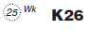
- Highest confidence, lowest uncertainty. Most reliable. Depth measured using best currently available methods. Currently covered by symbols. K2, K27, K42
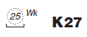

Conclusions
B-415 SWEPT DEPTHS AND AREAS; AREAS INVESTIGATED FOR DEEP DRAUGHT VESSELS
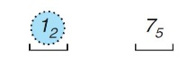
Swept depths must be shown by the symbol _ K2, for example:

The use of the symbol must be confined to areas investigated using the most reliable currently available survey techniques, resulting in a depth with the least uncertainty. While a depth can never be guaranteed, the use of this symbol should be reserved for investigations that leave little doubt that the minimum depth has been determined. Examples include properly controlled mechanical/wire sweeping & collection and analysis of sonar water column data.

B-422.3 A wreck which has been wire swept, by investigation using the most reliable currently available survey techniques, resulting in a depth with the least uncertainty and leaving little doubt that the minimum depth has been determined. This must be shown by sounding numerals showing the measured depth surrounded by a danger line, with the abbreviation ‘Wk’; the swept symbol K2 must be inserted under the danger line, for example:
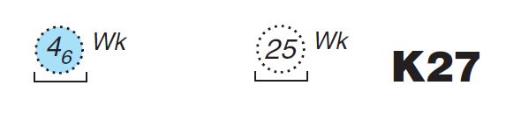

B-422.4 A wreck over which the least depth that is known has been found by investigation using reliable survey techniques, resulting in a depth with average uncertainty and with moderate confidence that the minimum depth has been determined. This must be shown as in B422.3 but without the swept symbol K2, for example:
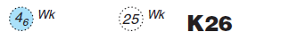

B-422.3 A wreck estimated safe clearance, For a wreck (in water less than 200m deep) over which the least depth is not reliable or has been estimated, a safe clearance depth must be estimated if possible. This must be shown as in B422.4 and safe clearance bar K3 must be shown, for example:
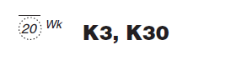

B-422.9
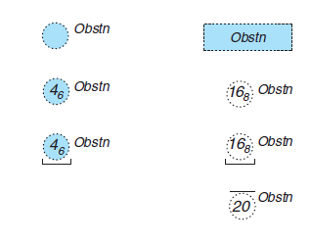 | K40 (depth unknown)  K41 (Moderate confidence, average uncertainty. Reasonably reliable)  K27 (Highest confidence, lowest uncertainty. Most reliable. Depth measured using best currently available methods.)  K30 K3 (Lowest confidence, highest uncertainty. Depth not reliable or estimated)

Recommendation
Accept these changes to S-4

Justification and Impacts
INT1 will be amended in due course to reflect these changes

Action required of DQWG
The DQWG is invited to:

- note this paper;
- comment and provide feedback on the above recommendation.

Annex A

Extracts from S-4 showing current depiction

