Paper for Consideration by NCWG
Merging of PA and PD abbreviations on paper charts

Submitted by: | France
Executive Summary: | Proposal to merge PA and PD
Related Documents: | Paper S-101PT6-14: “Quality of Horizontal Measurement” in S-101 ENCs  S-101PT6 Record of Meeting_Final.pdf
Related Projects: | S-4 (including INT1); S-101 FC and DCEG

Introduction / Background
Introduction / Background
- During the VTC meeting 6 (23-24 February 2021), the S-101 Project Team has decided to reduce the allowable values for attribute Quality of Horizontal Measurement in S-101 ENCs to:
- 4 (approximate) and
- 5 (position doubtful).
- This paper first aims at presenting the S-101PT decision, as required by action S-101PT6-18: “Raise the decisions made in relation to the restriction of the values of the attribute Quality of Horizontal Measurement to the NCWG for possible impacts on S-4 and INT1”.
- As the project team felt this decision could be a first step towards the creation of a Boolean attribute (e.g. Position unreliable), this paper extends to a new proposal to merge the use of abbreviations PA and PD on paper charts.
Analysis / Discussion
A - Quality of Horizontal Measurement in S-101 ENCs
- Paper S-101PT6-14 “Quality of Horizontal Measurement” in S-101 ENCs was submitted at the S-101PT meeting 6 (VTC). Quality of Horizontal Measurement is a S-101 spatial attribute. It is the equivalent of QUAPOS in S-57.
- In the version of the S-101 Data Classification and Encoding Guide at the time of S-101PT6, Quality of Horizontal Measurement admitted the same allowable values than QUAPOS. The main proposal of Paper S-101PT6-14 was to reduce the allowable values for Quality of Horizontal Measurement in S-101 to 4 (approximate) and 5 (position doubtful).
- The proposal was motivated by the following reasons:
- Among the 9 admitted values at the time, some (surveyed, unsurveyed, inadequately surveyed) do not relate to the quality of the measurement but to the global quality of bathymetry in the area; others (estimated, calculated, precisely known) bring no useful information to the mariner or is subjective; value 6 (unreliable) convey the same information than values 4 and 5.
- In terms of S-52 ECDIS display (at this point of time, there is no difference between S-52 and S-101 portrayal on this aspect), when QUAPOS is populated with a value different than 1 (surveyed), 10 (precisely known) and 11 (calculated), a same special “Low accuracy” symbology is activated for soundings, points and lines objects, whatever the value of QUAPOS.
- As a consequence of the decision made by the S-101PT, it is suggested to review S-4 (B-424), after: “The abbreviations ‘PA’ and ‘ED’ may be applied to features other than dangers where necessary.”, to add the following guidance: “On modern cartographic production systems, abbreviations ‘PA’ and ‘ED’ on paper charts can be derived from the qualitative attribution (i.e. QUAPOS) on the corresponding S-57 features. In order to support future ECDIS route planning and route monitoring functionalities, it is strongly recommended to also include quantitative information by populating all relevant S-57 attributes (e.g. POSACC).

B - Merging of abbreviations PA and PD on paper charts.
- France would like to take advantage of this paper to suggest the merging of abbreviations PA and PD on paper charts.
- S-4 (B-424.1 and B-424.2) provide definitions of these two abbreviations. PA is used to indicate that the position of an object has not been accurately determined or does not remain fixed. PD is used when an object has been reported in various positions and not confirmed in any of them.
- In fact, when “avoiding” the object concerned, the mariner might well come to its true position: both attribute values 4 and 5 bring, for the mariner, the same information (i.e. the object may not be at its charted position), and should produce exactly the same caution (in terms of safety of navigation) from the mariner.
- In terms of uncertainty, is there a difference between both information?
In figure 1 below:
- In black: Wreck encoded with PA (the positional uncertainty is shown by the black circle);
- In green: Wreck reported at three different positions (the wreck will be charted at one of these positions, with PD according to S-4);
- In red: Wreck reported at three different positions (the wreck will be charted at one of these positions, with PD according to S-4).
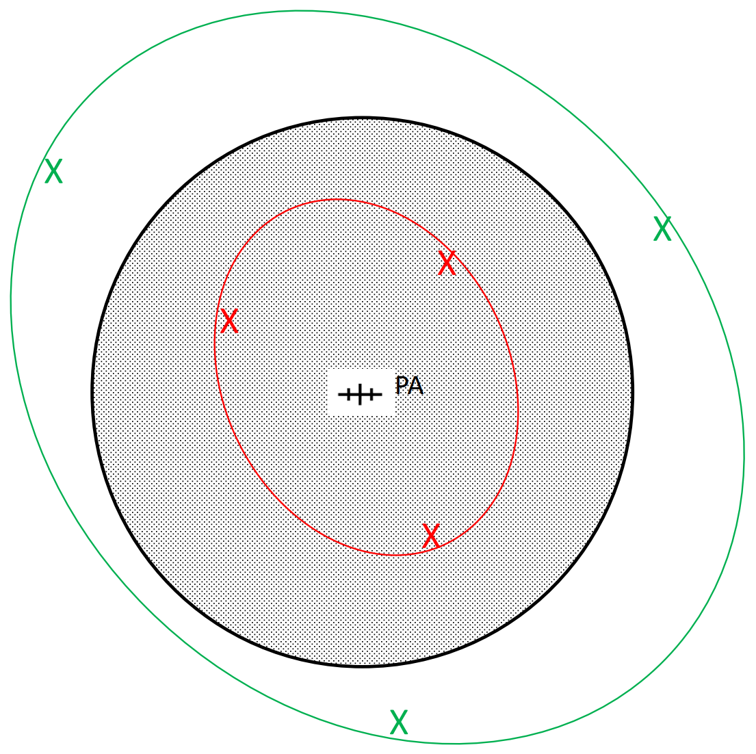
Figure 1: 3 different cases for a wreck

The figure shows that, for the mariner, it is impossible to evaluate any degree of uncertainty from abbreviations PA and PD. In any of these 3 situations, when “avoiding” the object concerned, the mariner might well come to its true position.
- From the above, it is suggested to merge PA and PD abbreviations and definitions into PA (“approximate” is a term regularly used in S-4).
- If the NCWG agrees with this proposal, S-4 should be reviewed to delete all references to “Position doubtful” and amend definition of “Position approximate”. Suggested changed are:
- B-122.1, page 4: Mark abbreviation "PD” as obsolescent on charts;
- B-422, Clause h.: Delete “PD”;
- B-424: Delete “PD” (twice);
- B-424.1: Review to read:
“PA, meaning Position approximate, must be used to indicate that the position of a shoal, wreck or other object, either has not been accurately determined or does not remain fixed or has been reported in various positions and not confirmed in any of them.
- B-424.2 should be replaced by: “PD, meaning Position doubtful, was formerly used to indicate a shoal, wreck, or other object has been reported in various positions and not confirmed in any of them.
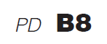
It is no longer useful to chart PD, as it brings no additional value as compared to PA to the mariner in terms of navigation. See B-424.1.
- C-404.3: Delete “PD,”;
- INT1: B7 and B8 should be reviewed to be in line with B-424.1;
- INT1: “PD” should be deleted from the table of abbreviations;

- If the above proposal were accepted by the NCWG, a further paper would be submitted to the S-101PT to consider the replacement of attribute Quality of Horizontal Measurement in S-101 by a Boolean attribute Position unreliable (True/False). On cartographic production systems, the population of this attribute with value “True”, could be used to drive the display of abbreviation “PA” on the paper chart. No further change would be required in S-4.

Conclusions
- To reflect the fact that modern cartographic tools are based on S-57 data and to consider future ECDIS systems functionalities with ENCs, guidance should be included in S-4 on the population of S-57 quantitative spatial attribute POSACC.
- Abbreviations PA and PD should be merged on paper chart order to simplify its use by the mariner.
Recommendations
- Refer to recommendations as included in paragraphs 7 and 13.
Action required of NCWG
- The NCWG is invited to:
a. Discuss this paper and its recommendations.
b. Agree on a way forward in regard to the recommendations.

