Paper for Consideration by NCWG
Charted depiction of decommissioned oil/gas platform jacket structural remains

Submitted by: | UKHO
Executive Summary: | Request to consider depiction of decommissioned oil/gas platform jacket, prior to the provision of a clearance certificate.
Related Documents: | N/A
Related Projects: | For consideration among HOs considering the depiction of offshore energy features.

Introduction / Background
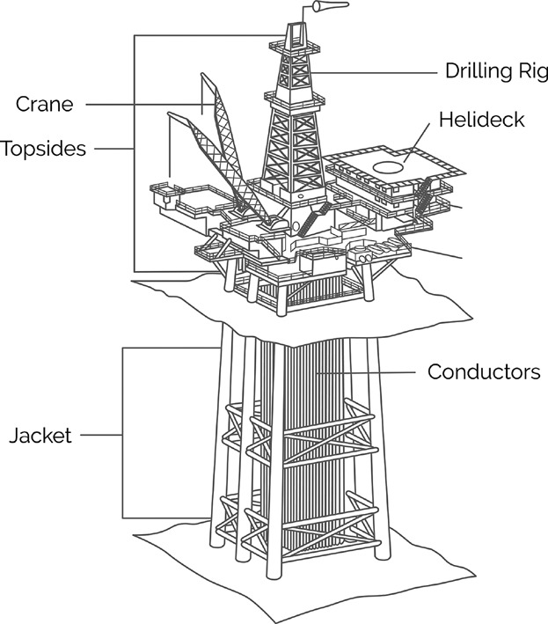
Introduction / Background
Offshore energy facilities are increasing, a General Lighthouse Authority Coastal Inspector has informed UKHO of a growing number of Oil & Gas platform decommissioning programs where the jacket structure is cut at around 80m below sea level, leaving behind the lower half of the jacket, see image right and Annex A.

The remains pose a dangerous snagging hazard to fishing vessels and dived navigation. The number of these features is going to increase, can a specific way be considered to mark these objects beyond just “obstruction”?

Analysis / Discussion
Generally, an obstruction symbol / danger circle is used to define the position of a decommissioned oil/gas platform, INT 1 Section K.
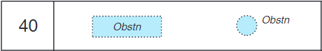

Active submerged production features include use of a legend, INT 1 Section L.

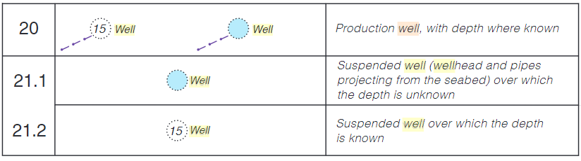

S-4 Section B-445.1 A and B: Wells, Wellheads, Templates and Manifolds adds additional information regarding when the legends should be used and if the obstruction symbol / danger circle should contain tint.
S-4 Section B-445.1 C: describes submerged production systems such as ‘production well’ in relatively deep water which do not have a permanent platform do not present a danger to navigation.

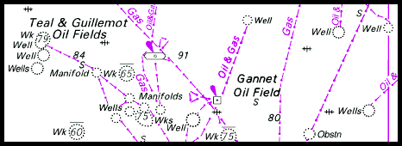

Considerations:

- Why now? Concern has been raised by the increasing number of these features by a General Lighthouse Authority Coastal Inspector.
- Create a specific new legend to differentiate the danger from a generic obstruction symbol / danger circle.
- The remedial impact on HOs to amend features to the new symbol should be limited, where the information is available to be specific.
- Will a specific legend improve the safety of navigation?
  - Yes, if it adds more context to the fishing hazard.
- There is already provision in S4 to draw additional attention to offshore energy features for emphasis. However, advice from mariners suggests that without a specific new term, an existing term (e.g., well/manifold) will cause confusion. It was also suggested that at larger scales, consider use of an area symbol as the jacket may be larger than the point symbol.

Options
- Consider a new legend to describe the remaining oil/gas platform jacket e.g., Platform (disused).
- Consider charting a limit around the feature, however this does not add additional information and in areas densely populated with offshore energy facilitates the areas will overlap.
- Retain current depiction.
- HO’s consider contacting local energy authorities and other national stakeholders for feedback regarding the current charted depiction and proposals above.

Recommendations
- A new legend will support a safer depiction of this kind of underwater obstruction.
- Suggest to the S-101 working group to consider a specific attribute for this obstruction in the DCEG.

Impacts
- S4 will be impacted and require updating if a proposed new legend is approved
- INT 1 will be impacted if a proposed new legend is approved, details can be included in the next update of the publication.
- INFORM could be considered for the S-57 ENC, the specific legend could be considered by the S-101 Working Group for inclusion in the DCEG.
- Priority: medium, the current symbols do not indicate how far the jacket may project from the sea floor.

Action required of NCWG
The NCWG is invited to:
a. endorse
b. Support the proposal that a new *legend will support a safer depiction of this kind of underwater obstruction and advise necessary national stakeholders.
(* agreed ‘new legend’ to be decided)
c. note

Annex A:
Engineers drawing of a jacket cut below the surface.

