**InfoPaper for Consideration by NCWG7**

**[Mapping for a Sustainable World]**

|  |  |
| --- | --- |
| ***Submitted by:*** | BSH (Germany) |
| ***Executive Summary:*** | Contributing marine cartographic and hydrographic aspects to the booklet “Mapping for a Sustainable World” |
| ***Related Documents:*** | UN-GGIM side event Aug 2021 |
| ***Related Projects:*** | UN SDGs (Sustainable Development Goals) |

**Introduction / Background**

At an UN GGIM side event in August 2021 there was presented the booklet on „Mapping for a Sustainable World” dated July 2021 where different cartographic approaches to reflect certain UN SDG at global and regional scales are discussed. It was developed by the International Cartographic Association together with the United Nations Geospatial Information Section. The booklet is available for free (digital and printed) and will be offered during several forthcoming in-person meetings.

[https://www.un-ilibrary.org/content/books/9789216040468#](https://www.un-ilibrary.org/content/books/9789216040468)

**Sustainable Development Goals are:**

[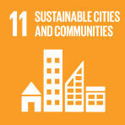Sustainable Cities and Communities](https://www.un-ilibrary.org/content/sdgs/sdg11)

[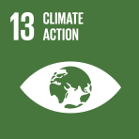Climate Action](https://www.un-ilibrary.org/content/sdgs/sdg13)

[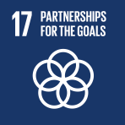Partnerships for the Goals](https://www.un-ilibrary.org/content/sdgs/sdg17)

**Analysis / Discussion**

After the meeting took place a little conversation between former NIPWG Chair (Jens) and IHO Sec (Yves). The idea was born to consider participation of NCWG in a new version if planned, if they want to address SDG14 as well for instance. Germany was suggested to make a proposal or info paper to NCWG7 meeting.

Surely there are other NCWG members who have stronger links with UN GGIM. E.g. the US representative in NCWG could bring some good ideas as well, "bridging"" with the UN GGIM Marine Geospatial Information WG.

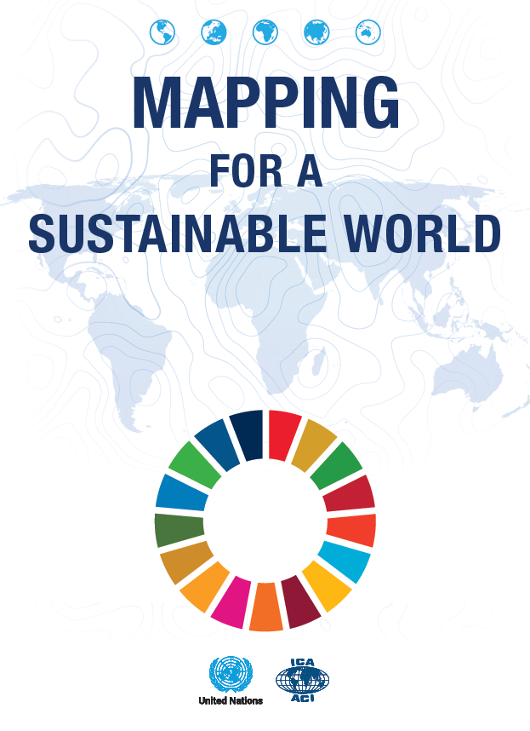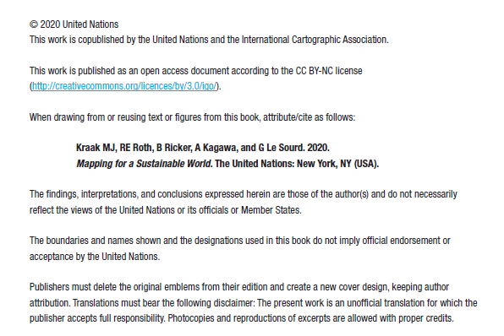

**Conclusions**

At NCWG7 suggest to be discussed on how it could be handled to include the marine cartographic and hydrographic aspects, then report to HSSC. Then, the IHO Secretariat could certainly make a proposal to the UN on behalf of IHO MS.

Previous IHO Head (Rob Ward) always underlined the importance of hydrography and the water covered area at various UN occasions.

**Recommendations**

Cartographic aspects of marine charts (digital and paper) and possibly hydrographic aspects as some UN and SDG touching fields in which the IHO is involved could be contributed to the booklet. Could be included in the work plan and be resolved through correspondence under voluntary MS.

During the UN GGIM meeting it was mentioned that the writers will get in touch with the IHO if a next

version or expansion of the booklet is scheduled.

**Justification and Impacts**

The proposed priority is dependent on a new version of the above booklet (medium or low for now).

**Action required of NCWG**

The NCWG is invited to:

a. discuss and

b. endorse recommendation