Paper for Consideration by NCWG
Guidelines for coloured CATZOC diagrams

Submitted by: | The Netherlands
Executive Summary: | Coloured ZOC diagrams
Related Documents: | S4 B-297
Related Projects: | NCWG5 agenda item 6.12 (2019)

Introduction / Background
Introduction / Background
A growing number of paper charts contain ZOC-diagrams instead of source diagrams. ZOC diagrams give an impression of the quality of data and are in closer agreement with the ENC’s as the source diagrams.

In S4 chapter B-297 the rules for ZOC-diagrams are described.
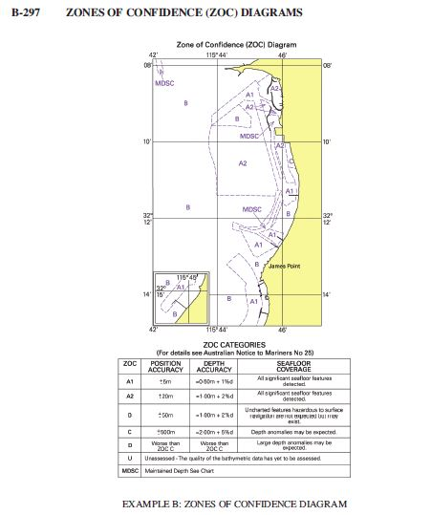

In the S4-guidelines the various CATZOC values are displayed in text. However: there could be an advantage to display the areas in colour. It can improve the readability but requires standardization.

In NCWG5 2019 there was already a paper about this subject. Four years later the development of automated production of paper charts is progressing and generation of CATZOC diagrams could be easier when areas are defined in colours instead of text.

Enough reason to make another attempt to allow CATZOC diagrams in standardized colours.

Quote form final minutes NCWG5 (2019 Stockholm):

  - Guidance for coloured CATZOCs
Docs: NCWG5-6.12A Guidelines for coloured CATZOC diagrams

The Chair commented that he was pleased to see this submission by Netherlands. Members were invited to share details of their practices and a good discussion was had. The IHO Sec questioned whether the real focus of our efforts should be invested in data quality work regarding CATZOC depiction in ENCs as opposed to colours used on paper charts. The Chair commented that he considered the move from showing source diagrams to CATZOC diagrams a good thing as it brought the paper chart into closer agreement with ENCs.
ESRI commented that a CATZOC that included colours only would support automated production whereas CATZOCs that incorporated elements of text such as the example that the UK offered were more complex and made it difficult to automate.
The chair concluded that this issue probably needs resolving before we get even more variations in the use of colour. The IHO Sec informed that a colour pattern had been adopted for INToGIS II for the CATZOC Layer ( from A1 – green – to D – red, and U – grey -). The chair asked members to vote on whether to make changes to S-4 or not.

DECISION: 10 nations voted against changing S-4 and 7 members voted for changing it. The vote concluded that no changes to S-4 will be made.

Analysis / Discussion:

Looking in various nautical charts some CATZOC diagrams are displayed in colours. An example is the following diagram:

(Notice the blue area where CATZOC=C)

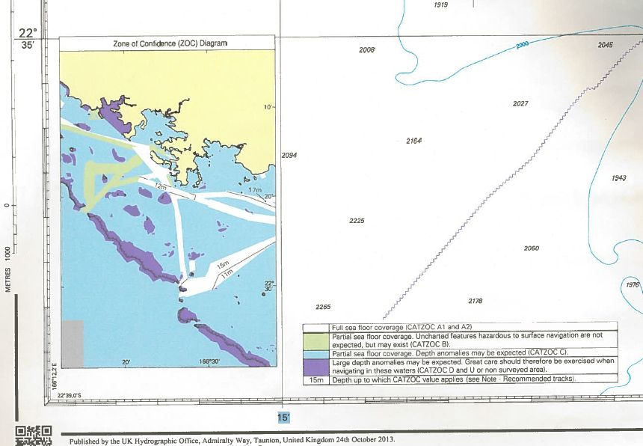

Another example with other colours and for a national chart. (this is not an official CATZOC diagram but has the same meaning. The blue area can be translated as CATZOC=A1/A2)

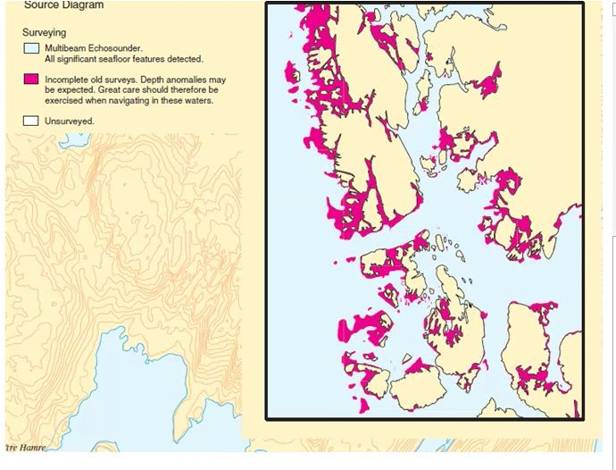

There are more examples of these coloured ZOC-diagrams, but the example above shows that there is absolutely no guideline for the colour use in these diagrams.
In theory it’s possible that a certain colour is used as CATZOC A1 on an INT charts of a member state, whilst being used for CATZOC D or Unassessed on a chart from a different member state. This will certainly cause confusion to mariners, and may undermine confidence in ZOC diagrams in general.
The use of a ZOC diagram with coloured areas can be very useful and easy to read:

Model of a possible new ZOC diagram:

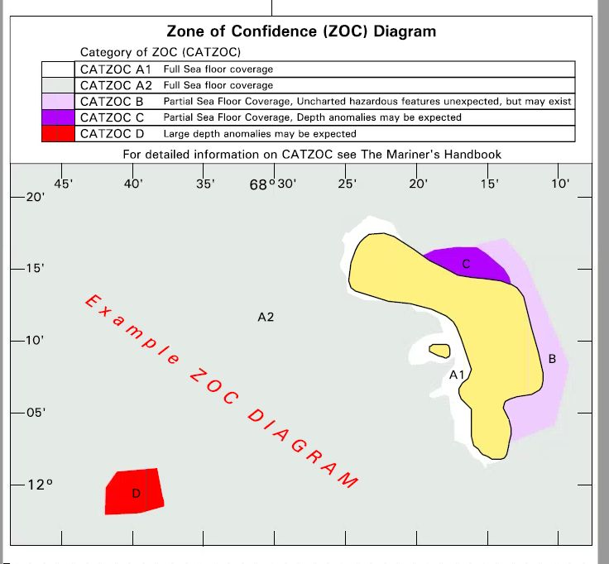

Guidelines for the use of coloured areas are barely given in S4, except in B-297.2 where

“Grey tint (or another colour except green, blue or magenta) may be used to highlight areas covered by after disaster surveys (see B-417.8)”

If these ZOC diagrams are allowed in colour there must be a high level of standardization in order to avoid confusion..
Last but not least: the development of automated paper chart generation is progressing. Automated production of ZOC diagrams require the use of colour in the different areas, whereas text infill would make the procedure more complex.
Justification and Impacts
In practice there are various charts with multi-coloured ZOC-diagrams. Without standardization this can cause confusion when interpreting the quality of source data. With standardized colours ZOC-diagrams will be better readable and intuitive to interpret.
An advantage for automated paper chart production would be that coloured areas are easier to generate in the ZOC-diagram.

Action required of NCWG

NCWG is again invited to consider the use of colour in CATZOC-areas in the ZOC-diagram. And if coloured diagrams will be allowed guidelines for the use of these colours are necessary.

