Paper for Consideration by NCWG
Charting of Platform jackets

Submitted by: | The Netherlands
Executive Summary: | Amendment S4 Platform jacket
Related Documents: | S4 B-422.10  Paper NCWG8-6-6.2
Related Projects: | NCWG8 Action 2a

Introduction / Background
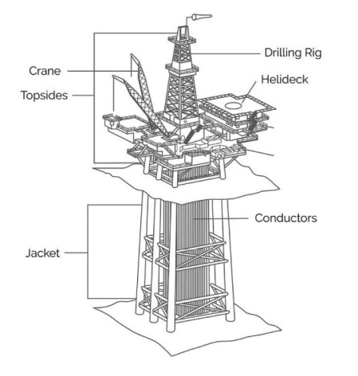
Introduction / Background

Offshore energy facilities are increasing, a General Lighthouse Authority Coastal Inspector has informed UKHO of a growing number of Oil & Gas platform decommissioning programs where the jacket structure is cut at around 80m below sea level, leaving behind the lower half of the jacket, see image right and Annex A.

The remains pose a dangerous snagging hazard to fishing vessels and dived navigation. The number of these features is going to increase.

Analysis / Discussion

Generally, an obstruction symbol / danger circle is used to define the position of a decommissioned oil/gas platform, INT 1 Section K.
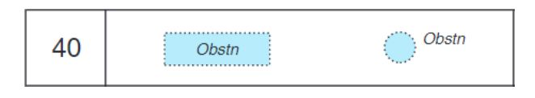

Active submerged production features include use of a legend, INT 1 Section L.
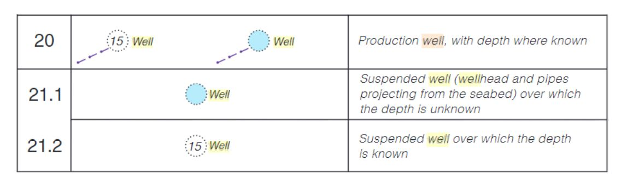

S-4 Section B-445.1 a and b: Wells, Wellheads, Templates and Manifolds adds additional information regarding when the legends should be used and if the obstruction symbol / danger circle should contain tint. S-4 Section B-445.1 C: describes submerged production systems such as ‘production well’ in relatively deep water which do not have a permanent platform do not present a danger to navigation.

During NCWG8 this was discussed and it was decided to add a legend to these kind of obstructions.
This will differentiate the danger form a generic obstruction symbol / danger circle.
It was decided to stay within the definitions of the hydrographic dictionary for this legend.
The outcome was to use the legend : “Rig(Ru)” for these jackets.

Outcome

The outcome of the discussion was to specify a legend to differentiate these jackets from a generic obstruction symbol. In the meeting the legend “Rig(Ru)” was chosen. These abbreviations are already defined in the Data Dictionary.
Suggest amend B-422.10 as follows:

B-422.10 Submerged obstructions too small to be shown to scale must be charted similarly to wrecks (see B-422.3, 422.4, 422.7) but with the international abbreviation ‘Obstn’ in place of ‘Wk’.
Further information may be provided by replacement of the legend ‘Obstn’ with appropriate legends to
indicate the characteristics of the submerged obstruction, where known, for example: ‘ODAS’;
‘Diffuser’. The legend ‘Rig(Ru)’ indicates submerged jackets of decommisioned plaforms.
Larger obstructions must be charted with a danger line and legend. Blue tint must be added over obstruction symbols in accordance with the charted depth, and in all cases where a depth numeral is not charted and the general depth of water is less than 100m.

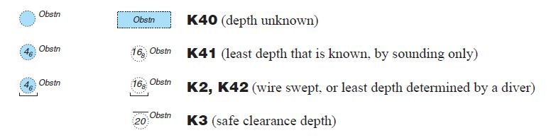
Suggest amend B-445.1 as follows:

B-445.1 Wells, Wellheads, Templates and, Manifolds and Jackets

Add paragraph “h” as follows:
h. Decommissioned oil/gas platform jackets. When decommissioning oil or gas platforms in deeper water, the jackets are cut-off well below sea level, leaving behind the lower half of the jacket. Due to the depth of water, such an installation is normally of no concern to surface navigation. However the remains of these jackets are large structures which may extend up to 50m from the seabed and might be a hazard to fishing and underwater operations.
These structures must be charted as obstructions (see B-422.10) with the legend ‘Rig(Ru)’, instead of ‘Obstn’.

S101

Action 2b: S101 PT will be informed about the discussion and invited to consider amending S-101 to state ‘distributed remains of a platform’.

Justification and Impacts
The impact for S4 is that these changes (if agreed) must be included in a new version of S4.

Action required of NCWG
The NCWG is invited to agree with the text concept in S4 or to give additional comments.

