**Paper for Consideration by NCWG**

**S-101 Portrayal proposals**

|  |  |
| --- | --- |
| ***Submitted by:*** | Australian Hydrographic Office, S101 PsWG Lead |
| ***Executive Summary:*** | Request for comment on feature symbology |
| ***Related Documents:*** | See IHO GitHub links below |
| ***Related Projects:*** | S-101 Portrayal-subWG |

## Introduction / Background

**Introduction / Background**

The S-101 Portrayal subWG (PsWG) has been discussing a number of portrayal related issues in their GitHub space. Some of them have been tagged for submission to the NCWG as they refer to the development of new symbology.

.

Below is the list of issues the S101 PsWG would like the NCWG to discuss and provide recommendations for:

1. *Missing symbolisation instruction for Pontoon Point feature #142*

<https://github.com/S-101-Portrayal-subWG/Working-Documents/issues/142>

1. *Missing symbolisation instruction for Floating Dock Point feature #141*

<https://github.com/S-101-Portrayal-subWG/Working-Documents/issues/141>

1. *New symbology for Waterfall features of type Point - NCWG8_2022_06.10A #110*

<https://github.com/S-101-Portrayal-subWG/Working-Documents/issues/110>

1. *Underwater rock hides a Land area. #99*

<https://github.com/S-101-Portrayal-subWG/Working-Documents/issues/99>

1. *Sounding Approximate #95*

<https://github.com/S-101-Portrayal-subWG/Working-Documents/issues/95>

1. *Ice area #94*

<https://github.com/S-101-Portrayal-subWG/Working-Documents/issues/94>

1. *Proposal to amend the orientation of the existing symbol for Spotlights #93*

<https://github.com/S-101-Portrayal-subWG/Working-Documents/issues/93>

1. CategoryOfCargo = 7 (hazardous cargo) for other features than Berth #116

<https://github.com/S-101-Portrayal-subWG/Working-Documents/issues/116>

1. Restricted area on Dock area #98

<https://github.com/S-101-Portrayal-subWG/Working-Documents/issues/98>

**Analysis / Discussion**

1. ***Missing symbolisation instruction for Pontoon Point feature #142***

<https://github.com/S-101-Portrayal-subWG/Working-Documents/issues/142>

Currently S-57 does not allow the population of **Pontoon** features of geometric primitive type Point. However within S-101 **Pontoon** point primitives are now allowed. Is there a current stakeholder need for this geometry type? Stakeholders should also be aware that at large compilation scales the ‘footprint’ of the **Pontoon** symbology will take a large geographic space. This will potentially obscure other features in congested waters. It would be advantageous to capture all **Pontoon** features as either Line or Area geometry types to avoid symbology clashes.

Stakeholders are invited to discuss and debate the need for **Pontoon** features of type Point and recommend a corresponding symbol to accommodate this initiative.

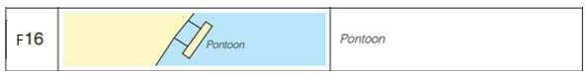

1. ***Missing symbolisation instruction for Floating Dock Point feature #141***

<https://github.com/S-101-Portrayal-subWG/Working-Documents/issues/141>

Currently S-57 does not allow the population of **FloatingDock** features of geometric type Point. However within S-101 **FloatingDock** point primitives are now allowed. Is there a current stakeholder need for this geometry type? Stakeholders should also be aware that at large compilation scales the ‘footprint’ of the **FloatingDock** symbology will take a large geographic space. This will potentially obscure other features in congested waters. It would be advantageous to capture all **FloatingDock** features as either Line or Area geometry types to avoid symbology clashes.

Stakeholders are invited to discuss and debate the need for **FloatingDock** features of type Point and recommend a corresponding symbol to accommodate this initiative.

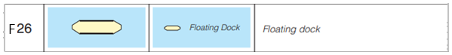

1. ***New symbology for Waterfall features of type Point - NCWG8_2022_06.10A #110***

<https://github.com/S-101-Portrayal-subWG/Working-Documents/issues/110>

At NCWG8 and S101PT9 meetings it was agreed that, in certain circumstances, waterfalls can be a valuable aid to navigation and therefore it was decided to enable the symbolisation of **Waterfall** features of type Point.

Note that, in S-52:

* Point features **are not** symbolised
* Curve features **are** symbolised and conspicuous WATFAL curves are depicted differently than non-conspicuous ones.

Based on this, and to provide consistency, it seems logical to either:

* Create 2 versions of a Point symbol - One for conspicuous features and one for non-conspicuous ones **OR**
* Create one Point symbol only (for conspicuous features) and remove the existing mapping that provides symbology to non-conspicuous **Waterfall** features of type Curve.

Below is an example of a potential symbol design. For this symbol, the potential use of colours such as LANDF (for the waterfall boundaries), AZUBL (for the downstream and ripple lines at the bottom of the waterfall) and CHWHT (as the backdrop colour for the area of the waterfall - in between the LANDF and including the area covered by the ripples). If a 'conspicuous' version is required, we could replace LANDF with CHBLK

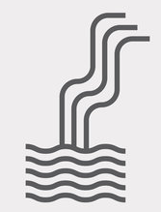

Stakeholders are invited to discuss and debate the above statement to reach a consensus on future portrayal practices.

1. ***Underwater rock hides a Land area. #99***

<https://github.com/S-101-Portrayal-subWG/Working-Documents/issues/99>

**UnderwaterRock** symbol covers (hides) point **LandArea** (which is a more dangerous feature).  
[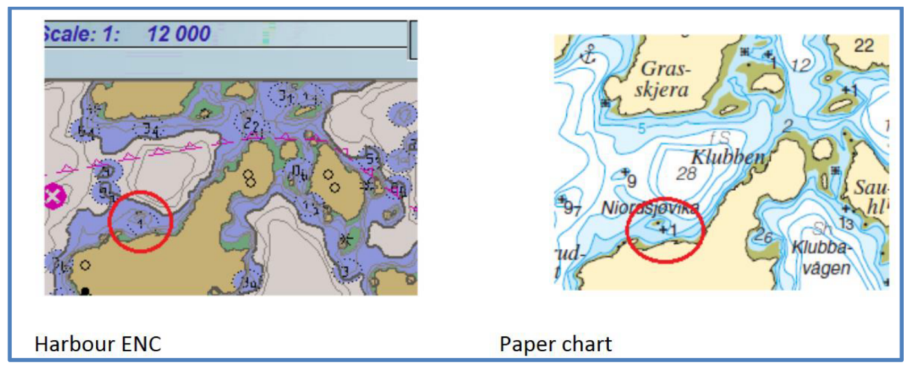](https://user-images.githubusercontent.com/71139640/181256130-c0cae062-2bf4-4311-a4c8-a83488150b48.png)

This has not been checked in S-101. If confirmed, could this be improved playing with the Display Priority: a feature should never mask a more dangerous one?  
In this specific case, there may be a compilation issue: is it necessary to show the **UnderwaterRock** so close to the island?  
But there may be other situations that need to be improved. Probably needs further investigations.

Dependencies

1. It seems to be a problem with the priority allocated to **LandArea** features of type Point.
2. The subWG decided to experiment with altering the DP on a test data set. It is important to confirm that unwanted results on other features are not accidentally triggered by this change.
3. Norway will provide the S-101 ENC test data set and will perform the assessment and report findings at the next subWG meeting. NIWC is to assist Norway by providing a PC version that has a higher priority allocated to **LandArea** point features.

Stakeholder Feedback (NIWC)

To ensure **LandArea** is always on top of any **UnderwaterAwashRock** (and other potential isolated dangers) would require a drawing priority greater than 24 (8 in S-52), or changing the priority of many features. Unfortunately, text and the danger highlight also share priority 24; moving **LandArea** to 25 would obscure text, and cause the feature to obscure the danger highlight.

Appearance of the **UnderwaterAwashRock** depends on the values selected for the safety contour and the safety depth.

You may wish to encode other representative features in the area so their stacking order can be evaluated.

|  |  |  |  |  |
| --- | --- | --- | --- | --- |
| Safety  Contour | Safety  Depth | UnderwaterAwashRock | LandArea | Result |
| 30 | 30 | Priority=24 | Priority=12 | image |
| 0.5 | 30 | Priority=12 | Priority=12 | image |
| 0.5 | 0.5 | Priority=12 | Priority=12 | image |

**Suggested Remediation.**

*Suggestion 1*

This will also be an issue in S-52. I don't think this can be solved by adjusting priorities. With a small land area surface the coastline draws at a higher priority so it can still be seen. So as stated above the issue is with a point land area. The symbol covering other data is the DANGER01 symbol which is filling the oval with a solid DEPVS colour and masking anything underneath. Keep in mind that DANGER01 is only used when the surrounding area is shallow water. Maybe we could try using a transparent fill for DANGER01. With a 50% transparency the land area point can still be seen.

The first image below is using the current DANGER01 symbol. The land area surface (upper left) coastline can still be seen. The Land Area point (upper right) is hidden.  
In the second image DANGER01 is using a 50% transparency for the fill. (style="fill-opacity:0.5;”)

 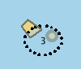

*Suggestion 2*

SCAMIN is a reliable method of symbology deconfliction. Cartographers should be encouraged to use SCAMIN to generalize charts based on what is observed at each compilation scale. In the examples, the rock should disappear at the scale its symbology clashes the land (or not be encoded at all if that’s the view at compilation scale).

1. ***Sounding Approximate #95***

<https://github.com/S-101-Portrayal-subWG/Working-Documents/issues/95>

The use of a circle around approximate sounding increases clutter and can be confused with a depth contour.

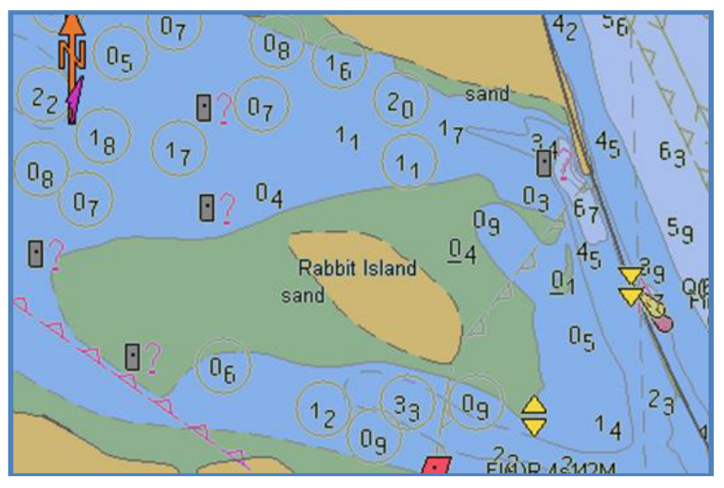

The 'circle' [SY(SOUNDGC2) & SY(SOUNDSC2)] around soundings is triggered by a number of different attribute values.

Summary is listed below but refer to CSP SNDFRM04:

* STATUS=18
* QUASOU=2 or 3 or 4 or 5 or 8 or 9
* QUAPOS=2 or 3 or 4 or 5 or 6 or 7 or 8 or 9

The 'blanket' effect on ENC is usually caused by the over encoding of:

* QUAPOS=4 (PA) - Most likely due to legacy Paper Chart to ENC conversion issues where paper charts showed numerous upright soundings (INT1 I14). Upright soundings in Paper Charts should, according to S-4, reflect 'unreliable soundings' which, according to the UOC, are those soundings that are less reliable (lower ZOC) than the charted CATZOC value (M_QUAL) for the area (i.e. a ZOC C sounding that couldn't be disproved by a new CATZOC B survey and had to be retained due to its depth). In short, encoding guidance should state that when all soundings are from the same ZOC (or higher) none of them should be encoded with QUAPOS=4, even if they are all ZOC D or a bad ZOC C. In the example, only the ZOC C sounding should be encoded, as 'unreliable' (QUAPOS=4 and QUASOU=4 as per the UOC) and therefore display the 'circle' around it. The quality and reliability of the charted depths in ENC is now informed by M_QUAL (i.e. if the ZOC=D, you do not need circles around the soundings to know their values/positions/sea bottom coverage is bad). S-57 to INT1 mapping rules can help with keeping PC symbology if desired ....... (i.e. soundings within ZOC D areas must come upright when migrated to INT1).
* QUASOU=5 (NBA) - Not sure why INT1 symbol I13 was not migrated to S-52. We could explore bringing it back and/or amend the UOC and direct encoders to capture SWPARE when the NBA area is extensive (i.e. common output from LIDAR surveys nowadays).

1. ***Ice area #94***

<https://github.com/S-101-Portrayal-subWG/Working-Documents/issues/94>

The portrayal of an Ice area encoded on Land area is very similar to **UnsurveyedArea**. It is then very difficult to distinguish between **IceArea** and **UnsurveyedArea**.

A new S-101 symbology for Ice area would be desirable.

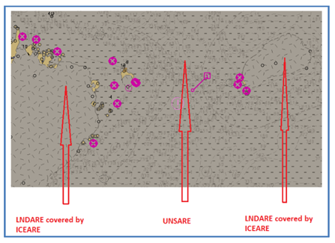

**Suggested Remediation.**Pattern and line thickness as per ICEARE04. Background colour could be a bit more greyish if required

[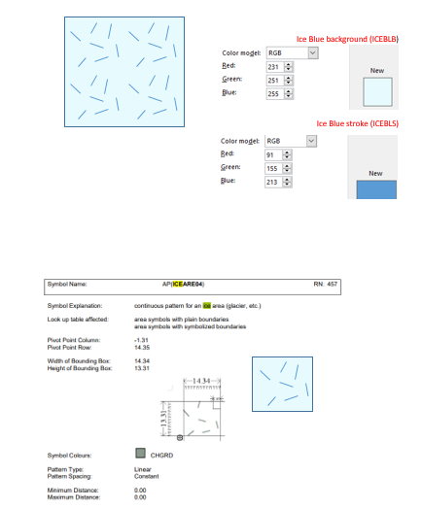](https://user-images.githubusercontent.com/70189016/190561222-4c7dd696-35df-43cd-9bf7-230b18f2ec09.png)

1. ***Proposal to amend the orientation of the existing symbol for Spotlights #93***

<https://github.com/S-101-Portrayal-subWG/Working-Documents/issues/93>

Dedicated Github issue to discuss topic presented by dKart ([@IngaFjellanger](https://github.com/IngaFjellanger)) in the paper below:

[Comments to Portrayal Catalogue_last version.docx](https://github.com/S-101-Portrayal-subWG/Working-Documents/files/9193818/Comments.to.Portrayal.Catalogue_last.version.docx)

Extract from paper:

Drawing symbol LIGHTS82 is used to depict both light category values 8 (flood light) and 11(spotlight). However, lights with those values light in different directions. Usually a flood light illuminates a structure and/or surrounded area. In this case the symbol LIGHTS82 logically directs bearing towards the structure symbol. For the spotlight it would be more correct to use a similar symbol directed away from the structure symbol since the spotlight is used to illuminate area aside the structure.

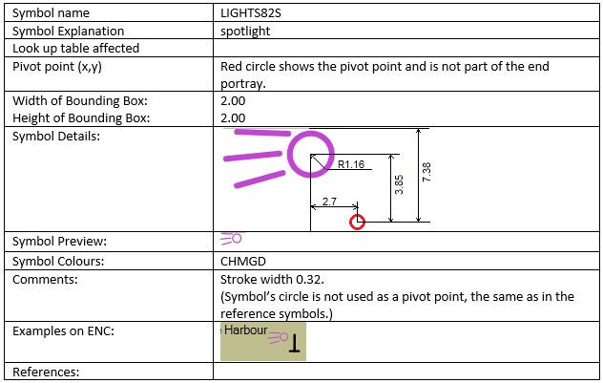

Stakeholders are invited to discuss and debate the above statement to reach a consensus on future portrayal practices.

1. ***CategoryOfCargo = 7 (hazardous cargo) for other features than Berth #116***

<https://github.com/S-101-Portrayal-subWG/Working-Documents/issues/116>

The S-100 Project Team (at S101PT9) identified a need for a unique symbol related to categoryOfCargo = 7 (dangerous or hazardous cargo) for **AnchorBerth.** Currently  S-52 presentation already includes a point symbol as part of the drawing instruction (BRTHN01):



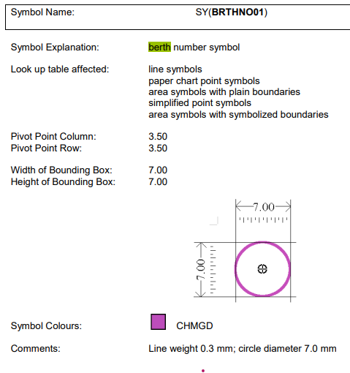

The images below show two potential portrayals - ANCBDNG1 one to one joining the symbols, and ANCBDNG2 sizing the BRTHDNG1 to match the Anchor height.

[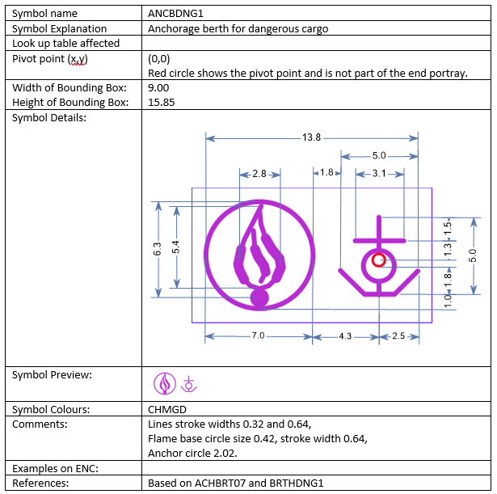](https://user-images.githubusercontent.com/72803214/243693783-aa4a64b5-3f65-4cc7-88e5-5173075f770a.png) [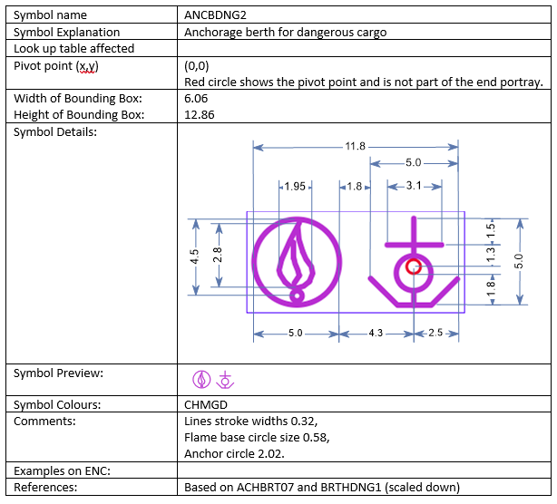](https://user-images.githubusercontent.com/72803214/243693853-a42d966a-9991-4a75-a86a-7b110cc13b49.png)

Based on modelling changes to **AnchorBerth** introduced in S-101 1.2.0, the mapping of the new symbol ANCBDNG2 has to be amended from categoryofAnchorage=4 to categoryOfCargo = 7

In the same GitHub issue the conversation then drifted to the potential use of a similar symboogy for **AnchorageArea**.

Instead of making a decision on 'dangerous cargo' anchorages in isolation, the S101 PsWG decided to refer the issue to the NCWG to look at the 'extension' of the portrayal of **AnchorgaeArea** more holistically and not just for on type of cargo.

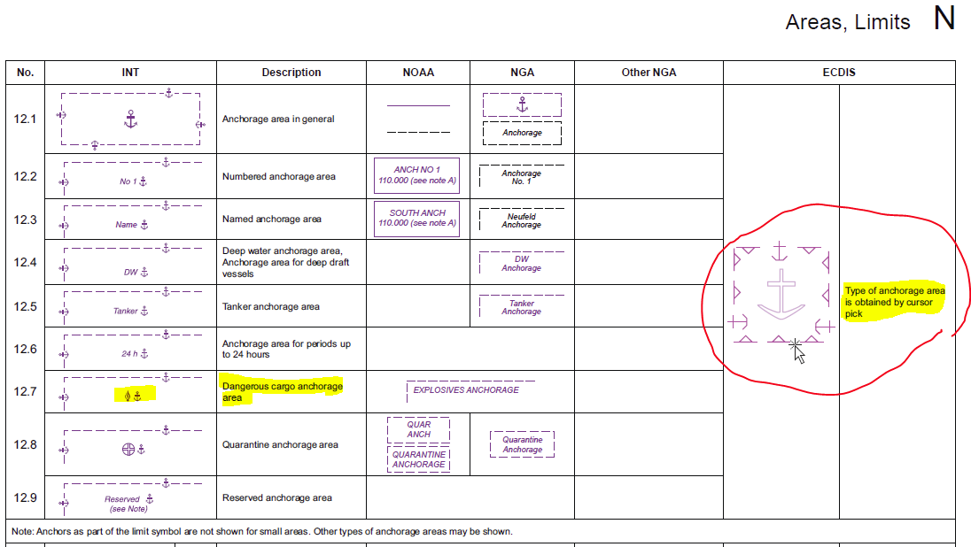

Stakeholders are invited to discuss and debate the expansion of S101 symbology for **AnchorageArea** features considering that many more 'combined' symbols could be created to represent different types of Anchorages.

1. ***Restricted area on Dock area #98***

<https://github.com/S-101-Portrayal-subWG/Working-Documents/issues/98>

The portrayal of **DockArea** needs to be re-assessed. **DockAreas** have been removed from the list of Group1 features. When encoded, the **DockArea** will need to be covered by either **DepthArea**, **UnsurveyedArea** or **LandArea**. There will be a flow on impact on the need for the encoding of COALNE/SLCONS features, etc.

Below are screenshots from an S-101 ENC where **DockArea** is no longer a Group1 feature (it sits on top of DEPARE and COALNE is a must along the boundary between Land and Water.

The S101 PsWG has decided to remove the Blue infill colour from **DockArea** (colour will be dictated by underlying DEPARE.  
In short, **DockArea** will only be depicted by a solid black line in S101.

Accordingly, Stakeholders are invited to discuss and debate a new portrayal for **DockArea** including. The simplest solution could be the addition of a new central symbol to the area to reinforce its purpose.

[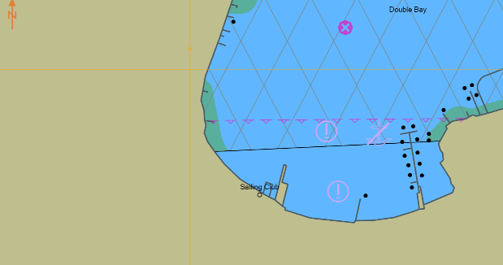](https://user-images.githubusercontent.com/70189016/275355037-72e22d90-46a0-4374-a834-ec8ba651c341.png)

**Recommendations**

Discuss each of the listed items above and provide recommendations back to the S101 PsWG by adding a comment at the end of each GitHub issue.

**Action required of NCWG**

The NCWG is invited to:

a. Debate each issue

b. Reach consensus on each issue

c. Document and implement agreed outcomes