**Paper for Consideration by NCWG**

**Guidance on how to encode windfarms and associated features.**

|  |  |
| --- | --- |
| ***Submitted by:*** | UK Hydrographic Office, Denmark and Sweden. |
| ***Executive Summary:*** | Inclusion of encoding and capture guidance of windfarms and associated features in S-57 UOC and S-4. |
| ***Related Documents:*** | ENCWG 8 - 5.4 (Bird Nesting Structures) |
| ***Related Projects:*** | S-57 / S-101, S-4 |

## Introduction / Background

**Introduction / Background:**

At ENC WG 8 a UK paper was submitted regarding the unknown encoding of Bird Nesting structures which the UK Offshore Energy sector has started to install. These features are still rare but are becoming more prevalent around the UK as part of ecological consent orders. The ENC WG were unsure how to encode these structures.

Through the discussion further questions were raised from other member states around if and how other supporting features associated to wind farms e.g., power support platforms and the wind farms themselves should be encoded. The ENC WG decided the best option was to submit a paper to the NCWG for consideration.

**Analysis / Discussion:**

* As member states work towards decarbonisation wind farms are becoming more prevalent and their associated structures and supporting infrastructure is growing.
* Member states expressed clarity is needed on the capture and encoding of wind farms. Questions were raised around should all turbines, cables and associated lights be captured and when a windfarm area should be used instead?
* Sweden expressed that the guidance on the level of detail for windfarms may be differentiated, depending on whether you are allowed to sail through the windfarm, which depends on national regulations.
* Denmark informed the group they currently capture and encode power platforms linked to windfarms as offshore platforms with INFORM = ‘transformer platform’, as something that better described this feature doesn’t currently exist.
* Due to their rarity and uniqueness the UKHO is unsure how to encode bird nesting structures in the related document. Discussed solutions included Piles, Platform of unknown category or a building slaved to a pile. There is a worry these structures could be mistaken for mooring structures from afar.

**Conclusions:**

There is still some ambiguity amongst member states as to if and how wind farms and supporting features should be captured and encoded on ENCs. Member states have different encoding practices and clearer guidance could be provided in the S-57 UOC and S-4.

**Recommendations:**

* A review of wind farms, the growing number of new supporting and associated structures should be conducted.
* Guidance in S-4 and the S-57 UOC should be expanded to help answer the questions raised above and provide member states guidance on how to capture and encode windfarms and associated structures.
* Consider how new features linked to wind farms should be captured in S-57 and if new features/symbols should be considered for S-101.

**Justification and Impacts:**

* Through the discussion at ENC WG 8 it became evident that member states all had their own interpretations of the encoding and capture of wind farms and their associated features. Improving guidance would help member states encode these growing features consistently and remove any ambiguity.

**Action required of NCWG:**

The NCWG is invited to:

1. Note this paper and ongoing discussion.
2. Consider reviewing and expanding guidance in S-4 and the S-57 UOC on the capture and encoding of wind farms and their associated features.

**Bird Nesting structure.**

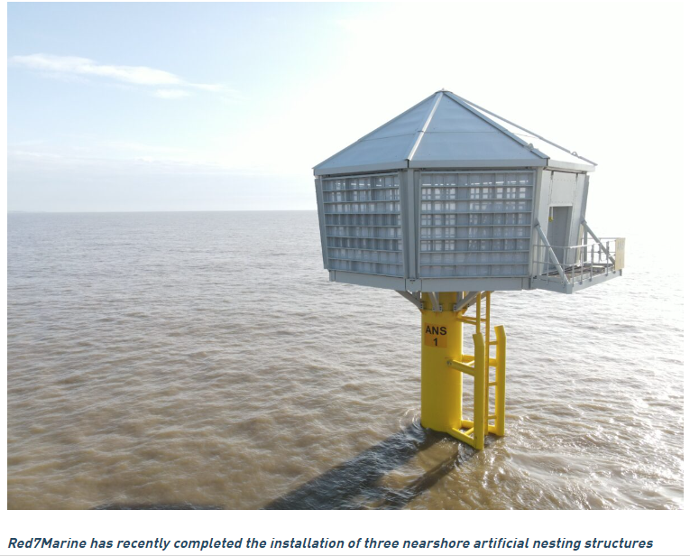

**Currently how the UKHO has encoded bird nesting structures.**

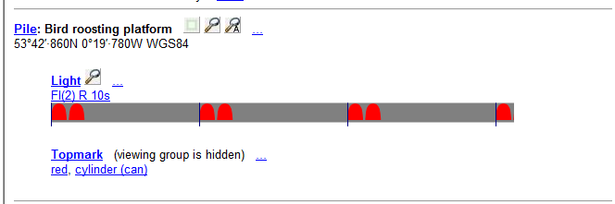

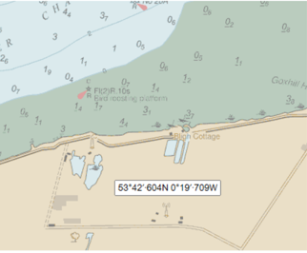

ENC Approach  
Cell GB40344B  
Compilation scale 1:22,000  
  
540 0006115039 00001 Pile  
Object class: PILPNT Pile  
OBJNAM (Object name) = Bird roosting platform  
Slave 1 is 540 0006115062 00001 Point Topmark  
Slave 2 is 540 0006115049 00001 Point Light