NCWG9-5.8

Paper for Consideration by NCWG

Charting of areas where power-driven vessels are prohibited

Submitted by: | Sweden
Executive Summary: | It is identified that there is an increasing need for charting areas where power-driven vessels are prohibited. Any clarifications in S-4 needs to be considered.
Related Documents: | S-4
Related Projects: | S-101

Introduction / Background
- Over the past two decades, it has become increasingly common that regulatory authorities, in national waters, prohibit vessel traffic for power-driven vessels. This is mainly to protect the sensitive environment in certain shallow areas, but is in some cases this is done for safety reasons. In these areas, vessels are allowed to pass using sail, by rowing or by paddling but not using any kind of engine power.

Analysis/Discussion
- S-4 B-439.2 states that the T-shaped dashed line “is used for areas (within territorial waters) which local or national regulatory authorities have specifically declared to be restricted for one or more aspects of navigation”.
- Since this type of restriction affects the vast majority of all mariners, SMA has made the interpretation that it is suitable to use the N2.2 symbol (entry prohibited) in combination with a legend “Power-driven vessels prohibited”.
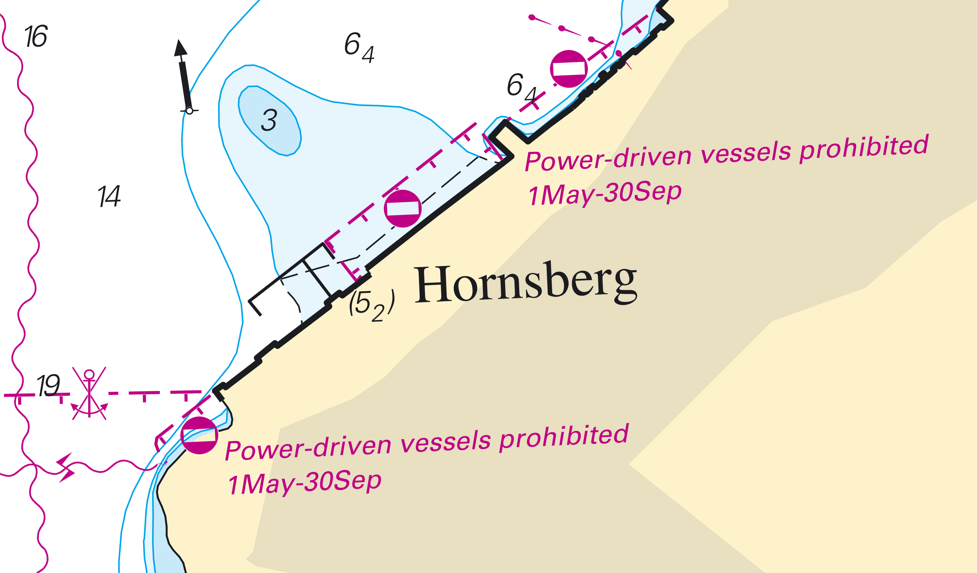
- The legend has been worded in accordance with Rule 3 (b) in the 1972 COLREGS: “The term 'power-driven vessel' means any vessel propelled by machinery".

Conclusions and recommendations
- The NCWG should consider if any further clarifications is needed in S-4.

Justification and Impacts
As the timeline for the S-101 development is very short, Sweden proposed to S-101PT11 that a new enumeration value “Power-driven vessels prohibited” for the attribute restriction should be included in edition 1.2.0 of S-101. The proposal was accepted but any comments from the NCWG can be included in the operational edition 2.0.0 if necessary.

Action Required of S-101PT
The NCWG is invited to:
- Discuss this paper and its recommendations
- Address any comments affecting S-101 to S-101PT

