Paper for Consideration by NCWG
Guidance on how to capture marine mammal migration routes.
Submitted by: | Indonesia.
Executive Summary: | Inclusion of encoding and capture guidance of of marine mammal migration routes and associated features in S-4.
Related Documents:
Related Projects: | S-4

Introduction / Background
Introduction / Background:
On Saturday, September 30 2023, a whale hit and capsized a boat in La Perouse Waters, Sydney, causing one person to die.
Whale Baleen was hit by KM Mount Dempo on his way from Nabire, Papua to Wasior, West Papua, it was discovered on Sunday, September 12 2021.
A ferry sailing from Niigata Harbour to Sado Island in the Sea of ​​Japan allegedly hit a humpback whale causing injuries to 87 passengers and a 15cm long crack in the ship's stern.

From these events, we analyzed that the migration path of marine mammals is very important to capture on marine maps. Apart from ensuring navigation safety, it is also an action to protect marine mammals.

Analysis / Discussion:
- If the migration routes of marine mammals are depicted on maps, it will increase the safety of shipping navigation.
- If marine mammal migration paths are depicted on charts, it will facilitate action to protect marine mammals.
- Clarity is needed regarding the depiction and encoding of marine mammal migration paths. Are all the migration routes of marine mammals depicted or are only protected fish, then what is the correct depiction of the migratory routes, how is the direction of travel of the migration routes depicted?
- Currently there are no precise features to describe the migration path of this marine mammal.
- Indonesian waters contain more than a third of the world's whale and dolphin species, including several species that are categorized as rare and endangered. Several types of cetaceans use migration routes through eastern Indonesian waters. The Savu Sea is a breeding and feeding area for whales. The Savu Sea is a potential place because it is used as a routine migration route for various cetacean species.

Conclusions:
Considering the importance of depicting marine mammal migration routes for navigational safety and protection of marine mammals, it is concluded that marine mammal migration routes and their supporting attributes should be depicted along with a detailed explanation of the depiction in S-4.
Recommendations:
- Review of marine mammal migration paths and other supporting attributes.
- The guidance in S-4 should be clarified to help answer the questions raised above and provide guidance to member states on how to describe marine mammal migration pathways and their supporting attributes.
- Consider how new features relate to marine mammal migration pathways in S-4 and whether new features or symbols should take into account S-101.

Justification and Impacts:
- By updating the guidance in S-4 regarding the depiction of marine mammal migration routes, it will help member countries in describing marine mammal migration routes.

Outcome
Depiction of Marine Mammal Migration Flows on Paper Maps.

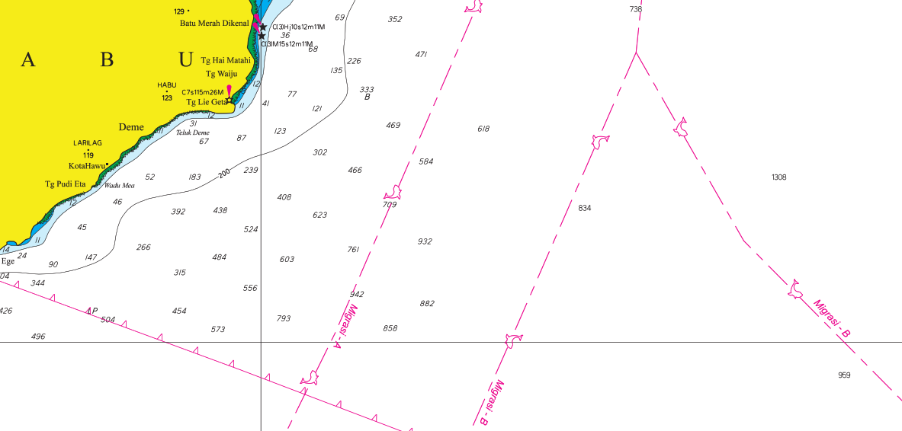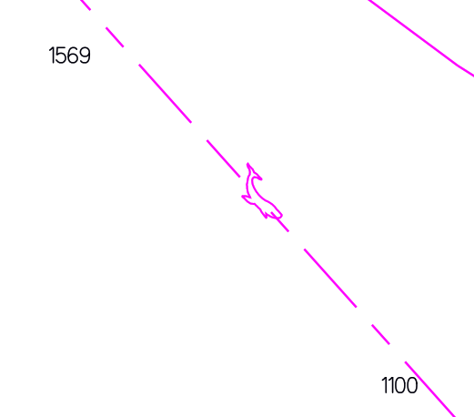

MIGRATION FLOWS OF MARINE MAMMALS
Migration flow of marine mammals (Cetacea) as additional information, the flow on the map consists of two migration seasons, namely migration A (April-June) and B (October-January). The direction of migration corresponds to the direction of the whale symbol.

Action required of NCWG:

The NCWG is invited to:

- Note this paper and ongoing discussion.
- Consider reviewing and expanding guidance in S-4 on the capture and encoding of of marine mammal migration routes and their associated features.

