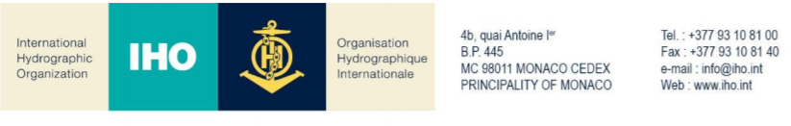
NAUTICAL CARTOGRAPHY Working Group

Chair: Mikko HOVI  Finnish Transport and Communications Agency  Opastinsilta 12 A  00520 Helsinki  Finland | Secretary: James TIMMINS  United Kingdom Hydrographic Office  Admiralty Way, Taunton, Somerset  United Kingdom
Tel: +358 29 5346730 | Tel: +44 1823 483941
Email: mikko.hovi@traficom.fi | Email: james.timmins@ukho.gov.uk

NCWG Letter: 01/2020

To NCWG Members
Date 14th February 2020

Subject: 1) Wording for NCWG5 Action 5 to review

Dear Colleagues,
The Netherlands Hydrographic Office has kindly provided proposed S-4 wording changes as part of NCWG5 action 5, regarding swept wrecks. Please may you review the proposed wording at Annex A and provide your responses by 10th April using the response form at Annex B. I have included a list of the NCWG5 actions at Annex C for your reference.

Best Regards
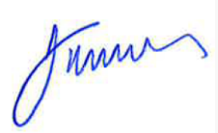
James Timmins
NCWG Secretary

Annex A
NCWG 5 Actions
Actions in blue
Comments and explanations in green
Extracts from S-4 in black with:
- Proposed additional words in red
- Proposed deletions crossed through.
ACTION 5\5

5/5 6.7 NL to re-draft proposed S-4 wording for swept wrecks based upon the comments received.

Introduction / Background
The most reliable survey method for wrecks is sweeping by wire drag but as technology improves there are other methods to measure a reliable least depth for wrecks and obstructions.

Extract from NCWG4 report:
12.1 INF1 Wreck symbolisation (NL)
Docs: NCWG4-12.1 INF1 Wreck symbolisation
A good discussion was had by members regarding whether or not it was considered acceptable to show wrecks as swept based upon findings from high quality multi-beam surveys. Whilst some members felt that this was ok there were concerns from some members and also the DQWG regarding the consistency and standard of accuracy between different nations. Finland informed the meeting that they already classified certain underwater features as swept based upon multi beam survey data only. UK will give feedback later on their policy regarding this issue.
ACTION 4\14 - Netherlands to draft wording for S-4 regarding swept wrecks and also consider impact on S-57. (NE)
Background
In the surveying of wrecks we have to deal with the following issues:

- Least depths of swept wrecks (with symbol K27) have a higher reliability than wrecks surveyed by soundings. Especially in the past with SBES this was a common rule and well-defendable.
- With new MBES techniques (like Water Column Imaging (WCI) it should be possible to obtain a least depth of an obstruction with high reliability.
- If the WCI-method gives a reliable result (equal to sweeping) it will be a much more efficient method. However: in charting the “swept” symbol K27 cannot be used, due to the description in S4, which only refers to “swept by wire drag or determined by a diver”
As a result of this a draft wording was produced by the Netherlands and this resulted in various comments. During NCWG5 the Chairman provided an overview of the responses received from members to the proposal for further guidance on Swept wrecks. The responses from members were circulated by NCWG Letter 5 before the meeting and this was also displayed during the meeting. There was an even number of members supporting the proposal and not supporting it. France and Germany explained how they class wrecks as swept when they have been surveyed or examined by two independent methods.
This resulted in a new action for the Netherlands to re-draft proposed S-4 wording for swept wrecks based upon the comments received. Main issue was here not to describe new methods of survey, but mention the reliability of the new methods used. In this proposal the methods “swept” and “investigated by diver” are maintained keeping in mind that certain surveys may be very old and do not match the current standards anymore.

For ENC’s there are some attributes dealing with the accuracy/confidence in the wreck sounding:
QUASOU for the quality of measurement
TECSOU for the sounding technique. This attribute should have an extra value for water column imaging. However, as S57 is frozen this should be done in S100.
Justification and Impacts
The impact for S4 is that these changes cannot have the status of clarification, but must be included in a new version of S4.
Action required of NCWG
The NCWG is invited to agree with the text concept in S4. Also to define an action for S100 WG to include an attribute within TECSOU to describe the WCI method.

B-415 SWEPT DEPTHS AND AREAS; AREAS INVESTIGATED FOR DEEP DRAUGHT VESSELS
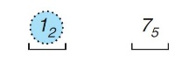
Swept depths must be shown by the symbol _ K2, for example:

The use of the symbol must be confined to areas swept by wire drag or investigated by diver. Newer technologies also include survey techniques with an equal high reliability. Areas investigated by techniques, which are considered to not fully guarantee the least depth sonar, laser or multibeam echo sounder must not be described as ‘swept’ on charts.

Suggest amend B-422.3 as follows:

B-422.3 A wreck which has been wire swept, or has had its least depth determined by a diver. Newer technologies also include equally reliable survey techniques which really confirms the depth. This must be shown by sounding numerals showing the measured depth to which it has been swept , surrounded by a danger line, with the abbreviation ‘Wk’; the swept depths symbol K2 must be inserted under the danger line, for example:
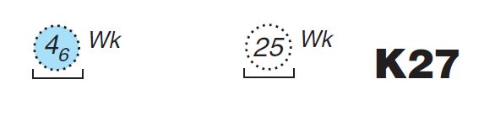

Suggest amend example under B-422.9 as follows:

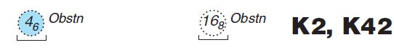
(wire swept, or least depth determined by a diver. Newer technologies also include equally reliable survey techniques which really confirms the depth.)
Annex B

Response Form
(please return to NCWG Secretary by 10 April 2020)
James.timmins@ukho.gov.uk
If you vote ‘No’ to any of the following questions, please explain in the ‘Comments’ section. You can also use that section to record other suggestions.
No. | Question | Yes | No
1a | Action 14:  Do you agree with the proposed wording for B-415 Swept Depths?
1b | Do you agree with the proposed wording for B-422.3 Swept wrecks

Further comments: ……………….

Annex C

NCWG5 ACTIONS
No | NCWG5  Agenda item | NCWG5 Action | Delegate | Status
5/1 | 4.6 | All members to consider proposal and provide feedback to DQWG. | All members
5/2 | 5.1 | NCWG to review terms of reference during NCWG5. UK, CA, SE, IHO Sec circulate via minutes and respond in 4-6 weeks and Chair to submit | UK, CA, SE, IHO SEC
5/3 | 6.4 | IHO Sec to update IHO GIS systems for region D and E limits and provide UK with amendments for S-4 clarification. (IHO Sec) | IHO SEC | In progress
5/4 | 6.4 | UK to update S-4 (A204.8) and diagram with footnotes and positions of limits of charting regions D and E. (UK) | SEC, UK | In progress
5/5 | 6.7 | NL to re-draft proposed S-4 wording for swept wrecks based upon the comments received. | NL | Included in letter 1 of 2020
5/6 | 6.8 | IHO SEC and NCWG SEC to report back to HSSC requesting guidance on how we proceed and then liaise with NIPWG. | IHO SEC , NCWG SEC
5/7 | 6.1 | FOPNC sub WG to develop recommendations based upon discussions during NCWG5 meeting for inclusion in FOPNC report. Recommendations to be distributed to NCWG following timescales in FOPNC timeline. | FOPNC subWG (AU, BR, CA, DK, FI, FR, DE, IT, KR,NL, RU, SE, UK, US NGA, US NOAA, IHO Sec, ESRI, CARIS)
5/8 | 6.10 | Report to HSSC about WIG craft and seek guidance on WIG craft. | Chair
5/9 | 6.11 | UK to provide summarised comments regarding ASL in TSS and two way route symbols in ENC, to sec and Indonesia. | UK | completed
5/10 | 12.1 | UK to formulate final text for S4 regarding unexploded ordnance exceptional circumstances based upon discussion had. | UK
5/11 | 9.2 | NCWG to review paper on Harmonised portrayal and provide comments to NCWG by end of January 2020. Chair will then send comments to group. | all | Deadline has passed
5/12 | 6.1d | ICA to consider paper NCWG5-06.1d Future of paper chart -a different perspective and provide feedback. | ICA
5/13 | 9.3 | members to review paper NCWG5-09.3A and provide feedback to DCWG via their delegate or via NCWG chair. Deadline for comments is 15th December. If passing comments via NCWG chair please pass comments earlier. | all | Deadline has passed
5/14 | 7.1 | DE to provide confirmation that they will provide support for English int 1 by 2020. UK to confirm date for new edition. Aim to coordinate dates to avoid gaps. | DE, UK | In progress
5/15 | 12.6 | Aus to check if there is a proposal to ncsr7 to submit a new definition on back up paper charts. | AU | Completed – no proposal made at this stage
5/16 | 12.7 | KR to provide update on S-100 portrayal project | KR

