Navigational Warning must always be on when use in route monitoring mode.
System must have function to list all Navigational Warning on the screen plus a buffer around the screen (buffer size? Fixed size, e.g. 20NM? Scale based buffer?). List function must include means to distinguish between already viewed Navigational Warning and new to the user Navigational warning. List should be user specific so to track what acknowledgments each user has done and permit easy discovery of changes between watches.

Symbology | Description | Encoding Description
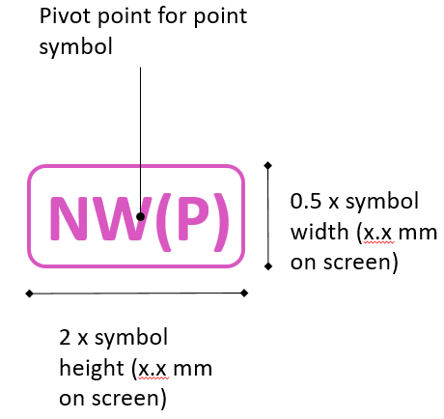 | Point symbol [To do: need to create symbol engineering drawing]
 | Line style
 | Area
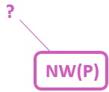 | Navigational Warning point with position approximate.  Majority of NW will probably be this kind.  No fill background to reduce blocking underlying objects.
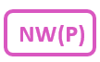 | NW with position known. No fill background to reduce blocking underlying objects.
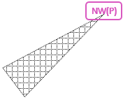 | Navigational Warning point symbol (position known) with user action (e.g. selected in pick report) causing affected area to be highlighted  NW point with affected area highlight. For example a light outage with the light arc. Location of light is the NW and the light arc is the affected area.  Use of affected area would be to help user see impact of a Navigational Warning and for enabling a system query based on route + buffer to better find Navigational Warning affecting route planning and monitoring.
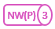  2 3 4 5 6 7 8 9 | Grouping of NWs that are close and causing clutter at screen resolution. The number of grouped NW is shown in the circle in the right side of the symbol. Numbers 2 through 9 are possible. Any grouping over 9 retain 9.  No fill background to reduce blocking underlying objects.  From S-100WG5: grouping symbol need further specification. It is at rendering side and could apply to all S-100 symbols. OEMs want some specification. Can be supported by some form of attribute in the portrayal that points to a grouping symbol that systems should use when appropriate. May require some changes to the portrayal model, but are probably limited to point features.  May be sufficient to propose an optional attribute to the point symbol reference in portrayal instructions to give an alternative symbol for use with groupings.
 | Line style for NW with line geometry
 | NW Area pattern style with a fixed offset between the NW symbol
Affected area pattern style. Only to display when the NW is selected by pick report or other user action.
Also recommended to be used for whole NAVAREA messages and other very large areas.

Question to consider; should users be allowed to turn it on if they so choose?
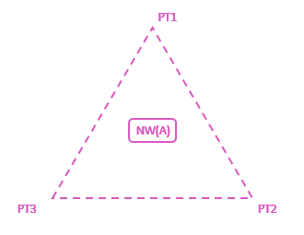 | Area NW with text placements to simplify visual reference between NW text and NW area.  An example of use can be a new regulation that adds an area with 3 points. The 3 points can be marked with text to improve the cognitive connection between the text and the point ‘on the screen’.

Additional considerations;
Is it possible that NW symbols do not mask the chart details by for example using transparency or symbol with on offset? Example of use case; when a NW is related to a charted AtoN, then the AtoN on the chart should remain visible.
Is it possible to add a function of a trailing symbol behind own ship symbol that can indicate the area type, including any NW area? Trailing symbol function could replace or enhance the centered symbol function described in S-52 Presentation Library, section 8.5. [need drawing to illustrate] It has been suggested that this functionality can serve as an enhancement of portrayal of Navigational Warning with no portrayal (e.g. very large areas, poorly defined areas or whole NAVAREA messages).

S-124 Portrayal
Response Form
(please return to NCWG Chair and Secretary by 27 August 2021)
mikko.hovi@traficom.fi, edward.hands@kartverket.no

No. | Question | Yes | No
1 | Do you agree that the general direction of S-124 Portrayal draft is good, and that the S-124PT should continue developing it based on the work presented in Annex A?  If ‘no’, please explain in the space below:
2 | Do you see in the proposed portrayal any conflicts with established cartographic design principles, as laid out in S-4 and S-52/S-101, that would need resolving?  If ‘yes’, please explain in the space below:
3 | Keeping in mind that S-124 envisions resulting portrayal will always be ‘on’ during route execution in the ECDIS, do you see any potential conflicts with other symbols or symbol combinations with the proposed portrayal?  If ‘yes’, please explain in the space below:
4 | Do you agree that magenta is the right colour to be used for Navigation Warnings information on ECDIS?  If ‘no’, please explain and give your preferred alternative colour with reasoning in the space below:
5 | The portrayal draft at Annex A envisions a need to make clear distinctions between points, line and area symbols. It was proposed at the recent S-124PT2 meeting that this need may not be well founded as this is generally clear from context. Do you think that a clear distinction between points, lines and areas is needed?  Please provide your reasoning in the space below:
6 | If you have any further comments, proposals or advice for the S-124PT on the S-124 portrayal, please write the in the space below:

Date:
Name:
Organization:

