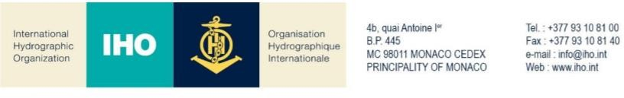

NAUTICAL CARTOGRAPHY WORKING GROUP

Chair: Mikko HOVI  Finnish Transport and Communications Agency  Erik Palménin aukio 1  00560 Helsinki Finland | Secretary: Edward Hands  Norwegian Hydrographic Service Prof. Olav Hanssens vei 10  4021Stavanger  Norway
Tel: +358 29 5346730 | Tel: +47 975 87721
Email: mikko.hovi@traficom.fi | Email: edward.hands@kartverket.no

NCWG Letter: 05/2021

To NCWG Members
23 December 2021

Subject: Baseline Symbology Project Team (BSPT) Terms of Reference

Dear Colleagues,

Action NCWG7/6 called for the Baseline Symbology PT to convene and finalize their Terms of Reference, and submit them to the Working Group for approval by December 2021.

The Project Team convened online on 14 December 2021 to discuss the ToRs. The resulting finalized ToRs are included in Annex A of this letter.

I ask you all to review the Terms of Reference for the Baseline Symbology PT in Annex A once more. If you approve them, no response is required. If you don’t approve or have comments, please respond by email to me (mikko.hovi@traficom.fi), the Secretary (edward.hands@kartverket.no) and the BSPT Lead (daniel.brousseau@dfo-mpo.gc.ca) on 17 January 2022 at the latest.

Yours sincerely,

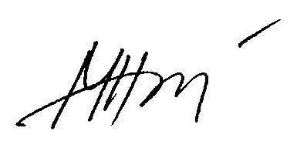
Mikko Hovi
Chair NCWG

Annex A

Baseline Symbology Project Team (BSPT)
NAUTICAL CARTOGRAPHY WORKING GROUP (NCWG)
Terms of Reference and Rules of Procedure
Ref: 1) 1st NCWG Baseline Symbology Project Team VTC Meeting (March 1st, 2021)
2) 2nd NCWG Baseline Symbology Project Team VTC Meeting (December 14th, 2021)
1. Mandate:
a) Establish a common IHO symbology, based on S-4, that can be used to support the automated creation of paper chart products directly from S-101 data. A common symbology library will help hydrographic offices, private industry, developers and others, to view ENC data and facilitate direct creation of ENC derived products more efficiently and quickly.
2. Objectives
Focus on:
a) Development of a symbol library comprising a common set of symbols (in SVG format) and related portrayal rules. This will support efforts toward the automated or semi-automated creation of paper charts.
b) Submit the SVG baseline symbol library, based on S-4, compatible to the requirements of IHO S-100 based product specifications, to the IHO Geospatial Information Registry.
3. Authority
a) This Project Team (PT) is a subsidiary of the Nautical Cartography Working Group (NCWG). Its work is subject to NCWG approval.
4. Composition and Chairmanship
a) The PT shall comprise representatives of IHO Member States (MS), Expert Contributors (EC), observers from accredited Non-Governmental International Organizations (NGIO), and a representative of the IHO Secretariat. A membership list shall be maintained and posted on the IHO website.
b) The Project Lead will monitor PT membership to ensure proper representation on the PT.
c) EC membership is open to entities and organizations that can provide a relevant and constructive contribution to the work of the PT.
d) All members shall inform the project lead in advance of their intention to attend meetings of the PT.

5. Procedures
a) The PT should work by correspondence, teleconferences, in-person meetings, workshops or symposia. The PT should meet regularly, about once a month or less.
b) Decisions should generally be made by consensus. If votes are required on issues or to endorse proposals presented to the PT, only MS may cast a vote. Votes at teleconference and in-person meetings shall be on the basis of one vote per MS represented at the meeting. Votes by correspondence shall be on the basis of one vote per responding MS represented in the PT.
c) The date and venue of PT meetings shall normally be announced by the Project Lead at least 4 weeks in advance and be on the 2nd Tuesday of the month @ 1200 UTC.
d) The meetings notes shall be distributed by the Project Lead to the PT for review. Comments should be returned to the Project lead and the results will be shared with the PT.
e) The PT will maintain close liaison with other HSSC WGs, particularly the NIPWG and S-100WG. The PT should liaise also, via the NCWG chair, with other IHO bodies, international organizations and industry, as appropriate and as instructed by HSSC.

