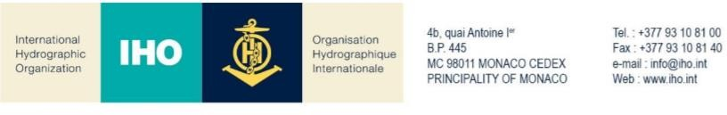

NAUTICAL CARTOGRAPHY WORKING GROUP

Chair: Mikko HOVI  Finnish Transport and Communications Agency Opastinsilta 12 A  00520 Helsinki Finland | Secretary: Edward Hands  Norwegian Hydrographic Service Prof. Olav Hanssens vei 10  4021Stavanger  Norway
Tel: +358 29 5346730 | Tel: +47 975 87721
Email: mikko.hovi@traficom.fi | Email: edward.handsartverket.no

NCWG Letter: 03/2021

To NCWG Members
Date 23 August 2021

Subject: Arrangements for NCWG-7 November 2021

Dear Colleagues,

I hope you are all well as we continue to deal with the challenges placed upon us by the ongoing global pandemic. It is clear that uncertainty and restrictions remain for many of us and it is difficult to make firm plans regarding the format for NCWG-7.

Our colleagues at The Instituto Hidrográfico de la Marina, have confirmed their ability to host the meeting in Cadiz, Spain as previously agreed. However we are aware that many may still be unable to attend an in-person meeting at this time for a variety of reasons.

Thankfully the option to conduct the meeting virtually still exists and presents a very viable alternative to ensure a successful meeting can take place. We hope to be able to provide a final update regarding the format of the meeting to all members by 13 September.

In order to help inform the final decision we would be pleased if members could indicate their availability for an in-person meeting using the attached form by 1 September.

Yours sincerely,

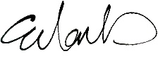
Edward Hands, NCWG Secretary

NCWG-7 Meeting
Response Form
(please return to NCWG Chair and Secretary by 1 September 2021)
mikko.hovi@traficom.fi, edward.hands@kartverket.no

No. | Question | Yes | No
 | Are you Would you be available to attend an in person meeting in Cadiz 9-12 November?

Further comments:

Date:
Name:
Organization:

