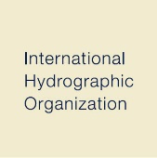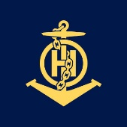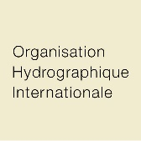 | 4b quai Antoine 1er  B.P. 445  MC 98011 MONACO CEDEX  PRINCIPALITY OF MONACO | Tel: +377 93 10 81 00  Fax: +377 93 10 81 40  Email: info@iho.int  Web: www.iho.int

 | NAUTICAL CARTOGRAPHY WORKING GROUP
Chair: Mikko Hovi  Finnish Transport and Communications Agency Traficom |  |  | Secretary: Patricia Sheatsley  ESRI
Tel: +358 29 534 6730  Email: mikko.hovi@traficom.fi |  |  | Tel: +1 909 369 5048  Email: psheatsley@esri.com

NCWG Letter 04/2024
To NCWG Members
23 April 2024
Updates for S-4 to Review
Dear Colleagues,
At NCWG8 we agreed a number of updates to S-4. These were discussed under the following papers:
NCWG8-06.2A Oil/Gas Platform Jacket Depiction
NCWG8-06.4A Impact of the Change of Limits between the MACHC and the SWAtHC Submitted by IHO Secretariat.
NCWG8-06.7A Merging of PA and PD abbreviations on paper charts
NCWG8-06.8A New abbreviations
NCWG8-06.12A Marine Radiobeacon Clarifications
NCWG8-06.13A Proposal on Adding the Symbol of Differential Beidou Satellite Nav System Reference Station.
A draft of all the changes can be found at Annex A.
Please reply, using the Response form at Annex B, no later than 22 May 2024. I ask you to use the ‘Reply to all’ option for responses, to ensure the full Working Group membership is aware of developing discussions.

Yours sincerely
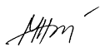

Mikko Hovi
Chair NCWG
Annex A
Extracts from S-4 in black with:

- Comments in blue
- Proposed additional words in green.
- Proposed deletions crossed through.

1. NCWG8 Action 2 based on NCWG8-06.2A and NCWG9_05.12A Oil/Gas Platform Jacket Depiction
Do you agree to include an additional paragraph to B-445.1 to cover decommissioned oil/platform jackets cut off below sealevel but still retaining a large superstructure?

B-422.10 Submerged obstructions too small to be shown to scale must be charted similarly to wrecks (see B-422.3, 422.4, 422.7) but with the international abbreviation ‘Obstn’ in place of ‘Wk’. Further information may be provided by replacement of the legend ‘Obstn’ with appropriate legends to indicate the characteristics of the submerged obstruction, where known, for example: ‘ODAS’; ‘Diffuser’. The legend ‘Rig(Ru)’ indicates submerged jackets of decommissioned platforms. Larger obstructions must be charted with a danger line and legend. Blue tint must be added over obstruction symbols in accordance with the charted depth, and in all cases where a depth numeral is not charted and the general depth of water is less than 100m.

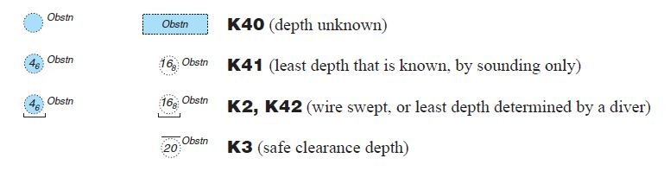
Amend B-445.1 as follows:

B-445.1 Wells, Wellheads, Templates and, Manifolds and Jackets

Add paragraph “h” as follows:
h. Decommissioned oil/gas platform jackets. When decommissioning oil or gas platforms in deeper water, the jackets may be cut-off well below sea level, leaving behind the lower half of the jacket. Due to the depth of water, such an installation is normally of no concern to surface navigation. However the remains of these jackets are large structures which may extend up to 50m from the seabed and might be a hazard to fishing and underwater operations.
These structures must be charted as obstructions (see B-422.10) with the legend ‘Rig(Ru)’, instead of ‘Obstn’.

Annex A
1. NCWG8 Action 4 based on NCWG8-06.4A Impact of the Change of Limits between the MACHC and the SWAtHC Submitted by IHO Secretariat.

Replace this paragraph update the diagram to remove the country names which are maintained in S-11 Part B.
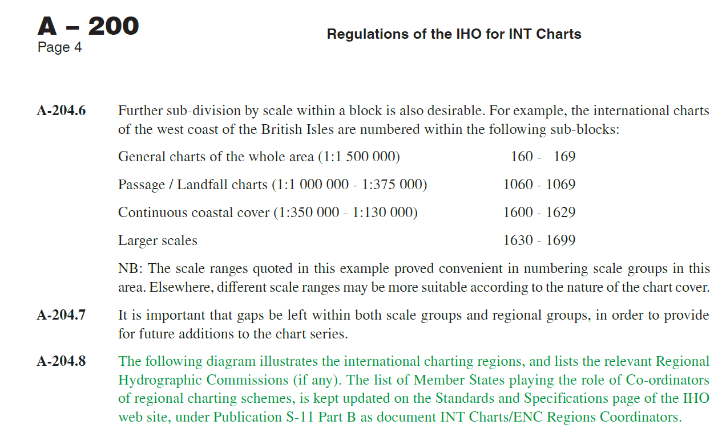
Remove the names of the member states playing the role of co-ordinators of regional charting schemes from the diagram and amend the limit between MACHC and SWAtHC to the latest agreed limit. An updated diagram has been produced as the old raster diagram was no longer editable.
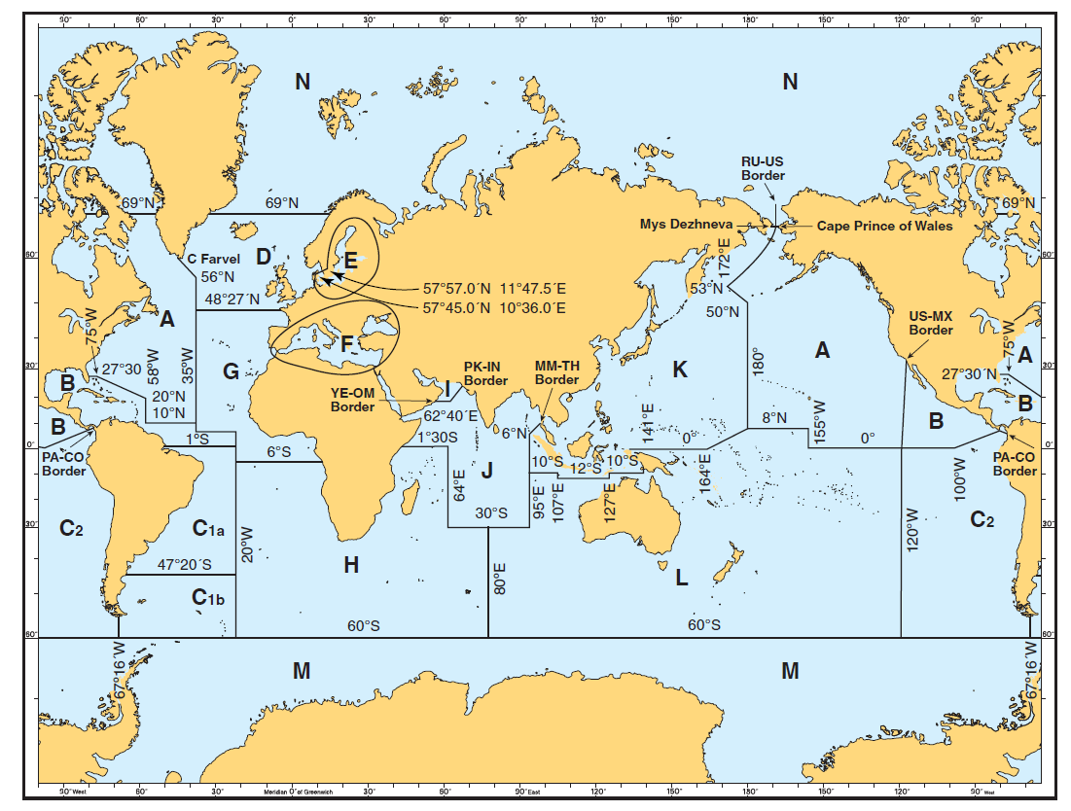
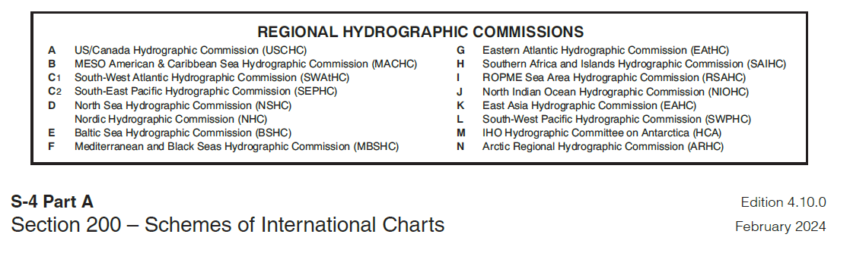
Under the existing diagram delete this line.
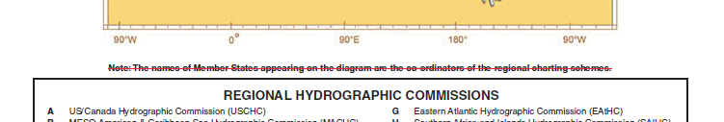

3. NCWG8 Action 6 NCWG8-06.7A Merging of PA and PD abbreviations on paper charts
It was proposed at NCWG7 to merge the definition of PA and PD as the separate definition does not bring additional value to the mariner in terms of navigation. These amendments were agreed in full by NCWG8.

Annex A
The obsolete symbol has been added to PD in B-120 International abbreviations.
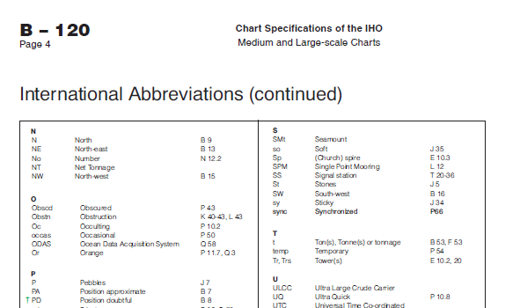
PD has been removed from the paragraphs below.
B-422 WRECKS, FOUL GROUND, OBSTRUCTIONS
h. The abbreviations ‘PA’, ‘PD’ and ‘ED’ may be inserted against wreck symbols as appropriate, see
B-424.

B-424 DOUBTFUL DANGERS

The international abbreviations ‘PA’,‘PD’,‘ED’,‘SD’ must not be written in full or translated. Brackets and full stops should be omitted. The abbreviations should be in sloping letters when applied to a water feature, for example shoal or submerged wreck. Doubtful shoals must be encircled by a danger line, or the appropriate depth contour. However, existing depth contours should not be extended to accommodate these shoals.

Note: Technical Resolution 1/1947 as amended recommends hydrographic offi ces to ‘review the applicable legends appearing on their charts and remove all those that do not seem to refer to actual or possible dangers to navigation.’

The abbreviations ‘PA’,‘PD’ and ‘ED’ may be applied to features other than dangers where necessary.

Note that reports of uncharted islands in unexpected places may be from sightings of floating debris or volcanic residue. Genuine uncharted islands in deep water are increasingly unlikely now that satellite imagery is readily available. Equally, satellite imagery and other modern data sources may enable previously reported doubtful features to be removed from charts with confidence.

Annex A

Paragraphs B424.1 and B424.2 have been amended to reflect the changes.

B-424.1 PA, meaning Position approximate, must be used to indicate that the position of a shoal, wreck,
or other object, either has not been accurately determined or does not remain fixed. Or has been reported in various positions and not confirmed in any of them.

PA B7

B-424.2 PD, meaning Position doubtful, must be, was formerly used to indicate a shoal, wreck, or other object has been reported in various positions and not confirmed in any of them.

PD B8
It is no longer useful to chart PD as it brings no additional value as compared to PA to the mariner in terms of navigation (see B424.1).

C-404 DANGERS TO NAVIGATION

C-404.3
Doubtful dangers and reported shoal depths: these should be charted in accordance with B-424. The former practice of encircling all reported depths by a danger line (INT1 I4) has been discontinued. When depths of less than 200 metres are involved, or implied, the appropriate blue tint shall be added (see C-402.4). The abbreviations PA, PD, ED, SD and Rep shall be used as appropriate (see B-424.1 to B-424.4). It is essential that doubtful dangers can be identified without ambiguity and that they can be distinguished from confirmed features, particularly where the small-scale chart is the largest scale for an ocean area. The year (in parentheses) in which the doubtful data were reported may be inserted, provided that this additional information does not render the chart less legible.

4. NCWG8 Action 7 NCWG8-06.8A New abbreviations
This paper improves consistency between S-4 and S-101. Two new abbreviations have been added to B-120 International Abbreviations. Note that formatting amendments have also been made under V to correct a historical typographical error including removing reference to the now unused Section G of INT1.

Annex A
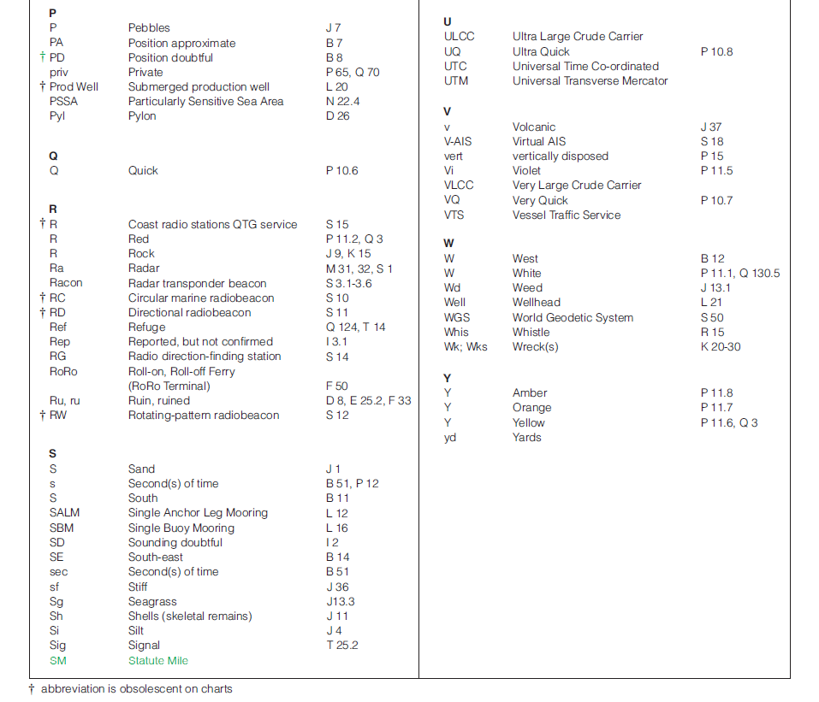
5. NCWG8 Action 12 NCWG8-06.12A Marine Radiobeacon Clarifications
This paper proposed that Aeromarine radiobeacons should be added to the list of radio position fixing stations which no longer need to be charted as RDF equipment is generally no longer fitted on vessels.

Annex A
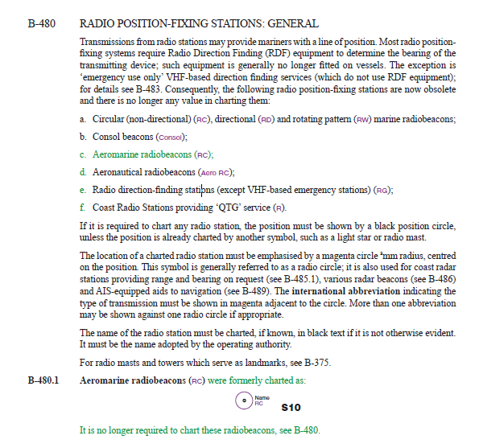
6. NCWG8 Action 13 NCWG8-06.13A Proposal on Adding the Symbol of Differential Beidou Satellite Nav System Reference Station.
It was agreed by NCWG8 that rather than added a new symbol for Differential Beidou Satellite Nav System Reference Station, S-4 should refer to the generic term DGNSS and only use specific systems as examples.
Replace
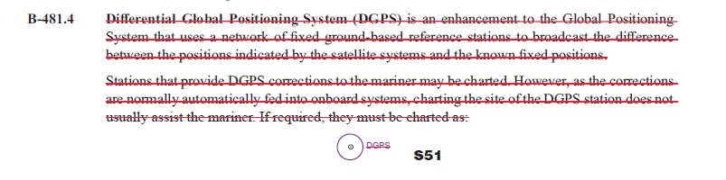
Annex A
With:
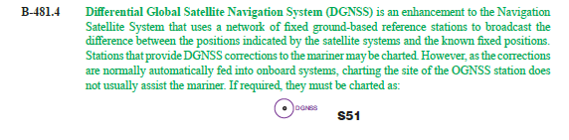

7. NCWG8 Action 14 Minor typographic error noted in CATZOC table
B-297.9 CATEGORY OF ZONES OF CONFIDENCE IN DATA - ZOC TABLE
(S-57 Edition 3.1 Supplement No. 2 Appendix A Chapter 2)
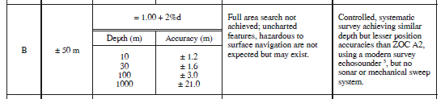
The reference to Footnote 5 should read footnote 7
7 Modern survey echosounder - a high precision single beam depth measuring equipment,
generally including all survey echosounders designed post 1970.

Annex B to NCWG Letter 04/2024
Amendments to S-4 from NCWG8
Response Form (please return to NCWG Chair and Secretary by 22 May 2024)
mikko.hovi@traficom.fi, PSheatsley@esri.com,
If you answer ‘No’, please explain in the ‘Comments’ section. You can also use that section to record other suggestions and comments.

No. | Question | Yes | No
1 | NCWG8 Action 2 (also NCWG9_05.12A)  Do you agree to include an additional paragraph to B-445.1 to cover decommissioned oil/platform jackets cut off below sealevel but still retaining a large superstructure?
2 | NCWG8 Action 4  Do you agree to Update A-204.8 to refer to S-11 for Regional coordinators and update diagram for RHC boundary changes and associated wording changes?
3 | NCWG8 Action 6  Do you agree with the merging of PA and PD abbreviations on paper charts. This proposal was agreed at NCWG 8, no further changes should be proposed?
4 | NCWG8 Action 7 Do you agree to include the proposed abbreviations for Statutory Mile and Yard in B-122.1? Please note some minor amendments have also been made to correct typographical errors and remove reference to Section G of INT 1 which is no longer used. Agreed at NCWG8
5 | NCWG 8 Action 12  Do you agree to mark Aeromarine Radiobeacons as obsolete and no longer charted?
6 | NCWG8 Action 13  Do you agree to the use of DGNSS as a generic term replacing DGPS?
7 | NCWG8 Action 14  Minor typographical change to footnote in CATZOC table.

Further comments:

Date:
Name:
Organisation:

