NIPWG-VTC2020
Paper for Consideration by NIPWG
S-124 portrayal investigations
Submitted by: S-124NW PT Chair
Executive Summary: Update on S-124 portrayal investigations since NIPWG7 in November 2019
Related Documents: S-124
Related Projects: S-100
Introduction / Background
At NIPWG7, the chair of S-124 Correspondence Group (renamed S-124 Navigational Warning Project Team, S-124NW PT as of December 2019) agreed to share experience with developing the S-124 portrayal. This paper provides a synopsis of activities undertaken since NIPWG7.
Analysis/Discussion
Discussions with industry and IEC at S-100WG and TSM meetings revealed that the MSI symbol present in SN.1/Circ.243/Rev.2 would present a challenge in developing portrayal for navigational warnings. To address this, the chair worked with Transport Canada, Australian Maritime Administration and others to create an input paper that was submitted as a Canadian input to IMO NCSR7 (NCSR 7-22-2). Discussions around the submission took place in the Navigation Working Group and resulted in agreement in the sub-committee on recommending Maritime Safety Committee remove the MSI symbol from the circular. This act will remove the limits imposed by the circular on the S-124 portrayal discussions and development.

With the removal of the SN.1/Circ.243/Rev.2 limitations, there was a portrayal discussions at S-124PT1, held in June 2020. This discussion led to the formation of a group to work on the portrayal document. The portrayal drafting group started with the earlier portrayal drafts and made some modifications to of symbols and portrayal operation descriptions. Some of the portrayal functions that have been identified as important will likely need a change to S-100 Portrayal to accomplish what is desired, in particular this involved a function to group overlapping symbols into a new symbol indicating that at the present screen scale multiple symbols are located at a given location. Submission of such a function is planned for TSM meeting in the fall. NCWG input has not yet been received. The working draft of the portrayal work is available in Annex A.
Conclusions
The work on S-124 portrayal symbols and portrayal operations continues.
Action required of NIPWG
The NIPWG is invited to:
- note this paper.

Annex A – Working Draft Portrayal document

Navigational Warning must always be on when use in route monitoring mode.

System must have function to list all Navigational Warning on the screen plus a buffer around the screen (buffer size? Fixed size, e.g. 20NM? Scale based buffer?). List function must include means to distinguish between already viewed Navigational Warning and new to the user Navigational warning. List should be user specific so to track what acknowledgments each user has done and permit easy discovery of changes between watches.

Symbology | Description | Encoding Description
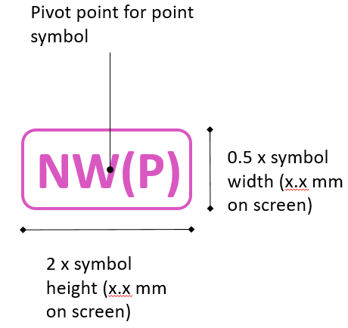 | Point symbol [To do: need to create symbol engineering drawing]
 | Line style
 | Area
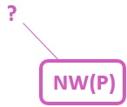 | Navigational Warning point with position approximate.  Majority of NW will probably be this kind.  No fill background to reduce blocking underlying objects.
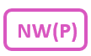 | NW with position known. No fill background to reduce blocking underlying objects.
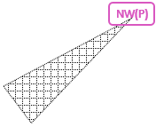 | Navigational Warning point symbol (position known) with user action (e.g. selected in pick report) causing affected area to be highlighted  NW point with affected area highlight. For example a light outage with the light arc. Location of light is the NW and the light arc is the affected area.  Use of affected area would be to help user see impact of a Navigational Warning and for enabling a system query based on route + buffer to better find Navigational Warning affecting route planning and monitoring.
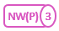  2 3 4 5 6 7 8 9 | Grouping of NWs that are close and causing clutter at screen resolution. The number of grouped NW is shown in the circle in the right side of the symbol. Numbers 2 through 9 are possible. Any grouping over 9 retain 9.  No fill background to reduce blocking underlying objects.  From S-100WG5: grouping symbol need further specification. It is at rendering side and could apply to all S-100 symbols. OEMs want some specification. Can be supported by some form of attribute in the portrayal that points to a grouping symbol that systems should use when appropriate. May require some changes to the portrayal model, but are probably limited to point features.  May be sufficient to propose an optional attribute to the point symbol reference in portrayal instructions to give an alternative symbol for use with groupings.
 | Line style for NW with line geometry
 | NW Area pattern style with a fixed offset between the NW symbol
Affected area pattern style. Only to display when the NW is selected by pick report or other user action.
Also recommended to be used for whole NAVAREA messages and other very large areas.

Question to consider; should users be allowed to turn it on if they so choose?
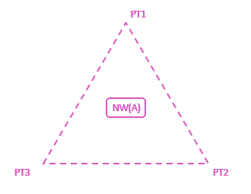 | Area NW with text placements to simplify visual reference between NW text and NW area.  An example of use can be a new regulation that adds an area with 3 points. The 3 points can be marked with text to improve the cognitive connection between the text and the point ‘on the screen’.

Additional portrayal considerations

Is it possible that NW symbols do not mask the chart details by for example using transparency or symbol with on offset? Example of use case; when a NW is related to a charted AtoN, then the AtoN on the chart should remain visible.

Is it possible to add a function of a trailing symbol behind own ship symbol that can indicate the area type, including any NW area? Trailing symbol function could replace or enhance the centered symbol function described in S-52 Presentation Library, section 8.5. [need drawing to illustrate] It has been suggested that this functionality can serve as an enhancement of portrayal of Navigational Warning with no portrayal (e.g. very large areas, poorly defined areas or whole NAVAREA messages).

