NIPWG VTC-04 2021 - 10-1-1

Paper for Consideration by NIPWG

Classification of S-10X Product Specs into “NauticalProduct” and “ElectronicChart” in S-128

Submitted by: | Hannu Peiponen/Furuno Finland Oy
Executive Summary: | The S-128 is intended to provide information about products available from HOs. It should be clear how each entry for an individual product in S-128 compliant dataset fits the IMO SOLAS requirement for mariners to carry nautical charts and nautical publications.
Related Documents: | S-128 Product Specification_1.0.0.docx dated 15th Jul 2021
Related Projects: | Any related projects that may impact upon considerations

Introduction / Background
1. NIPWG had comment resolution meeting (7th Sep 2021) on comments received on the draft S-128. Input papers included combination of all received comments and a new draft “S-128 Product Specification_1.0.0.docx” dated 15th Jul 2021.

2. I had submitted comments. Some of the comments were focused on the issue how different S-10X Product Specifications (for example S-101, S-102, S-104, etc.) are classified within the object model of the S-128. The NIPWG S-128 comment resolution meeting requested me to draft a paper on this subject to the NIPWG VTC 2021 meeting.

3. Figure 6.2 (see below) subdivide S-10X Product Specifications into two possibilities: Alternatives are either “NauticalProduct” (note complexAttribute productSpecification) or “ElectronicChart” under “AbstractChartProducts” (note complexAttribute productSpecification included in FeatureType “ElectronicChart”).

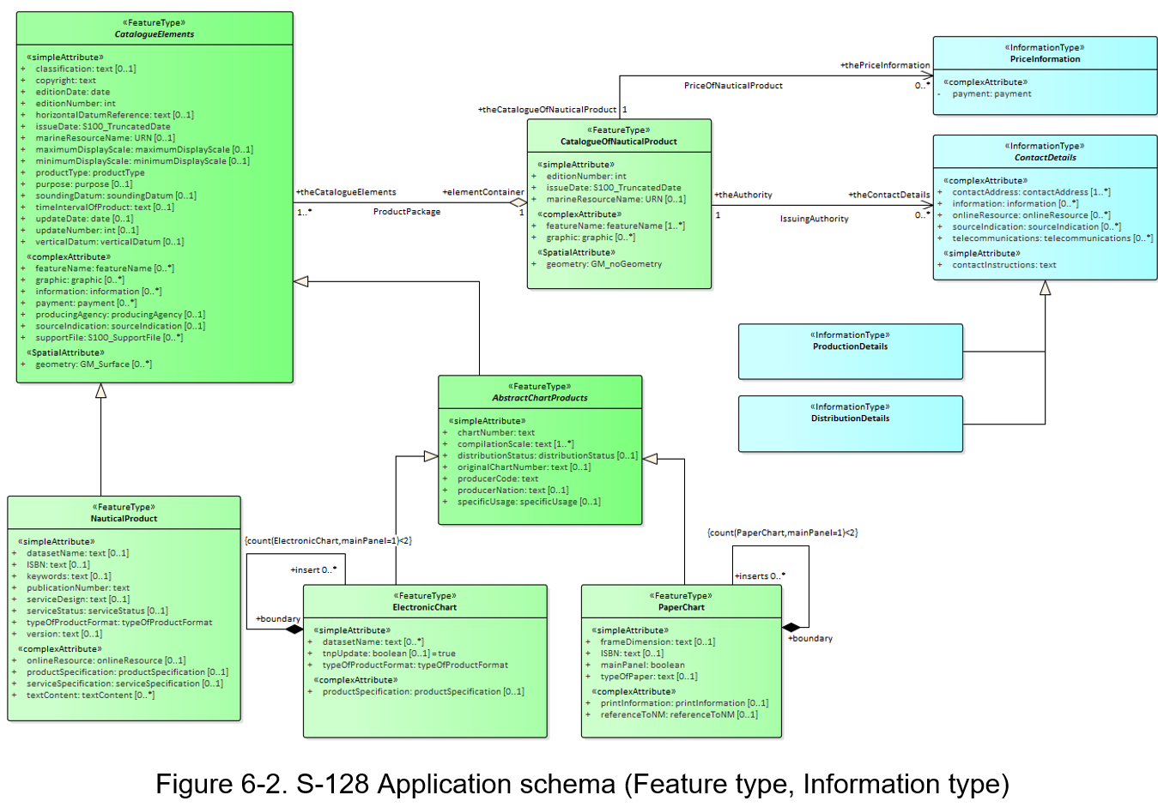

4. Open issue is how different S-10X Product Specifications (for example S-101, S-102, S-104, etc.) are divided between these two options.

5. Another aspect is that S-128 has at least two different user group: a) Mariners and b) Internal users within HO community. The focus of this paper is in mariners as users.

6. IHO standards are recognized by IMO. The SOLAS convention is binding all governments who has signed it.
SOLAS Chapter V Regulation 2 specify:
Regulation 2 - Definitions
For the purpose of this chapter:
2 Nautical chart or nautical publication is a special-purpose map or book, or a specially compiled database from which such a map or book is derived, that is issued officially by or on the authority of a Government, authorized Hydrographic Office or other relevant government institution and is designed to meet the requirements of marine navigation.*

* Refer to appropriate resolutions and recommendations of the International Hydrographic Organization concerning the authority and responsibilities of coastal States in the provision of charting in accordance with regulation 9.
SOLAS Chapter V Regulation 9 specify:
Regulation 9 - Hydrographic services
1 Contracting Governments undertake to arrange for the collection and compilation of hydrographic data and the publication, dissemination and keeping up to date of all nautical information necessary for safe navigation.
2 In particular, Contracting Governments undertake to co-operate in carrying out, as far as possible, the following nautical and hydrographic services, in the manner most suitable for the purpose of aiding navigation:
.1 to ensure that hydrographic surveying is carried out, as far as possible, adequate to the requirements of safe navigation;
.2 to prepare and issue nautical charts, sailing directions, lists of lights, tide tables and other nautical publications, where applicable, satisfying the needs of safe navigation;
.3 to promulgate notices to mariners in order that nautical charts and publications are kept, as far as possible, up to date; and
.4 to provide data management arrangements to support these services.
3 Contracting Governments undertake to ensure the greatest possible uniformity in charts and nautical publications and to take into account, whenever possible, relevant international resolutions and recommendations.*
4 Contracting Governments undertake to co-ordinate their activities to the greatest possible degree in order to ensure that hydrographic and nautical information is made available on a world-wide scale as timely, reliably, and unambiguously as possible.

* Refer to the appropriate resolutions and recommendations adopted by the International Hydrographic Organization.
SOLAS Chapter V Regulation 27 specify:
Regulation 27 - Nautical charts and nautical publications
Nautical charts and nautical publications, such as sailing directions, lists of lights, notices to mariners, tide tables and all other nautical publications necessary for the intended voyage, shall be adequate and up to date.

Analysis/Discussion
7. Mariners have obligation to carry products listed in SOLAS V Reg 27. For this obligation mariners need to know what is what in order that they are able check if they have fulfilled their obligation by electronic publications or if they need to carry the traditional paper-based product.

8. It should be noted that although mariners have the obligations, there are a lot of shore-based actors related to this obligation. Often the organization of the shipowner is behind the purchase of the products. Flag state inspectors, Port state control inspectors and Vetting inspectors from the owner of the cargo are all keen to check that the mariners have fulfilled their obligations before a vessel leave a port and start sailing. All these actors need also to understand what is what and when the SOLAS V Reg 27 requirements of having the products is met.

9. Based on SOLAS V Reg 9 the contracting governments have obligation to provide their products for mariner as unambiguously as possible. One part of this is the ability of the mariner to know if an individual product belongs to “nautical charts” or to “nautical publications”. Further mariner should be able to know within the “nautical publications” if an individual product belongs to a) sailing directions, b) lists of lights, c) notices to mariners, d) tide tables or e) all other nautical publications so that the mariner is able to check whether mariner has adequate and up to date products in electronic form or in traditional paper-based form.

10. From mariner point of view the S-128 provides the “data management arrangement to support” the services provided by the contracting governments through authorized actors as required by SOLAS V Reg 9 Paragraph 2.4. Data management could be interpreted to include among others up-to-dateness information and information about what is what compared to items required by SOLAS V Reg 27. Further SOLAS V Reg 9 Para 4 requires that contracting governments coordinate that the “nautical xxxx” are made available worldwide unambiguously (i.e. based on one single uniform model).

11. From mariner point of view it would be beneficial if the names used in SOLAS to identify different members of the nautical publications would be part of the terminology used in S-128. A one-to-one relation would ensure worldwide unambiguous interpretation.

12. Many new S-100 based electronic alternatives are constructed to that they do not contain everything which has been included into a traditional paper-based products (i.e. the names of products as listed in SOLAS). For example, there is not yet (and probably never) any S-10X Product specification named “sailing directions”, but many S-12x Product specification contain elements traditionally being available in the paper based “sailing directions”.

13. Many new S-100 based products go beyond what has been available as paper-based products. Examples include the S-102 Detailed bathymetry (Is it part of “nautical chart” or ??), S-104 Water level (Obviously it is more than “Tide Table” as it contains changes of water level for any reason not limited to tidal. Further S-57 ENC charts have had facilities to include tidal information as tables), S-111 Surface currents (traditional paper charts and S-57 charts have had information about surface currents as simple direction and strength based on statistical average. The S-111 is able to provide both current values and forecast of future).

14. The FeatureType CatalogueElements include SpatialAttribute geometry:GM_surface. This provides coverage of each entry in the S-128 based catalogue. Based on these coverages it is possible both to know (human and machine) and to manage by machine, if there are products available to fulfil SOLAS V Reg 27 obligation to have “nautical charts” and “nautical publication” adequate for the intended voyage.

15. It might be so that the current portfolio of S-10X Products specifications under drafting do not yet cover everything what has been available to fulfil the obligations of SOLAS V Reg 9 Para 2.2. The drafted object model is clear for the “nautical charts” – the upper level is “AbstractChartProducts” which is sub-divided as “ElectronicChart” and “PaperChart”. Such clarity is missing for the “nautical publications”.

Conclusions
16. The S-128 should include classification of the nautical products into different terms (i.e. categories) used in SOLAS.

17. The maritime community as whole would benefit if the “nautical publication” part would use same style as “nautical charts” i.e. first “AbstractNauticalProducts” under which there would be “ElectronicNauticalProduct” and “PaperNauticalProduct”.

18. It is very clear that, for example, S-101 belongs to FeatureType ElectronicChart. Unclear is, for example, if the detailed bathymetry S-102 is a part of ElectronicChart or a part of NauticalProduct. Similar unclear cases are, for example, S-104 Water level and S-111 Surface currents.

Recommendations
19. Recommendation is to consider what to do with the conclusions.

Justification and Impacts
20. Justification for provision of clarity is that the clarity is an obligation of contracting governments of SOLAS.

21. Impact of not providing clarity is clear. The hesitation and take-over of the electronic versions of S-10X Products beyond S-57 and S-101 will continue for a long time. World-wide acceptance will be delayed and result is similar teething problems as with S-57 ENC charts – early users of the S-57 ENC charts found that it was not enough that their flag country has accepted the carriage of electronic charts instead of paper charts. In practice these early users were stopped by the Port State Control inspectors in foreign ports and required to get the full set of paper-based products in order to continue. The result was lost motivation for the shipowners to go for electronic alternative.

Action Required of NIPWG
The NIPWG is invited to:
- Clarify the classification/role of each S-10x Product specification in relation to mariner obligations specified in the SOLAS
- Improve the drafted object model of the S-128

