IHO Definition: BRIDGE: (1) An elevated structure extending across or over the weather deck of a vessel, or part of such a structure. The term is sometimes modified to indicate the intended use, such as navigating bridge or signal bridge. (2) A structure erected over a depression or an obstacle such as a body of water, railroad, etc., to provide a roadway for vehicles or pedestrians.
S-127 Geo Feature: Bridge (BRIDGE)
SuperType: Supervised Area (Abstract)
Primitives: Surface
Insert new UML or tables in S-101 DCEG style

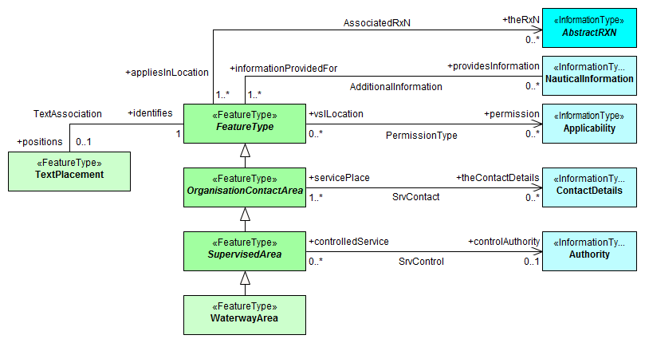
Bridge
5.15.1 Bridges
If it is required to capture requirements regarding contacting bridges prior to transit then a bridge feature area shall be encoded with necessary associations to an authority class for capturing contact details, ship reporting and service hours. Any additional information can be captured in a Nautical Information class. Vertical and horizontal clearances are captured in the ENC and therefore not needed in S-127 datasets.
Bridge Information
To encode the bridge information:
- Using Features/Attributes from the S-101 Digital Capture and Encoding Guide (DCEG)—Category of Bridge (CATBRG).
- Using Features/Attributes from the Inland ENC DCEG:
- Vertical Clearance Fixed (VERCLR).
- Vertical Clearance Closed (VERCCL).
- Vertical Clearance Open (VERCOP).
- Horizontal Clearance (HORCLR).

5.15.1.1 Bridge reporting and service hours
Example of bridge operation on the following schedule:
Days | Time (Local) | Remarks
Monday to Friday | 0730-0830 and 1700-1830 | Bridge does not open to vessel traffic
 | 0830-1700 | Opens on signal
 | 0000-0730 and 1830-2400 | Opens on signal with a 12-hour advance notice to the Bridgetender
Saturday to Sunday | 0730-2000 | Opens on signal
 | 0000-0730 and 2000-2400 | Opens on signal with a 12-hour advance notice to the Bridgetender

Explain how to encoding the contact details
Contact Information
To encode the ship-to-bridgetender contact information, it must be done using the information class Contact Details. The Contact Details must be associated to the Bridge feature using the association AdditionalInformation.

Explain link with service hours and how it’s encoding using above example.
Service Hours (operating schedule)
To encode service hours, it must be done using Features/Attributes from the S-127 Digital Capture and Encoding Guide (DCEG):
- Information Types (Part 7)—Non-Standard Working Day (7.10) and Service Hours (7.11).
- Complex Attributes (Part 8)—Fixed Date Range (8.4), Notice Time (8.9), Periodic Date Range (8.12), Schedule by Day of Week (8.15) and Time Interval by Day of Week (8.20).

Question: how is the request from the vessel to the bridge captured? Do we need to use ship report or is it explained via contact details?
Add as an example of how bridge communication may be done. Is this material for NauticalInformation or something else?
How is 12-hour notice captured? Is there an “advance notice” Feature/Attribute?
Bridge communications—NauticalInformation? I think this is now covered above.

Bridge operating signals can be seen in the table titled Le Petomane Bridge—Signals.
Le Petomane Bridge—Signals
Signal | Meaning
Two long blasts from vessel | Request bridge opening.
Two long blasts from bridge | Bridge will open.
Five short blasts from bridge | Bridge will not open.
Siren from bridge | When in closed position. Bridge will be opening.
 | When in open position. Bridge will be closing.
Fixed green light on bridge centerline and fendering system | Bridge in fully open or closed position. Vessel transit permitted.
Flashing red light on bridge centerline and fendering system | Bridge in opening or closing process. Vessel transit prohibited.

Remarks:
- Any remarks?
Bridge Signals
Need to develop new:
- Feature (Sound Signals) and Attributes (short blast, long blast, prolonged blast, stroke, and ringing).
- Feature (Sound Device) and Attributes (whistle, horn, siren, ball, and gong).
- Note.—Meaning would best be served as Text.

Distinction: Lockgate, waterway

Waterway Area
IHO Definition: WATERWAY AREA: A line of water (river, channel, etc.) which can be utilized for communication or transport (IHO Dictionary, S-32, 5th Edition, 5881)
LOCK: A signal station for the control of vessels entering or leaving a lock. (IHO Registry)
LOCK BASIN: A wet dock in a waterway, permitting a ship to pass from one level to another. (IHO Registry)
Should a new Class titled Lock be developed vice Waterway Area?
S-127 Geo Feature: Waterway area (WATARE)
SuperType: Supervised Area (Abstract)
Primitives: Surface
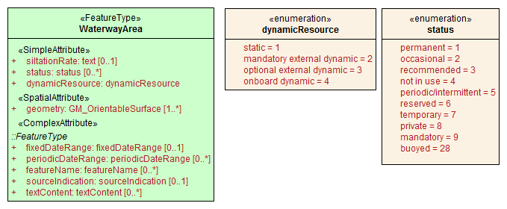

5.15.1 Waterway areas
Waterways can be encoded to indicate how specific sections of water have been divided for various administrative purposes such as for organizing traffic and managing the available water column. When it is required to encode a section of water as a waterway, this must be done using the feature Waterway Area. A waterway area must declare how a vessel must used either a shore-based or other resource to obtain up-to-date information about the waterway, by using the attribute dynamicResource.

Explain how to use for locks and elaborate on the way to capture radio communication with locks
Contact Information
To encode the ship-to-lockmaster contact information, it must be done using the information class Contact Details. The Contact Details must be associated to the Lock feature using the association AdditionalInformation.

Explain how vessel dimensions are captured using following example;
Based on lock clearances and layout, the following vessel limitations are in effect:
- Maximum vessel length: 80.0m
- Maximum vessel breadth: 13.5m

Vessel Dimensions
To encode vessel parameters, it must be done using Vessel Measurements (VSLMSM) from 8.22 of the S-127 DCEG.

Lock Dimensions
To encode lock dimensions, it must be done using Geo Feature Attribute and Enumerate Descriptions (27.104 through 27.108) from the S-101 DCEG.

Operation hours explain using following example;
The Madeleines Locks operate, as follows:
- From 0000, 15 December to 2400, 31 December—Locks are closed to vessel traffic for major maintenance and repairs.
- From 0000, 1 January to 2400, 15 January—Locks are closed for major maintenance and repairs.
- From 0000, 16 January to 2400, 14 December—Locks are open to vessel traffic except the locks are closed for maintenance, as follows:
- From 0000 to 2400 on the first Sunday in April.
- From 0000 to 2400 on the first Sunday in July.
- From 0000 to 2400 on the first Sunday in October.
Note.—All times are local time.

Service Hours (operating schedule)
To encode service hours, it must be done using Features/Attributes from the S-127 Digital Capture and Encoding Guide (DCEG):
- Information Types (Part 7)—Non-Standard Working Day (7.10) and Service Hours (7.11).
- Complex Attributes (Part 8)—Fixed Date Range (8.4), Notice Time (8.9), Periodic Date Range (8.12), Schedule by Day of Week (8.15) and Time Interval by Day of Week (8.20).

Explain contact details using the following example;
Vessels must send their ETA to the Lockmaster 24 hours prior arrival. The Lockmaster can be contacted, as follows:
- Call sign: Madeleines Locks
- VHF: VHF channel 10
- Telephone: 1-999-23456543
- Facsimile: 1-999-23456544
- E-mail: madeleineslocks@jussland.net

Explain how lock signals are captured (nautical information?) using following example;
How is 24-hour notice captured? Is there an “advance notice” Feature/Attribute?
Lock communications—NauticalInformation? I think this is now covered above.

Locks signals are displayed on the NE wall of the inbound lock and on the SW wall of the outbound lock. See the table titled Madeleines Locks—Signals.

Madeleines Locks—Signals
Signal |  | Meaning
Three fixed red lights, horizontally disposed. |  | Lock gate closed. Vessels may not approach.
Three fixed yellow lights, horizontally disposed. |  | Lock filling.
Three flashing yellow lights, vertically disposed. |  | Lock gate opening.
Three fixed green lights, vertically disposed. |  | Lock gate open. Vessels may approach.
Three flashing red lights, horizontally disposed |  | Lock gate closing.

Lock Signals
To encode Lock Signals, it can be done using Features/Attributes from the S-101 Digital Capture and Encoding Guide (DCEG):
- Category of Traffic Signal Station (CATSIT).
- Color (COLOUR).
- Light Characteristic (LITCHR).
- Note 1.—Meaning would best be served as Text.
- Note 2.—Need to develop “vertically disposed” and “horizontally disposed.”
- Note 3.—Would this better be coded as PIC?

Remarks (Note that these would not be necessary under Locks):
- When it is required to encode the siltation rate of a waterway, this must be done using the attribute siltationRate.
Distinction: Underkeel Clearance Management Area, Underkeel Clearance Allowance Area, Routeing Measure

