Attachment 1

Templates and Recommendations for Product Specifications

14 December 2022

Prepared by Raphael Malyankar

[Clause numbering below is hypothetical and will depend on the structure of the actual Product Specification document.]

Data Content and Structure

Application Schema

Domain model

Feature associations / Information associations
Recommendation: All (NPUB) product specifications should include clause(s) summarizing the feature and information associations in the model. One or more UML diagrams capturing the relationships should be included. In order to reduce diagram clutter, attributes should not be included within the boxes representing feature and information classes (example figure from S-131 included below). (S-131 1.0 already contains such a clause.
Feature associations in S-131 are depicted in Figure 2.1.
[S-131 text explaining the diagram deleted from this template; since the associations are different, each product specification will need its own explanatory language.]
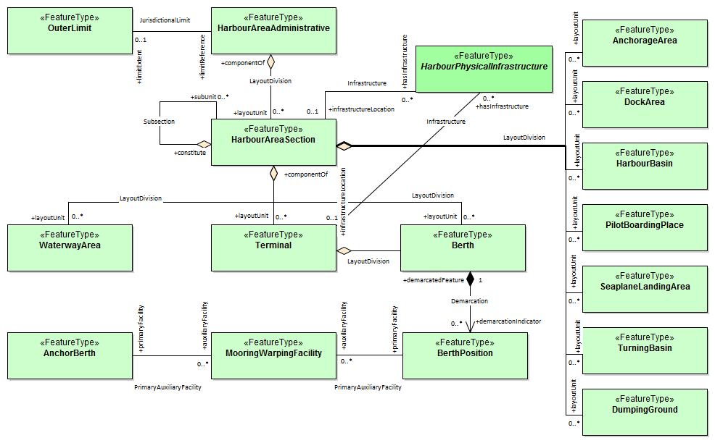
Figure 2.1 - Relationships between geographic features

Feature Catalogue
Recommendation: The Product Specification should include a section describing feature bindings, preferably as a reproduction, summary, or elaboration of S-100 5-4.2.5.2 and 5-4.2.5.3, though a reference to those clauses may suffice.
Note that the recently concluded S-100 WG7 discussed a proposal to revise feature and information bindings in the S-100 feature catalogue model, which may require revisions to those clauses. The proposal was deferred to the March 2023 TSM so a specific description cannot be provided yet (the revision would be effective only with S-100 Edition 5.1, anyway.)

Feature and information associations
A feature association links instances of one feature type with instances of the same or a different feature type.
An information association links instances of feature types or information types to instances of information types.
Feature and information bindings are implemented in feature catalogues using feature and information bindings, described in S-100 5.0 clauses 5-4.2.5.2 and 5-4.2.5.3 respectively (see Attachment 3).

Portrayal

General rules and guidelines

Portrayal of associations
Recommendation: The Portrayal section of a Product Specification which uses the Applicability information type to describe the applicability of regulations (and recommendations, etc.) to vessels should include the paragraph below, making revisions appropriate to the data model in the particular Product Specification.
The text generated [from instances of the information type Applicability] should be linked or otherwise related to the feature or information type to which it applies depending on the nature (and attributes, if any) of the association between Applicability and the feature or information type to which it is associated. For example, the text generated might be preceded by the text of the linked Regulation (for InclusionType associations), or the text generated from Applicability appear in a hover box linked to a geographic feature (for PermissionType associations).

