Nautical Information Provision Working Group (NIPWG)
3rd Monthly dedicated S-128 Meeting
19th December 2023 – VTC, Worldwide

Annex A: List of Action items
Annex B: Agenda
Annex C: List of Attendees

- Update Status of the S-128 Product Specification
- NIPWG noted the presentation.
- EM: Question: What is the plan for submitting the 233 items that are currently missing from the Registry? There is a 60-day processing time for submissions, so this needs to be started as soon as possible. Mike Kushla is the NIPWG registry representative.
- HS: All the items have been identified that need registering, however the ones that are not registered still need definitions drafted.
- EM: NIPWG membership should review the definitions before the items are submitted.

- RM: Question: Will any existing items be updated?
- HS: Only planning on reusing them. They will be kept as is.

- EM/HS: Timeframe discussion: English is not the national language of the Project Team therefore it would take a little while, around a month. Therefore, the S-128PT will create a list of the names of the missing items that need definitions, and a small task group will work on drafting the definitions over the next month.

Action Item 1: List of all missing items to be passed to task group to create definitions. HS. 22nd December 2023

Action Item 2: Task group to create definitions for the items that require submission to the registry. EM(Lead), JSC, BG, RB. End of Jan 2024.

- HS: There has been no objections to the new data model, therefore the team is starting to update all parts of the S-128 Product Specification such as feature catalogue etc.

- Review of Comments from S-128 1.1.0
- Discussions held on the following comments which are based originally on the Edition 1.1.0 Data Model.
- 1.
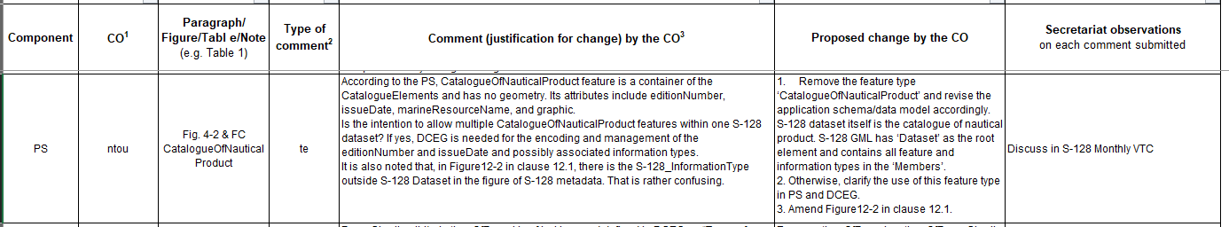

- SJC: ‘CatalogueOfNauticalProduct’ has no geometry, it is only a list of all the catalogue elements. A concern is if one of the catalogue elements is for example removed the this ‘CatalogueOfNauticalProduct’ will have to be replaced altogether. Secondly, S-128 is a catalogue of nautical products, so do we still need ‘CatalogueOfNauticalProduct’ feature with S-128 within the dataset? Thirdly is the intention to allow multiple catalogues within S-128 data set.
- EM: This is more like an InformationType, header information. A small task group is needed to discuss this comment further and to feedback to the group by the end of the week, to settle the question; Do we need to keep ‘CatalogueOfNauticalProduct’ in some iteration, either as a FeatureType with some geometry or as an InformationType?

- 2.
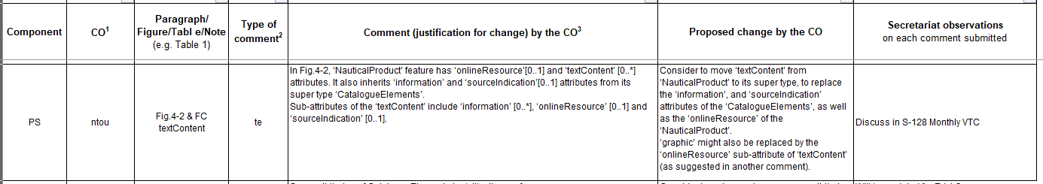

- SJC: the first part of this comment is to avoid duplication. The graphic part is due to the consideration of the distribution of S-128 and use of S-128. To allow a ‘graphic’ inside the S-128 Dataset will cause some complications. For the user, if they would like to see the graphic, they can access it via ‘onlineResource’.
- EM: ‘textContent’ has been removed from the new data model.
- HS: Graphics are for nations who want to display pictures, such as the front cover of publications.
- EM: No objections and therefore approved to remove the attribute ‘graphic’ and change the multiplicity of ‘onlineResource’ from zero to 1 to zero to many.
- SS: ‘textContent’ to also be removed from the overview of complex attributes below the diagram.

- 3.
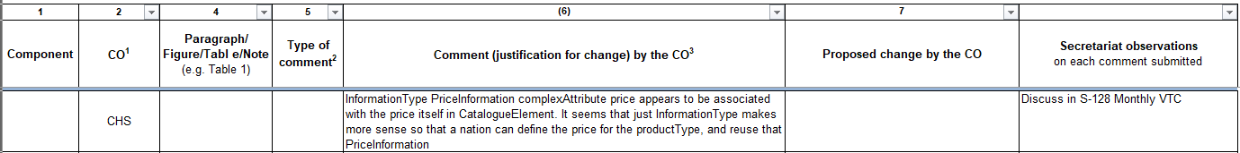

- DS: This comment still applies to the new data model.
- EM: Why is price its own ‘informationType’ and not as an attribute of the ‘CatalogueOfNauticalProduct’ if that class is retained, and then does it make sense to put the price of the catalogue with the product itself, or should it be in the discovery metadata?
- SS: The price ‘informationType’ is there to be used for the price of the S-128 catalogue itself. The price information within the catalogue elements would reflect the prices of the products referred to by the S-128 product.
- EM: This is correct, however DS’s question is why model differently. It could just be an attribute under the catalogue element itself. There is probably a case for a price on the catalogue itself as a product, however, to be determined is where is the right place, keeping in mind that if it is within the catalogue, it means you must have access before you know the price. It makes more sense to have something in the discovery metadata, but it could be both places.
MK: There is also just three attributes; ‘price’, ‘currency’ and ‘contractPeriod’. UKHO would like additional attributes such the type of package that you are buying, ‘contractPeriod’ may not be enough to differentiate between the type of prices that you may have for products.
EM: More discussion is needed. This comment to be discussed by the same small task group discussing comment 1 above.

Action Item 3: Task group to review comments 1 and 3 and submit proposals back NIPWG. SJC(Lead), HS, RB, MK. 22nd December 2023

- 4.
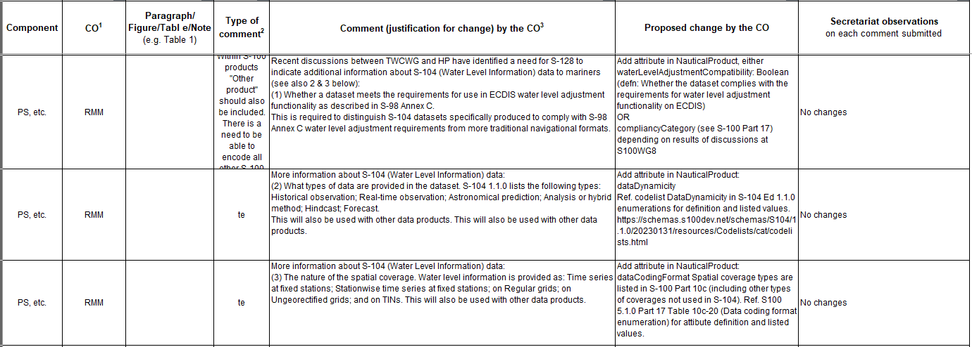
- RM: What is the reason for ‘No Changes’?
- HS: The team thinks that the water level information should be covered by S-104.
- RM: This is metadata that should be useful to manage without having to open the dataset. These comments refer to S-104 and S-111 because they are mature products. This will apply to future products such as S-411 (Sea Ice Information) and S-412 (Weather and Wave Hazards). They should still be discussed as an option and postponed and retained as comments for Edition 1.2.0.
- EM: Agreed to re discuss following the release of Edition 1.2.0.
The group needs to think about the classification of products and how much information should be in there and how it should be done. Is it sufficient to have general categories and then have some kind of textual field to provide bit more detail or should there be categories for just about everything?

- S-57/S-101 Equivalence functionality with S-128
- Ran out of time – postponed to next S-128 meeting.

- Updating of Product Specification: How a full dataset is different to an update dataset.
- Ran out of time – postponed to next S-128 meeting.

- UKHO review of mandatory metadata. Action Item 1 from 2nd dedicated S-128 VTC
- Ran out of time – postponed to next S-128 meeting.

- S-128 and DQWG
- Ran out of time – postponed to next S-128 meeting.

- Close & Next meetings
- Next Dedicated S-128 VTC: 8th January 2024 12:00 UTC

Table of names & initials:
EM | Eivind Mong
HS | Hyunsoo Choi
RM | Raphael Malyankar
JSC | Jens Søe Christiansen
BG | Bridget Gagné
RB | Roderick Bera
SJC | Shwu-Jing Chang
MK | Marcey Klimek
SS | Svein Skjaeveland
DS | Deanna Sokoloski

Annex A: Action Items
# | Action Item | Agenda Item | Assigned | Status
2nd Dedicated S-128, Nov 2023 – Hybrid Meeting
1 | UKHO to define any of the catalogue metadata fields that’s mandatory for the S-128 generation that doesn’t originate from the original catalogue.xml | 2 | AR/MK | 3rd S-128 VTC 19th Dec  COMPLETED  To be discussed at 4th VTC in Jan
2 | UKHO discuss with recommendations with IEC and to submit paper through S-98/S-164 meeting. | 2 | TM/AR | Week Beginning 4th Dec 2023.  On Going
3rd Dedicated S-128, Dec 2023 – Hybrid Meeting
1 | List of all missing items to be passed to task group to create definitions | 1 | HS | 22nd December 2023
2 | Task group to create definitions for the items that require submission to the registry. | 1 | EM(Lead), JSC, BG, RB | End of Jan 2024
3 | Task group to review comments 1 and 3 and submit proposals back NIPWG | 2 | SJC(Lead), HS, RB, MK | 22nd December 2023
Annex B: Agenda
1.0 | Update Status of the S-128 Product Specification | HyunSoo Choi
 | Review of Comments from S-128 1.1.0 | HyunSoo Choi
 | S-57/S-101 Equivalence functionality with S-128 | Ed Kuwalek, Jonathan Pritchard, Andrew Richardson
 | Updating of Product Specification: How a full dataset is different to an update dataset. | Tom Mellor/ Andrew Richardson
 | UKHO review of mandatory metadata. Action Item 1 from 2nd dedicated S-128 VTC | Marcey Klimek
 | S-128 and DQWG | Eivind Mong
7.0 | Close & Next meetings | Jo Marks/James Weston
Annex C: List of Attendees
Attendees
IHO MEMBER STATES
Name | Country | Organization / Company
Jamie Murphy | Australia | Australian Hydrographic Office
Vitor Romano | Brazil | CHM - Centro de Hidrografia da Marinha
Bridget Gagné | Canada | Canadian Hydrographic Service (CHS)
Eivind Mong | Canada | Canadian Coast Guard - Chair
Deanna Sokoloski | Canada | Canadian Hydrographic Service (CHS)
Jens Søe Christiansen | Denmark | Danish Geodata Agency/Geodatastyrelsen (GST)
Stefan Engström | Finland | Finnish Transport Agency Hydrographic Office - Vice Chair
Roderick Bera | France | Service Hydrographique et Oceanographique de la Marine (SHOM)
Daniel Zühr | Germany | Bundesamt für Seeschifffaahrt & Hydrographie (BSH)
Tetsuichiro Yabuki | Japan | Hydrographic Department, Japan Coast Guard
Herman Schouten van der Velden | Netherlands | Hydrographic Service - Royal Netherlands Navy (NLHO)
Arno Meurink | Netherlands | Hydrographic Service - Royal Netherlands Navy (NLHO)
Andrew Richardson | UK | UK Hydrographic Office (UKHO)
James Weston | UK | UK Hydrographic Office (UKHO) - Secretary
Marcy Klimek | UK | UK Hydrographic Office (UKHO)
Thomas Mellor | UK | UK Hydrographic Office (UKHO)
Matthew Garland | UK | UK Hydrographic Office (UKHO)
Noel Dyer | USA | National Oceanic and Atmospheric Administration (NOAA)
Amilynn Adams | USA | United States Coast Guard (USCG)
INDUSTRY & TECHNICAL EXPERTS
Raphael Malyankar |  | Portolan Sciences
Su Marks |  | IC-ENC
Hyunsoo Choi |  | KRISO
Shwu-Jing Chang |  | NTOU
Svein Skjaeveland |  | PRIMAR / ECC

