NIPWG(2023) VTC01

Paper for Consideration by NIPWG

Proposals on Adding Hydrometeorological Conditions into S-127 Maritime Traffic Management Product Specification (2.0.0)

Submitted by: | Lyu Yuxiao, China MSA
Executive Summary: | It lacks hydrometeorological conditions such as visibility, wind speed, wave height, and current speed in S-127 1.0.1, which results in that some navigation rules concerning with certain hydrometeorological conditions cannot be accurately and comprehensively expressed. Thus, it is recommended to add Triggering Meteorological Conditions attribute and related sub attributes into S-127 (2.0.0).
Related Documents: | S-127 (1.0.1).
Related Projects: | S-127 Project.

Background
China MSA who has been producing S-127 test data set was invited to submit change proposals on the 1.0.1 version of the Maritime Traffic Management Product Specification (S-127), according to the action item 32 of the ninth Nautical Information Provision Working Group (NIPWG) Meeting.

Analysis/Discussion
Certain maritime traffic management rules correspond to specific hydrometeorological conditions, such as the following rules:
LNG vessels when entering and leaving the port, berthing, loading and unloading, or mooring in the port shall meet the hydrometeorological requirements of the present regulation, such as wind speed, wave height, current speed and visibility (see the figure).
LNG vessels already at berth shall safely leave the wharf in time, when the forecast hydrometeorological conditions don’t conform to the value range of hydrometeorological conditions for mooring in the port specified in the present Regulation.

No. | Operation stage | Allowable wind speed (m/s) | Allowable wave height (m) |  | Visibility (m) | Current Speed (m/s)
 |  |  | Beam sea H_{4%} | wave in ship direction H_{4%} |  | Cross current | fair current
1 | Entering and leaving port waters | ≦15 | ≦2.0 | ≦3.0 | ≥20000 | <1.5 | ≦2.5
2 | Berthing operation | ≦15 | ≦1.2 | ≦1.5 | - | <0.5 | <1.0
3 | Loading and unloading operation | ≦15 | ≦12 | ≦1.5 | - | <1.0 | <2.0
4 | Mooring in the port | ≦20 | ≦1.5 | <2.0 | - | <1.0 | <2.0

This proposal summarizes the hydrometeorological conditions involved in the navigation safety regulations, mainly including visibility, surface wind speed, beaufort force, wave height, surface current speed, etc. The navigation and related activities of a vessel affected by hydrometeorological conditions mainly includes entering and leaving the port, berthing and departing, shifting, passing, sailing, speed limit, crossing the bridge, reporting to the maritime authority, etc.
It lacks hydrometeorological conditions encoding in current version of S-127 1.0.1. In order to comprehensively and accurately express the relevant navigation rules in a structured way, it is necessary to register and define attribute concepts relative to hydrometeorological conditions, and create attribute composition. At the same time, this structured expression is also conducive to the interoperability between the S-127 products and the data products conforming to specifications (including S-412, S-413 and S-414) related to WMO domain under development. In the future S-100 ECDIS, the information in the S-41X products could be obtained and compared with values of these hydrometeorological conditions attribute and related sub attributes in S-127 products, so as to timely provide more accurate corresponding navigation rules for the vessels.

Detailed Recommendations

(1) Addition of complex attributes
Triggering Meteorological Conditions
Name: Triggering meteorological conditions
Definition: The meteorological conditions under which there are corresponding regulations to support the safety of navigation.
Code: triggeringMeteorologicalConditions
Remarks:
Aliases: (none)
Sub-Attributes
Sub-attribute | Type | Mult. | Permitted Values | Sequential
comparisonOperator | enumeration | 0..1 | 1: greater than  2: greater than or equal to  3: less than  4: less than or equal to  5: equal to  6: not equal to | false
surfaceCurrentSpeed | real | 0..1 |  | false
waveHeight | integar | 0..1 |  | false
beaufortForce | enumeration |  | 1: light air  2: light breeze  3: gentle breeze  4: moderate breeze  5: resh breeze  6: strong breeze  7: near gale  8: gale  9: strong gale  10: storm  11: violent storm  12: hurricane force  13: calm wind
horizontalVisibilityRange | complex | 0..1 |  | false
surfaceWindSpeed | complex | 0..1 |  | false

Surface Wind Speed
name: Surface wind speed
Definition: The ratio value with units that the distance covered by the air to the time taken to cover it at the surface.
Code: surfaceWindSpeed
Remarks:
Aliases: (none)
Sub-Attributes
Sub-attribute | Type | Mult. | Permitted Values | Sequential
speedUnits | enumeration | 0..1 | 1.metres per second  2.kilometres per hour  3.miles per hour  4.nautical miles per hour (Knots) | false
valueOfWindSpeed | integar | 0..1 |  | false

(2) Attributes Reference
Complex Attribute: Horizontal Visibility Range
Name: Horizontal visibility range
Definition: Greatest distance expressed numerically with units that a black object of suitable dimensions can be seen and recognized against the horizon sky during daylight or could be seen and recognized during the night if the general illumination were raised to the normal daylight level.
Code: horizontalVisibilityRange
Remarks:
Aliases: (none)
Reference Source：S-412 WMO Weather Product Specification
Sub-Attributes
Sub-attribute | Type | Mult. | Permitted Values | Sequential
distanceUnitOfMeasurement | enumeration | 0..1 | 1: metres  2: yards  3: kilometres  4: statute miles  5: nautical miles | false
visibilityRange | real | 0..1 |  | false

Simple Attribute: Surface Current Speed
Name: Surface current speed
Definition：Rate of motion. The terms “speed” and “velocity” are often used interchangeably, but “speed” is a scalar, having magnitude only, while “velocity” is a vector quantity, having both magnitude and direction. “Speed” may either be the ship's speed through water, or the speed made good over ground.
Code: surfaceCurrentSpeed
Remarks:
Aliases: (none)
Value Type: real
Reference Source: Hydrographic Dictionary, Part I Volume I, English

Simple Attribute: Wave Height
Name: Wave height
Definition: The average height of wind waves, significant waves, or swell waves.
Code: waveHeight
Remarks: Unit: defined in the LUNITS attribute; for example, meter. Resolution: 1 unit; Format: xx. Wave height values are rounded to the nearest whole unit. Example: 03 for a wind wave height of 2.5 m to 3.4 m.
Aliases: (none)
Value Type: interger
Reference Source: S-412 WMO Weather Product Specification

Simple Attribute: Beaufort Force
Name: Beaufort force
Definition: Wind force scale, originally based on the state of the sea, expressed in numbers from 0 to 12.
Code: beaufortForce
Remarks:
Aliases: (none)
Value Type: enumeration
Reference Source：WMO International Meteorological Vocabulary
Listed Values
Label | Definition | Code | Remarks
'light air'  Aliases: (none) | Wind with a speed between 1 and 3 knots (Beaufort scale wind force 1). | 1
Light Breeze  Aliases: (none) | Wind with a speed between 4 and 6 knots (Beaufort scale wind force 2). | 2
'gentle breeze'  Aliases: (none) | Wind with a speed between 7 and 10 knots (Beaufort scale wind force 3). | 3
'moderate breeze'  Aliases: (none) | Wind with a speed between 11 and 16 knots (Beaufort scale wind force 4). | 4
'fresh breeze'  Aliases: (none) | Wind with a speed between 17 and 21 knots (Beaufort scale wind force 5). | 5
'strong breeze'  Aliases: (none) | Wind with a speed between 22 and 27 knots (Beaufort scale wind force 6). | 6
'near gale'  Aliases: (none) | Wind with a speed between 28 and 33 knots (Beaufort scale wind force 7). | 7
'gale'  Aliases: (none) | Wind with a speed between 34 and 40 knots (Beaufort scale wind force 8). | 8
'strong gale'  Aliases: (none) | Wind with a speed between 41 and 47 knots (Beaufort scale wind force 9). | 9
'storm'  Aliases: (none) | A signal or message conveying information about storm conditions. | 10
'violent storm'  Aliases: (none) | Wind with a speed between 56 and 63 knots (Beaufort scale wind force 11). | 11
'hurricane force'  Aliases: (none) | Wind with a speed 64 knots and above (Beaufort scale wind force 12). | 12
'calm wind'  Aliases: (none) | Absence of air motion or wind with a speed of less than 1 knot (Beaufort scale wind force 0). | 13

Simple Attribute: Speed Units
Name: Speed units
Definition: The units for description of speed.
Code: speedUnits
Remarks:
Aliases: (none)
Value Type: enumeration
Reference Source: S-412 WMO Weather Product Specification

Listed Values
Label | Definition | Code | Remarks
'metres per second'  Aliases: (none) | An SI derived unit of both speed (scalar) and velocity (vector quantity which specifies both magnitude and a specific direction), defined by distance in metres divided by time in seconds. | 1
'kilometres per hour'  Aliases: (none) | A unit of speed, expressing the number of kilometres travelled in one hour. | 2
'miles per hour'  Aliases: (none) | An imperial and United States customary unit of speed expressing the number of statute miles covered in one hour. | 3
'nautical miles per hour (knots)'  Aliases: (none) | A nautical unit of speed. One knot is one nautical mile per hour. The name is derived from the knots in the log line. | 4

Simple Attribute: Distance Unit of Measurement
Name: Distance unit of measurement
Definition: A specified amount of a quantity, as of length, by comparison with which any other quantity of the same kind is measured or estimated.
Code: distanceUnitOfMeasurement
Remarks:
Aliases: (none)
Value Type: enumeration
Reference Source: S-101 IHO Electronic Navigational Chart Product Specification

Listed Values
Label | Definition | Code | Remarks
'metres'  Aliases: (none) | The basic unit of length in the International System of Units (SI) system. | 1
'yards'  Aliases: (none) | A common unit of linear measure in English-speaking countries, equal to 3 feet or 36 inches, and equivalent to 0.9144 metre. | 2
'kilometres'  Aliases: (none) | A unit of length, the common measure of distances equal to 1000 metres, and equivalent to 3280.8 feet or 0.621 mile. | 3
'statute Miles'  Aliases: (none) | A unit equal to 5280 feet. | 4
'nautical miles'  Aliases: (none) | A unit of length equal to 1,852 metres. This value was approved by the International Hydrographic Conference of 1929 and has been adopted by nearly all maritime states. | 5

(3) Recommended data model for complex attribute Triggering Meteorological Conditions

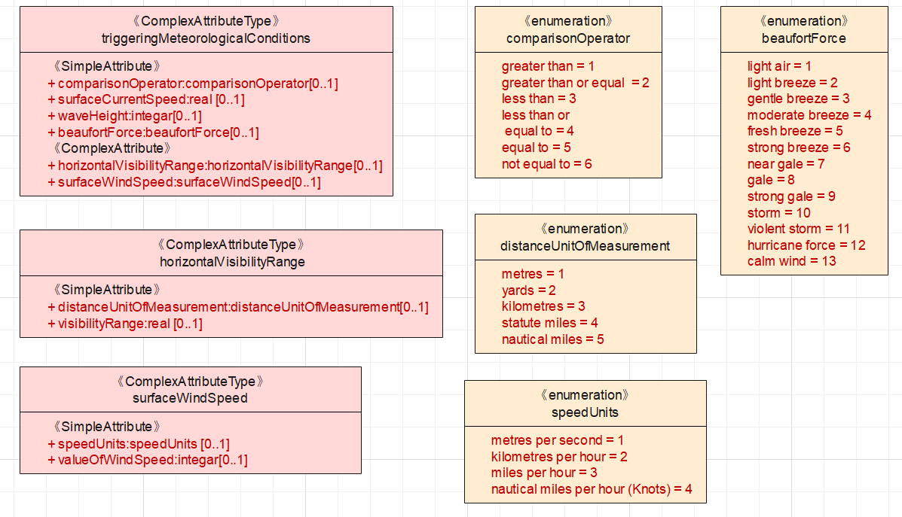

Conclusions and Recommendations
- Add the complex attribute Triggering meteorological conditions and sub attributes into S-127.
- Bind the attribute Triggering Meteorological conditions to the feature types of Restricted area navigational, Recommendations, Regulations and Restrictions, according to the navigation and related activities of a vessel affected by hydrometeorological conditions.

Action Required of NIPWG
The NIPWG is invited to:
- Agree with the above proposals.
- Note the information provided in this document.

