Guidelines for Harmonized Communication
and
Electronic Exchange
of
Nautical Data for Port Calls©

Version 1.6
CONCEPT
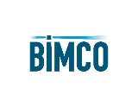
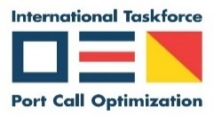

Document revision history
1.0 | 20/04/22 | Content of Port Information Manual 3.02, aligned with chapters of IMO BLU Code and aligned with IHO standards
1.1 | 17/05/22 | Review of IHO NIPWG processed for definitions
1.2 | 10/06/22 | Review of IHO NIPWG processed for units of measurement
1.3 | 31/01/23 | Review for submission to IMO FAL 46/INF.3
1.4 | 21/08/23 | Based on Guide for Nautical Data 1.3  Based on IMO BLU Code, IMO Resolution A.862(20) (bulk)  Based on OCIMF MTIS (tanker)  Based on Port Memo (container)  Focus on “nautical information necessary for safe navigation” as per SOLAS  Aligned with IMO FAL “Guidelines For Harmonized Communication And Electronic Exchange Of Operational Data For Port Calls”  Validated with IHO standards through IHO NIPWG
1.5 | 14/09/23 | Processed input IHO NIPWG meeting in Monaco  Processed input IAPH DCC meeting
1.6 | 16/10/23 | Naming of document changed to align with IMO FAL “Guidelines For Harmonized Communication And Electronic Exchange Of Operational Data For Port Calls”

Copyright Notice
All rights reserved. Permission to print or save the document or excerpts of it is only granted for
private, non-commercial use, without any right to resell or redistribute them or to compile or create derivative works therefrom. Any copyrights within the document remains with the original rights holder. Enquiries should be directed to Scherpenzeel.ehmc@harbourmaster.org

Please cite this document as: Guide for Nautical Data 1.4

Table of contents
Document revision history 2
1 Preamble 5
2 Abbreviations 6
3 Nautical data as part of the port call process 7
4 Standards - General 11
5 Standards - Terminals 13
Terminal 13
Terminal Identifier 13
Terminal Identifier – Global Location Number 13
Terminal Identifier – Port Facility Number 13
Terminal Identifier – UN Location Code 13
Terminal Identifier – SMDG Code 14
Terminal Identifier - Name 14
Terminal Latitude/Longitude 14
Category Of Harbour Facility 14
6 Standards - Berths 17
Berth 17
Berth Identifier 17
Berth Identifier – Global Location Number 17
Berth Identifier - Name 17
Berth Latitude/Longitude 17
Berth Types 18
7 Standards – Berth Positions 20
Berth Position 20
Berth Position Identifier 20
Berth Position Identifier - Global Location Number 20
Berth Position Identifier - Name 20
Berth Position Latitude/Longitude 20
8 Standards – For berth approaches and berths 22
General 22
Seabed Area 22
Nature of Seabed 22
Observed Depth 22
Margin To Cater For Uncertainties of Observed Depth Accuracy 23
Sounding 23
Maintainted Depth 23
Overdredge 23
Height of Tide 23
Draft (or Draught) 24
Underkeel Clearance 24
Density 24
Maximum Draught 25
Maximum Permitted Draught 25
Maximal Permitted Length 25
Maximal Permitted Beam 25
Route Info Air Draft Max 25
9 Standards – For berth approaches 26
Controlling depth 26
Dynamic Draught 26
Margin to Cater for Uncertainties of Dynamic Draught Accuracy 26
Dynamic Under Keel Clearance (UKC) 26
10 Standards – For berths 27
Berth Pocket 28
Minimum Berth Depth 28
Static Draught 28
Margin to Cater for Uncertainties of Static Draught Accuracy 28
Static Under Keel Clearance (UKC) 28

1 Preamble

1.1 These guidelines are intended to provide guidance to the implementation of an electronic and automated exchange of nautical data between port and hydrographic offices / services.

1.2 These guidelines will make reference to the IHO standards and other specifications where relevant but will not specify any specific protocol or information exchange standard.

1.3 These guidelines will help to demonstrate that Hydrographic Offices, Ports and Terminals are working together to discharge their collective responsibilities for SOLAS as per Chapter V Regulation 9: “Contracting Governments undertake to arrange for the collection and compilation of hydrographic data and the publication, dissemination and keeping up to date of all nautical information necessary for safe navigation”.

1.4 These guidelines will help ports and terminals to demonstrate that they are a “safe port” in the context of the Charter Party: “A port will not be safe unless, in the relevant period of time, the particular vessel can reach it, use it and return from it without, in the absence of some abnormal occurrence, being exposed to danger which cannot be avoided by good navigation and seamanship”.

1.5 These guidelines will lead to chartering, planning and safe berth to berth navigation (as per IMO Resolution A,893(21)) of vessels based on the same data with the same standards

1.6 The content of these guidelines is based on existing publications and databases of all trades:
- All segments: Guide for Nautical Data 1.3
- Bulk segment: IMO BLU Code, IMO Resolution A.862(20)
- Tanker segment: OCIMF Marine Terminal Information System
- Container segment: Port Memo’s
- IMO FAL Guidelines for Harmonized Communication And Electronic Exchange Of Operational Data For Port Calls
The content of these publications and databases has been filtered on data elements related to nautical information necessary for safe navigation as laid down in SOLAS.

1.7 The IHO has supported the search for best matching standards, thus ensuring harmonization between hydrographic offices and the industry.

1.8 The chapters have been organized in such a way that these standards can be validated frequently; the validation dates are shown in the Document Revision history.

2 Abbreviations
BIMCO | The world’s largest direct-membership organisation for shipowners, charterers, shipbrokers, and agents
ECDIS | Electronic Chart Display Information System
ENC | Electronic Navigational Chart
FAL | Convention Facilitation of International Maritime Traffic
HD ENC | High Density ENC
HO | Hydrographic Office
IAPH | International Association of Ports and Harbours
IBTA | International Bulk Terminals Association
ICS | International Chamber of Shipping
IHMA | International Harbour Master’s Association
IHO | International Hydrographic Organization
IMO | International Maritime Organization
INTERCARGO | International Association of Dry Cargo Shipowners
ITPCO | International Taskforce Port Call Optimization
MTIS | Marine Terminal Information System
OCIMF | Oil Companies International Marine Forum
RENC | Regional Electronic Navigational Chart Coordination Center
UKC | Under Keel Clearance
UKHO | United Kingdom Hydrographic Office
VAR | Value Added Resellers

3 Nautical data as part of the port call process

3.1 The port call process is based on a high-level business process of port calls, which is based on IMO regulations, BIMCO contracts, and requirements of port authorities and other stakeholders, making it a port and trade agnostic process. It has been created by the Industry (a group of leading ports and shipping lines) and validated during Industry Roundtable sessions organized by the IMO Global Industry Alliance (GIA) to Support Low Carbon Shipping. It has been used as such in the “Guidelines for setting up a Maritime Single Window”, IMO FAL 46/5/1.
The port call process and an explanatory appendix can be downloaded from www.portcalloptimization.org

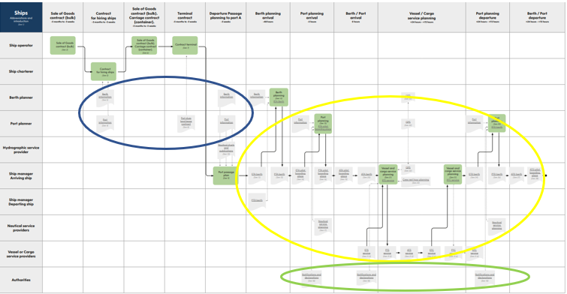

3.2 The data to be exchanged as part of the port call process includes the following:

3.2.1 Nautical data - blue
Data that is provided by Hydrographic Offices in Navigational Charts, Nautical Publications or coast pilots, and tide tables. Additionally, nautical data is used in the maritime industry for chartering and planning purposes.

3.2.2 Administrative data - green
Data that is submitted by ships or other non-authority parties to authorities in notifications and declarations

3.2.3 Operational data - yellow
Data that is submitted to non-authority parties as part of planning or execution of certain operations. Refer to IMO FAL Guidelines for Harmonized Communication And Electronic Exchange Of Operational Data For Port Calls published by IMO

3.3 Nautical data in the business process
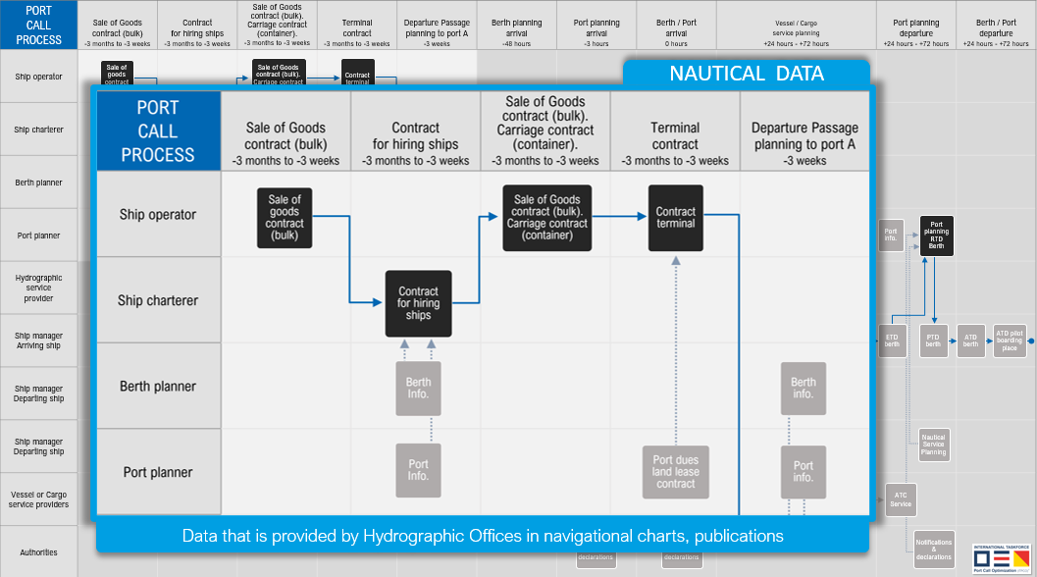
From the business process one can identify that nautical data is used for multiple purposes:

3.3.1 For Chartering and planning
The risk of a port or berth being unsafe is very often primarily for the Charterer. Based on a series of court judgements under common law, a widely accepted legal definition of a(n) (un)safe port under common law is the following: “A port will not be safe unless, in the relevant period of time, the particular vessel can reach it, use it and return from it without, in the absence of some abnormal occurrence, being exposed to danger which cannot be avoided by good navigation and seamanship”.

The Charterer uses shore-based databases and applications to select ships and make a ship-berth compatibility check. Therefore, having robust, globally unique identifiers for both the ship and the berth are crucial in this part of the process.

These databases and applications may collect their data about twice per year through e.g., but not limited to, agents, terminals, surveyors. However, these parties do not have an obligation to provide such data. The standards used are often trade specific (e.g., the bulk segment uses different standards than the tanker segment).

3.3.2 For Navigation
A Master is responsible for making a voyage plan from berth to berth as per IMO Resolution A.893(21): “detailed planning of the whole voyage or passage from berth to berth”. The Master can only use Nautical Charts (Electronic Navigational Charts, so called ENC’s) and Nautical Publications which are issued by, or on the authority of a Government-authorized Hydrographic Office (HO’s) or other relevant government institution. Only these publications fulfill the SOLAS carriage requirements.
A special form of an ENC is the High-Density bathymetry (HD ENC); a special ENC with more bathymetric content compared to ENC, not (yet) available to the Master, but used by e.g., local pilots.

These Nautical Charts and Publications are kept up to date by the “Contracting Government” as per SOLAS Chapter V Regulation 9: “Contracting Governments undertake to arrange for the collection and compilation of hydrographic data and the publication, dissemination and keeping up to date of all nautical information necessary for safe navigation”.

Most HO’s collect their data from Port Authorities, depending on when new data becomes available. HO’s of the IHO Nautical Information Provision Working Group experience a lack of data availability and consistency by Port Authorities, resulting in HO’s being unwilling to publish port infrastructure data in their charts and publications as they cannot guarantee the correctness of the data. Port Authorities in their turn face difficulties gathering data from all data owners in the port, as the Port Authority is not the data owner of all port data. E.g., terminals may be the data owner of the soundings of the berth pocket. In addition, Port Authorities do not always have the mandate nor the resources to organize the collection and dissemination of nautical data. Terminals again in their turn feel reluctant to provide data about the berth approach, as it’s normally the responsibility of the Port Authority.
Most HO’s act in accordance with the IHO recommendation to distribute ENC’s through a controlled process of validation and distribution through RENC’s and VAR’s. Taking into the account the external dependency of the onboard update mechanism, today the time between actual measurement or sounding and chart update on board may typically be about 4 weeks.

3.3.3 For Chartering, Planning and Navigation
As data for chartering, planning and navigation is collected from different parties, at different times and with different standards, it is inevitable that the same ship is chartered, planned, and navigated based on different data sets.
Therefore, efforts should be made that Port Authorities, Terminals. the Maritime Industry and HO’s start using the same standards, and consequently a minimum set of nautical data for safe navigation becomes available for both chartering, planning and navigating the same ship berth to berth.

As data for exact planning of maximum sizes and draughts depends on exact data of both berth positions and depths at these positions, efforts should be made that berth positions and depths are made available.

4 Standards - General

4.1 As shipping operates from port to port worldwide, the standards need to be accepted and respected by all ports globally (i.e. the standards need to be port agnostic).

4.2 As ports facilitate all types of trades (tanker, bulk, container, ro-ro, cruise etc.) the standards need to be accepted and respected by all trades (e.g. not only by container or tanker sector, i.e. the standards need to be trade agnostic).

4.3 As ports are all different from one another, the standards should be flexible enough to be implemented at each port.

4.4 As shipping operates from port to port globally, the standards should be sufficiently rigid to facilitate port to port navigation.

4.5 As shipping is the most important component in the global supply chain, the connection to the global supply chain is very important.

4.6 As data owners face a lot of administrative burden to update parties in different formats, and the navigational safety, environment and security are best served by real time updates, efforts should be made for maximum compatibility between navigational, administrative and operational data.

4.7 For this reason the definitions of IMO Compendium will be harmonized with those in IHO S-131 for locations.

4.8 As most trades are facing ship-berth compatibility issues, and are also part of the supply chain, efforts should be made for a robust data compatibility check between maximum sizes of both the ship and the berth by using the existing globally unique identification number for ships (the IMO ship number) and by using the existing globally unique identification number for berths (Global Location Number, ISO/IEC 6523).

4.9 As most Hydrographic Offices collect their data in a different way and from different sources than the maritime industry, nautical charts and publications on board the ship often show different data than shore-based data bases and applications. Efforts should be made to exchange the same data with the same standards with both parties to ensure that chartering, planning and navigation processes, as described in the port call process, are all executed using the same standards.

4.10 Links to IHO standards:
- IHO Concept Register: https://registry.iho.int/fc/list.do
- IHO Data Dictionary Register: https://registry.iho.int/fc/list.do
- IHO S-4: https://iho.int/uploads/user/pubs/standards/s-4/S4_V4-9-0_March_2021.pdf
- IHO S-32: http://iho-ohi.net/S32/engView.php
- IHO S-131: https://registry.iho.int/productspec/view.do?idx=193&product_ID=S-131&statusS=5&domainS=ALL&category=product_ID&searchValue=

5 Standards - Terminals

Terminal
IHO Concept Register: terminal
Definition: A terminal covers that area on shore which provides buildings and constructions for the transfer of cargo or passengers from and to ships

Terminal Identifier
IHO S-131: Terminal::terminalIdentifier
Definition: The unique identifier for a given terminal

Terminal Identifier – Global Location Number
IHO S-131: Terminal::globalLocationNumber
Definition: A globally unique, standardized identifier for parties and locations in business processes or supply chains
Format: ISO/IEC 6523; 13 digits in text format
Remark: for all terminals. Ideally assigned by the port authority so the number remains the same after change of ownership, aligned with IMO vessel number practices

Terminal Identifier – Port Facility Number
IHO S-131: Terminal::port FaciltiyNumber
Definition: Number assigned to the port facility in the IMO port facility database
Format: UN/LOCODE and a 4-digit code separated with a dash
Remark: only for terminals with ISPS; code will change after change of ownership - check

Terminal Identifier – UN Location Code
IHO S-131::Terminal::uNLocationCode – Proposal to IHO: UNLOCODE can be assigned to a city or port, but not to a terminal
Used to encode the UN Location Code
Format: UN/LOCODE

Terminal Identifier – SMDG Code
IHO S-131: Terminal::sMDGCode
A code from the SMDG (ShipMessage DesignGroup) Terminal Code List
Format: UN/LOCODE + SMDG Code (Alphanumeric between 3 and 6 characters)
Remark: only for terminals handling container and/or ro-ro; code may change after change of ownership

Terminal Identifier - Name
IHO S-131::Terminal::featureName
Definition: Terminal feature has attribute featureName to describe name of the Terminal
Format: text
Remark: for all terminals. Name will change after change of ownership

Terminal Latitude/Longitude
IHO S-131::Terminal::Geometry
Definition: Terminal feature contains a Geometry object, which can hold the coordinates (latitude and longitude) for a point, or surface area
Format for information exchange: degrees and decimal minutes; datum WGS84
Format for data exchange: decimal degrees to a defined precision (minus to indicate South and West); datum WGS84
Remark: for all terminals; for points a centre of gravity is chosen

Category Of Harbour Facility
IHO ConceptRegister: categoryOfHarbourFacility
Definition: Classification of harbour use

Bulk Terminal
IHO ConceptRegister: bulkTerminal
Definition: A terminal for the handling of bulk materials such as iron ore, coal, etc.

Container Terminal
IHO ConceptRegister: containerTerminal
Definition: A terminal with facilities to load/unload or store shipping containers

Ferry Terminal
IHO ConceptRegister: ferryTerminal
A terminal for passenger and vehicle ferries

Fishing Harobur
IHO ConceptRegister: fishingHarbour
Definition: A harbour with facilities for fishing boats

Naval Base
IHO ConceptRegister: navalBase
Definition: A centre of operations for naval vessels

Passenger Terminal
IHO ConceptRegister: passengerTerminal
A terminal for the loading and unloading of passengers

Pilotage Service
IHO ConceptRegister: pilotageService
Definition: The services of a person who directs the movements of a vessel through pilot water, usually a person who has demonstrated extensive knowledge of channels, aids to navigation, dangers to navigation etc, in a particular area and is licensed for that area, are available

Quarantine Station
IHO ConceptRegister: quarantineStation
A medical control center located in an isolated spot ashore where patients with contagious diseases from vessel in quarantine are taken

Ro Ro Terminal
IHO ConceptRegister: roRoTerminall
A terminal for roll-on roll-off ferrieswith facilities to load/unload or store shipping containers

Service Harbour
IHO ConceptRegister: serviceHarbour
Definition: A harbour within which the floating equipment )dredgers, tugs…) of harbour services are stationed

Service and Repair
IHO ConceptRegister: sserviceAndRepair
Definition: A place where mechanical services and repairs can be undertaken to engines or other vessel equipment

Ship Lift
IHO ConceptRegister: shipLift
Definition: A platfgorm powered by synchronous electric motors (for example syncrolift) used to lift vessels (lager than boats) in and out of the water

Shipyard
IHO ConceptRegister: shipyard
Definition: A place where ships are built or repaired

Straddle Carrier
IHO ConceptRegister: straddleCarrier
Definition: A wheeled vehicle designed to lift and carry container or vessels within its own framework. It is used for moving, and sometimes stacking, shipping containers and vessels

Tanker Terminal
IHO ConceptRegister: tankerTerminal
A terminal for the bulk handling of liquid cargoes

Yacht Harbour / Marina
IHO ConceptRegister: yachtHarbourMarina
Definition: A harbour facility for small boats, yachts, etc. where supplies, repairs and various services are available

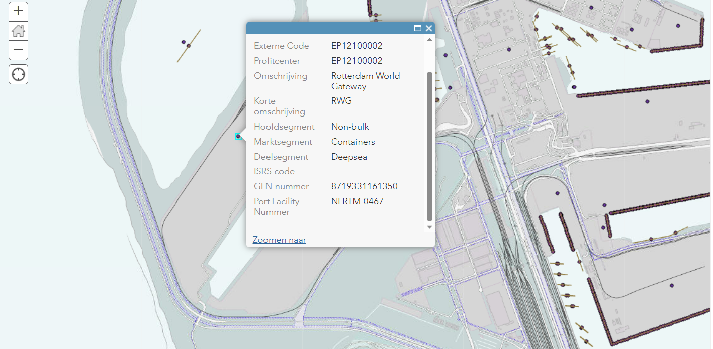

6 Standards - Berths

Berth
IHO Concept Register: berth
Definition: A place, generally named or numbered, where a vessel may moor or anchor

Berth Identifier
IHO S-131::Berth::berthIdentifier Proposal to IHO
Definition: The unique identifier for a given berth

Berth Identifier – Global Location Number
IHO S-131: Berth::globalLocationNumber Proposal to IHO
Definition: A globally unique, standardized identifier for parties and locations in business processes or supply chains
Format: ISO/IEC 6523; 13 digits in text format
Remark: for all terminals, already used in the supply chain industry, ISO/IEC 6523. Ideally assigned by the port authority so the number remains the same after change of ownership, aligned with IMO vessel number practices

Berth Identifier - Name
IHO S-131::Berth::featureName Proposal to IHO
Definition: Berth feature has attribute featureName to describe name of the Berth
Format: text.
Remark: for all berths. Name will change after change of ownership. Possibly combined with name of terminal name for better human recognition

Berth Latitude/Longitude
IHO S-131::Berth::Geometry Proposal to IHO
Definition: Berth feature contains a Geometry object, which can hold the coordinates (latitude and longitude) for a point, surface (=polygon) or curve (=line).
Format for information exchange: degrees and decimal minutes; datum WGS84
Format for data exchange: decimal degrees to a defined precision (minus to indicate South and West); datum WGS84

Remark:
- Fender Berth: curve (=line). The berth’s extent is between its two extremities measured in a straight line, indicated by A and B, orientation is not important. The line represents the fender line, being the position of the ship’s side when alongside.
- Multi Buoy Mooring (MBM) Berth: surface (=polygon). The berth’s extent is between the positions of the mooring buoys (this should also allow for the length of mooring lines)
- Anchor Berth: check with IHO

Berth Types
IHO S-131::Berth::featureType Proposal to IHO

Fender Berth
IHO ConceptRegister: fenderBerth
Definition: A designated physical location of berth infrastructure where a vessel may moor, defined by the fender line, which is the position of the vessel when moored

Multi Buoy Mooring (MBM) Berth
IHO ConceptRegister: multiBouyMooringBerth
Definition: A designated facility where a vessel may moor, usually by a combination of the mooring buoys and the ship’s anchors

Anchor Berth
IHO ConceptRegister: anchorBerth
Definition: A designated area of water where a vessel, sea plane, etc., may anchor

Fender berth types
IHO S-4: 321.1, 321.2, 324.3
- Quay, Wharf
- Pier, Jetty
- Promenade pier
- Pontoon

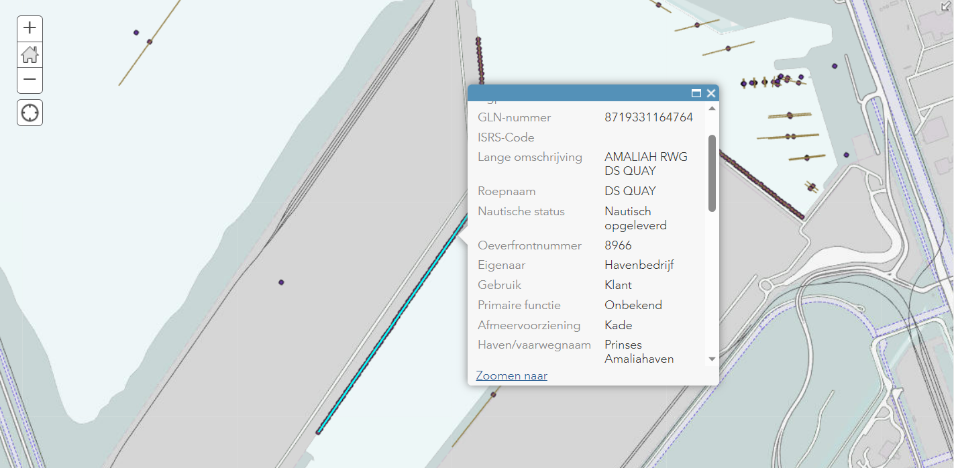

7 Standards – Berth Positions

Berth Position
IHO Concept Register: berthPosition
Definition: A specific position within a berth where a vessel may be moored or anchored

Berth Position Identifier
IHO S-131::Berth Position::berthPositionIdentifier Proposal to IHO
Definition: The unique identifier for a given berth position

Berth Position Identifier - Global Location Number
IHO S-131: BerthPosition::globalLocationNumber Proposal to IHO
Definition: A globally unique, standardized identifier for parties and locations in business processes or supply chains
Format: ISO/IEC 6523; 13 digits in text format plus extension (for the Berth Position name or number) separated with a dash
Remark: for all terminals, already used in the supply chain industry, ISO/IEC 6523. Ideally assigned by the port authority so the number remains the same after change of ownership, aligned with IMO vessel number practices

Berth Position Identifier - Name
IHO S-131::BerthPosition::featureName Proposal to IHO
Definition: Berth Position feature has attribute featureName to describe name of the Berth Position
Format: text

Berth Position Latitude/Longitude
IHO S-131::Berth::Geometry Proposal to IHO
Definition: Berth Position feature contains a Geometry object, which can hold the coordinates (latitude and longitude) for a point
Format for information exchange: degrees and decimal minutes; datum WGS84
Format for data exchange: decimal degrees to a defined precision (minus to indicate South and West), datum WGS84

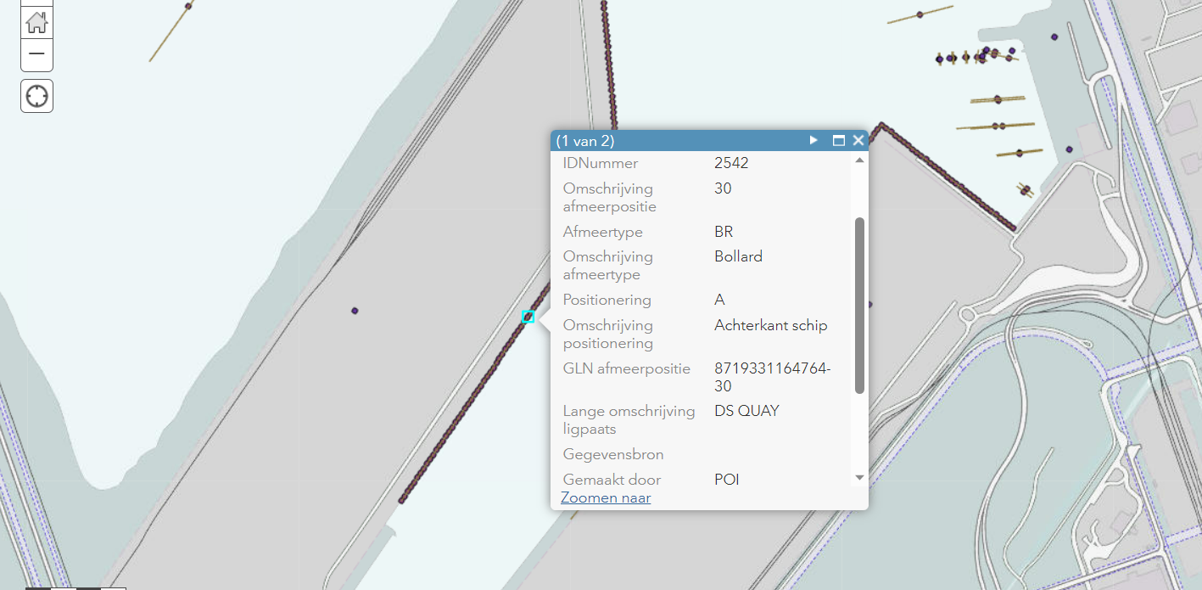

8 Standards – For berth approaches and berths

General
For the publication of depths by local Port Authorities the same Chart Datum should be used as in the Nautical Charts and Publications as published by the Hydrographic Office

Seabed Area
IHO ConceptRegister: seabedArea
Definition: A region of the seabed including the material of which it is composed and its physical characteristics. Also called nature of the bottom, character (or characteristics) of the bottom, or quality of the bottom

Nature of Seabed
IHO S-4: 423-427
- Sand
- Mud
- Clay
- Silt
- Stones
- Gravel
- Pebbles
- Cobbles
- Rock, Rocky

Observed Depth
IHO ConceptRegister: observedDepth
Definition: The vertical distance from the sea surface to the sea floor, at any state of the tide, based on S-44 measurements

Margin To Cater For Uncertainties of Observed Depth Accuracy
IHO ConceptRegister: marginToCaterForUncertaintiesOfObservedDepth Accuracy
Definition: Margin to cater for uncertainties of the charted water depth. This margin considers uncertainties of tidal height in tidal areas, or height with respect to the surface of still water in non-tidal areas, comprising tidal height during transit and maneuvering accuracy, sounding or dredging execution accuracy, and siltation of soundings
Format: decimal meters

Sounding
IHO Data Dictionary Register: 594
Definition: Measured or charted depths of water (maybe a drying height) or the measurement of such depth, which has been reduced to a vertical datum
Remark: IHO resolution specifies that soundings should be taken according S-44 standards

Maintainted Depth
IHO ConceptRegister: maintainedDepth Proposal to IHO “body of water” instead of “channel”
Definition: The depth at which a channel is kept by human influence, usually by dredging

Overdredge
Nautical Publication 100 (NP100) Mariners Handbook Proposal to IHO: submit definition?
Definition: An additional depth margin provided by a dredging operation to ensure that the depth at a specific location is never less than the pre-determined maintained depth over the interval between programmed dredging operations

Height of Tide
IHO ConceptRegister: heightOfTide
Definition: The vertical distance from the chart datum to the level of the water at any time

Draft (or Draught)
IHO ConceptRegister: draftOrDraught
Definition: The vertical distance, at any section of a vessel from the surface of the water to the bottom of the keel. When measured at or near the bow, it is referred to as draft forwards and when measured at or near the stern as draft aft. The mean draft is the mean of the drafts forward and aft. These drafts are more specifically described as displacement drafts as opposed to navigation drafts which are measured to the lowest appendage to the hull as opposed to the keel
Format: decimal metres to a defined water density measured in kg/m3

Underkeel Clearance
IHO ConceptRegister: underkeelClearance
Definition: The distance (usually a required minimum distance) between the lowest point of a ship’s hull and the sea bed
Format: decimal meters

Density
IHO ConceptRegister: density
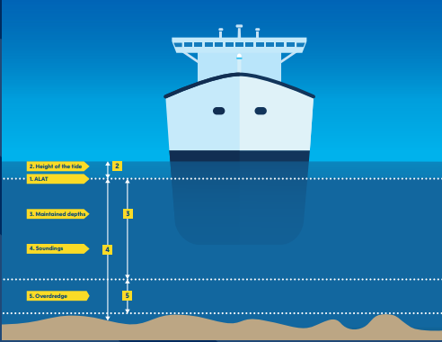
Definition: Density is equivalent to specific gravity and represents the ratio, at atmospheric pressure, of the weight of a given volume of sea water to that of an equal volume of distilled water at 4 degrees Celsius

Maximum Draught
IHO ConceptRegister: maximumDraught
Definition: The maximum vessel draught in meters, used as basis for the calculation
Format: decimal metres to a defined water density measured in kg/m3
Proposal to IHO: “used as basis for the calculation of UKC”

Maximum Permitted Draught
IHO ConceptRegister: maximumPermittedDraught
Definition: The maximum draught of a vessel permitted along a route, in a channel or dock, at a berth, or over a submerged feature
Format: decimal metres to a defined water density measured in kg/m3
Proposal to IHO: separate definitions Maximum Permitted Draught with and without the use of tide

Maximal Permitted Length
IHO ConceptRegister: maximalPermittedLength
Definition: The maximal permitted length of a vessel or convoy according to the particular article / clause of the applicable law/regulation

Maximal Permitted Beam
IHO ConceptRegister: maximalPermittedBeam
Definition: The maximal permitted beam (width of ship’s hull) of a vessel or convoy according to the particular article / clause of the applicable law/regulation

Route Info Air Draft Max
IHO ConceptRegister: routeInfoAirDraftMax
Definition: Maximum vessel air draft for which the route information is applicable
Proposal to IHO: can we align the naming of definition with “Controlling depth”- so “Controlling Air Draft” : the least height in the approach or channel to an area, such as a port or anchorage, governing the maximum air draught of vessels that can enter”

9 Standards – For berth approaches

Controlling depth
IHO ConceptRegister: controllingDepth
Definition: The least depth in the approach or channel to an area, such as a port or anchorage, governing the maximum draft of vessels that can enter
Format: decimal metres
Remark: controlling depth is described in S-4, for use on nautical charts. As such it would normally be given related to a given Chart Datum , and considered as any depth indication on the nautical chart

Dynamic Draught
IHO ConceptRegister: dynamicDraught
Definition: The vertical distance from the bottom of the keel to the water line when the vessel is making way or subject to sea and swell influences.
Format: decimal metres to a defined water density measured in kg/m3

Margin to Cater for Uncertainties of Dynamic Draught Accuracy
IHO ConceptRegister: marginToCaterForUncertaintiesOfDynamicDraughtAccuracy
Definition: Margin to cater for uncertainties in a vessel’s reported dynamic draught, or draught reading
Format: decimal metres

Dynamic Under Keel Clearance (UKC)
IHO ConceptRegister: dynamicUnderKeelClearance
Definition: The under keel clearance when a vessel has a dynamic draught
Format: decimal metres

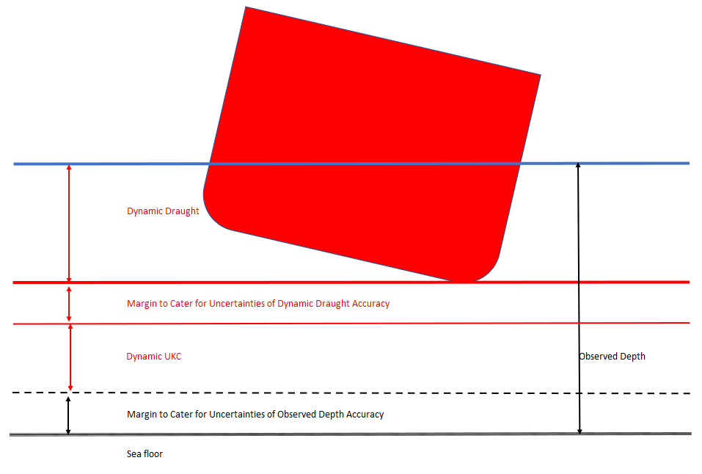
10 Standards – For berths

Berth Pocket
IHO ConceptRegiser: berthPocket
Definition: A body of water at a berth or anchor berth, of adequate dimensions to allow a vessel to make fast to the shore, mooring buoy, berthing dolphins or to anchor
Remark: Check with IHO: “berthing dolphins” not aligned with definitions in OCIMF Mooring Equipment Guidelines, should be “mooring dolphins”

Minimum Berth Depth
IHO ConceptRegister: minimumBerthDepth
Definition: The least depth of the body of water at the berth or in a berth pocket adjacent to the berth
Format: decimal metres

Static Draught
IHO ConcreptRegister: staticDraught
Definition: The vertical distance from the bottom of the keel to the water line when the vessel is not making way or subject to sea and swell influences
Format: decimal metres to a defined water density measured in kg/m3

Margin to Cater for Uncertainties of Static Draught Accuracy
IHO ConceptRegister: marginToCaterForUncertaintiesOfStaticDraughtAccuracy
Definition: Margin to cater for uncertainties in a vessel’s reported static draught, or draught reading
Format: decimal metres

Static Under Keel Clearance (UKC)
IHO ConceptRegister: staticUnderKeelClearance
Definition: The under keel clearance when a vessel has a static draught
Format: decimal meteres

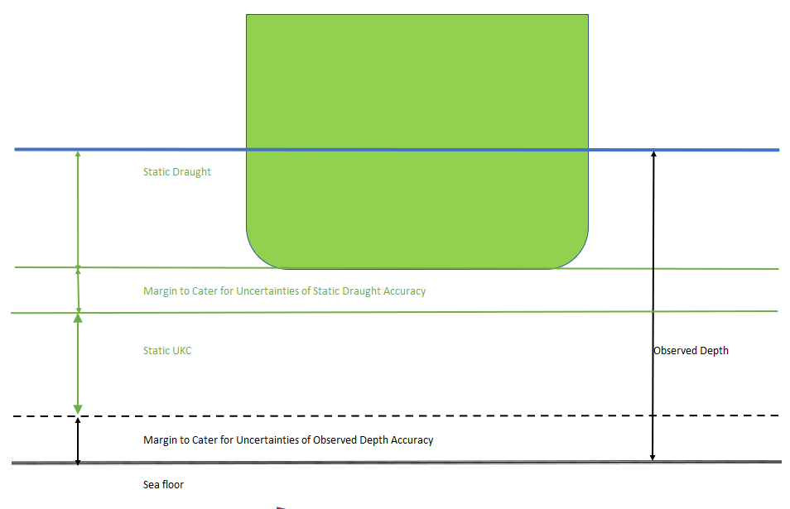

End of document

