Guidelines for Harmonized Communication
and
Electronic Exchange
of
Nautical Data for Port Calls©

Version 2.0
CONCEPT
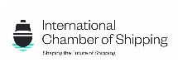
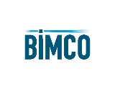

Document revision history
1.0 | 20/04/22 | Content of Port Information Manual 3.02, aligned with chapters of IMO BLU Code and aligned with IHO standards
1.1 | 17/05/22 | Review of IHO NIPWG processed for definitions
1.2 | 10/06/22 | Review of IHO NIPWG processed for units of measurement
1.3 | 31/01/23 | Review for submission to IMO FAL 46/INF.3
1.4 | 21/08/23 | Based on Guide for Nautical Data 1.3 (ports)  Based on IMO BLU Code, IMO Resolution A.862(20) (bulk)  Based on OCIMF MTPQ (tanker)  Based on Port Memo (container)  Focus on “nautical information necessary for safe navigation” as per SOLAS  Focus on data elements that serve the S-57 Electronic Navigational Charts  Aligned with IMO FAL “Guidelines For Harmonized Communication And Electronic Exchange Of Operational Data For Port Calls”  Validated with IHO standards through IHO NIPWG
1.5 | 14/09/23 | Processed input IHO NIPWG meeting in Monaco  Processed input IAPH DCC meeting
1.6 | 16/10/23 | Naming of document changed to align with IMO FAL “Guidelines For Harmonized Communication And Electronic Exchange Of Operational Data For Port Calls”
1.7 | 15/12/23 | Logos of document changed based on feedback IHO, IMO  Custodian body International Taskforce Port Call Optimization  Focus on IHO S-57  Focus on IMO A.862(20)  Per chapter data ownership  Per chapter data exchange through API if available
1.8 | 02/01/24 | Document for approval by IHO NIPWG March 2024, focus on S-57 ENC
1.9 | 31/01/24 | Processed all feedback of ITPCO meeting 17/01/24
2.0 | 08/02/24 | Processed all feedback of Netherlands Hydrographic Office

Copyright Notice
All rights reserved. Permission to print or save the document or excerpts of it is only granted for
private, non-commercial use, without any right to resell or redistribute them or to compile or create derivative works therefrom. Any copyrights within the document remains with the original rights holder. The custodian of this publication is International Harbour Masters Association
Enquiries should be directed to Scherpenzeel.ehmc@harbourmaster.org

Please cite this document as: Guidelines for Harmonized Communication and Electronic Exchange of Nautical Data for Port Calls
Table of contents
Document revision history 2
1 Preamble 5
2 Abbreviations 6
3 Nautical data as part of the port call process 7
4 Nautical data standards 11
5 Input for Electronic Navigational Chart 12
5.1 General 12
5.2 Terminal 13
Terminal 13
Terminal Identifier 13
Terminal Identifier – Global Location Number 13
Terminal Identifier – Port Facility Number 13
Terminal Identifier – SMDG Code 13
Terminal Identifier - Name 14
Terminal Latitude/Longitude 14
Terminal Types 14
Terminal API 16
Terminal Image 17
5.3 Berth 18
Berth 18
Berth Identifier 18
Berth Identifier – Global Location Number 18
Berth Identifier - Name 18
Berth Latitude/Longitude 19
Berth Types 19
Berth API 20
Berth Image 21
5.4 Berth Position 22
Berth Position 22
Berth Position Identifier 22
Berth Position Identifier - Global Location Number 22
Berth Position Identifier - Name 22
Berth Position Latitude/Longitude 22
Berth Position Types 23
Berth Position API 23
Berth Position Image 24
5.4 Berth Pocket 25
Berth Pocket 25
Berth Pocket Identifier 25
Berth Pocket Identifier – Global Location Number 25
Berth Pocket Identifier - Name 25
Berth Pocket Latitude/Longitude 25
Berth Pocket Maintainted Depth 26
Berth Pocket Nature of Seabed 26
Berth Pocket API 27
Berth Pocket Image 28
Berth Pocket Maintained Depth Image 29

1 Preamble

  - These guidelines are intended to provide guidance to the implementation of an electronic and automated exchange of nautical data between ports, hydrographic services and back office services.

1.2 These guidelines will make reference to the IHO standards and other specifications where relevant.

1.3 These guidelines will help ports and hydrographic offices to demonstrate that they’re working together to discharge their collective responsibilities for SOLAS as per Chapter V Regulation 9: “Contracting Governments undertake to arrange for the collection and compilation of hydrographic data and the publication, dissemination and keeping up to date of all nautical information necessary for safe navigation”.

1.4 These guidelines will help ports and terminals to demonstrate that they are a “safe port” in the context of the Charter Party: “A port will not be safe unless, in the relevant period of time, the particular vessel can reach it, use it and return from it without, in the absence of some abnormal occurrence, being exposed to danger which cannot be avoided by good navigation and seamanship”.

1.5 These guidelines will ensure consistency of approach for chartering, planning, port admission policy and navigation of vessels using agreed data format and presentation.

1.6 These guidelines provide input for:
- IHO S-57 / S-131: Electronic Navigational Charts (ENC’s): currently used on board of all vessels and future ENC’s
- IMO Resolution A.862(20): Port Information Books (appendix 1): used on board of all bulk vessels

1.7 The IHO has supported the search for best matching standards, thus ensuring harmonization between hydrographic offices and the industry.

1.8 These guidelines will not be disseminated until the formal endorsement of the IHO Nautical Information Provision Working Group (NIPWG) has been received.

2 Abbreviations
BIMCO | The world’s largest direct-membership organisation for shipowners, charterers, shipbrokers, and agents
ECDIS | Electronic Chart Display Information System
ENC | Electronic Navigational Chart
FAL | Convention Facilitation of International Maritime Traffic
HD ENC | High Density ENC
HO | Hydrographic Office
IAPH | International Association of Ports and Harbours
IBTA | International Bulk Terminals Association
ICS | International Chamber of Shipping
IHMA | International Harbour Master’s Association
IHO | International Hydrographic Organization
IMO | International Maritime Organization
INTERCARGO | International Association of Dry Cargo Shipowners
ITPCO | International Taskforce Port Call Optimization
MTIS | Marine Terminal Information System
OCIMF | Oil Companies International Marine Forum
RENC | Regional Electronic Navigational Chart Coordination Center
UKC | Under Keel Clearance
UKHO | United Kingdom Hydrographic Office
VAR | Value Added Resellers

3 Nautical data as part of the port call process

3.1 The port call process is based on a high-level business process of port calls, which is based on IMO regulations, BIMCO contracts, and requirements of port authorities and other stakeholders, making it a port and trade agnostic process. It has been created by the Industry (a group of leading ports and shipping lines) and validated during Industry Roundtable sessions organized by the IMO Global Industry Alliance (GIA) to Support Low Carbon Shipping. It has been used as such in the “Guidelines for setting up a Maritime Single Window”, IMO FAL 46/5/1.
The port call process and an explanatory appendix can be downloaded from www.portcalloptimization.org

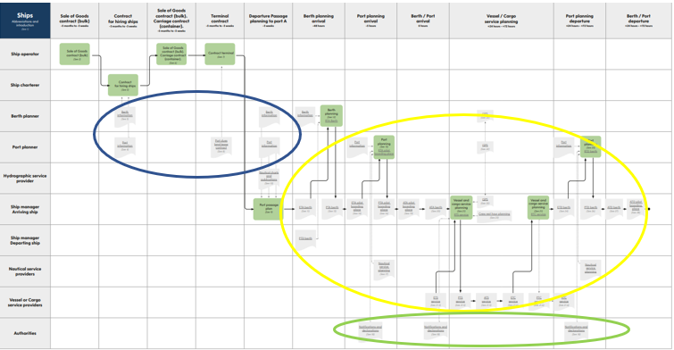

3.2 The data to be exchanged as part of the port call process includes the following:

3.2.1 Nautical data - blue
Data that is provided by hydrographic offices in Navigational Charts, Nautical Publications or coast pilots, and tide tables. Additionally, nautical data is used in the maritime industry for chartering, planning and admission policy purposes.

3.2.2 Administrative data - green
Data that is submitted by ships or other non-authority parties to authorities in notifications and declarations. Refer to Guide for Administrative data, FAL 5-Circ.42-Rev 2 published by IMO.

3.2.3 Operational data - yellow
Data that is submitted to non-authority parties as part of planning or execution of certain operations. Refer to IMO FAL Guidelines for Harmonized Communication And Electronic Exchange Of Operational Data For Port Calls published by IMO.

3.3 Nautical data in the business process
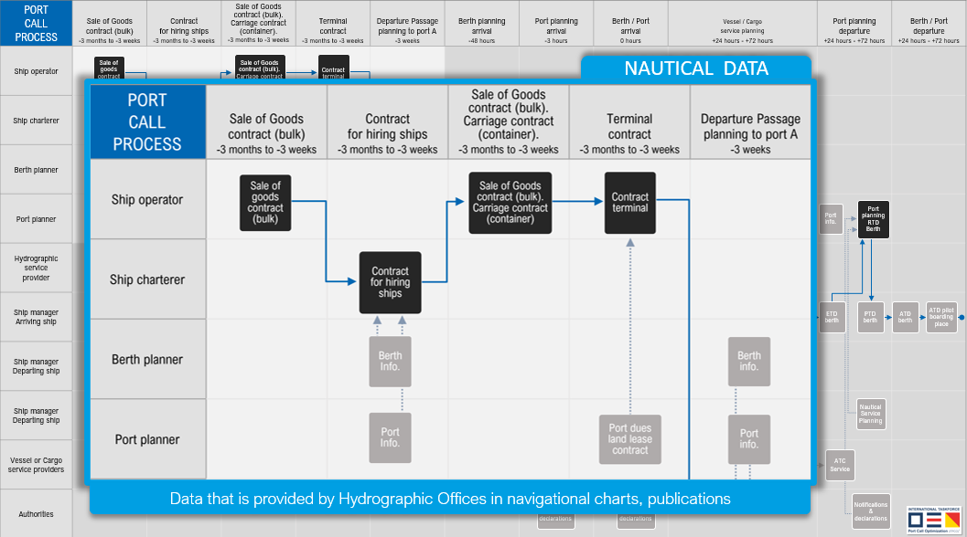
From the business process one can identify that nautical data is used for multiple purposes:

3.3.1 For chartering and planning
The risk of a port or berth being unsafe is very often primarily for the Charterer. Based on a series of court judgements under common law, a widely accepted legal definition of a(n) (un)safe port under common law is the following: “A port will not be safe unless, in the relevant period of time, the particular vessel can reach it, use it and return from it without, in the absence of some abnormal occurrence, being exposed to danger which cannot be avoided by good navigation and seamanship”.

The Charterer uses shore-based databases and applications to select ships and make a ship-berth compatibility check. Therefore, having robust, globally unique identifiers for both the ship and the berth are crucial in this part of the process.

These databases and applications may collect their data about twice per year through e.g., but not limited to, agents, terminals, surveyors. However, these parties do not have an obligation to provide such data, nor is the accuracy of data verifiable. The standards used are often trade specific (e.g., the bulk segment uses different standards than the tanker segment).

3.3.2 For port admission policy
The port admission policy is based on the port’s data and used on a daily basis to grant approval for arriving and departing vessels. Daily use of the same data in operations makes the data very reliable, as incorrect data will be noticed by operational people.

3.3.3 For navigation
A Master is responsible for making a voyage plan from berth to berth as per IMO Resolution A.893(21): “detailed planning of the whole voyage or passage from berth to berth”. The Master can only use Nautical Charts (Electronic Navigational Charts, so called ENC’s) and Nautical Publications which are issued by, or on the authority of a Government-authorized hydrographic office or other relevant government institution. Only these publications fulfill the SOLAS carriage requirements.
A special form of an ENC is the High-Density bathymetry (HD ENC); a special ENC with more bathymetric content compared to ENC, not (yet) available to the Master, but used by e.g., local pilots.

These Nautical Charts and Publications are kept up to date by the “Contracting Government” as per SOLAS Chapter V Regulation 9: “Contracting Governments undertake to arrange for the collection and compilation of hydrographic data and the publication, dissemination and keeping up to date of all nautical information necessary for safe navigation”.

Most hydrographic offices collect their data from ports, depending on when new data becomes available. Hydrographic offices of the IHO Nautical Information Provision Working Group experience a lack of data availability and consistency by ports, resulting in HO’s being unwilling to publish port infrastructure data in their charts and publications as they cannot guarantee the correctness of the data. Ports in their turn face difficulties gathering data from all data owners in the port, as the port is not the data owner of all port data. E.g., terminals may be the data owner of the soundings of the berth pocket. In addition, ports do not always have the mandate nor the resources to organize the collection and dissemination of nautical data. Terminals again in their turn feel reluctant to provide data about the berth approach, as it’s normally the responsibility of the port.

3.3.3 For chartering, planning, port admission policy and navigation
As data for chartering, planning, port admission policy and navigation is collected from different parties, at different times and with different standards, it is inevitable that the same ship is chartered, planned, permitted and navigated based on different data sets.
Therefore, efforts should be made that ports and hydrographic offices start using consistent standards, and consequently a minimum set of nautical data for safe navigation becomes available for chartering, planning, port admission policy and navigating the same ship berth to berth based on this agreed data format and presentation.
The question what the Single Point of Truth should be (e.g., is it the data owner or the ENC) needs to be discussed.

4 Nautical data standards
4.1 As shipping operates from port to port worldwide, the standards need to be accepted and respected by all ports globally (i.e. the standards need to be port agnostic).

4.2 As ports facilitate all types of trades (tanker, bulk, container, ro-ro, cruise etc.) the standards need to be accepted and respected by all trades, e.g., not only by container or tanker sector, i.e. the standards need to be trade agnostic.

4.3 As ports are all different from one another, the standards should be flexible enough to be implemented at each port.

4.4 As shipping operates in a network of up to 8.000 ports (Lloyds Maritime Atlas), it is crucial that the data connection to ports is the same.

4.5 For harmonized information exchange between humans, it is important to use the same non-technical definitions. E.g., do we use the same definitions for berth or depths. For nautical data the standards and guidelines of the International Hydrographic Organization (IHO) have been used.
Links to the IHO standards:
- IHO Concept Register: https://registry.iho.int/fc/list.do
- IHO Data Dictionary Register: https://registry.iho.int/fc/list.do
- IHO S-4: https://iho.int/uploads/user/pubs/standards/s-4/S4_V4-9-0_March_2021.pdf
- IHO S-32: http://iho-ohi.net/S32/engView.php
- IHO S-131: https://registry.iho.int/productspec/view.do?idx=193&product_ID=S-131&statusS=5&domainS=ALL&category=product_ID&searchValue=
4.7 For harmonized data exchange between computers, it is important to use the same technical definitions. E.g., do we use the same technical and business performance specifications to build an Automation Programming Interfaces (API). An API proves to be a very effective way for data owners to keep data users up to date: it takes less time to build an API then to build a website or to populate different questionnaires or data bases. For nautical data the API specifications are based on IHO S-131 and Json. Json is an open standard file format and data interchange format that uses human-readable text to store and transmit data objects. In future the API should also cater for tracking changes.

4.8 As most trades need ship-berth compatibility data, and are also part of the supply chain, efforts should be made for a robust compatibility check between ship and berth. This can only be done by using the globally unique identification number for ships (IMO ship number) and the globally unique identification number for berths (Global Location Number, ISO/IEC 6523). The latter also ensures data compatibility after the name of the location has changed, and compatibility with the existing ISO standard for supply chain data (ISO/IEC 19987:2017).

5 Input for Electronic Navigational Chart

5.1 General
The data scope is based on the current S-57 standard:
- Terminal
- Berth
- Berth Position
- Berth Pocket
The reasoning is that the current S-57 ENC cannot hold much more details regarding port infrastructure, and the exchange of soundings requires too much data capacity.

The data ownership is best organized by the port as the single point of contact for hydrographic office and IMO.
The reasoning is that e.g., the assignment of the Global Location Number is best organized by the port, as the number won’t change after change of ownership (e.g., if the terminal is sold to a different operator), which is important to maintain data compatibility.

5.2 Terminal

Terminal
IHO Concept Register: terminal
Definition: A terminal covers that area on shore which provides buildings and constructions for the transfer of cargo or passengers from and to ships

Terminal Identifier
IHO S-131: Terminal::terminalIdentifier
Definition: The unique identifier for a given terminal

Terminal Identifier – Global Location Number
IHO S-131: Terminal::globalLocationNumber
Definition: A globally unique, standardized identifier for parties and locations in business processes or supply chains
Format: ISO/IEC 6523; 13 digits in text format
Remark: for all terminals. Ideally assigned by the port authority so the number remains the same after change of ownership, aligned with IMO vessel number practices

Terminal Identifier – Port Facility Number
IHO S-131: Terminal::port FaciltiyNumber
Definition: Number assigned to the port facility in the IMO port facility database
Format: UN/LOCODE and a 4-digit code separated with a dash
Remark: only for terminals with ISPS

Terminal Identifier – SMDG Code
IHO S-131: Terminal::sMDGCode
A code from the SMDG (ShipMessage DesignGroup) Terminal Code List
Format: UN/LOCODE + SMDG Code (Alphanumeric between 3 and 6 characters)
Remark: only for terminals handling container and/or ro-ro; code may change after change of ownership

Terminal Identifier - Name
IHO S-131::Terminal::featureName
Definition: Terminal feature has attribute featureName to describe name of the Terminal
Format: text
Remark: for all terminals. Name will change after change of ownership

Terminal Latitude/Longitude
IHO S-131::Terminal::Geometry
Definition: Terminal feature contains a Geometry object, which can hold the coordinates (latitude and longitude) for a point, or surface area
Format for information exchange: degrees and decimal minutes; datum WGS84
Format for data exchange: decimal degrees to a defined precision (minus to indicate South and West); datum WGS84
Remark: for all terminals; for points a centre of gravity is chosen

Terminal Types
IHO ConceptRegister: categoryOfHarbourFacility
Definition: Classification of harbour use

Bulk Terminal
IHO ConceptRegister: bulkTerminal
Definition: A terminal for the handling of bulk materials such as iron ore, coal, etc.

Container Terminal
IHO ConceptRegister: containerTerminal
Definition: A terminal with facilities to load/unload or store shipping containers

Ferry Terminal
IHO ConceptRegister: ferryTerminal
A terminal for passenger and vehicle ferries

Fishing Harbour
IHO ConceptRegister: fishingHarbour
Definition: A harbour with facilities for fishing boats

Naval Base
IHO ConceptRegister: navalBase
Definition: A centre of operations for naval vessels

Passenger Terminal
IHO ConceptRegister: passengerTerminal
A terminal for the loading and unloading of passengers

Pilotage Service
IHO ConceptRegister: pilotageService
Definition: The services of a person who directs the movements of a vessel through pilot water, usually a person who has demonstrated extensive knowledge of channels, aids to navigation, dangers to navigation etc, in a particular area and is licensed for that area, are available

Quarantine Station
IHO ConceptRegister: quarantineStation
A medical control center located in an isolated spot ashore where patients with contagious diseases from vessel in quarantine are taken

Ro Ro Terminal
IHO ConceptRegister: roRoTerminall
A terminal for roll-on roll-off ferries with facilities to load/unload or store shipping containers

Service Harbour
IHO ConceptRegister: serviceHarbour
Definition: A harbour within which the floating equipment )dredgers, tugs…) of harbour services are stationed

Service and Repair
IHO ConceptRegister: sserviceAndRepair
Definition: A place where mechanical services and repairs can be undertaken to engines or other vessel equipment

Ship Lift
IHO ConceptRegister: shipLift
Definition: A platform powered by synchronous electric motors (for example syncrolift) used to lift vessels (larger than boats) in and out of the water

Shipyard
IHO ConceptRegister: shipyard
Definition: A place where ships are built or repaired

Straddle Carrier
IHO ConceptRegister: straddleCarrier
Definition: A wheeled vehicle designed to lift and carry container or vessels within its own framework. It is used for moving, and sometimes stacking, shipping containers and vessels

Tanker Terminal
IHO ConceptRegister: tankerTerminal
A terminal for the bulk handling of liquid cargoes

Yacht Harbour / Marina
IHO ConceptRegister: yachtHarbourMarina
Definition: A harbour facility for small boats, yachts, etc. where supplies, repairs and various services are available

Terminal API
“terminal”: [{
“gln”: “8719331161350”,
“name”: “RWG”,
“type”: “Container Terminal”,
“portfacilitynumber”: “NLRTM-0467”,
“coordinate”: {
“latitude”: 51.952891,
“longitude”: 3.984563
}]

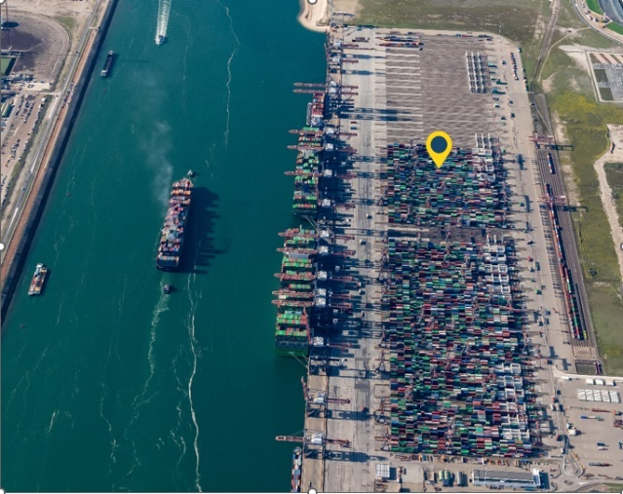
Terminal Image

5.3 Berth

Berth
IHO Concept Register: berth
Definition: A place, generally named or numbered, where a vessel may moor or anchor

Berth Identifier
IHO S-131: Berth::berthIdentifier Proposal to IHO
Definition: The unique identifier for a given berth

Berth Identifier – Global Location Number
IHO S-131: Berth::globalLocationNumber Proposal to IHO
Definition: A globally unique, standardized identifier for parties and locations in business processes or supply chains
Format: ISO/IEC 6523; 13 digits in text format
Remark: for all terminals, already used in the supply chain industry, ISO/IEC 6523. Ideally assigned by the port authority so the number remains the same after change of ownership, aligned with IMO vessel number practices

Berth Identifier - Name
IHO S-131::Berth::featureName Proposal to IHO
Definition: Berth feature has attribute featureName to describe name of the Berth
Format: text.
Remark: for all berths. Name will change after change of ownership. Possibly combined with name of terminal name for better human recognition

Berth Latitude/Longitude
IHO S-131::Berth::Geometry Proposal to IHO
Definition: Berth feature contains a Geometry object, which can hold the coordinates (latitude and longitude) for a point, surface (=polygon) or curve (=line).
Format for information exchange: degrees and decimal minutes; datum WGS84
Format for data exchange: decimal degrees to a defined precision (minus to indicate South and West); datum WGS84
Remark:
- Fender Berth: curve (=line). The berth’s extent is between its two extremities measured in a straight line, indicated by A and B, orientation is not important. The line represents the fender line, being the position of the ship’s side when alongside.
- Multi Buoy Mooring (MBM) Berth: surface (=polygon). The berth’s extent is between the positions of the mooring buoys (this should also allow for the length of mooring lines)
- Anchor Berth: check with IHO

Berth Types
IHO S-131::Berth::featureType Proposal to IHO

Fender Berth
IHO ConceptRegister: fenderBerth
Definition: A designated physical location of berth infrastructure where a vessel may moor, defined by the fender line, which is the position of the vessel when moored

Fender berth types
IHO S-4: 321.1, 321.2, 324.3
- Quay, Wharf
- Pier, Jetty
- Promenade pier
- Pontoon

Multi Buoy Mooring (MBM) Berth
IHO ConceptRegister: multiBouyMooringBerth
Definition: A designated facility where a vessel may moor, usually by a combination of the mooring buoys and the ship’s anchors

Anchor Berth
IHO ConceptRegister: anchorBerth
Definition: A designated area of water where a vessel, sea plane, etc., may anchor

Berth API
“berths”: [{
“gln”: “871933164764”,
“name”: “DS QUAY”,
“type”: “fender berth”,
“coordinateA”: {
“latitude”: 51.974834,
“longitude”: 3.986750
},
“coordinateB”: {
“latitude”: 51.95644195,
“longitude”: 3.995982
}
}]

Berth Image
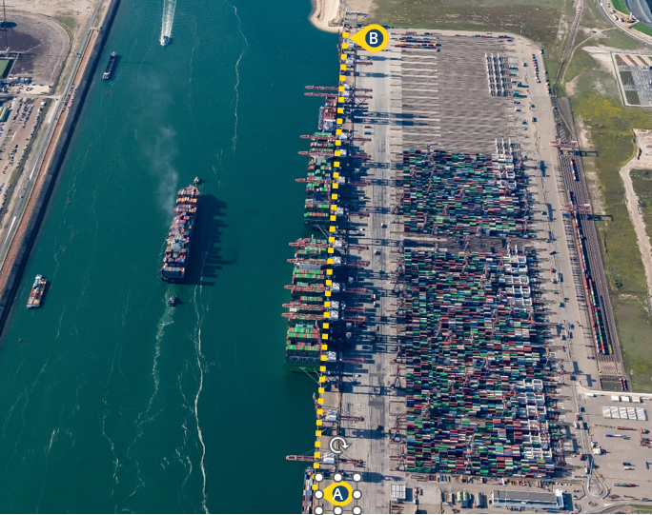

5.4 Berth Position

Berth Position
IHO Concept Register: berthPosition
Definition: A specific position within a berth where a vessel may be moored or anchored

Berth Position Identifier
IHO S-131: Berth Position::berthPositionIdentifier Proposal to IHO
Definition: The unique identifier for a given berth position

Berth Position Identifier - Global Location Number
IHO S-131: BerthPosition::globalLocationNumber Proposal to IHO
Definition: A globally unique, standardized identifier for parties and locations in business processes or supply chains
Format: ISO/IEC 6523; 13 digits in text format plus extension (for the Berth Position name or number) separated with a dash
Remark: for all terminals, already used in the supply chain industry, ISO/IEC 6523. Ideally assigned by the port authority so the number remains the same after change of ownership, aligned with IMO vessel number practices

Berth Position Identifier - Name
IHO S-131::BerthPosition::featureName Proposal to IHO
Definition: Berth Position feature has attribute featureName to describe name of the Berth Position
Format: text

Berth Position Latitude/Longitude
IHO S-131::Berth::Geometry Proposal to IHO
Definition: Berth Position feature contains a Geometry object, which can hold the coordinates (latitude and longitude) for a point
Format for information exchange: degrees and decimal minutes; datum WGS84
Format for data exchange: decimal degrees to a defined precision (minus to indicate South and West), datum WGS84

Berth Position Types
IHO S-131::Berth Position::featureType Proposal to IHO

Bollard
Normally used for positioning container, bulk and cruise ships

Loading arm
Normally used for positioning tanker ships

Ramp
Normally used for positioning ro-ro and ferry ships

Berth Position API
“berthPosition”: [{
“gln”: “871933164764-25”,
“name”: “25”,
“type”: “Bollard”,
“coordinate”: {
“latitude”: 51.952891,
“longitude”: 3.984563
}
}]

Berth Position Image
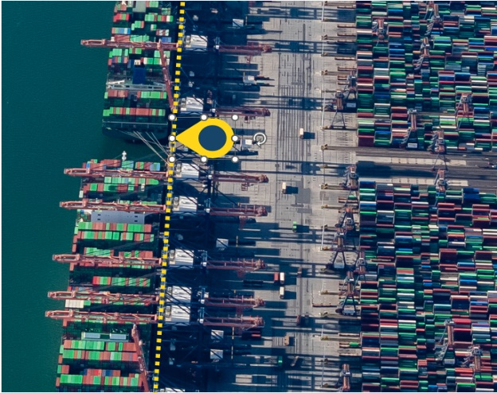

5.4 Berth Pocket

Berth Pocket
IHO ConceptRegiser: berthPocket
Definition: A body of water at a berth or anchor berth, of adequate dimensions to allow a vessel to make fast to the shore, mooring buoy, berthing dolphins or to anchor
Proposal to IHO: “berthing dolphins” not aligned with definitions in OCIMF Mooring Equipment Guidelines, should be “mooring dolphins”

Berth Pocket Identifier
IHO S-131: Berth Pocket::berthPocketIdentifier Proposal to IHO
Definition: The unique identifier for a given berth pocket

Berth Pocket Identifier – Global Location Number
IHO S-131: BerthPocket::globalLocationNumber Proposal to IHO
Definition: A globally unique, standardized identifier for parties and locations in business processes or supply chains
Format: ISO/IEC 6523; 13 digits in text format plus extension (for the Berth Position name or number) separated with a dash
Remark: for all terminals, already used in the supply chain industry, ISO/IEC 6523. Ideally assigned by the port authority so the number remains the same after change of ownership, aligned with IMO vessel number practices

Berth Pocket Identifier - Name
IHO S-131::BerthPocket::featureName Proposal to IHO
Definition: Berth Pocket feature has attribute featureName to describe name of the Berth Pocket
Format: text

Berth Pocket Latitude/Longitude
IHO S-131::BerthPocket::Geometry Proposal to IHO
Definition: Berth Pocket feature contains a Geometry object, which can hold the coordinates (latitude and longitude) for a surface area
Format for information exchange: degrees and decimal minutes; datum WGS84
Format for data exchange: decimal degrees to a defined precision (minus to indicate South and West), datum WGS84

Berth Pocket Maintainted Depth
IHO ConceptRegister: maintainedDepth Proposal to IHO “body of water” instead of “channel”
Definition: The depth at which a channel is kept by human influence, usually by dredging

Berth Pocket Nature of Seabed
IHO S-4: 423-427
- Sand
- Mud
- Clay
- Silt
- Stones
- Gravel
- Pebbles
- Cobbles
- Rock, Rocky

Berth Pocket API
“berthPocket”: [{
“gln”: “871933164982”,
“maintainedDepth”: 10.5,
“chartDatum”: Lowest Astronomical Tide,
“natureofSeabed”: mud,
“coordinateA”: {
“latitude”: 51.974834,
“longitude”: 3.986750
},
“coordinateB”: {
“latitude”: 51.95644195,
“longitude”: 3.995982
},
“coordinateC”: {
“latitude”: 51.974834,
“longitude”: 3.986750
},
“coordinateD”: {
“latitude”: 51.95644195,
“longitude”: 3.995982
}]

Berth Pocket Image
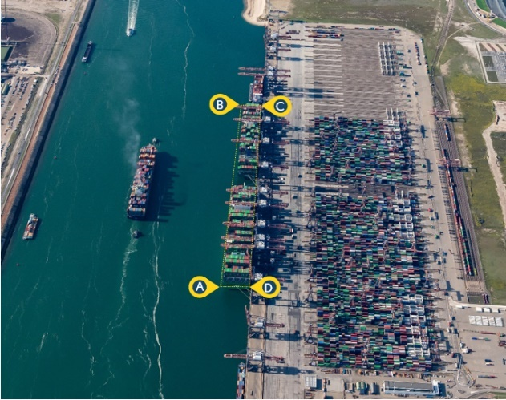

Berth Pocket Maintained Depth Image
