NIPWG-10

Paper for Consideration by NIPWG

Research of Identifying Vessel behavior Compliance Based on S-127 Maritime Traffic Management Rules

Submitted by: | China MSA
Executive Summary: | This proposal focuses on the application of the S-127 maritime traffic management data product in e-Navigation system. It provides a basic workflow, general rules and methods for identifying the vessel activities’ compliance with traffic management rules based on machine readable data and delivering navigation information. More specifically, the feature of radio calling-in point is taken as an example to illustrate the identification method of compliance and the subsequent system display and operations, which can serve as a reference for the application of S-127 data products.
Related Documents: | S-127 (Ed 1.0.1), IMO Resolution MSC.232(82), S-98 Part C (Ed 1.0.0)
Related Projects:

1 Background
On 7 November, 2022, IMO adopted the newly revised Performance Standards for Electronic Chart Display and Information Systems (ECDIS), establishing the legality of the application of future S-100 based products. Data products that comply with the S-127 specification can be applied and displayed on S-100 ECDIS as well as both on the shore-based system and on-board system of e-Navigation.
At present, some researches and experiments have been conducted on the production and display of S-127 data products, but the research of the application of S-127 products in ECDIS or e-Navigation systems is less. By closely integrating S-127 data products with the dynamic behavior of vessels, we can study and identify the navigational situation of vessels and give immediate information tips or warnings to mariners, which can enhance navigational safety and reduce the workload of mariners by informing them of navigational rules in a more targeted, intelligent and convenient way.
As mentioned in Harmonised User Experience for ECDIS and INS, S-98 Part C (Ed 1.0.0), alerts are associated with drawing instructions output by the portrayal, and are triggered when the vessel route (either actual track, during route monitoring, or planned, during route planning) intersects the geometry (which may be restricted or augmented) of a feature. The events are alarms, warnings, cautions, or indications as described in IMO MSC.252(83).
This document describes in detail how to push the navigation rules in S-127 data sets to ships according to their vessel behavior, taking the e-Navigation Service System developed by Southern Navigation Service Centre, China MSA as an example, which can be used as a reference for the application of S-127 data products in the e-Navigation shore-based systems.

2 Application Work Flow
When S-127 data set is applied in e-Navigation, one of the main purposes of the application, in addition to graphically displaying marine traffic safety management regulations, is that the system can determine whether the vessel activities comply with traffic rules based on machine readable data, and thus deliver the navigation information in time to the end users. The processing flow of the system is as follows:

- Validity checks of the features. Before the vessel activities recognition process, the time and status validity of the features in S-127 data product in the system should be pre-judged to see whether the features are currently valid.
- Monitoring and identifying the behavior of a ship relative to S-127 features. Based on the position and dynamic status of a vessel, the system determines whether the vessel interacts with S-127 geographical features, i.e., the vessel enters, approaches, crosses a certain S-127 geographical feature, or navigates within or stays within it.
- The system extracts the attributes and associated information types of the feature, then makes relevant logical judgments, and determines the navigation assistance operations to be taken, such as delivering hints, warnings or guiding the vessel to leave, etc.
- The system pushes information to optimize the ship’s navigation or guide it to leave (automatically recommend a planned departure route).
- Displaying the relative information including alarms, warnings, cautions, or indications, on e-Navigation terminals.

In this workflow, traffic management information, navigation rules and associated vessel characteristics data are derived from the S-127 product. The vessel dynamic data in the e-Navigation shore-based system is sourced from AIS, Vessel Traffic Service (VTS) and other systems.

3 General Methods and Rules

3.1 Validity Checks of Features.
For all features, three attributes, fixedDateRange, periodicDateRange and status, are checked to determine whether the feature is currently in a valid state.
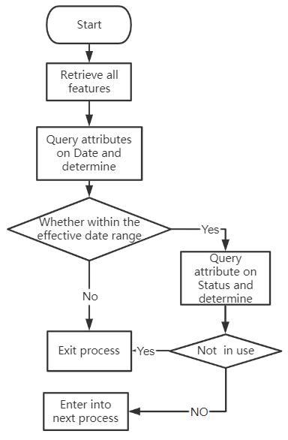
Figure 1 Work flow for the validity checks of the features

3.2 Classification and Judgment Methods of Interaction behavior
The interaction behavior between vessels and S-127 geographical features with different types of geometries also varies, as shown in Table 1.
Table 1 Vessel Behavior Responding to Geometric Types of Features
Geometric type | Applicable behavior
point | approaching
line | Approaching, crossing
surface | Approaching, Entering, Exiting, Navigating inside, Staying inside
The judgment methods and thresholds for different behavior are shown in Table 2.
Table 2 Judgment Methods and Thresholds for Ship Behavior
behavior | Judgement method and threshold
Approaching | Geographic features (point, line or surface) are located in front of the ship's sailing direction(see the following remarks) and the distance from the current ship position is less than (vessel speed × custom threshold time)
Crossing | Two consecutive ship positions are located on either side of the geographical feature (line).
Entering and exiting | The two consecutive ship positions are located on the inner and outer sides of the geographical features (surface).
Navigating inside | Multiple consecutive ship positions are located on the inner side of the geographic feature(surface) with an average speed greater than or equal to 3 knots for a duration of more than 10 minutes.
Staying inside | Multiple consecutive ship positions are located on the inner side of geographical elements (planes), with an average speed of less than 3 knots and a duration of more than 10 minutes.
Remarks:
(1) How to determine the feature is in front of the ship's sailing direction: when there is a planned route, it should be determined according to the fact, that the geographical range, i.e., the planned route plus the safe distance to its left and right sides, will overlap with the feature; when there is no planned route, it should be judged according to the fact that the sector viewport constructed by the ship heading plus the safe distance (or distance automatically calculated according to vessel size)to its left and right sides and a certain angle(set according to the situation), overlaps with the geographic feature.
(2) The default threshold time is 300 seconds, which can be further optimized after actual development test and verification, and users can set the threshold time of warning reminder by themselves.

3.3 General Rules of Vessel Parameter Matching
Vessel parameter matching focuses on identifying the specific ships to which the feature rules apply. The attributes of the S-127 feature and its associated information types are matched to the static parameters of the ship with which the feature interacts, i.e., the parameters of the ship's type, size, cargo, etc., are checked to see if they fall within the scope affected by that S-127 feature.
For features with attribute categoryOfVessel and categoryOfCargo, such as RadioCallingInPoint and PilotBoardingPlace in S-127 data, the attribute categoryOfVessel and categoryOfCargo of this feature should be used to match the parameters of the interacting vessel firstly. Then, examine whether the feature has an associated Applicability information type. If the association exists, the other vessel parameter attributes in the Applicability should be further matched. If there is a conflict between the contents involved in the determination, the content in attribute (categoryOfVessel and categoryOfCargo) is of the higher priority.
In addition, the restriction attribute of the feature should be queried to match the vessel types implied in the attribute values. For example, the attribute fishing prohibited and fishing restricted are corresponding to fishing vessels, the attribute Dredging prohibited and restricted dredging are corresponding to dredger. If there is a conflict, the Applicability information is of higher priority than the Restriction attribute.
If none of the attributes above is assigned, it means that the feature is valid for all ships.

3.4 Identifying Vessel Behavior Compliance and Pushing Information
Combining the vessel's behavior state at current time and the matching result of vessel parameters, logical judgments can be made, and finally the specific operation can be determined by the system, such as delivering cautions, warnings or guiding the vessel to leave, etc.
This process requires specific analysis for specific S-127 features. Please refer to the annex, Vessel Behavior Compliance Identifying and Alerts/Indications Pushing for Specific S-127 Feature Types. The annex only chose RadioCallingInPoint as an example, which could be expanded in subsequent studies.

3.5 General Rules of Information Prompts
After the identification of vessel activity, relevant navigation information will be delivered as a result. The general rules are as follows:
- The warning and prompt should refer to the attribute featurename of the feature and textContent of associated information type, such as:
——You are approaching featureName.Name, please note: textContent.information.text, please avoid it.
——You have entered featureName.Name, please pay attention to navigation safety.

If the value of featureName is null, replace it with the name of feature type, for example:
——You have entered (Caution area or Waterway area or Restricted area navigational...), please pay attention to navigation safety.

If the value of textContent attribute is null, replace the textContent with the relevant navigation requirements, for example:
——You are approaching featureName.Name, this (name of feature type) prohibits the entry of specific types of vessels. Please be careful to avoid it.

The red text in the above examples is determined according to the ship's behavior and the specific rule, for more details, please see the Annex.
- In the system, the information prompts use the text attribute values of the corresponding language version in S-127 data, that is, the Chinese version calls the Chinese value, and the English version calls the English value.

3.6 General Processing Rules for On-board Application
After completing the identification of vessel behavior compliance, relevant navigation information will be pushed according to the identification result. Examples of general rules for information prompting are as follows:
- In on-board application of e-Navigation, a way should be provided to display the details of the features of S-127 and other features and information types associated with them, including traffic rules, data sources, regulatory authority information, etc.
- intermittent pushing warnings or alerts, meaning infrequent reminders at intervals of, for example, 20 minutes. the default interval can be further optimized based on practical application experience. the specific time interval should support user-defined.
- When a vessel’s activity triggers a rule, the corresponding S-127 geographic feature should be highlighted.

4 Action Requested of NIPWG
The NIPWG is invited to:
- Note the proposal.
- Consider the basic processes and general rules in this document.
- Consider the need to establish a task group to further research the interoperability of S-100 based product data with ship data, and develop guidelines on relevant rules and methods, which can provide some reference for the application of S-100 based data products in future S-100 ECDIS.

Annex

Vessel Behavior Compliance Identifying and Alerts/Indications Pushing

for Specific S-127 Feature Types
The feature validity check method is consistent for all feature types and will not be described in the annex. This annex introduces the identification of ship behavior compliance and alerts/indications for specific feature types.

1.RadioCallingInPoint
1.1 Judgment of Interaction Behavior
Feature geometric type: point, line.
Judge interaction behavior between a vessel and the geometry of a feature according to the corresponding methods shown in Table 1 and Table 2 in the main text above.
Table 1 Vessel Behavior Corresponding to Geometric types of RadioCallingInPoint
geometric type | Applicable behavior
point | approaching
line | approaching, crossing

1.2 Vessel parameter matching and information prompts
1.2.1 When there is no information type associated
1) RadioCallingInPoint does not have the restriction attribute.
2) Check the attributes categoryOfCargo and categoryOfVessel, to determine the vessel type and cargo type. If no value is assigned in the attributes, then it states that the reporting requirement applies to all ships.
3) Check the values of trafficFlow and orientationValue to determine the direction of the entry and exit reporting points (lines) required for the vessel to report.
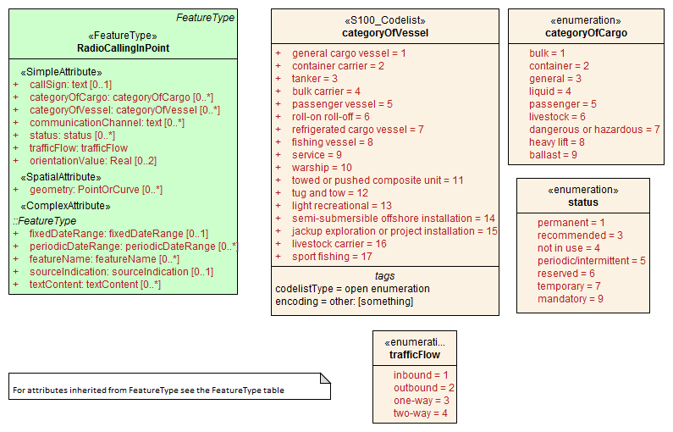
Figure 1 attributes of RadioCallingInPoint
Attribute CategoryOfVessel of this feature specifies the type of vessel for which the report should be submitted, and categoryOfCargo specifies the type of cargo carried on the vessel for which the report should be submitted. If categoryOfVessel and/or categoryOfCargo have a value assigned, this value should be used first to determine the applicable ship type. If neither the categoryOfVessel nor categoryOfCargo attributes are assigned a value, nor is there an associated Applicability , then any vessels are considered to be required to submit a report.
Since the specific category of cargo, except for passengers and the dangerous or the hazardous, carried by the ship is usually not known through AIS data, if the categoryOfCargo attribute is assigned a value, it is impossible to accurately identify whether the ship needs to be reported, that is, "report may be required".
The direction in which reporting is required could be ensured by the trafficFlow and orientationValue attributes, that is, it is possible to request a report when entering, a report when exiting, or both entering and exiting.
Summarising the above analysis, there may be three situations, namely "determined to require report", "not sure whether to require report" and "not required to report", the corresponding processing is shown in the following table:
Table 2: Judgment and processing based on the attributes of RadioCallingInPoint
Interaction behavior | Ensure to request a report | Not sure if reporting is required | not required to report
Approaching | The system prompts that there is a report line ahead, and the ship needs to report | The system prompts that there is a calling-in line ahead, and the ship may need to report, and indicates the type of ship and cargo type required for the report | No system operation
Crossing | The system prompts that the reporting line has been passed, please confirm whether the report has been made as required | The system prompts that the reporting line has been passed, please confirm whether the report has been made as required | No system operation

1.2.2 When there are information types associated
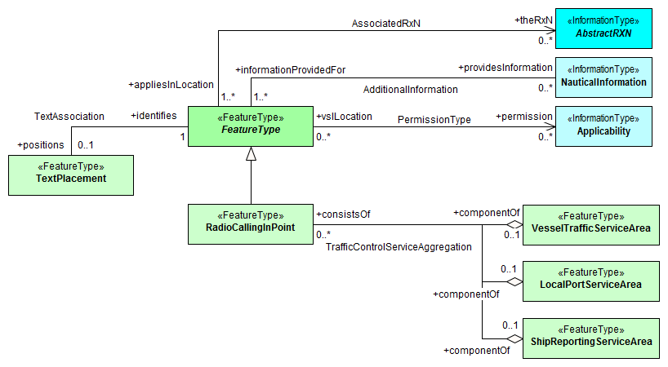
Figure 2 information associations and feature associations of RadioCallingInPoint
As shown in Figure 2, among the information types associated with this feature, only Applicability affects logical judgments of Identifying Vessel behavior Compliance and the specific operation to be taken.
Applicability is associated via the PermissionType association, and specifies the applicable vessel parameters. When the categoryOfVessel and categoryOfCargo attributes of the feature are not assigned, it will affect the judgment process.
1) Check the value of categoryOfRelationship attribute bound to PermissionType association. For the radio reporting point, the attribute value equal to 1 (Prohibited), 2 (not recommended), 3 (Permitted), 6 (not required) has no practical application significance.
2) Check whether the current vessel parameters are consistent with the relevant attributes in Applicability, and then determine whether the vessel needs to be reported. How to determine whether the specific parameters are consistent will not be detailed here, please refer to the S-127 product specification.
3) The direction in which reporting is required when vessel crossing is still determined according to the method mentioned in 1.2.1, based on. the values of trafficFlow and orientationValue.
4) Make logical judgements by combining items 1), 2) and 3) and determine the system operations to be taken, as shown in the table below:

Table 6: Judgment and processing of RadioCallingInPoint based on information association
categoryOfRelationship | Interaction behavior | Vessels need to report | Ships don't need to report
4 Recommended | Approaching | Prompt that a calling-in line is ahead and vessel is recommended to report. | No operation
 | Crossing | prompt that vessel has passed the calling-in line, please confirm whether the report has been made as required | Prompt vessel has entered
5 Required | Approaching | Prompt that there is a report line ahead, and the ship is required to report | No operation
 | Crossing | Prompt that vessel has entered, and remind that the vessel should keep navigating inside | Prompt vessel has entered

1.3 Special Rules for Information Prompts
The information prompt rules follow the general rules given in the main text above. A distinction should be made for the feature between calling-in point and line, for example:
——You are approaching the calling-in point (line) featureName.Name , please note: textContent.information.text , please report as requested.
where " point " or " line " depends on the geometry of the feature.
1.4 Processing of Feature Association
As shown in figure 2, RadioCallingInPoint is associated with VesselTrafficServiceArea, LocalPortServiceArea and ShipReportingServiceArea. These associations do not affect the discriminatory processing of vessel behavior, but when users click to view the details of RadioCallingInPoint, the details of the associated features shall be displayed in an appropriate manner in on-board system or APP of e-Navigation.

