Paper for Consideration by NIPWG
Comments by USA (NGA)
on Proposals for the adoption of Chinese version of Marine Traffic Management Product Specification (S-127 1.0.1)
Submitted by: | USA (NHG)
Executive Summary: | Comments on China MSA’s proposal to adopt a Chinese-language version of the S-127 (Version 1.0.1) Product Specification
Related Documents: | S-127 (1.0.1)
Related Projects | S-127 Project.

Background
China MSA has completed the Chinese-language version of Marine Traffic Management Product Specification (S-127 1.0.1) for the development of the S-100 standard.

Analysis/Discussion
Q1: Based on China MSA’s request, should NIPWG adopt a Chinese-language edition of the English version of the S-127 Product Standards into Chinese?
A1: Yes. China is willing to undertake the translation effort of both S-127 Production Specification (Version 1.0.1) and future updates to the document.

Q2: Is there an IHO process/procedure for translating IHO documents from one language to another?
A2: Unknown. Translation have been done in the past so this process/procedure may exist. Previous examples of IHO Standards and Specifications translations are, as follows:
- Spanish (7 items—including S-4, S-32, S-44, S-53, and S-67).
- Japanese (3 items—including S-66).
- Chinese (2 items—S-44 and S-67).
- Portuguese (1 item—S-44).

Q3: After the translation is completed, should a third party review the document, concentrating on wording and idioms that might not match between the two languages?
A3: Not sure. It doesn’t seem to have been a problem in the past. However, different words and idioms may be used for similar concepts, possibly resulting in a different meaning than intended. For example:

Topic | United States English | United Kingdom English
Automobile terms | Trunk | Boot
 | Hood | Bonnet
Food terms | French fries | Chips
 | Chips | Crisps

An even more graphic example is the different terms used to describe carbonated non-alcoholic beverage in different regions of the United States. The major terms are soda, pop, coke, cocola, and soft drink. This doesn’t include more regional variations such as tonic, soda pop, cold drink, and soda water.
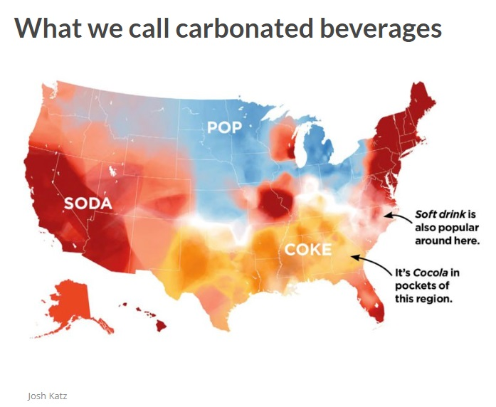

NIPWG Action
- Approve China MSA’s request to develop the Chinese-language version of the S-127 Product Specification.
- Determine of there is an established IHO process/procedure for translating IHO documents.
- Determine if the procedure described in Q3 is necessary.

