NIPWG10-11.5.3

Input paper for consideration by NIPWG

A review of which services should consider using S-128

Submitted by: | Finland and IEC
Executive Summary: | A review of which services should consider using S-128
Related Documents: | HSSC15-05.3A (NIPWG report at HSSC 15)
Related Projects: | S-128, Classification of S-100 based products and services

Introduction / Background
During S-128 related discussions at NIPWG 9, an action to review which services should consider using S-128 products and services was proposed. Once the review is complete, NIPWG will communicate through IHO secretariate with relevant bodies/organizations to see how they may consider S-128 as a tool.

ACTION ITEM 18 - A review of which services should consider using S-128 products and services will be completed by SE and HP. NIPWG-10.

Even though the current version of S-128 is more focused on products provided as datasets, this paper assumes a future version of S-128 to be suitable also for indicating the availability of services. This assumption is based on discussions during the S-100WG TSM9, which revealed that the product specification needs some modifications to support real time data service description.

The report by NIPWG at HSSC 15 included a diagram describing the role of S-128 in potential scenarios of ENC and ENDS services. The core thought described was, that each provider of selected S-100 products or services should also provide accompanying S-128 data to describe the service. Multiple datasets could be compiled as needed to create national- and regional (RENC) datasets. The S-128 task group is working on the details of how to validate S-128 products from all relevant producers, and currently consider producer codes as the leading candidate to do so.

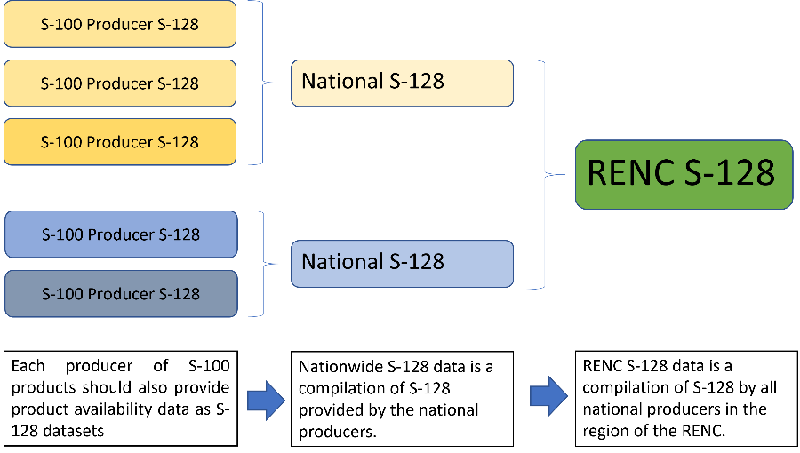
The purpose of this review is then to identify the relevant S-100 products and services, that should be included in a nationwide compilation of S-128. Producers of these S-100 products and services would be obliged to also produce S-128 to describe the service. Where the word service is used in this paper, it should be understood to include both products and services.

Analysis/Discussion

NIPWG works on a related action to classify S-100 related products and services. At HSSC 15, NIPWG presented the below diagram, that link S-100 products to e-Navigation Maritime Services. This diagram was created as a way to describe what ENDS is, and also to classify S-100 products and services. This classification is highly related to S-128 product catalogue creation.
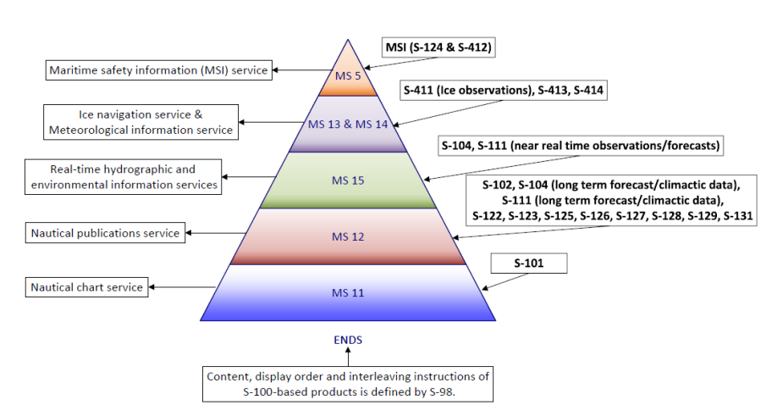

Conclusions
It could be concluded, that initially any S-100 service related to a SOLAS carriage requirement, recognized as a (potential) part of an ENDS service or otherwise related to a recognized Maritime Service would be relevant for S-128. Therefore, a general recommendation would be that a producer of any of the services mentioned in the classification of products related to ENDS, would also be recommended to provide corresponding S-128 data to describe the service. It could also be concluded, that it would be especially important for any producer of a service or product included into S-98 to also provide data descriptions as S-128.

It is further assumed in this paper, based on previous discussions, that SOLAS carriage requirements of nautical chart and nautical publications in the future might be met by using a combination of traditional publications and S-100 / ENDS- services. It is not yet fully defined how this situation is to be regulated, but it is anticipated an obligation of each nation to provide information regarding the S-100 / ENDS services provided and to which extent carriage requirements can be fulfilled by electronic means. In case of a Port State Control, it must be possible to clearly determine the data needed to fulfill carriage requirements.

In this regard, as S-128 could contain both traditional products and electronic services, the nationwide S-128 might need to fill the additional function of indicating the minimum set of products / services needed to fulfill SOLAS carriage requirements, and possibly indicate alternatives.

Initial list of considerations used to support the decision for the need to provide S-128

- Services included and used in ECDIS interoperability S-98
  - Any service forming a part of ECDIS interoperability must be included in the relevant S-128 service
- Services considered a (potential) part of an ENDS- service
  - Whenever a service, that is recognized to potentially be a part of ENDS, a description as S-128 must be provided. (Even if that particular service might not be provided as an ENDS- service).
- Any service potentially fulfilling a SOLAS (or similar) carriage requirement
  - This consideration includes traditional nautical chart and publication products, especially those SOLAS carriage requirements. Additionally, any service that could potentially or partially substitute such traditional publication in order to fulfill a SOLAS carriage (or similar) requirement, should provide a service description as S-128.
- Any other service case-by-case
  - The relevancy of providing corresponding S-128 to describe other services must be determined case-by-case.

Special consideration is needed for services that provide S-100 formatted data, optimized for a given vessel, such as S-129 and S-421. The availability of general services such as a route optimization- or Dynamic UKC- service, utilizing these data formats might be described in nautical publications and other products such as S-101 or S-127. However, such ship specific datasets available as S-129 or S-421 products should not be included into the S-128.

As a conclusion, it is considered, that S-128 should only describe products / services which are generally available and common to all vessels. For example; a route optimization service where a vessels route is received and an optimized route returned in S-421 format should not be included in S-128, but merely described as an available service in S-127. On the other hand, if static S-421 datasets of recommended routes are provided, these could be described in S-128.

The need for product description as S-128 is indicated using following recommendations;

- Mandatory - The service must be included
- Recommended - The service is recommended for inclusion
- TBD (To Be Decided) - A decision is not yet needed or available
- Not suitable - The product is not suitable for inclusion
- Not needed - A recommendation to not include the product in S-128

Service | Description as S-128 | Justification / Description
S-101 | Mandatory | Part of S-98 1.0.0
S-102 | Mandatory | Part of S-98 1.0.0
S-104 | Mandatory | Part of S-98 1.0.0
S-111 | Mandatory | Part of S-98 1.0.0
S-112 | TBD | New reservation
S-122 | Recommended | Part of ENDS, MS 12, Nautical publication data
S-123 | Recommended | Part of ENDS, MS 12, Nautical publication data
S-124 | Recommended | Part of ENDS, MS5, MSI-data
S-125 | Recommended | Part of ENDS, MS 12, Nautical publication data
S-127 | Recommended | Part of ENDS, MS 12, Nautical publication data
S-128 | Not suitable | S-128 itself is a special case
S-129 | Not suitable | Ship-specific service by request only
S-130 | TBD | TBD
S-131 | Recommended | Part of ENDS, MS 12, Nautical publication data
S-164 | NA | ECDIS Test data sets
S-201 | Not needed | Service not intended for End User
S-210 | Not needed | Service not intended for End User
S-211 | Not needed | Service not intended for End User
S-212 | Not needed | Service not intended for End User
S-230 | Not needed | Service not intended for End User
S-240 | Not needed | Service not intended for End User
S-245 | Not needed | Service not intended for End User
S-246 | Not needed | Service not intended for End User
S-247 | Not needed | Service not intended for End User
S-401 | Not suitable / TBD | Considered out of scope
S-402 | Not suitable / TBD | Considered out of scope
S-411 | Recommended | Part of ENDS, MS 13 / 14, Meteo and ice data
S-412 | Recommended | Part of ENDS, MS5, MSI- data
S-413 | Recommended | Part of ENDS, MS 13 / 14, Meteo and ice data
S-414 | Recommended | Part of ENDS, MS 13 / 14, Meteo and ice data
S-421 | Not needed / TBD | Mostly ship-specific service by request only

Recommendations
This review revealed that the question of which services are to be included in S-128 interlinks to the discussions of classification of services. Therefore the following considerations are recommended when determining whether a (product or) service should be available in the nationwide S-128;
- Does the service form a part of ECDIS interoperability as described in S-98?
- Is the service recognized as a potential part of an ENDS- service?
- Can the service be used in order to fulfill SOLAS- carriage (or similar) requirements?
- Is the service intended for the end user?
- Is the (S-100 formatted) data generally available and same for all vessels?

NIPWG is recommended to ensure that a nationwide S-128 could be used to convey information of the products and services needed to fulfill SOLAS- requirements.

NIPWG is requested to consider whether a separate agenda item is needed, to cover the evolving discussion related to ENDS, product classification and SOLAS carriage requirements.

A separate agenda item covering IMO and SOLAS related requirements to NIPWG S-100 products might better describe the content and current importance of this discussion. A separate agenda item would also provide a better platform for periodical review of this topic.

Action Required of NIPWG
The NIPWG is invited to:
a. note this paper
b take action as appropriate

