NIPWG8-49.2

Paper for Consideration by NIPWG

Report on creation of Canadian S-123 datasets

Submitted by: | Eivind Mong (Canadian Coast Guard)
Executive Summary: | This paper gives a summary of the efforts by Canadian Coast Guard to develop S-123 coverage in Canada. It includes a sample of challenges faced with creating the data and proposes a dedicated meeting to review issues faced with the S-123 v.1.0.0 product specification.
Related Documents: | S-123 v.1.0.0
Related Projects: | S-123

Introduction / Background
The Canadian Coast Guard (CCG) has contracted Caris to create the Canadian coverage of S-123 data. The source document is the official Canadian publication Radio Aids to Marine Navigation (RAMN).

Analysis/Discussion
The contract was awarded in two phases; phase 1 was to test the capabilities and see what the results would be. The Great Lakes was chosen as the test area due to its variation of types of data to capture and it’s relatively easily definable geographic area. Along with the data creation, the contract included a detailed report on the exercise as to help CCG understand the process better and the state of S-123.
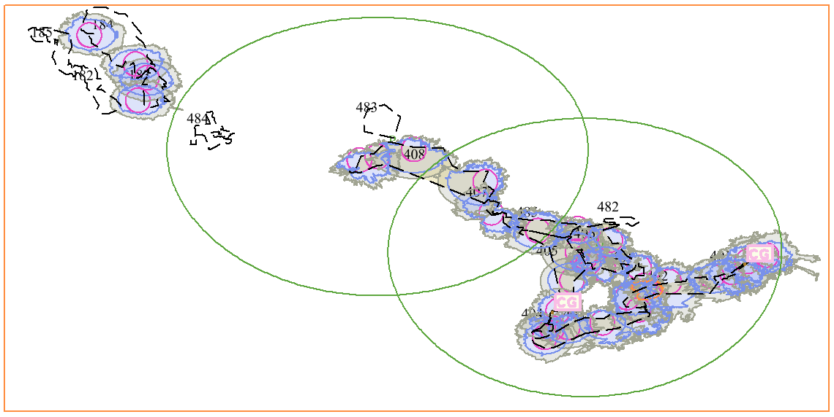
Figure 1 - Radio Services in Great Lakes region of Canada
The exercise proved very helpful for CCG to understand the state of its readiness and data management for S-100 products. The exercise showed CCG that it’s data management is too person dependent, which can make source discovery difficult. It has also helped uncover areas where investment is needed in order to enable a true operational service that is capable of providing up to date S-123 data. Areas like staff training, production environment and options for distribution are now being looked at. Moreover, the exercise yielded several comments on how S-123 functioned as a standard to create data from, including areas where improvements can be helpful. A sample of some of these comments have been included below for discussion.

S-123 Metadata
S-123 are expected to be scale independent. Discovery metadata has the attribute specificUsage, which is mandatory. However for a product such as S-123, the product is typically scale less and applies to every usage where someone wants to use it. S-100 only has it as a character string, S-101 limits to 3 choices (Port Entry, Transit, Overview) Maybe it should be optional or there should be a choice for 'any' when there is a one size fits all product. S-123 states "brief description of the resource and/or resource series usage" but it would be better to make this a fixed value or a choice.

S-123 Data Model
Examples where data model may be improved;
The sub-complex attribute contactAddress uses the attribute deliveryPoint as a common holder for address information. This was probably done since there are a great variety of ways to do addresses world-wide. However, it can become challenging to re-uses the data when there are multiple entries.

Contact details for Prescott Marine Communications and Traffic Service becomes quite complex with multiple attribute types being reused, sometimes without a means to distinguish from one another making it harder to use the data to generate a web document, pdf or similar.
InformationType:ContactDetails: Address, Phone, Fax, email, MMSI
Mailing Address: - contactAddress
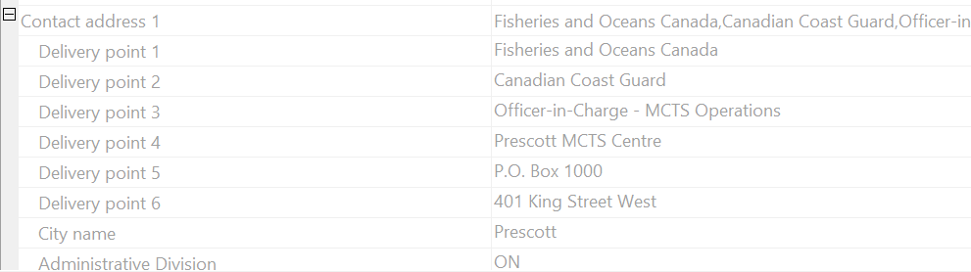

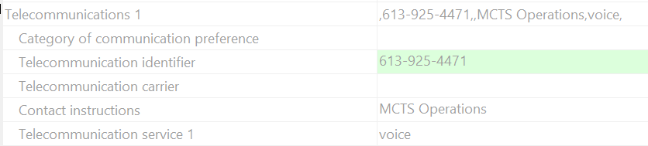
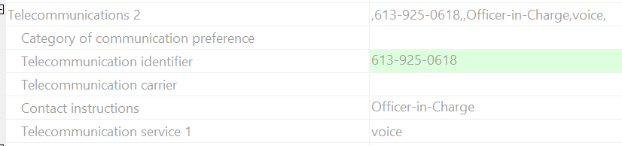
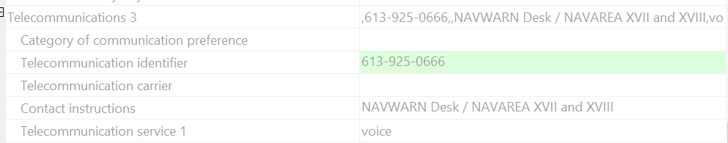
Note: contactInstructions seems to be the only field to put the information about the purpose/use of the phone number

There does not appear to be an association in S-123 between the Coast Guard station and the subsidiary Radio Station sites. This will make it difficult to recreate tables such as Table 2-13.
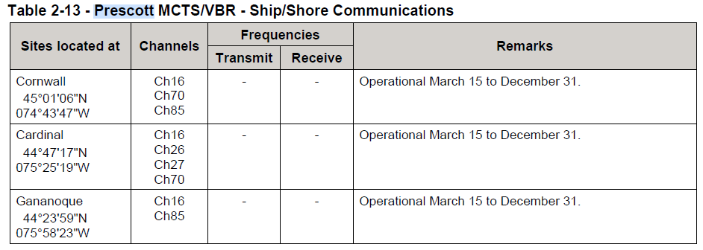
It could be useful to add an association between Coast Guard station and Radio Station to allow the explicit capture of these relationships.

Use of GML
The spec seems to indicate the desire to use shared geometries by reference. The sample from the IHO registry uses geometry inline without shared geometries defined at the start of the file. In other words the Spatial records for by-reference geometries are missing and the geometries are defined inline (repeated on each feature instance when geometries are common) at the feature level.
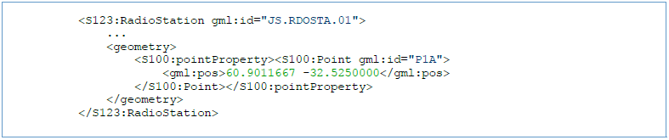
In addition, the elements for geometry and S100:pointProperty appear to be redundant. One or the other could be used and both are not needed. It could be beneficial to update the data sample to show both in line and by reference geometry.

Language
Canada is a bi-lingual county where both French and English are official languages. As such, many broadcasts are repeated in both languages. For example an English only broadcast can be followed by a French only broadcast some minutes later or we use different channels for each language.
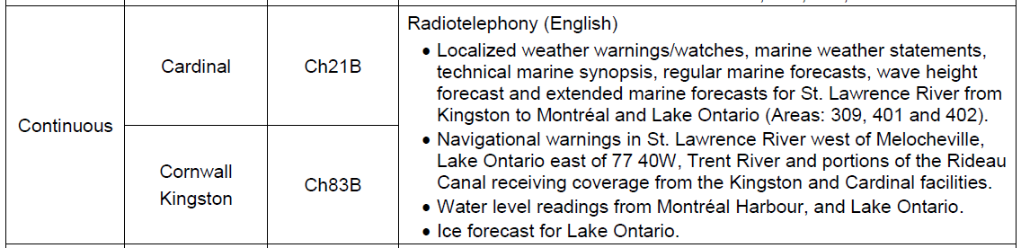
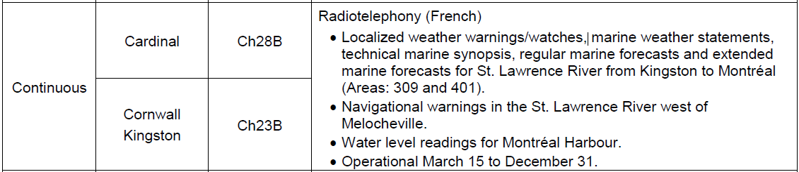
We found it difficult to capture this in S-123. It seems like a language identifier attribute should be added into the ‘radiocommunications’ attribute complex so that each identified ‘radiocommunications’ entry could indicate the language or languages related to each service or broadcast. There is a ‘languageInformation’ attribute at the top level of ‘RadioServiceArea’ but it would not provide a way to search or filter out the specific broadcasts, channels, etc. which are operating in a specific language.

Software Notes
The software used to create the CCG S-123 data is currently configured for S-100 Edition 4 exchange set and associated meta data creation. S-123 is based on S-100 Ed 3 and so some differences had to be handled manually since it was not anticipated that support of S-100 Ed 3 productions was needed. This is an important topic to consider for overall maintenance of the S-100 based product specifications under the remit of NIPWG and for data producers to consider in their operations.

Portrayal
S-123 has no portrayal provided. This was done by design as portrayal is optional and more experience was needed at the time of developing S-123. For the S-123 data creation, Caris has made a simple portrayal to help visualise the data for review within Caris EasyView. More efforts are needed to develop ECDIS ready portrayal for S-123 data.
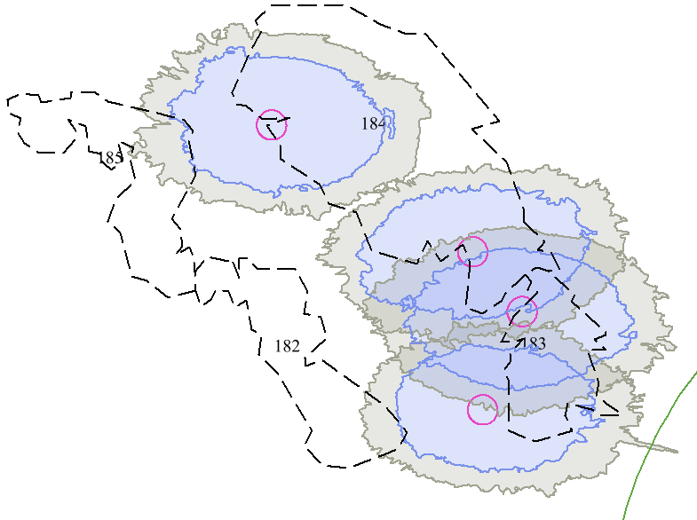
Figure 2 - Lake Winnipeg, Lake Winnipegosis and Lake Manitoba radio services
Magenta circles are radio stations, blue blobs represent the theoretical 90% certainty coverage, grey zones represent the theoretical 50% certainty coverage and numbered areas with dashed black boundaries are Marine Forecast Areas.

Conclusions
The exercise of creating national S-123 data coverage has been very insightful for planning next steps of S-100 implementation into the organization. It has helped uncover gaps and areas of improvement within the organization on the road to a fully operational S-123 service. The full coverage of Canadian waters is scheduled to be delivered on March 31st, 2021. Several observations has been made regarding S-123, and considering its status as a test version, it could be beneficial to schedule a VTC to go over the observations in detail and investigate possible improvements to the S-123 product specification.

Action Required of NIPWG
The NIPWG is invited to:
a. note this paper and take any action appropriate.

