NIPWG8-09.2
Paper for Consideration by NIPWG
NO experience in contacting ports to complete the data base entries
Submitted by: NHS (NO)
Executive Summary: A summary of NHS Port Data Project from 2020, and our experience with contact and cooperation of the ports.
Related Documents:
Related Projects: S-131 Marine Harbour Infrastructure Product Specification development
Introduction / Background
During 2020 the Norwegian Hydrographic Service (NHS) was engaged in a project relating to the standardization and gathering of port data. In connection with the work currently being done on the S-131 Product Specification, we were asked to provide some information regarding our experience with contacting and enlisting the cooperation of the ports.
Analysis/Discussion

Norwegian Port Structure
There is a multitude of different ports in Norway, both in relation to size, ownership, organization, and function. The ports span from the large commercial ports, to smaller fishing ports, ports related to leisure boats and private ports. We do not have a complete list of the number of ports, as it depends, among other things, on how broad-based a definition that is used. We also count small ports that do not necessarily have a UNLOCODE or GLN-number.

The ports have distinct kinds of organization and ownership. Public ownership dominates, while private ports make up only a small part. Public ports are usually owned by the municipality, but can have several different forms of organization. It can be as part of the municipal administration, as a municipally owned cooperation or inter-municipal companies (owned entirely by multiple municipalities and/or county municipality) and more. The county municipalities have recently taken over the ownership for state fishing ports.

The ports can also be spread over a larger area, referred to as a port district. For example the ports of Trondheim (Norway’s 3rd largest city) are distributed over 13 municipalities.

Port Data Standard
The need for port data and a port data standard arose when working with the digitalization of the Norwegian Pilot, where difficulties in obtaining updated and available information about port and port facilities were discovered. The work on a Norwegian Port Data Standard started initially in 2016, but most of the work in relation to ports was done in the last half of 2020.

Port Data 2020 Project
Due to Covid-19, the Norwegian Mapping Authority/NHS received some additional funding from the Ministry (summer of 2020), which was earmarked to be used for surveys and mapping the ports in accordance with the Norwegian Port Data Standard. The Port Data 2020 Project was completed by the end of the year.

In this project 17 ports were mapped (not bathymetry/depths), and a registration instruction on how to map the port data was developed (containing requirements for accuracy, mandatory attributes, where on the object the measurement is to be taken and so forth).

The data collected is stored in a database, hosted by the Norwegian Mapping Authority. Users can access the data through API’s for Geo synchronization. The database is also available for inspection via WMS. A plugin to QGIS was also created in the Port Data 2020 Project. Users with access (port authority, other data owners ++) can make updates directly in the database with this API. It is desirable that the port itself keeps their data up to date. The ports have also the opportunity to develop their own software in collaboration with commercial software developers.

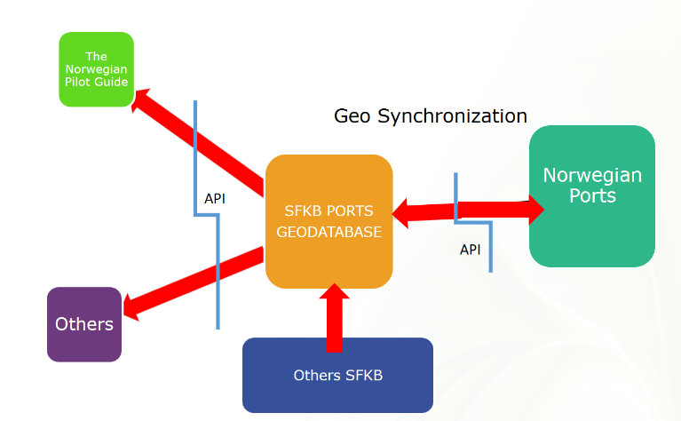

Contact with the ports
Of the 17 ports that were chosen in this project, we initially started with 30 candidates. We aimed to get a geographical spread throughout the country, and ports with varying sizes, as well as make sure the most important where included. The ports although differing in size, where all commercial. A separate project dealt with mapping of the depths, and we tried to coordinate so that the selected ports were the same in both projects.

Each harbour was approached individually by phone or e-mail (and later virtual meetings), and enquiries were made about the type of system the port itself had to store and gather information about the port and the port objects.

How information was stored varied considerably. Some had it written on paper or PDFs, excel-documents, old drawings, or maps, and some had begun the process of digitalization.

All the ports we were in contact with were eager to cooperate, and viewed the project positively. The digitalization of the port data is beneficial to the efficiency of the port, but a contributing cause to the goodwill shown may also be due to the fact that the NHS was responsible for the financing.

The agency that performed the surveys where in contact with the port shortly before arrival, so that the port could be prepared to provide the necessary information (mostly attribute information) and guide them in the areas to be mapped. The objects mapped where mainly the quay/berth itself, fence/safety areas, water connection points, mooring points, fenders, cranes, emergency response equipment (ladder, lifebuoy ++), power connection points, fuel point and more. The post-processing of data was done by the agency that performed the mapping, and then delivered to the Norwegian Mapping Authority, that read the data into database.

Remaining work
The Port Data 2020 Project is complete, but there is some outstanding work yet to be done. There remains some work on the Norwegian Port Data Product Specification and the QGIS plug-in, and there is a strong desire to map more ports.

Contact with smaller ports such as those used for leisure boats, fishing ports and private ports, has yet to be established. We have been in touch with the umbrella organisations for the 60 largest ports in Norway but have received little response.

NHS and the Norwegian Mapping Authority is currently following-up the 17 ports that were mapped and is attempting to get them to use the collected data and update the database with missing attribute values. Some of the attribute values were partly or entirely excluded provided during the mapping process, due to lack of time and/or funds (the project was to be completed by the end of the year).

NHS has been commissioned by the Ministry to prepare proposals for a co-financed cooperation model, which provides answers on a more permanent solution for how to finance further surveying of port data and how to store and distribute the data. This work is currently underway.

Action required of NIPWG
The NIPWG is invited to:
- Note this report.

