 | 9th Meeting of Nautical Information Provision Working Group  Niterói, Brazil - 13 to 16 September 2022 | 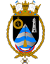

Logistics Information
Updated April 8, 2022

The 9th Meeting of the Nautical Information Provision Working Group (NIPWG) will be hosted by the Directorate of Hydrography and Navigation (DHN) in Niterói, Rio de Janeiro, Brazil, from 13 to 16 September 2022. As the organizer for the meeting, DHN is pleased to welcome you to Niterói and to provide the following logistic information. Please contact us if you need any additional information or assistance.

1) Location:
The meeting will be held at the DHN located in the city of Niterói, state of Rio de Janeiro, at the following address:

Directorate of Hydrography and Navigation (DHN)
(Diretoria de Hidrografia e Navegação)
Barão de Jaceguay, s/n - Ponta da Armação
24048-900 Niterói-RJ
Brazil

DHN is located at Lat 22º 52,991'S, Lon 043º 08,048'W about 25 km from the Tom Jobin/Galeão International Airport in the city of Rio de Janeiro and 4-5 km from the neighborhoods of Ingá and Icaraí in the city of Niterói.
You can click in this LINK to access the position in Google Maps.

2) DHN Point of Contact:
Mr. Rodrigo OBINO
Email: obino@marinha.mil.br / obinors@hotmail.com
Phone: +55 (21) 2189-3014 / +55 (21) 99710-1940 (WhatsApp)

Chief Warrant Officer Dulcivaldo FREITAS
Email: dhn.intrel@marinha.mil.br
Phone: +55 (21) 2189-3511

Please indicate “NIPWG9 (Respective Country)” in the subject of your email.
Example: “NIPWG9 (Brazil)”

3) Accommodation in Niterói:
Meeting participants are expected to arrange their own accommodation. We suggest the following hotels in Niterói near to DHN:

- H Niterói Hotel: http://hniteroi.com.br/ (LINK to Google Maps)
- Quality Hotel Niterói: https://www.reserveatlantica.com.br/hotel/quality-hotel-niteroi (LINK to Google Maps)
- Icaraí Praia Hotel: http://www.icaraipraiahotel.com.br (LINK to Google Maps)
- Niterói Palace Hotel: http://www.niteroipalacehotel.com.br (LINK to Google Maps)

After making the reservation, please fill the participant registration form for administrative purpose only with your contact details, your travel details and the hotel information, so we can organize your transport from and to the Airport and DHN.

4) Local Transportation:
DHN will provide transportation from and to the hotel if you stay in any of the above hotels in Niterói. A bus/van will start picking up the participants every morning at 08:15 a.m. to take them to the meeting venue. If you stay in other hotels please move to one of these hotels in order to enjoy the transport to DHN.

5) Lunch during meeting days:
DHN will offer coffee breaks and lunch in the meeting days. Participants are invited to arrange their breakfasts and dinners.

6) City information:

Visit Niterói website:
http://www.visit.niteroi.br/en/

Welcome to Niterói:
https://www.youtube.com/watch?v=Pmttuo0IaVg

Visit Rio de Janeiro website:
https://visit.rio/en/welcome/

Discover the city of Rio de Janeiro:
http://br.youtube.com/watch?v=EQ3GOVycA7M

7) Passports and Visas:
All meeting participants should check well in advance whether you need a visa to travel to Brazil and apply for with the necessary anticipation. If you need a letter of invitation to support your visa application, please contact us using the email address above. Please provide your full name as on your passport, nationality, date of birth, job title and passport number (participants may send a copy of the main page of the passport). Your passport must be valid for at least 6 (six) months.
Read the Entry Visas to Brazil to find out if you need a visa to travel to Brazil.

8) Health protocols:

Status for entry into Brazil:
- Fully vaccinated travelers must present proof of vaccination;
- Foreigners who are not fully vaccinated remain prevented from entering.

Information about the Proof of Vaccination:
- must be printed or electronically (proofs that are exclusively in QR-CODE format will not be accepted);
- must contain the name of the traveler, the commercial name or name of the vaccine manufacturer, the number(s) of the lot(s) of the applied dose(s) and the date(s) of application of the dose(s);
- vaccines approved by the Brazilian Health Regulatory Agency (Anvisa), the World Health Organization (WHO) or the authority of the country in which the traveler was immunized are valid;
- the application of the single dose or the last dose of the primary vaccination schedule must have occurred at least 14 days before the date of departure;
- the primary vaccination schedule consists of two doses or a single dose, according to the immunizer.
* Documents issued abroad must be in Portuguese, Spanish or English.

Travelers should wear face masks in Brazilian airports and airplanes. Head bands, scarves and face shields, when used without a mask underneath, will not be allowed, as well as masks made of acrylic or transparent plastic and those having exhalation valves.

Some restaurants, cultural centers and museums could request the clients/visitors to present proof of vaccination.

9) Other information:

a. Electrical Power:
The electrical plug is the type N (see image below) and current is 120 V, 60 Hz. However, you may still find types A and B in some old installations.

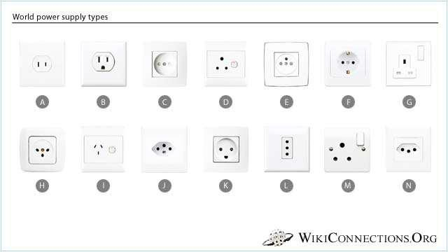

b. Internet:
Wireless LAN service is planned in the meeting room.

c. Currency:
The local currency is Brazilian Real (BRL).
USD 1 = ± R$ 4.72 (as per April 8, 2022).

d. Weather:
In Niterói and Rio de Janeiro September is near the end of winter season, temperatures ranging from an average low of 19°C to an average high of 24°C, mostly sunny.

