S-100 5.2.0 US comments

As implementers start digging into the draft edition of 5.2.0 that is currently out for HSSC approval they have noted that there are a few corrections that need to be made. These corrections have been vetted by the S-100 Technical Experts and the corrections/clarifications have been submitted by the United States as part of their vote on S-100 Edition 5.2.0. They are as follows:

- Revisions to Part 10c Table 10c-6 in red below:

23 | Metadata | metadata | 0..1 | String | MD_Metadata.fileIdentifier  Name of XML metadata file (clause 10c-12).  Ref. S-100 Part 8.  Must be present and populated if an ISO XML metadata file describing this dataset is included in the exchange set; must be omitted otherwise.

- S-100 Part 9 - Hatch Fill - S-100 states that there can only be one hatch fill - amend schema for Hatch to maxOccurs = 1
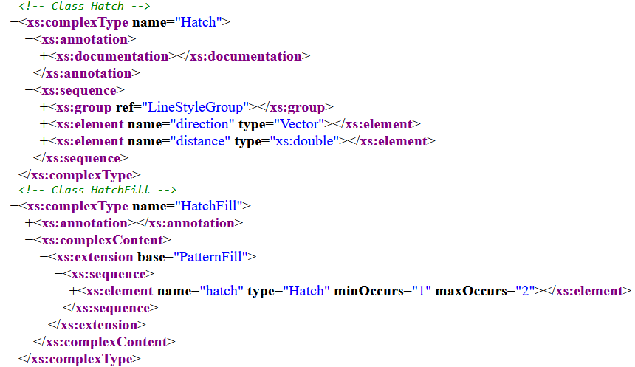

- Typo in S-100 5.1 Table 5-A-10 S100_FC_FeatureAssociation
UML will need to be updated
Multiplicity should be 0..*
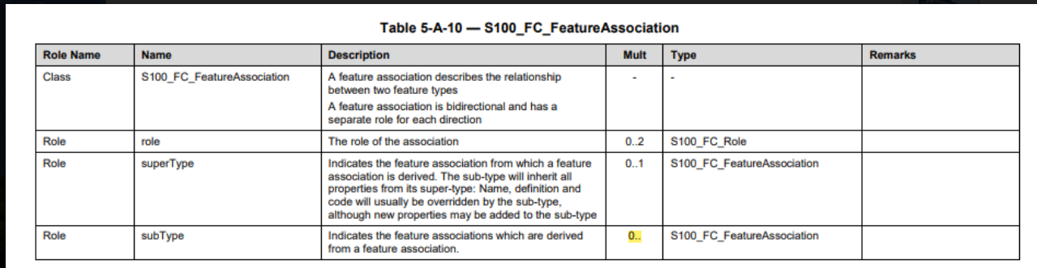
- Permit.XML

No. | S-100 Version No. | Part No. | Section No. | Proposal Summary
1 | 5.2.0 | 15 | 8.8 | Update the examples of digital signatures in 15-8.8 (Additional digital signatures) to use XML examples conforming to the Part 17 exchange catalogue model..
2 |  | 15 | XSD | Update Part15.xsd to allow {header, products} [1..*] internal structure decided by Part 15 breakout group
3 |  | 17 | XSD | Update exchange catalogue XSD file to replace import of old Part 15 XSD file with new Part15 XSD file

Detailed revisions in red below.

Item 1: Replace the examples of signatures in discovery metadata with the examples below.

(datasetDiscoveryMetadata entry)
<S100XC:digitalSignatureValue>
<S100SE:S100_SE_SignatureOnData id="s1" certificateRef="PROD1"
dataStatus="unencrypted">(sig. omitted)</S100SE:S100_SE_SignatureOnData>
</S100XC:digitalSignatureValue>

<S100XC:digitalSignatureValue>
<S100SE:S100_SE_SignatureOnData id="s2" certificateRef="RENC1"
dataStatus="encrypted">(sig. omitted)</S100SE:S100_SE_SignatureOnData>
</S100XC:digitalSignatureValue>

<S100XC:digitalSignatureValue>
<S100SE:S100_SE_SignatureOnSignature id="s3" certificateRef="DIST1"
signatureRef="s2">(sig. omitted)</S100SE:S100_SE_SignatureOnSignature>
</S100XC:digitalSignatureValue>

Item 2: The breakout group for S-100 Part 15 decided to change the structure of PERMIT.XML to allow multiple permits in a single file, structured as outlined below:

<Permit>
<header>...content of header 1 ... </header>
<products>...products using the permit in header 1 ...</products>
<header>...content of header 2 ...</header>
<products>...products using the permit in header 2 ...</products>
... additional header/products pairs ...
</Permit>

In short, the permit file will now allow a sequence of header/products pairs. Header / products pairs after the first are optional.

Two changes to the Part 15 XML schema are required:
1) The multiplicity of the sequence content of the Permit element in the Part 15 XML schema needs to be changed to allow the new structure.
2) Since this change is incompatible with the old Part 15 XML schema, it will be necessary to update the namespace in the Part 15 schema to use an Edition 5.2 namespace.

Item 3: Since the exchange catalogue schema imports the Part 15 schema, it will also be necessary to update the exchange catalogue schema to import the new Part 15 schema. As a consequence of the incompatibility of new and old imported schemas, the exchange catalogue schema will also require a new Edition 5.2 namespace.

- Part 15 clause 8.4.1 needs to have additional clarification as the IHO will have both a Scheme Administrator certificate to create scheme Data Server certificates, and an IHO Data Server certificate used to digitally sign and distribute e.g. S-100 portrayal/feature/interoperability catalogues. Important to inform both system developers and users of the protection scheme about these two roles for.

Add the following text to clause 8.4.1 - The schema administrator may also issue a data server certificate to itself.
- Part 15 -
Table 8.11.1 | ed | PRIMAR has seen many examples of different encodings of schemeAdministrator; for example root, IHO, urn:mrn etc. Add correct encoding in table 8.11.1 to remove any ambiguity. Other attributes include example encoding, e.g. productIdentifier, optimumDisplayScale, identifier | Add the following text to the schemeAdministrator Remarks column: The encoding of IHO as schemeAdministrator is <S100SE:schemeAdministrator id="IHO"/> | Add as an example

- Change Proposal (4a-5.4&4a-5.6) - Both NOTE3 in Table 4a-1 of Section 5.4 and the constraint (g) in Table 4a-4 of Section 5.6 have the same content: "(The use of geographic bounding box is recommended - see Section 5.6.3)" in the end, in which "see Section 5.6.3" should be amended to "see Section 5.7.3".
- Change Proposal (Appendix 6-A 6-A-2) The sentence: "This example is similar to A.2. It defines a projected CRS by referencing the EPSG Geodetic Parameter Data Set. " Should be amended to: "This example is similar to A.1. It defines a projected CRS by referencing the EPSG Geodetic Parameter Data Set. "
- Change Proposal (Appendix 6-A 6-A-4) Add ">" symbol at the end of the last line: "</SC_CompoundCRS:example4".
- Change Proposal (7-4.1) "This profile consists of simple geometry which can be expressed in multiple configurations as described in ISO 19107:2003 clause 6.1.3. ", the clause 6.1.3 should be changed to clause 6.1 or Chapter 6.
- Change Proposal 7-4.2.1.1 In section Circular arc by 3 points (circularArc3Points) , "The interpolation defined by a series of three DirectPositions on a circular arc passing from the start point through the middle point to the end point for each set of three consecutive controlPoints. " should delete "three" before DirectPositions.
- Change Proposal (8-3.2&8-9) - "ISO 19130, Geographic information — Sensor and data models for imagery and gridded data" should be amended to "ISO 19130, Geographic information — Imagery sensor models for geopositioning ".
- Change Proposal (8-7.1 Figure 8-21) - "Figure 8-21 - S100_IF_Point" should be changed to "Figure 8-21 - S100_IF_PointSet"
- Change Proposal (10a-3) - The phrase "Structure implementations" from the sentence "ISO/IEC 8211:1994, Specification for a data descriptive file for information interchange Structure implementations." should be omitted.
- Change Proposal (10a-4.4) - "The body of the table specifies the subfield names and labels as well as the ISO/IEC 8211." should be changed to "The body of the table specifies the subfield names and labels as well as the ISO/IEC 8211 format." Add "format" at the end of sentence.
- Change Proposal (10a-6.1.2.2) -
Number of Surface records | NOSN | b14 | Number of surface records in the data set
Number of Feature Type records | NOFR | b14 | Number of feature type records in the data set
Incorporate "type" to ensure consistency between the content of "Subfield content and specification" and "Subfield name".
- Change Proposal (10a-6.2.2.6)

Datum Source | DTSR | b11 | {1} - IHO CRS Register  {2} - Feature Catalogue  {3} - EPSG  {254} - Other Source  {255} - Not Applicable
Datum Source Information | SCRI | A() | Information about the CRS source if DTSR = ‘Other Source’
"CRS" should be replaced by "datum".

- Change Proposal (10a-7.1.2.1) - The title "Information Type Identifier field structure" should be changed to "Information Type Record Identifier field structure."
- Change Proposal (10a-7.2.4.1) - There is a typo in the 2nd sentence - replace "filed" with "field": "3)Modify Segments ... record. Each segment that is to be modified must have at a Segment Header filed, a Coordinate Control field and if necessary the appropriate Coordinate fields."
- Change Proposal (10a-7.2.4.2.8) -
Number of derivatives at start and end | NDRV | b11 | The number or derivatives at each end. The number of derivatives at the start and end must be the same. If the start and end have different numbers of derivatives the missing values must be encoded as ‘omitted’ values (see 10a-3.5)
Number derivatives Interior | NDVI | b11 | The number of interior derivatives required to be continuous. For example., “2” means the first and second interior derivatives must be continuous
There is a typo in the 1st sentence – replace “or” with “of”:
- Change Proposal (10a-7.3.2.4, 10a-7.3.2.5) - 10a-7.3.2.4 title "Feature Association field" should be " Feature Association field structure" 10a-7.3.2.5 title "Theme Association field" should be " Theme Association field structure"
- Change Proposal (10b-8.2.1) - The first sentence below Table 10b-1: "All S-100 types referred to in Table 10a-1 are defined within the S-100 GML Profile." should be amended to: "All S-100 types referred to in Table 10b-1 are defined within the S-100 GML Profile."
- Change Proposal (10b-10.3) - The sentence: "2. Add the S-100 GML Profile compliance declaration within the schema annotation.The compliance declaration is the XML code in Table 10b-1 above." Should be amended to: "2. Add the S-100 GML Profile compliance declaration within the schema annotation.The compliance declaration is the XML code in Table 10b-2 above."
- S-100 Part 17-4.4.1 (in red): Fileless cancellation may be achieved by using a dataset metadata entry with the filename and original digital signature specifying the resource to be cancelled, and with all other mandatory metadata fields also set to the same values as the original, with the exception of the issueDate which must be set to the issueDate of the fileless cancellation itself.

