Title: Addressing Capability Gaps in the S-100 Portrayal Model
S-100 Maintenance - Change Proposal Form

Organisation | NIWC | Date | 1/16/2020
Contact | David Grant | Email | S100Viewer@navy.mil

Change Proposal Type (Select only one option)
1.Clarification | 2.Correction | 3.Extension
 |  | X

Location (Identify all change proposal locations)
S-100 Version No. | Part No. | Section No. | Proposal Summary
4.0.0 | 9 | Throughout | Closes gaps in part 9
 | 9a | Throughout | Closes gaps in part 9a

Change Proposal
See accompanying redlines for part 9/9a. Fig. 9-10 UML changes highlighted:
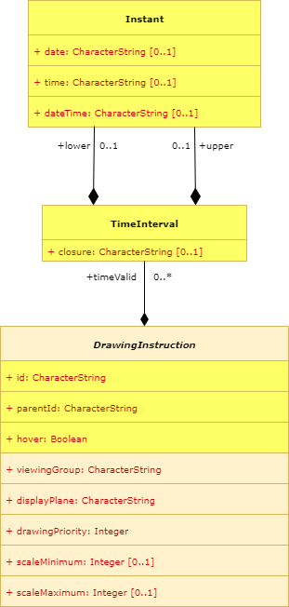
Instant constrained
To: date, time or dateTime

Change Proposal Justification
See TSM7-5.4 Addressing Capability Gaps in the S-100 Portrayal Model.

Adds support for S-52 hover-over, Date Dependent Symbology, and Dependent Symbol Visibility (labels and highlights – e.g. text and SY(INFORM01 / CHDATD01))

What parts of the S-100 Infrastructure will this proposal affect?

☐ S-100 Feature Concept Dictionary Interface or Database
☐ S-100 Portrayal Register
☐ S-100 Feature Catalogue Builder
☒ S-100 Portrayal Catalogue Builder
☒ S-100 UML Models
☒ S-100 GitHub Schemas

Please send completed forms and supporting documentation to the secretary S-100WG.

