S-100 ECDIS Governance Document
Draft: v008 11th Dec 2021

Contents
1. Definitions and Background 4
1.1. Introduction to the S-100 ECDIS and Dual fuel Mode Governance Document 4
1.2. Addressing the needs of the Stakeholder groups 4
1.3. What is an ECDIS? 5
2. S-100 and ECDIS - Introduction 6
2.1. Model based design 7
2.2. Multiple Product Specifications 7
2.3. Machine Readability. 8
2.4. What is an S-100 ECDIS? 8
2.5. The three types of ECDIS data 9
2.6. S-100 ECDIS operation 10
2.6.1. The S-100 ECDIS “Operating Model” 10
2.6.2. Data “Validation” on S-100 ECDIS 11
2.7. Regulatory status of data in S-100 ECDIS. 12
3. The Rationale for Dual Fuel. 13
3.1. The consequences of not introducing dual fuel 13
4. Operation of S-100 ECDIS in Dual Fuel Mode. 14
4.1. The Original Dual Fuel concept 15
4.2. The mechanisms of Dual Fuel 16
5. How is S-100 ECDIS and Dual Fuel mode supported by the IHO community 19
5.1. OEM implementation of S-100 19
5.2. Revisions of IHO standards and product specifications 19
5.3. Data Producer impacts and options for co-production. 20
5.4. Data Producer impacts from other product specifications. 23
6. Annex : Standards and support 24
6.1. Component IHO standards for ECDIS 24
6.2. S-100 and S-57 Standards comparison 24
6.3. S-100 Standards 24
7. Annex 2: Summary of identified gaps. 27
7.1. Versions of datasets. 27
7.2. Revision of IMO Documentation 27
7.3. Loading Strategy. 27
7.4. ENC Co-Production Strategies 28
7.5. Scope of implementation for OEMs 28
7.6. S-100 product specification overlays on ENC. 28
7.7. Support to the external communities (including test data provision) 28
7.8. Impacts of Enhanced ECDIS functionality. 28
7.9. How many revisions of product specs are required to be implemented by OEMs? 29
7.10. Phasing out S-57 29
7.11. Impact of Changes to ENC on end user. 29
7.12. How to update S-100 itself 29
7.13. S-128 development. 30
7.14. Categorisation of product specifications. 30
7.15. The S-100 ECDIS Operating Model. 30

Revision History | Date
Created Initial Draft v007 | Jonathan Pritchard December 2021
v008 Revised for WG review and presentation | December 2021

Definitions and Background

Introduction to the S-100 ECDIS and Dual fuel Mode Governance Document
The S-100 ECDIS and Dual Fuel Governance document was originally conceived with the following aims:
- Recognise and define each of the stakeholders and end users of the S-100 ECDIS
- Capture all the relevant details at a high level and describe the “changes” required across the entire ecosystem.
- Describe the S100 ECDIS and the Dual Fuel “concept”, defining how it builds the picture for the end user from multiple data layers and products. This should also relate how these component parts interact together in the defined stages of navigational processes according to IMO definitions.
- Detail the IHO’s transitionary period. Examples would be how data producers cope with co-production of S-57/S-101, how to assess the benefits, costs and risks of production of multiple data products (e.g. S-102) in addition to S-101, how type approval testing is implemented
- Fill in the detail between the conceptual IMO processes, the defining standards, the producing entities and the supporting stakeholders; so from each users’ perspective, how do they contribute to the operation of the system by the user. Summary of the detail included in existing IHO standards.
- Define how primary supporting bodies (RENCs, RHCs) can support distribution and any likely changes.
- Define summary information suitable for communication with IHO member state stakeholders and the community defining S-100 ECDIS focused on the IMO Performance Standard.
In essence the Governance document presents a view of S-100 ECDIS and Dual Fuel Mode which can be used as a definitive guide containing just the essential details. The rest of the technical detail is defined by the component standards defined by the IHO, IEC and under revisions to IMO conventions and performance standards.
The governance document ultimately represents the views of those who have contributed to it. Contributors have been drawn from across IHO Member states, ECDIS OEMs and S-100 Technical Experts. In addition to major workshops held in September and October 2021, several follow up sessions have been held, all of which resulted in the draft document presented.
This document includes sections which highlight where current (at the time of writing) gaps exist in the IHO standards base and other allied structures, but much of the document is written without drawing attention to these gaps in order to present a complete, holistic picture of S-100 ECDIS and Dual Fuel Mode. The gaps themselves are documented in more detail in section 7 along with current thinking and areas of current development.

Addressing the needs of the Stakeholder groups
While assembling the Governance Document the stakeholder groups were consulted both individually and within a group context. The groups consulted were:
- The IHO Member states and representatives of the data producer communities, including representatives of data validation/distribution, tool manufacturers, allied industries
- ECDIS developers (“OEMs” in this document) responsible for the construction of hardware/software systems implementing S-100 alongside the current IHO standards in ECDIS. Also included in this group were representatives of the international technical standards groups outside IHO responsible for ECDIS implementation within the IMO community.
- Representatives of the IHO technical standards working groups.
The following diagram shows these broad stakeholder groups and their domains within the context of ECDIS “use”, that is its construction and testing and how data is constructed and supplied to it. Notable, of course, is the view of the end user in this list of stakeholders. The topic of consultation with the end user is a far larger subject than the scope of the current governance document – many end user requirements are present in current ECDIS and their views are (at least partly) represented by the other stakeholders.
The primary reason for creation of the governance document is to provide a central view of how S-100 ECDIS “works” and, in particular, the dual fuel mode and this is possible without engaging in a (necessarily large scale) end user consultation.

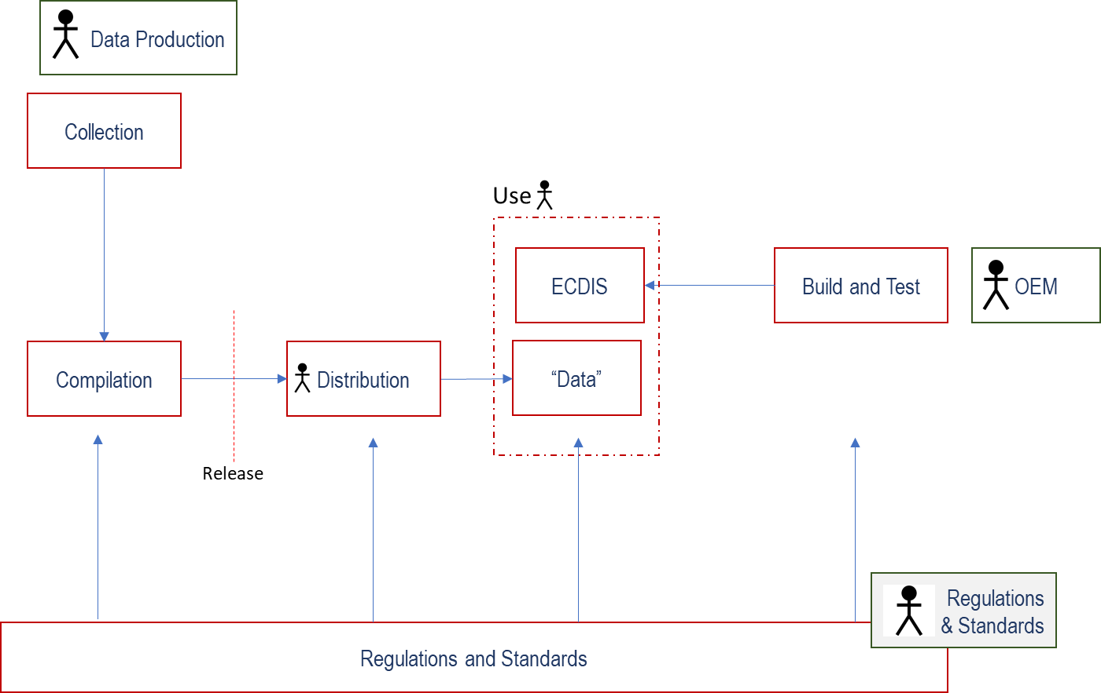

These broad groupings of stakeholders have different requirements for the Governance Document and the technical standards it references:
- Data Producers require comprehensive descriptions of options and definitive statements of how ECDIS implementation will reflect their decisions and actions as they implement Dual fuel production and S-100 for charts and nautical publications.
- ECDIS OEMs require definitive descriptions of how S-100 implementation should be addressed, with assurances that technical implementation is sound, unambiguous and complete. OEMs require comprehensive summaries of the standards regime and where each component part is located/defined.
- Regulators and representatives of IHO technical working groups require confidence that the full spectrum of the international conventions defining the requirement for ECDIS have been addressed without omission, and that technically rigorous and sound approaches exist in all the component standards. Where gaps exist at the time of writing they should be clearly recorded and detailed.
This document attempts to provide content meeting all stakeholder requirements. This is done by providing a mixture of normative specification which may not exist in component standards alongside descriptions of options where they exist.

What is an ECDIS?
An ECDIS is a navigation system which is designed, constructed and tested to meet the standards required for primary navigation under the SOLAS convention when combined with official data. The IMO Performance Standard sets out the required functionality of ECDIS, and the technical standards to which it refers.
[insert SOLAS text]
An S-100 ECDIS which conforms to the (soon to be) updated IMO Performance Standards which specifically reference S-100 and is the implementation of the IHO’s S-100 framework, realized for primary navigation of SOLAS vessels.
ECDIS has, of course, been in existence for many years and is defined by a combination of the type approved hardware and software developed by Original Equipment Manufacturers (“OEMs”) and official chart data, issued by, or on behalf of, authorized Hydrographic Offices. Such data is encoded using the S-57 standard for its content and, largely, the S-63 standard for its packaging, data protection and authentication.
An ECDIS is (currently) a machine designed for importing data in S-57 format supported by S-63 and providing a user with a set of machine behaviours which meet the provisions of the IMO Performance Standard.
The broad functional groups are :
- Chart Loading, Unloading
- Updating, from automated updates and manually
- Display (Portrayal)
- Feature Interrogation
- Alarms and Indications, Areas where special conditions exist and Safety Contour Generation.
- Route Planning and Monitoring
- "Other" functions - stipulated by the IMO PS.
SOLAS places an obligation on member states to produce and promulgate ENC data to support mandatory carriage of ECDIS. Currently that mandate is fulfilled by the production of S-57 ENC charts.
The addition of S-100 to the IMO PS will allow S-100 data to also satisfy the carriage requirement of ENC. States will provide ENC data which is safe as defined by the relevant standards. The addition of S-100 to the IMO PS will also allow S-100 data to satisfy the carriage requirement for nautical publication in electronic form (ENP).

S-100 and ECDIS - Introduction
S-100 is the IHO’s “Universal Hydrographic Data Model”, currently at edition 4.0.0 with edition 5.0.0 in advanced stages of development. The S-100 framework defines:
- An encompassing standard for the expression of marine phenomena in multiple, discrete, named “product specifications”
- A set of three encodings (ISO8211, HDF5 and GML) in which datasets can be expressed for ingest to the ECDIS
- A set of registries located at the IHO storing feature concepts, portrayal items, product specifications and normative reference documentation.
- Metadata structures conformant with ISO19115
- A General Feature Model which describes how the fundamental entities making up S-100 datasets are structured along with their geometry.
- A Feature Catalogue structure which allows the registry entries to be bound, related and transported in a defined, validatable XML format.
- A specification for a portrayal engine, capable of expressing the richness of portrayal required by ECDIS.
The S-100 ECDIS is conformant with the S-100 framework, rather than a discrete, fixed list of individual product specifications. An S-100 ECDIS thus provides a platform on which multiple S-100 products can be used by an end user.
One of the core concepts of S-100 is the idea of the “Universal Hydrographic Data Model” – this fundamental development is that S-100 does not specify, in any of its component parts, actual marine geospatial “data” itself. S-100 provides an all-encompassing (“Universal”) set of tools and guidance for the modelling and specification of marine (“hydrographic”) phenomena in product specifications (“Data Model”). This concept extends the domain of IHO standards from purely chart-based (S-57) to any number of maritime, and marine related domains by the application of a rigorous modelling process, the definition of concepts and their entry into the IHOs geospatial registry and the bindings of those concepts into expressible product specifications in a number of appropriate data formats. Assistance for developers of product specifications is provided by the IHO through IHO S-97. Models are generally constructed using a subset of Unified Modelling Language (UML) structures and then translated to instances of an IHO Feature Catalogue, usually alongside an accompanying portrayal catalogue and encoding. The three fundamental elements of the S-100 concept most relevant to development and implementation of S-100 ECDIS development are:
- The idea of the implementation of a “model”
- Multiple product specifications
- Machine Readability
Many of the core concepts are defined under the ISO191XX framework and S-100’s implementation of them is comprehensive. The ISO frameworks are not explored in this governance document but they provide a design basis for many of the designs of S-100’s elements, the general feature model, geometry, feature catalogue and the IHO geospatial registry. The aim of S-100 is to provide a standalone framework, however, which can be understood and implemented with the minimum of external references, a crucial point for implementers of ECDIS systems.

Model based design
S-100 is a model based framework encapsulating a description of a generic model, the S-100 General Feature Model, together with a description of types, attributes and geometry. These are all core ISO concepts which have been realized by S-100. Under S-100, marine phenomena are modelled in product specifications via a descriptive framework based on the Universal Modelling Language (UML) and the norms laid out in S-100. Such Application Schemas are “instances” of the core S-100 schema. The S-100 ECDIS implementer develops compatibility with the S-100 framework, not its specific instances, the product specifications. The fundamental design principle is that the S-100 ECDIS is “dynamic”, compatible not just with a core set of IHO product specifications, but with the entirety of marine geospatial data expressible by the S-100 model.

Multiple Product Specifications
The second of the core concepts of the S-100 ECDIS is that of multiple product specifications. S-100 itself defines no “data content” but leaves it to independent product specifications, defined to be conformant with the S-100 framework. These product specifications define formats of data which can be ingested, installed and used on the S-100 ECDIS in a seamless and integrated way. S-100 Part 16 defines an interoperability mechanism for the harmonized portrayal of multiple product specifications. This interoperability mechanism defines up to four levels of interoperability in progressively increasing sophistication (only the first two levels are for implementation in S-100 ECDIS as documented in S-98). The interoperability mechanisms allow for simple interleaving of portrayal of multiple product specifications and the suppression of features between multiple product specifications to “de-clutter” and harmonise the S-100 ECDIS display.
The impact of multiple product specifications on the S-100 ECDIS is profound. Such product specifications offer data producers the opportunity to deliver far more sophisticated data to end user systems alongside the regulatory minimum electronic chart data. Additionally, the addition of nautical publication data to the ECDIS enables fully digital planning processes and contextual enhancement of existing chart data for the end user. The transition to multiple product specifications will have impacts across the entire data chain from producers to the end user. This Governance Document only presents the defining standards and constraining on this transition for clarity. The areas of S-100 ECDIS most affected in these terms are:
- How data production is impacted, including best practices
- Interoperability and use of multiple product specifications for navigation and planning on the ECDIS
- The impact on regulatory approval and inspection

Machine Readability.
The other core concept of the S-100 framework, and the S-100 ECDIS is that the framework defines a set of fixed-format machine readable files, from which an implementing system’s behaviour is derived. This allows the implementing system (the S-100 ECDIS) to be fully dynamic and scalable in respect of several significant categories of its behaviour:
- Ingested data and metadata content
- Data portrayal, including interoperability between multiple datasets of differing product specifications.
- Alarms/Indications
The move to a model-driven and machine readable environment for the S-100 ECDIS is a significant one. In contrast to IHO S-57 where the feature/attribute definitions and content were set within the standard itself, S-100 defines a number of standardized forms for expressing certain aspects of the data content and operation of the ECDIS, via machine readable files which conform to the standardized forms. Where S-57 used machine readable files (for example revision control (S-63’s PRODUCTS.TXT) and portrayal (the .dai file)) these now form a core part of the framework and have their own defining schemas. In most cases these standardized forms are expressed as XML Schemas, maintained by the IHO.
The following functional areas have their descriptions formalized in S-100 and schemas for machine-readable files defined.
- Feature content, Attribute content, definitions, bindings and textual descriptions
- Portrayal, symbology and colours
- Conditional Symbology processing
- Service revision status (the revision status of each piece of data in the system and its individual coverage)
- Context Parameters and Viewing Group titles
- Interoperability (defined under S-98), which allows product specifications to interact with each other harmonising the portrayal and function of data. This allows states who wish to issue such enhanced data to end users to have it used as part of the ECDIS’ core functionality.

What is an S-100 ECDIS?
The “S-100 ECDIS” concept is in essence:
      - A navigation system compatible with the entirety of the S-100 “Framework” and able to ingest not only datasets conformant with established S-100 product specifications but also future product specifications which are similarly conformance with the framework.
      - During the transition period a navigation system implementing S-100 will be inherently “dual fuel” in nature – it will deal with both S-100 based navigational products as well as legacy S-57 ENC charts presenting a harmonised “side-by-side” chart display system for the end user. The “dual fuel” mode only describes how the provision of nautical charts is achieved. Other product specifications can also be used with S-101 while in dual-fuel model
      - The core IMO concept of an ECDIS currently remains unchanged as a minimum performance standard for the nautical chart part of digital navigation.
      - The current IMO ECDIS may also be able to present nautical publications, as IMO has allowed it, see the related quotations below from MSC.232(82). This discussion is ongoing over the best approach for the revision of IMO documents specifically in relation to Nautical Publications, and the accompanying categorisation of IHO product specifications.
THE MARITIME SAFETY COMMITTEE,
NOTING that the up-to-date charts required by SOLAS regulations V/19 and V/27 can be provided and displayed electronically on board ships by electronic chart display and information systems (ECDIS), and that the other nautical publications required by regulation V/27 may also be so provided and displayed,
7 DISPLAY OF OTHER NAVIGATIONAL INFORMATION
7.1 Radar information and/or AIS information may be transferred from systems compliant with the relevant standards of the Organization. Other navigational information may be added to the ECDIS display. However, it should not degrade the displayed SENC information and it should be clearly distinguishable from the SENC information.
7.2 It should be possible to remove the radar information, AIS information and other navigational information by single operator action.
7.3 ECDIS and added navigational information should use a common reference system. If this is not the case, an indication should be provided.
      - S-100 ECDIS shall have compatibility with an arbitrary set of S-100 product specifications which conform to the specifications within IHO S-100. These product specifications form a set of interlocking data products which are used to form the interface with the end user.
      - The navigational core of the system is the provision of IHO S-101, S-102, S-104, S-111 and S-128 data which provide the “equivalent” of the current global S-57 ENC database.
      - S-101 data can then be enhanced with data from (at least) a set of further navigational products, such as:
- S-122 Marine Protected Areas
- S-123 Marine Radio Services
- S-124 Navigational Warnings
- S-126 Marine Physical Environment
- S-127 Marine Traffic Management
- S-129 Under Keel Clearance Management
- S-131 Marine Harbour Infrastructure
      - The system can also import, load, display, interrogate, and “use” data from other IHO S-100 compliant product specifications. This is done by loading data and its catalogues which enable and configure the ECDIS’ compatibility with that data.
      - The user interface and behaviour of the ECDIS is similarly configurable. Configurable elements within the system (i.e. those configurable by machine readable product specifications defined under S-100) include:
  - Feature content, Attribute content, definitions, bindings and textual descriptions
  - Portrayal, symbology and colours
  - Conditional Symbology processing
  - Service revision status (the revision status of each piece of data in the system and its individual coverage)
  - ECDIS Interoperability (defined in S-100 and S-98), which allows product specifications to interact with each other harmonising the portrayal and function of data. This allows states who wish to issue such enhanced data to end users to have it used as part of the ECDIS’ core functionality.
      - Manufacturer equipment shall continue to be tested using IEC61174 for type approval certification referring to the appropriate parts of IHO S-64 (S-57 test datasets for ECDIS) and S-164 (the S-100 test dataset suite).

The three types of ECDIS data
As stated in the previous section, data in the S-100 world can be assigned one of three different categories. A distinction/classification is made between:
- S-100 product specifications specifically designed for use as navigational charts (in the IMO sense) – S-101 and S-401 currently fit this description. Charts are a mandatory minimum requirement and are always present in some form on the ECDIS.
- S-100 product specifications designed to enhance specific features included in electronic charts. S-102, S-104 and S-111 fit this description. From the IMO/IHO perspective, these product specifications can be seen as integral to chart content and are therefore (optional) “extensions” of chart data. These product specifications are likely to be optional for users but may be mandatory depending on individual maritime safety authorities.
- S-100 product specifications containing data, of which the larger proportion is derived from existing Nautical Publications. Although these product specifications may contain features already included in electronic charts, their content may also be unique to those product specifications and provide (predominantly textual) support to the mariner during planning. Although carriage of nautical publications is mandatory under SOLAS carriage of IHO conformant nautical publications in digital form is not (currently) and SOLAS only makes passing references to examples for the exact requirement. This may be captured in future revisions to IMO instruments but is currently undefined.
In order to make dual fuel mode work it is important that some notion of “equivalence” is defined between the two “chart” products. IHO does not currently define a class of “chart” – this is needed, as noted by several individual stakeholders, to define “chart” and “nautical publication” and to which category individual product specifications fit into. The backdrop to S-100 ECDIS (and existing ECDIS) is a “chart” and is always present. S-101 clearly is the “chart” (as is S-401 inland ENC). Other layers on top of the chart are then either directly chart-related or nautical publications.
Mapping of S-1XX products to Nautical Publications is many to many. So, an individual publication can contain data which is in multiple product specifications and different product specifications can contain data in multiple publications. Despite this, a broad classification and mapping can be formed, e.g.
- Tide Tables: S-104
- Sailing Directions: S-127 + S-131 + S-101
- List of Radio Services: S-123
From an equivalence point of view this mapping should be constructed by IHO HSSC WGs cooperatively and used to define capabilities of ECDIS to satisfy SOLAS compliance in respect of Nautical Publications. IHO will state equivalence of categories of Nautical Publication with collections of one or more S-100 product specifications to inform their equivalence with existing paper publications by issuing authorities. This may require clarification of the current wording in SOLAS.

S-100 ECDIS operation

The S-100 ECDIS “Operating Model”
Operation of S-100 ECDIS is the end result of the data chain, from data production, its validation, packaging and distribution to the end user ready for installation.
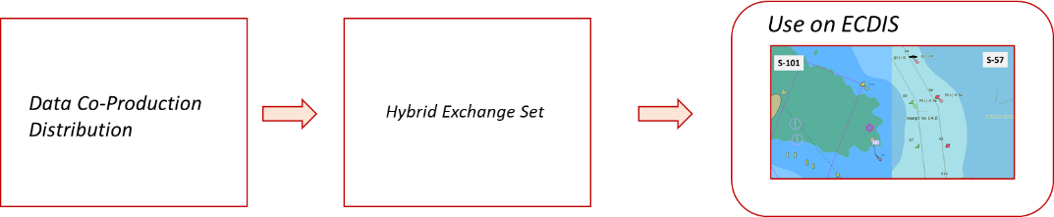
Figure 1: The data chain from production, packaging and use
These elements are all defined in this Governance document. The operation of the S-100 ECDIS is not defined in a single place and is, to some degree, down to the implementation of the OEM creating it. The standards defined by IHO, IEC and the IMO Performance Standard MSC 232(82) list all required functionality. Additionally some elements of S-98 Annex C define processes for data ingest and import and areas of functionality which may lie outside S-100 itself.
Together, the IHO standards define an “operating model” for the S-100 ECDIS, which, together with the existing standards for S-57 ECDIS provide all necessary elements for S-100 ECDIS development.
It is important to note that much of the operating model of the S-100 ECDIS is captured in the S-164 test data and scenarios it describes. Whether this sum total of standards and procedures they define for S-100 ECDIS (and dual fuel mode) is sufficient for ECDIS manufacture, testing and use remains to be seen. It is highly likely that IHO will have to enhance and clarify some of the component standards during the testing phases. Certainly the S-100 ECDIS with Dual Fuel mode has many more processes within it, such as for data ingest, installation, system configuration and use than existing S-57 ECDIS. These may require more extensive specification in the component IHO standards. In particular IHO S-98 and its Annex C (being incorporated into S-100 edition 5.0.0) provides a location for much of the ECDIS functionality not directly related to data content.

Data “Validation” on S-100 ECDIS
One important by-product of the extensive use of formal schemas for machine readable files is the ability to validate the syntax and content of data and catalogues imported to the ECDIS, providing a basic level of sanity checking for data and configuration information
Detailed validation of data delivered to end users through the global distribution chain (including RENCs, VARs and direct channels) will continue and, due to the introduction of multiple products, is likely to include cross-product validation (between S-57 and S-101 and between other S-XXX products and S-57/S-101)
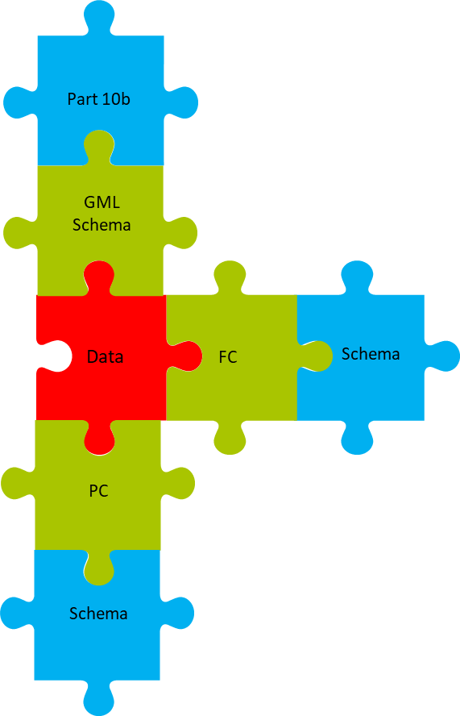
S-100 ECDIS machine-readable files are, generally, XML based with a defined syntax encapsulated in schemas (derived from the S-100 provisions).
These schemas enable the ECDIS to read and validate in an unambiguous way the configuration files loaded to it. The Schemas defined by the S-100 Framework (and defined by each edition of S-100) should therefore be considered a component of the S-100 ECDIS.
The diagram illustrates this concept. The interlocking jigsaw pieces represent data, catalogues and schemas where compatibility is required at a format and/or content level. The red piece represents a dataset instance of a product specification dataset (here encoded using S-100’s Part 10b encoding).
The Green elements (FC=Feature Catalogue, PC=Portrayal Catalogue) are XML files which configure the S-100 ECDIS’ actions in respect of the dataset. This implements the IHO’s “Plug and Play” concept for the S-100 ECDIS, its dynamic approach to feature content, portrayal and behaviour.
The Blue pieces are schemas defined by IHO S-100 and form part of the OEMs ECDIS implementation. These are not part of the plug and play mechanisms (i.e. there is no intention of making them interchangeable on an ECDIS). Indeed, any updates to such schemas would require bespoke engineering from the OEM implementer – this should be part of communications with implementing OEMs to future proof ECDIS manufacture as much as possible.
Red and Green pieces are delivered to the ECDIS in the S-100 Exchange Set (itself described in S-100 Part 4a), the blue pieces are used to ensure the delivered data and any catalogues or machine-readable files are well-defined in terms of their syntax. It should also be noted that the following points follow as a direct consequence of the machine readable nature of such files in the S-100 ECDIS.
- Feature Catalogue and GML Schemas represent the same data structure. GML Schemas may contain restrictions on the GML format data tighter than any imposed in the Feature Catalogue. Their prime purpose though is to allow easy off-the-shelf format validation.
- Validating Feature Catalogues against data is not always an XML validation as data may have GML, HDF5 or ISO8211 formats. For GML, data syntax may be checked against the GML Schema (and its conformance with the Part 10b components), HDF5 and ISO8211 data require bespoke syntax checks to be carried out on the ECDIS prior to data ingest to the SENC. These are, as yet, unspecified and should be distinguished from detailed data validation such as IHO S-58. A basic sanity check against feature catalogue names, types and multiplicities would seem appropriate on ECDIS prior to import but this is not yet specified, nor part of the ECDIS operating model.
- Feature and Portrayal Catalogues are constant for a single revision of a product specification. So, in practice most exchange sets will only include datasets, not portrayal/feature catalogues and the validation of such catalogues against the S-100 schemas (blue pieces) is only required when they are installed or updated.
The requirement to support “updating” of machine-readable files defines a requirement for the S-100 ECDIS to support (at least) two versions of feature and portrayal catalogues (and their use on the ECDIS). This allows for the ECDIS to update catalogues, and receive new editions of datasets as they are released by producers. In all cases, the IHO HSSC and its working groups will coordinate the update and release of all machine readable files, schemas in close cooperation with the S-100 ECDIS stakeholders and user community – this group of stakeholders is likely to be an extension of the current community around the S-57 ECDIS but, as noted by participants, will require fresh approaches to ensure close technical interworking because of the dynamic nature of S-100 ECDIS and the complexity of the S-100 ECDIS.

Regulatory status of data in S-100 ECDIS.
IMO will mandate a continued need for all navigation materials (whether Nautical chart or Nautical Publications) to be “up to date”. Currently this functionality is provided by the revision information held in metadata delivered to the ECDIS and service metadata delivered (in the form of the S-63 PRODUCTS.TXT). This allows the ECDIS to update those datasets which have been delivered and check that all installed datasets continue to be up to date.
When a user has multiple S-100 datasets installed and is using them for primary navigation, whether for planning or monitoring then carriage compliance states they must all be up to date, using the S-100 mechanism for establishing revision status (S-128).
IHO standards contain, within S-98 Annex C, the ECDIS update status reports, for Nautical charts and Nautical publications which record the up to date status of all S-100 datasets installed, using exchange set S-128 data.
To avoid potentially conflicting views of the revision status of charts in Dual Fuel mode, the S-128 data also includes service metadata for S-57 charts. Hence the user must keep all S-100 and S-57 datasets up to date in respect of the S-128 delivered alongside any exchange sets to remain carriage compliant.
S-101 and S-57 are sufficient for carriage compliance under SOLAS and form a minimum requirement. States may wish to place additional requirements on vessels and enforce such restrictions using port state control inspections.

The Rationale for Dual Fuel.
In order to take advantage of the new S-100 framework, a product specification to represent electronic navigational charts (ENCs) has been developed, IHO S-101. This product specification is intended to replace, in time, IHO S-57.
In order to transition to the use of S-100 exclusively (in the context of navigational data) on ECDIS used on the bridges of commercial SOLAS vessels, there is a need to go through a period of transition where:
- Data producers will migrate their existing tools and methodologies to produce
  - S-100 versions of existing S-57 charts (using the S-101 product specification)
  - Optionally, other datasets conforming to S-100 product specifications.
- Distributors will adapt their networks to accommodate S-100 data
- OEMs will construct systems capable of using S-100
- Users are educated and informed of the new capabilities
In order to effect the transition to the use of S-101 electronic charts (and solely in the context of electronic charts rather than the broader considerations introduced by nautical publications) in the most efficient manner a “dual fuel mode” of S-100 ECDIS has been proposed. This mode of operation for the S-100 ECDIS will enable the ECDIS to use ENCs in both S-57 and S-101 forms. The operation of the ECDIS in respect of chart data will be split between the two forms of chart data. This split will extend to all areas of ECDIS functionality, including:
- Data Ingest
- All portrayal
- ECDIS operations including Alarms/Indications
This timeline is illustrated in the following diagram:
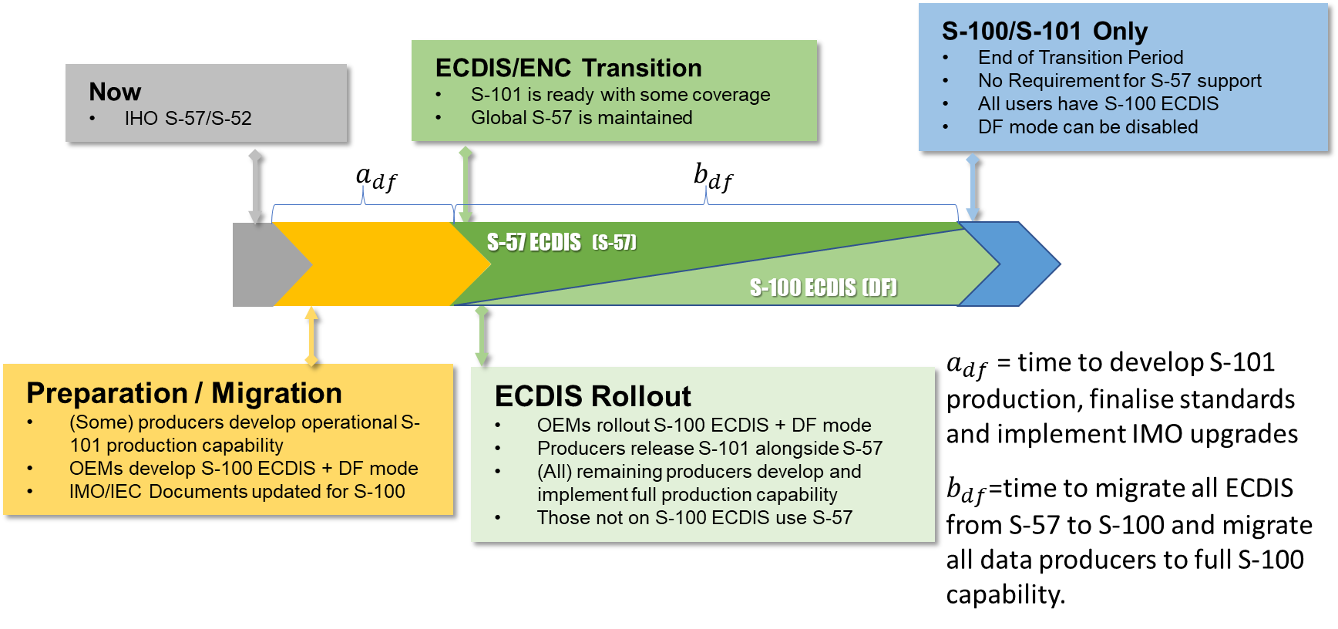
Figure 2: S-100 and S-100 ECDIS Dual Fuel Mode timeline

The consequences of not introducing dual fuel
If a dual fuel approach to S-100 transition is not taken then S-100 ECDIS would be S-100-only on introduction to the market. This would then mean that either :
- S-100 ECDIS could not begin rollout until ALL data producers had established 100% co-production of S-57 and S-101 ENCs

OR

- A “perfect” conversion mechanism was developed for S-57 ENCs to the S-101 form. This 1-1 conversion could be implemented by distributors or even on the S-100 ECDIS itself enabling safe, forward compatible conversion for the emerging S-100 ECDIS.
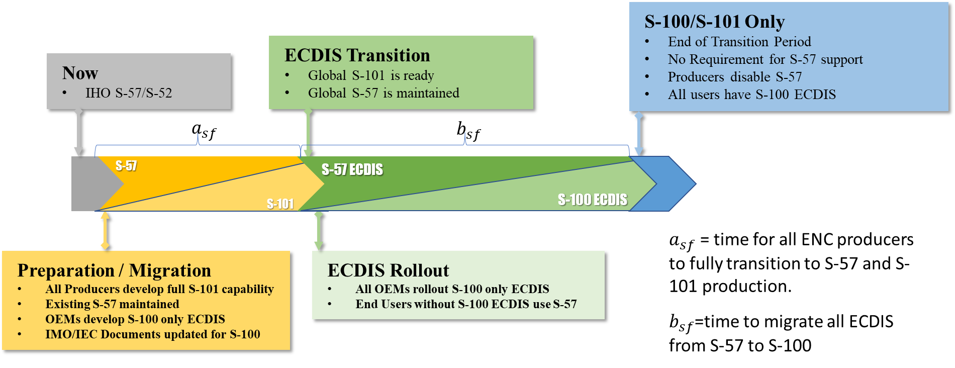
Figure 3: Timeline with No Dual Fuel sf=”Single Fuel”
Option 1 entails a substantial delay in rollout of S-100 ECDIS to the end user and (potentially years) of production by hydrographic offices of both S-57 and S-101 whilst awaiting complete transition by all ENC producers.
Option 2, therefore, presents a possible alternative approach. However, the models driving each ENC form differ significantly in their foundations and in the arrangement of feature/attribute bindings between them. Although a number of processes can be automated, no explicit defined process currently exists which covers the scope of all ENC charts and without ambiguity and which are suitable for co-production for all data producers globally. Additionally, the production of converting incremental updates is (currently) unresolved. More details on this aspect of the dual fuel rationale and current thinking on transition for data producers is contained in section 5.3.
So the rationale of Dual Fuel Mode as the means of delivering transition from S-57 to S-101 charts is that:
- Option 2, the challenge of converting ENC charts from the S-57 form to the new S-101 form, is simply not perfect nor complete
- Option 1, waiting until all data producers have fully transitioned to S-101 entails unacceptable delays for both data producers and OEMs (as well as end users).
Within the dual fuel mode of ECDIS during the transition period, ingest and update should be carried out as harmonised operations and S-100 Part XX contains an arrangement of S-57 and S-100 exchange sets in a harmonised structure. S-98 Annex C contains any specific guidance required for Dual Fuel operations and S-164 contains test data with representative examples of hybrid exchange sets in this form.
Existing S-52 portrayal and ECDIS behaviour in respect of S-57 charts is unaffected by Dual Fuel mode. Dual Fuel mode is a requirement for both chart types to be supported within an integrated form in S-100 ECDIS for the entirety of the transition period to S-101.
During the transition period, and when acting in Dual Fuel mode the ECDIS continues to be suitable for primary navigation and satisfies the SOLAS carriage requirement. As they transition to S-101 across their source data, existing ENC producers will continue to produce and maintain S-57 data to support those users still using non S-100 ECDIS.

Operation of S-100 ECDIS in Dual Fuel Mode.
It is important to note that the Dual Fuel mode of S-100 ECDIS only relates to the operation of the S-100 ECDIS in relation to electronic charts, ENCs, not to its operation in relation to any other S-100 product specification nor the S-100 ECDIS’ potential to meet carriage requirement for nautical publications. The specification, therefore, of how S-100 ECDIS Dual fuel mode works is purely within those boundaries.

The Original Dual Fuel concept
Dual Fuel Mode was originally proposed in a paper to IMO NCSR7. The justification for dual fuel (expanded on in this document in Section 6) were summarized and the statements below included to provide a broad definition of how the Dual Fuel transition was to take place.

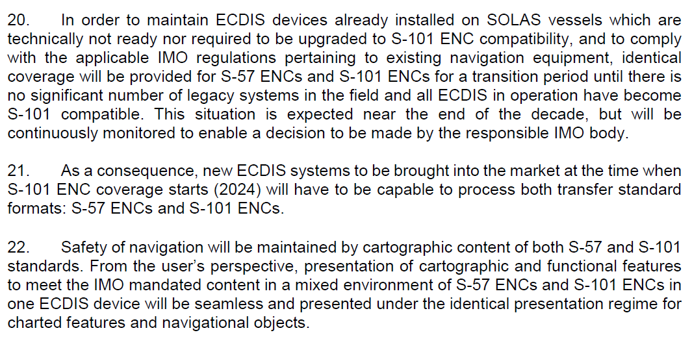
Figure 4: IHO Paper to NCSR
The following clarifications are defined in this Governance Document of the statements made in this paper:
[20]: “identical coverage” | Coverage of S-57 will continue to be provided in addition to the new S-101 form to ensure vessels without S-100 ECDIS are able to navigate safely and ensure carriage compliance. “identical” coverage does not require identical spatial extent of individual ENCs or equal Compilation Scale/Maximum Display Scale of ENCs, nor does it imply identical feature content.
[20]: timescales | All timescales are provisional and are driven by IMO processes for update of the IMO Performance Standard, associated testing standards and satisfactory publication of all dependent IHO standards.
[22]: seamless  [22]: identical presentation regime | The presentation regime will not be completely identical. Indeed the presentation of S-101 charts is driven through the portrayal catalogue developed for S-101 data and is therefore subject to change.  Development of the S-101 Portrayal Catalogue will take into account the need to maintain a portrayal which is sympathetic to the existing portrayal, and which minimizes confusion caused to the end user by modification of existing portrayal and introduction of new portrayal.  However long-standing improvements to existing portrayal will be implemented in the first release(s) of the S-101 portrayal catalogue and so some differences will exist.  All changes to portrayal of S-101 data will be driven by IHO HSSC Working Groups and the need to thoroughly test and account for training and education in the end user community will be an essential part of the update process.

Unstated in the original paper is the operation of the ECDIS in respect of the IMO Performance Standard. This can be viewed in the same way: the original principle was that S-100 ECDIS is “at least as safe as” the existing S-57 based ECDIS.
In essence, the only differences to alarm/indication and anti-grounding under the IMO sections (ref:) are either
- Those conditions which have been withdrawn because of remodeling of S-101 data and which are captured in the S-101 DCEG.
- Improvements due to User selected safety contour and (optionally) WLA processing, as specified in S-98 Annex C
In summary.
[1] Every alarm/indication generated by S-101 data on an S-100 ECDIS should also generate an alarm/indication on an S-57 ECDIS using the corresponding S-57 “version” of the data.
[2] S-57 data may generate more alarms/indications than the S-101 version of the data. These “extra” alarms generated by S-57 data are those which the S-101 data modelling has concluded as “not required” under the S-100 regime.
[3] Additionally, the Water Level Adjustment feature of S-100 ECDIS will alter the placement of safety contour elements and anti-grounding behaviour in areas where S-102 (and S-104) data coincide with ENC chart areas. The User selected safety contour and Water Level Adjustment processes drafted in S-98 Annex C will result in the suppression of the S-101 ENC Depth Areas, Dredged Areas and Depth Contours (in the area of overlap between S-101 and S-102 (and S-104 for full Water Level Adjustment). So, alarms/indications for depth-related features will be significantly improved, and therefore different to those generated by the S-57 data alone.

Alarm/indication behaviour will always be predicated on the principle that the S-100 ECDIS is “no less safe” than an S-57 ECDIS. Similar to the portrayal regime, though, this does not preclude differences between the two modes constituting Dual Fuel operations. Expanding this principle (and bearing in mind the ENC conversion observations made in section 4.10:
In all cases, however the S-101 chart is “at least as safe” as the corresponding S-57 chart. This is because all alarms/indications generated by the S-57 chart are either reproduced in the S-101 chart [1], dropped because they do not represent IMO specified real-world conditions for an alarm/indication [2] or improved upon [3].

The mechanisms of Dual Fuel
Dual Fuel Mode is the operation of the S-100 ECDIS under both the existing S_57 regime and also using the OEM’s implemented support for the S-100 framework. As data producers transition production to full S-101 coverage, existing source databases (the content of which drive production of operational ENC data) are migrated to support fully production of ENCs implementing the data model of S-101.
As cells are completed and ready data producers will release, progressively:
- New S-101 “versions” of ENC coverage for S-100 ECDIS
- Existing S-57 “versions” of ENC coverage for users of ECDIS which are only capable of S-57 ingest
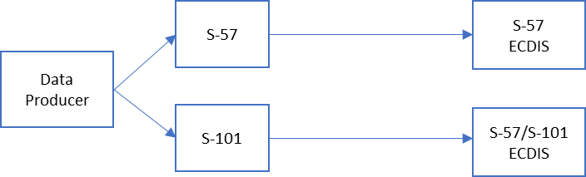
Figure 5: Distribution of data to both S-100 and S-57 ECDIS
These cells are all updated with incremental updates. There are a number of distribution models globally which deal with the transport of data from aggregators or producers to the ECDIS itself. Some of these models are “selective” where only data specific to a customer arrives at the ECDIS, and some are “complete”, where all data within a service is packaged and the ECDIS selects only the data required (and, usually, licenced/purchased as part of a subscription) for installation to the SENC.

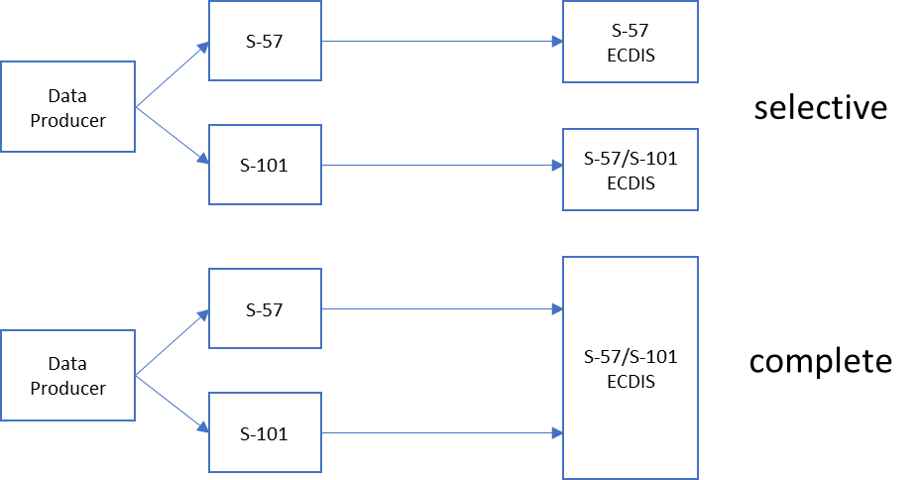
Figure 6: Complete Distribution vs Selective Distribution
The S-100 ECDIS, therefore is likely to be presented with a situation where both the S-57 and S-101 “versions” of a producer dataset are able to be selected and installed. In this situation, S-98 defines a presumption of the installation and use of the S-101 “version” of the dataset in preference to the S-57 version. There is no requirement for only the S-101 version to be installed/used and it has been proposed by some OEMs that an “S-57 only model” may be useful for some users in some areas where S-101 coverage is sparse. Distribution models will almost certainly evolve where only a single “version” of a cell is delivered to the ECDIS depending on its model/version and ability to ingest S-101 data but this can not be guaranteed and a formal mechanism for identifying equivalent cells and resolving such overlaps is therefore necessary.
This is in contrast to the existing model of S-57 ECDIS where only a single “version” of the ENC is ever delivered (along with its updates). The S-57 ECDIS then imports all data it is licenced for and installs it in the SENC, summarized in the following table.
 | S57 | S-100 ECDIS in Dual Fuel Mode
Data Packaging | Anything (S-57/S-63) | Anything (Hybrid Exchange Set, Part XX Metadata defines S-57/S-100 combined contents)
Data Ingest | Everything (licenced, S-63) | Must install at least S-101 version if available, may install both if “S-57 mode” is required.
Selection from SENC | All Installed data | Largest Scale with Preference for S-101 where scales are equal.
Use | S-52/OEM | Portrayal

S-57 ENCs continue to be valid and meet carriage requirements even when S-101 versions exist. The ECDIS is only required to use one version of the definitive ENC for a given region and scale and not split or integrate two versions together – where there is any ambiguity the user is consulted and chooses which to use (the methodology in existing ECDIS for dealing with overlaps within the same usage band). Both S-57 and S-101 ENCs will continue to satisfy carriage compliance there are no issues for the end user for inspection purposes. Additionally, as both S-57 and S-101 remain suitable for carriage, all data (when installed in the SENC) must be kept up to date in line with SOLAS.
The Part 4a Metadata of S-100 Edition 5.0.0 (onwards) contains a detailed specification for combined exchange sets containing S-57 and S-100 product specification data alongside catalogues including optional encryption and authentication mechanisms. These are illustrated in the following diagram.
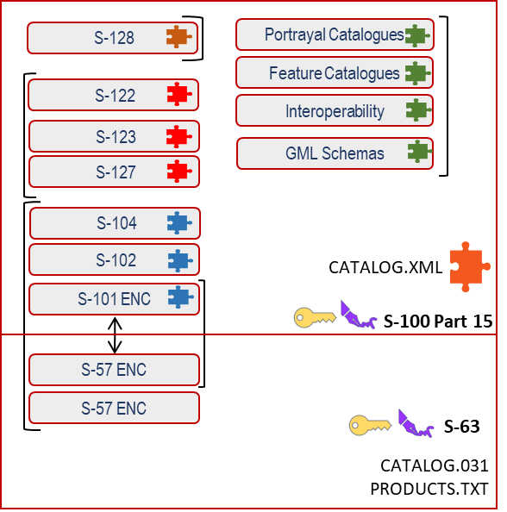
Once installed in the S-100 ECDIS SENC datasets for Dual Fuel mode are selected for use in ECDIS portrayal and operations. The largest scale of data in the SENC continues to be used where necessary for alerts/indications under MSC/232 (82). S-98 Annex C defines in more detail any specific operations relating to Dual Fuel presentation including how portrayal overlaps are resolved. This is an ongoing development, indeed S-98 Annex C provides a good repository for crucial details required by the OEM for detailed implementation over and above what is in the detailed standards.
The OEM implements the existing S-57 regime for ECDIS usage alongside S-100 (the standards defining these are included in section 10.1. this extends to all existing content in S-57, S-52 and subject to the testing regimes defined in S-64. In terms of the actual implementation of dual fuel, few implementation barriers still exist.
Many ECDIS have harmonized portrayal of raster and unofficial vector along with overlays such as AML alongside official ENC for many years. Establishing the loading strategy for S-101 ENCs will improve the definition of how dual fuel mode behaves for the user and also deliver the remaining guidance required for data producers to understand how their ENCs (in both forms) will be used by S-100 ECDIS.
No current process for phasing out S-57 ECDIS nor S-57 ENCs has yet been planned in detail. As S-101 coverage grows and becomes dominant a more detailed phasing out will be planned, alongside any required clarifications in IMO resolutions or IEC documentation.

How is S-100 ECDIS and Dual Fuel mode supported by the IHO community

OEM implementation of S-100
The OEM is responsible for implementation of S-100 within the ECDIS. Contrary to existing S-57, OEM implementation is expected to deal, not only with the initial IHO product specifications for electronic and closely allied datasets but products conforming to specifications currently under development.
It is impossible to predict the detail of future product specifications for S-100 ECDIS but the overall scope shall be defined as that which is necessary to satisfy discharge of international obligations under the SOLAS convention. The authority for defining what constitutes the content of such obligations is IHO standards and IHO will maintain a set of normative standards and allied machine readable catalogues which describe the component product specifications.
An essential component of the IHO’s support to the S-100 community is the provision of comprehensive test datasets (under S-164) which exercise all parts of S-100 required for ECDIS implementation and which express any significant “edge cases”. The test datasets must implement not just ECDIS data but exercise the ECDIS functionality required for its update and configuration in respect of S-100’s machine readable files.
The OEM must, therefore, implement all parts of S-100 described by the S-164 test datasets. Any other elements of S-100 not included in the test datasets but which are required shall be highlighted by the IHO. All test datasets will be referenced against the versions of the product specifications against which they are valid. When product specifications or their component catalogues are updated, test datasets will be revised and published (see 9.2)
The introduction of S-100 to the ECDIS presupposes an extremely close working and technical relationship between the IHO and the ECDIS OEM community. How this is to be formulated and maintained is ongoing, see 10.4.4

Revisions of IHO standards and product specifications
As stated in the previous section, the IHO will maintain the definitive list of current and historical revisions to all IHO standards and product specifications required for S-100 ECDIS. IHO will maintain revision processes for all component standards relating to S-100 ECDIS (and will maintain existing S-57 standards in relation to support for existing ENCs during the transition period).
IHO will also maintain revision processes for all component machine readable files relevant to S-100 ECDIS construction and testing. These are:
- Feature Catalogues
- Portrayal Catalogues
- Interoperability Catalogues
- S-100 Schemas for:
  - Exchange Catalogue
  - Data Protection Permits and Signatures
IHO will maintain a definitive, open and accessible repository of all machine readable files. One of the core aims of S-100 ECDIS is the provision of a system for its dynamic update by the end user. The S-100 ECDIS therefore, must be capable of supporting multiple revisions of individual product specifications and the machine readable files which control their portrayal and ECDIS behaviour.
As update is required functionality, a minimum of two versions is mandatory with no maximum currently defined. S-100 ECDIS must provide, within its core functionality, the ability to import new revisions of machine readable files (feature catalogue, portrayal catalogue and interoperability catalogues) relating to product specifications, and then ingest data conforming to the new versions alongside the previous version(s). No data migration or update functionality in respect of different versions are required within the S-100 ECDIS. Such update processes are specified in S-98 with specific examples in S-164 test datasets including trapping of errors and incompatibilities. Rollout processes for changing of individual feature catalogue and/or portrayal catalogue versions have not been mapped out yet. A more detailed view of the ECDIS operating model would show how data producers are impacted from (potentially) multiple versions of data specifications and their rollout to end users.
The IHO has the authority to set standards in relation to data content and portrayal and this extends to the revision control of machine readable files in relation to ECDIS and their ability to control portrayal and ECDIS behaviour. It is for the IHO (at a level to be defined) to develop, test, release and approve and distribute all machine readable files relating to ECDIS to the ECDIS community.
IHO, together with representatives from stakeholder groups and broader standards bodies will ensure coherence of portrayal and behaviour on ECDIS, particularly during the transition period. As yet no formal set of procedures exist, other than IHO revision processes. In particular no industry/IMO liaison “approval” process or criteria currently exists. The initial release of IHO S-101 and its feature/portrayal catalogue will require communication with end users (and the broader ECDIS community) describing the differences it contains. Portrayal and alarm/indication behaviour will obviously require precise definition and potentially resource implications could be better managed if specific criteria can bound the extent of portrayal changes between S-57 and S-101.
As stated in Section 4.1 it is accepted that the presentation regime of the S-101 component of Dual Fuel ECDIS will not be “identical” but will contain a number of differences. This is obviously a crucial point in relation to the introduction of S-100 ECDIS and requires broad considerations including user education, risk assessments and sustained, comprehensive testing. As stated here IHO remains the authority for the eventual rollout and coherence of content which will be used during the transition period through the activities of the responsible working groups.
IHO will also maintain S-100 itself. There is no requirement for ECDIS to maintain multiple versions of S-100 although this is not defined anywhere currently. How minor changes or clarifications to S-100 schemas (e.g. Feature Catalogue or Portrayal Catalogue schemas) are achieved is similarly undefined as yet. The initial version of S-100 for S-100 ECDIS will be edition 5.0.0 and all component product specifications will require publication current with edition 5.0.0 for inclusion in S-100 functionality. Part of the definition of S-100 ECDIS at the outset should be a vision of how/whether versions of S-100 itself are expected to develop and how this is to be accomplished with the ECDIS OEMs. This also has impacts on data producers as any changes to S-100 could lead to a situation where data producers would need to provide multiple versions of products.

Data Producer impacts and options for co-production.
The actions of data producers determine the use of ECDIS dual fuel mode as data producers determine coverage and scheming of data for all products within a defined region (under the WEND100 principles S-100 and its product specifications is brought under international conventions and guidelines).
The IHO S-101PT and ENCWG established a sub working group to examine in detail conversion aspects of ENCs between S-57 and S-101. This group was tasked to look only at data conversion between S-57 and S-101 in relation to data producers’ initial migration to support S-101 production. The group does not look in detail at ongoing production aspects such as updates or co-production of ENC to support Dual Fuel Operations. However, the group’s activities are relevant to the content of the S-100 ECDIS and Dual Fuel Governance Document as it contributes to the understanding of how the S-101 ENC differs in look and behaviour to the S-57 ENC. Although the group is not finished in its primary task (the production of an IHO guidance document for initial conversion from S-57 to S-101) the following summary points can be made:
- The conversion of data in an S-57 form (in conformance with S-57 Appendix B1, encoded as per the Use of the Object Catalogue and valid according to IHO S-58) to an S-101 equivalent (content defined by the current edition of the S-101 Feature Catalogue and conformant with the S-101 Data Classification and Encoding Guide) is not a simple 1-1 mapping.
- Much of the conversion is straightforward and can be achieved automatically without ambiguity.
- It should be recognised that S-101 represents a much more restricted set of feature/attribute bindings than S-57. A large number of S-57 object/attribute bindings are not valid in the S-101 feature catalogue and are as a result of a long process of review and update by the relevant IHO working groups.
- Additionally, S-101 introduces new features, attributes and an enhanced set of named relationships, some of which exist in different forms in the current S-57 and some of which are new to the ENC domain.
- It is highly likely, therefore, that data producers will require a period of initial review of existing data to ensure that the S-101 versions of their ENCs adequately present data to their internal standards and guidance. This should be a process which is only carried out once, may be partly automated and guided by others (e.g. RENCs etc…)
- Conversion tools are at varying stages of production and are likely to offer varying degrees of customisation to the user which will allow tailoring of the conversion process to the individual data producers.
- It is likely that the conversion process will be specific to individual data producers and, while a base process will account for a large proportion of ENC content, most data producers will require some degree of tailoring specific to their needs, policies and existing data encodings. This does not preclude an automated solution but acknowledges the likelihood of a tailored process for many producers.
- A number of mappings from S-57 to S-101 may require data producer attention post-conversion. These are noted in the guidance document produced by the working group. Some could be significant, depending on individual producers. Some items may be addressed by one-time configuration of conversion tools, if supported. Much work remains to be done to support data producers with validation tools which will assert conformance with the relevant IHO standards. Conversion tool producers, like ECDIS OEMs have a strong requirement for representative, comprehensive test datasets to support development.
The conversion group has not specifically considered automated conversion, nor any issues relating to ongoing co-production of S-57 and S-101 to support dual fuel operation or legacy S-57 ECDIS although future projects building on this initial guidance document will look at this area.
In terms of ongoing data two broad categories of operating model have emerged (with a number of sub-variants).
- Conversion. In this model, a data producer produces either S-57 or S-101 data exclusively. A post-extraction automated process converts data into one or other form. So, a data producers produces S-57 and converts to S-101 to support Dual Fuel or produces S-101 and backwards converts data to S-57.
- Co-Production. In this model a production system uses a superset model (effectively aggregating the S-57 UOC and the S-101 feature catalogue/DCEG) to extract both S-57 and S-101 data from a single production system.
Example conversion models are shown in the following diagram:

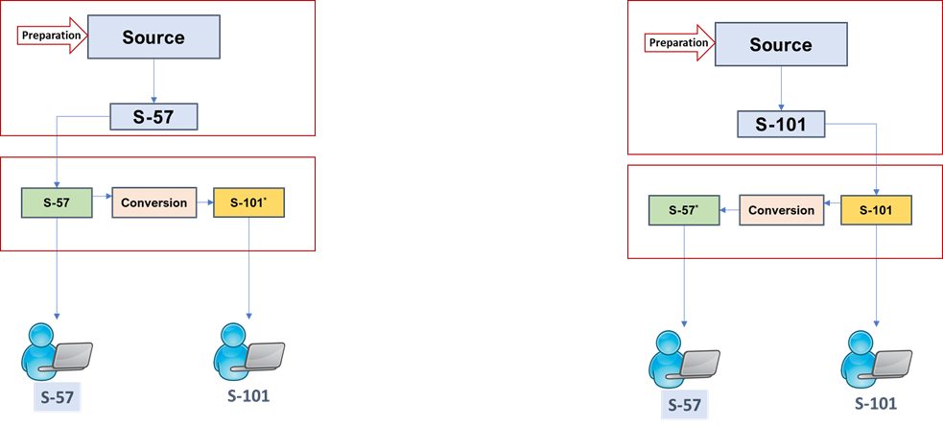
Figure 7: Co-Production by Conversion
In this model, ongoing daily/weekly ENC production is carried out and either S-57 or S-101 data is output. The other form required is acquired by use of a conversion tool with a (probably) producer-specific set of transformation parameters. This allows the data producer to produce both ENC types with the advantage of only directly maintaining one.
A co-production model is illustrated in the diagram below, in this scenario a combined model directly produces both S-57 and S-101 and their incremental updates.
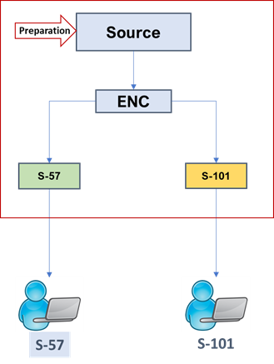
Figure 8: Co-Production by a combined model

In terms of ENC Scheming and scales there are no mandatory constraints on chart production and coverage and producers may choose S-57 Compilation Scale and S-101 Maximum Display Scale as they see fit. The overall requirement of adequate coverage for all types of ECDIS will dictate the answers to many of these questions and if an “equivalence” is established to aid the ECDIS in chart selection in Dual Fuel mode this is likely to provide more freedoms between S-57 and S-101 versions of chart schemes. This work is ongoing with the initial conversion guidance in progress in the IHO sub-working group and an IHO R&D Lab project proposed for its testing. Much of the detail of S-101 and its production alongside S-57 is clear with the S-101 data model well advanced.
As noted in the next subsection the co-production of ENC does raise questions of validation between ENCs (in addition to the requirement for validation of S-101 to the same rigour as IHO S-58). This would be more acute in a “conversion” production environment as the producer is dislocated from one of the end products and has no means to directly encode its features/attributes – ensuring coherence for the end user would be crucial in such a scenario and would likely require cross-product validation.

Data Producer impacts from other product specifications.
As stated earlier in this document the product of “other” product specifications is not the main focus of the governance document as its main emphasis is use of both S-57 and S-101 ENC in Dual Fuel mode on the S-100 ECDIS. If a data producer wishes to produce S-100 other than S-101 ENC then the same considerations as S-101 exist.
- Liability. If a data producer wishes to provide data for use in primary navigation on SOLAS vessels, which will be integrated into the ECDIS SENC and portrayed using harmonized S-98 mechanisms then it inevitably will attract liability in the same way as production/issuing of ENC charts does. Such risk assessments should be carried out by individual data producers
- Up-to-datedness. As with S-101 and S-57 ENCs data must be kept up to date by the end user on the S-100 ECDIS and there is a corresponding responsibility on the data producer to keep date up to date and available for distribution to the end user.
- Validation. Correctness of form (syntax, format, types) is essential always in any data and detailed validation (as defined by IHO S-58 for ENCs) will evolve for all product specifications.
In addition the following should be considered:
- Validation will likely extend across products to ensure they integrate on the S-100 ECDIS as expected and, if different product specifications represent the same features, that their semantic and geographic representations do not conflict. These inter-product validation tests are currently undefined.
The current model for S-100 ECDIS operation allows any S-100 product specification to overlay any chart product. This does not restrict in any way the producer of overlay products in relation to the ENCs they may be installed with. If the OEM provides compatibility this would also allow (by not explicitly prohibiting in the standards) S-1XX product specifications to overlay S-57 data. This has provoked much discussion in the preparation of the Governance Document and has obvious relevance to WEND100 principles. The enhanced Part 15 of S-100 could potentially allow a technical means for enforcing WEND100 principles. During testing of S-98 1.0.0 such enhancements could be drafted in addition to the evolving conventions and agreements which underpin data production for the future.

Annex : Standards and support

Component IHO standards for ECDIS

S-100 and S-57 Standards comparison
This informative subsection tabulates the broad equivalence of the different components of the existing S-57 regime with standards defined for use in implementation of S-100 ECDIS.
S-57 ECDIS definitions | S-100 Definitions
S-57 Main Document  Geometry  Feature Structure | S-100  Part 7  Part 3  Part 4a
S-57 Appendix B1 (ENC Product Specification) | S-101 product specification  S-101 Feature Catalogue  S-101 Portrayal Catalogue  [Some features also relocated to Other product specifications]
S-57 Objects and Attributes (and bindings) | Registry (Hydro) encapsulated in Feature Catalogue(s).
CATALOG.031 | Part 4a  CATALOG.XML and Schema
S-52 . dai file | Portrayal Catalogue
S-52 CSP | Part 9 and Portrayal Catalogue
S-52 ECDIS elements | S-98 Annex C
S-63 and Data Protection Scheme | S-100 Part 15  S-98 SSE Codes  S-98 ECDIS Update Status Report  IHO Processes for data protection scheme  S-128 (Update Status reports)
S-64 | S-164 (under development)
S-58 | S-158 (under development)
S-62 | IHO registry
S-57 Use of the Object Catalogue | DCEG S-101  S-101 Feature Catalogue

S-100 Standards
The following table specifies where elements of the S-100 ECDIS functionality is to be located in the S-100 Standards and IHO community. Where elements are machine-readable a note describing their defining schema/format is given.

Functionality | Clarifying remarks | Standard/Section/Schema
Data content structure | All product specifications | Feature Catalogue XML Schema
Data Content | GML Encodings | Product Specification GML Schema, Part 10b Schemas.
Portrayal Catalogue |  | Portrayal Catalogue XML Schema
CATALOG.XML | Data ingest | S-100 Catalogue Schema
Interoperability |  | Interoperability Catalogue Schema
ENC Data Content | ISO 8211
Exchange Set | File Structure | Part XX metadata
Revision information | For data services, includes data not contained in CATALOG.XML | S-128 (GML)
Data Loading? |  | S-98
External Standards

HDF5 |  | S-100 Part XXX
GML |  | S-100 Part 10b  Individual product specification GML Schemas
ISO8211 |  | S-100 Part 10a
Feature Geometry |  | S-100 Part 7 (levels of topology)
Data content and structure |  | S-100 General Feature Model
Data Portrayal |  | S-100 Part 9 (portrayal of features)  S-98 Annex C (supplemental portrayal)  S-98 (interoperability between product specifications)
Data Security/Integrity and Ingest processes |  | S-100 Part 15 (Data Security and Integrity)  S-98 Annex C (SSE codes and processes for data and catalogue ingest)  IHO Data Protection Scheme
Exchange set structure |  | S-100 Part XX Exchange Set metadata and structure.  CATALOG.XML (XML Schema)

A description of each of the functional areas of ECDIS operation are detailed below along with the normative standards which define them.
Data Production
- IHO S-100 GFM Part 3, General Structure of all data. This encompasses other parts of S-100, notably Part 1 (others?).
- S-97 Guidelines for product specification developers
- S-100 Part 5 – Feature Catalogues, guided by product specification DCEG documentation which mirror the content of the IHO geospatial registry (Part Y). These encapsulate the S-100 GFM, geometry and metadata (Part 4a). Portrayal Catalogues also are highly relevant to enable producers to understand how end users will experience their data.
- One or more of the S-100 encodings, ISO8211 (Part 10a), GML (Part 10b), HDF5 (Part 10c). these may also use supplementary files in a number of formats enumerated in Part XX Metadata.
- Metadata (Part 4)
Packaging
- S-100 Part 15 for the digital signature and optional encryption of data. This uses the AES encryption algorithm, DSA digital signature algorithm and ZIP for compression of exchange set entities.
- Use of the IHO Data Protection Scheme for authentication of data and packaging of contents.
- Part XX Metadata for description of metadata content and packaging of data, together with S-57 elements in “hybrid” exchange sets.
Distribution
- No formal methodologies for distribution of data to ECDIS are currently in operation. S-100 contains a non-normative part 14 which details the exchange of data via API. This is likely to be revised and expanded and other (external) frameworks such as SECOM may enable API access to ECDIS for S-100 data. AIS Application Specific Messages are also included in this category of data which some product specifications may implement.
- S-100 Part 15 is used to reconcile data when delivered to the end user, by reference to the scheme administrator certificate installed independently on the ECDIS.
Data Ingest on ECDIS
- Ingest of Catalogues require the individual S-100 part in which they are defined, Part XX, Part 9 and Part 16.
- Basic syntax checking of catalogues and versions can be done by XML conformance to the schemas defined by S-100
- S-98 Annex C deals with some aspects of the data management and ingest, flow diagrams for decryption and authentication of digital signatures prior to ingest.
- ECDIS implementation of Part XX metadata, Part 15 and its implementation of the GFM, metadata, geometry and data encodings will ensure ingest of data to the ECDIS.
Use
- Implementation of product specifications’ portrayal catalogue - Portrayal – S-100 Part 9
- Aspects of portrayal not directly connected to portrayal of data – S-98 Annex C
- Interoperability of product specifications – S-98 Annex C
- Loading Strategy and Portrayal/Use of data in Dual Fuel mode – S-98 Annex C
- ECDIS Update Status Reports – S-98 Annex C, Appendix B
- User Selected Safety Contour and Water Level Adjustment – S-98 Annex C, Appendix C

Annex 2: Summary of identified gaps.
This section lists gaps in the current S-100 support, whether within the established standards base or conceptual gaps which require attention to complete the implementation of S-100 and Dual Fuel mode on the ECDIS. Where possible, approaches to filling such gaps has been suggested. All gaps listed in this section have been discussed in the workshops defining the Governance Document.

Versions of datasets.
No versioning mechanism currently exists between S-57 and S-101 Charts. This is a complex area and one which may require considerable discussion to establish the optimal way forward. During the transition period all producing authorities will be releasing ENCs in both S-57 and S-101 forms. There will, hence, be >=2 “versions” of each ENC dataset for any area. Although this relationship is not 1-1 and equivalence undoubtedly exists and there is nowhere in the S-100 hybrid exchange set mechanism to define it.
Moreover, for maximum flexibility for data producers the equivalence is between S-57 M_COVR/M_CSCALE features and S-101 DataCoverage features with a many to many relationship.
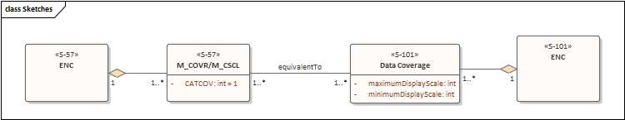

This lack of equivalence currently defines an area of ambiguity when a hybrid exchange set contains S-57 and S-101 which overlap and may be close in scale. A “versioning” mechanism which defines such a many-to-many relationship between the components of S-101 cells and S-57 cells would remove this ambiguity and enable ECDIS to make clear choices about which data to install (or which data to select from the SENC for its operations). It would also give the data producer more choices of scale and scheming when migrating ENC data holdings from S-57 to S-101.
Such a change necessarily involves referring to both S-57 and S-101 so probably does not belong in any of the S-100 component standards. If a lower level of granularity is settled on (at a cell level rather than a coverage feature level) then the solution is a lot simpler and could be defined either in S-98 or the S-128 product specification both of which are in development. The impacts for data producers on scheming can then be defined accordingly.
A recent meeting of the data loading subgroup has concluded that all coverage features are to be loaded and simultaneously as a single entity. This establishes the “dataset” as the granular element of equivalence and, if agreed, will substantially simplify the task of specifying equivalence between cells.

Revision of IMO Documentation
The IMO Performance Standard requires update to include S-100 as the foundation for ECDIS operation. This has been instigated and the IHO component standards to be referenced are now at version 1.0.0 or later. S-100 Edition 5.0.0 will be the baseline for compatibility with S-100 ECDIS. In particular the equivalence of the S-100 ECDIS for Nautical Publications is not explicit and will also need to be more properly defined as the IMO PS is revised. Following this revision, the relevant testing standards require revision. This is a large undertaking and will also need to ensure testing for the existing S-57 regime can remain in place (should updates be required).

Loading Strategy.
“Loading Strategy” – the mechanism by which individual datasets are selected for portrayal and rendered on screen using the S-100 Part 9 portrayal engine, is still the subject of intense discussion. This is closely related to 7.1 and its conclusion will provide a normative method for equating scales between datasets and/or selecting datasets for portrayal from those installed in the ECDIS. Defining a consistent loading strategy for the S-100 ECDIS will also implicitly define whether S-101 or S-57 “versions” of a cell are made available to the end user and whether different datasets are presented “overlaid” or “side by side”. This discussion is ongoing and will result in a definition of loading strategy for the S-101 product specification with likely consequences for S-98 edition 2.0.0.

ENC Co-Production Strategies
The S-57 to S-101 conversion subgroup, set up jointly between the ENCWG and S-101PT is preparing a document recommending guidance for initial conversion of ENC holdings to forms capable of producing S-101 ENCs. There is currently nowhere in scope an investigation on the optimum method of producing S-57 and S-101 cells on an ongoing basis for data producers and no automated methods for incremental updates. This may be addressed in part by the IHO R&D Lab project proposal which will look at the issue in conjunction with a test phase of the conversion guidance document.

Scope of implementation for OEMs
No definitive scope for ECDIS OEMs currently exists in terms of what parts of S-100 require implementation for S-100 ECDIS. Certainly, all clauses required for S-101 and the other initial S-100 product specifications would be required. Conversely, it also difficult to define which areas of S-100 are definitely NOT required for S-100 ECDIS implementation.
The current approach from the S-100 WG is to demonstrate by example what is required by the creation of extensive and comprehensive test data under IHO S-164. This approach requires consultation with the OEM community and could be enhanced with clarifications on particular areas if required. It does pose challenges though, especially for early adopters who are without representative test data nor a detailed description of scope.

S-100 product specification overlays on ENC.
Discussions around S-100 ECDIS have touched on the topic of whether S-100 products other than ENCs (those in categories (2) and (3) defined in section 2.5) overlay just S-100 ENCs or whether they can also overlay or interoperate with S-57 ENCs as well. This is a topic of specific interest in relation to S-102/S-57 but also has been discussed in relation to other S-1XX products. Additionally, whether WEND100 principles should be “enforced” on the S-100 ECDIS through Part 15 implementations expressed in S-98 Annex C should be discussed within the IHO community as the technical possibility exists. At an early stage of ECDIS development it is possible to make such constraints but once ECDIS is developed it will be unlikely to change.
Such requirements have never existed on S-57 ECDIS because no concept of overlays being used for SOLAS navigation existed. This requires further discussion and an approach defined in (most likely) S-98 with OEMs being given definitive guidance either way.

Support to the external communities (including test data provision)
One of the items which has become clear from the workshops driving the creation of the Governance Document is the scope and complexity required between the IHO and the implementers of S-100 ECDIS. The complexity of the S-100 ecosystem is considerably greater than that surrounding S-57 and all parties/stakeholders will require support to ensure coherence is maintained of data and implementations. In order to best support OEMs, testers, data producers, regulators and other implementers of S-100 scalable, open access, infrastructure will be required long term.
A known gap is certainly test data within S-164 which tests the entirety of the S-100 framework as well as test data to test validation specifications. This isn’t technically a “gap” as what needs to be done is well known in the community but it is a large deficiency in the community currently which risks planned implementation timescales and holds up progress by implementers and testbed development. It is therefore included here as its production is likely to lead to further requirements and change within S-100 and its component product specifications destined for S-100 ECDIS.

Impacts of Enhanced ECDIS functionality.
One of the features introduced in the S-98 Annex C v1.0.0 is User Selected Safety Contour and Water Level Adjustment. This is an OEM-specific portrayal and Alert/Indication implementation which provides a tight integration between S-101 and either/both S-102 and S-104. Implementation is similar to functionality required by interoperability levels 3 and 4 but is, for the purposes of S-100 ECDIS, implemented as a bespoke OEM extension to the S-100 model implementation required.
These features are likely to be accompanied by a number of impacts on data producers. The implementation of such features is a major step forward for ECDIS functionality and those data producers who choose to distribute dense bathymetry and water level data to end users are likely to need to evaluate such impacts. These include:
- The Liability acquired concerning use of S-102 and S-104 for navigation decisions
- Cross product validation
- Up to datedness issues – the user must keep the S-102 / S-104 up to date in the same way as the S-101 data
- Extents and coverage decisions to maximise use and ensure coherent portrayal of data for the end user.
None of these are insurmountable problems but they represent a new category of consideration/governance issue for any implementing data producer in the S-100 era.

How many revisions of product specs are required to be implemented by OEMs?
Section 10.4.5 details the requirement for S-100 ECDIS to support multiple versions of IHO product specifications but little in the way of tangible requirements or implementation details currently exist for this important aspect of the dynamic S-100 ECDIS. Clearly at least two versions are required to be supported by the ECDIS to enable the most basic of updates by the end user and data migration by data producers but the exact number (per product specification) and process for their introduction/migration has yet to be defined. This is closely linked to the comments made on the S-100 ECDIS “operating model” and suggests that a more complete picture of how the ECDIS operates should be established (as a summary of the processes defined in S-98, S-164 and the IMO PS) and maintained. Certainly the S-98 Annex C v1.0.0 contains some of this information and comprehensive test datasets will contribute to better understanding but some detailed modelling of scenarios (similar to that proposed in 7.12) would support OEM implementation better at this crucial stage of development.

Phasing out S-57
No formal description, timescale or sequence of events has yet been put forward for how S-57 is actually phased out at the end of the transition period. There are likely to be a substantial number of external dependencies to this process. The timescales are, of course, unknown, as yet and likely to be some time in the future. If more revisions are likely to be required, e.g. subsequent changes to either SOLAS or the IMO PS for ECDIS then this should be noted for future reference.

Impact of Changes to ENC on end user.
Initial Rollout of ENC is likely to release a number of changes in portrayal and, via remodeling, alerts/indications. There is no defined process to establish whether such changes should be included or not and for their impacts to be communicated to end users and data producers. Some initial steps have been taken in this area and, although IHO ultimately has the authority to make such changes, through promulgation of new feature and portrayal catalogues, no bounding set of guidance currently exists to arbitrate these decisions. This should be addressed as it could potentially reduce the amount of effort/resource necessary to meet planned timescales for S-100 ECDIS implementation.

How to update S-100 itself
Procedures for updates of S-100 will require development, ideally before mainstream implementation of S-100 is commenced by the OEM community. Procedures for update of S-57 and other component standards already exist within the IHO community but S-100 is such a far-reaching standard with its elements embedded in the S-100 ECDIS that greater support is likely to be required, greater consultation and testing required and the attendant update of component product specifications likely to need attention from the working groups concerned. Modelling such scenarios (along with end of life for S-57) should be done prior to more work on ECDIS implementation taking place so that OEMs can be aware of how such migration is likely to take place.

S-128 development.
The S-128 data model is still at an early stage of development. S-128 has been identified as crucial for reliable exchange of S-100 exchange catalogues between service providers and end users for two main purposes
- The specification of revision information for a user’s service which determines the content of the revised Update Status reports on the ECDIS (contained in S-63 and S-98 Annex C)
- Mapping of equivalent “versions” of ENCs, should such equivalence be established as part of the conclusion of the loading strategy discussions currently underway.
S-128, ultimately, fulfils the goal of “service metadata” for S-100 ECDIS and each service provider will need to develop compatibility with it in order to present a full service to end users and to satisfy requirements for ECDIS update status reports to satisfy inspection regimes.

Categorisation of product specifications.
In section 2.5 a categorization of individual product specifications has been proposed. In order to clarify within IHO standards, and for external users there is a need to clarify which of the three categories proposed each IHO product specification exist. Additionally, in order to provide clarity through IMO requirements, a mapping of IHO project specifications to nautical publications is required. This is not necessarily 1-1 but should state which IHO product specifications map to which category of SOLAS nautical publications so that a firm equivalence can be established between paper and digital products. IHO is able to make such a mapping. This may also require clarity at IMO level to make it clear to end users and inspectors. There is a clear rationale behind the use of ECDIS to satisfy carriage requirements for nautical publications.

The S-100 ECDIS Operating Model.
A full operating model for S-100 ECDIS is not completely defined. Gaps exist in how the ECDIS is defined at a detailed level in some areas, and at a high level in others. Some of these gaps can be addressed by S-164 test data illustrating test cases and IEC61174 will define exact test scenarios for some parts of the ECDIS functionality. S-98 Annex C contains a definitive list of ECDIS error codes (SSE) inherited from IHO S-63 which define some parts of how the ECDIS is to operate. Data Producer impacts of how the ECDIS operates should be defined for IHO stakeholders to assess impacts of proposed changes (and how migration to new versions of product specifications can be achieved).

In the main body of this document, often existing ECDIS is referred to as “S-57 ECDIS”. The full list of standards implemented by current ECDIS is included for completeness in 6.2.
The IHO Standards explicitly referenced by the IMO Performance standard are S-57, S-52, S-64, S-32, S-61 and S-63. This list will grow with the revision proposed for S-100 support and is presented in more detail in the appendix.
Revision of the IMO Performance Standard revision is in progress.
Whether provision of other S-100 product specifications over S-57 data is within ECDIS functionality is yet to be decided. See 7.6
See 7.2
See 7.2
See 7.14. A formal categorisation is likely to be in S-98 with products defined in the registry.
Still to be defined, likely to be in S-128. See 7.13
This is NOT the same as data validation as currently defined in IHO S-58 (and under development for various S-100 product specifications. This is validation of the syntax of data presented to the ECDIS and provides a powerful mechanism for establishing its basic correctness.
This implies an S-100 ECDIS will embed the XML Schema files for e.g. feature catalogue, portrayal catalog and CATALOG.XML within its processing systems. Delivery of updates to these schemas is not specified within S-100, nor the effects any such updates might have. Updates to these schemas will be managed by the IHO revision control process – it is likely any updates to such schemas may require changes to S-100 ECDIS processing systems.
See 7.12
S-128 is currently incomplete. See 7.11
The exact requirements for data producer “scheming” (extents and scales) will be dependent on the outputs of S-101 developments on loading strategy and ENC conversion. Certainly “equivalent” production is an option (arguably the most simple) but many producers may wish to combine S-101 migration with rescheming and rationalisation of multiple compilation scales. As specifications conclude these requirements will be taken into account. At the time of writing it is not possible to provide any best practice. See also 7.4.
Noting that ENC coproduction strategies are still under development. See 7.4
This “version” mechanism is not defined in the standards yet. See 7.1
Scale equivalence between S-101 and S-57 is not defined yet See 7.2
See 7.3
See 7.10
The exact number may remain undefined but S-164 will contain a representative testing sample.. See
See 7.15
See 7.11 and 7.8
See 7.11
The model left out is one where the data producer simply sets up parallel production facilities, producing base and incremental updates from separate systems (fed with the same information). This is undoubtedly an option but for many data producers would result in a significant overhead of maintenance and migration long term during the transition period and is therefore untenable.
See 7.4
See 7.6

