S-100 – Part XX

Discovery Metadata for Information Exchange Catalogues

Page intentionally left blank

Contents

4a-1 Scope 1
4a-2 Conformance 1
4a-2.1 Conformance of this Profile with other Standards 1
4a-2.2 Backward compatibility 2
4a-3 Conformance to this Profile 2
4a-4 Normative references 2
4a-4.1 Profile definition 2
4a-4.2 Informative references 2
4a-5 Requirements 3
4a-5.1 Business purpose and Intended use 3
4a-5.2 Metadata for describing geographic data and other resources 4
4a-5.3 Obligations/conditions 5
4a-5.4 Minimum metadata requirements 5
4a-5.5 S-100 compliancy categories 11
4a-5.6 Recommended metadata for geographic datasets 11
4a-5.7 Variations and preferences 14
4a-5.7.1 Metadata element metadataIdentifier 14
4a-5.7.2 Metadata element parentMetadata 14
4a-5.7.3 Geographic extent of the dataset 14
4a-5.7.4 Data and Date Time information 14
4a-5.7.5 Metadata extension information 15
4a-5.8 Metadata for services 16
Appendix 4a-A Metadata Schema Class Information 19
Appendix 4a-B Data Dictionary 21
Appendix 4a-C Metadata Implementation 23
Appendix 4a-D Discovery Metadata for Information Exchange Catalogues 25
Appendix 4a-E Metadata Extensions 45

Page intentionally left blank

Scope
The S-100 Discovery Metadata for Information Exchange Catalogues profile described in this part provides a specification for describing and creating exchange catalogues that enables users to identify, discover and manage content of the S-100 exchange sets. More importantly it leverages XML to allow machine to machine discovery and exchange of information about about geographic datasets commonly produced by hydrographic organizations. Its purpose is the creation of metadata records that provide information about the identification, spatial and temporal extent, quality, application schema, spatial reference system, and distribution of digital geographic data. It is applicable to the cataloguing of datasets, clearinghouse activities, and the full description of geographic and non-geographic resources.
For information exchange, there are several categories of metadata required: metadata about the overall exchange catalogue, metadata about each of the datasets contained in the catalogue, and metadata about the support files that make up the package. If the exchange catalogue contains any Feature, Portrayal or Interoperability Catalogues there is a provision to carry additional metadata about those.

This document is intended for developers and implementers of metadata applications, and provides a basic understanding of the principles and the overall requirements for standardisation of geographic information. It should be used in conjunction with the standards listed under clause 4a-4 – Normative references.

Conformance

Conformance of this Profile with other Standards
The S-100 Discovery Metadata for Information Exchange Catalogues profile adopts data types defined in other ISO standards, mainly in ISO 19115 Geographic information - Metadata and ISO 19136 Geographic Information - Geography Markup Language, along with their underlying obligations and conditions. The XML schema references related to these external data types are embedded in the XML schemas for this profile, thus ensuring the conformance of this profile with other standards during authoring and validation of XML catalogue instances.

Conformance to this Profile
The conformance to this profile can be confirmed by validating XML catalogue instances against the S-100 Metadata Profile schemas which are available from the IHO S-100 repository.

Normative references
The following referenced documents are required for the application of this document. For dated references, only the edition cited applies. For undated references, the latest edition of the referenced document (including amendments) applies.

Profile definition
The following documents were the references used to define the S-100 Metadata Profile:
ISO 19115-1:2014, Geographic information – Metadata – Part 1 - Fundamentals
ISO 19115-1/Amdt01:2018, Geographic information – Metadata – Part 1 - Fundamentals (Amendment 1)
ISO 19115-2:2009, Geographic information - Metadata - Part 2: Extensions for imagery and gridded data
ISO 19119:2016, Geographic information – Services
ISO/TS 19115-3:2016, Geographic information - Metadata - XML schema implementation for fundamental concepts

Informative references
ISO 19115:2003, Geographic information – Metadata
ISO 19115:2003/Cor.1:2006, Geographic information - Metadata (Technical Corrigendum 1)
ISO/TS 19139:2007, Geographic information - Metadata - XML schema implementation

Overview

S-100 Exchange Set Structure
The S-100 Exchange Set is a data container that provides all the elements needed for a reliable and secure exchange of S-100 conformant data. It is intended to be a self-contained entity consisting of data files and metadata records packaged together using applicable data integrity and optional security provisions. The overall concept of the S-100 Exchange Set is a realization of the ISO 19115-3 classes, which fundamentally underpin the interchange of geospatial data and relevant metadata, as depicted in figure 4a-D-1. This figure depicts, from left to right, the ISO data exchange structural classes, the relevant ISO classes for metadata for exchange, S-100 structure classes representing the S-100 exchange set components, and the relevant S-100 exchange set metadata classes.

Note that the S-100 structure classes represent components of the exchange set (files/folders/archives), not XML fragments in an exchange file. Accordingly, they do not have attributes nor do they have corresponding documentation tables in this Part.

Note also that the S-100 exchange set metadata classes are analogues of the corresponding ISO classes but (strictly speaking) not specialisations or realisations of them.

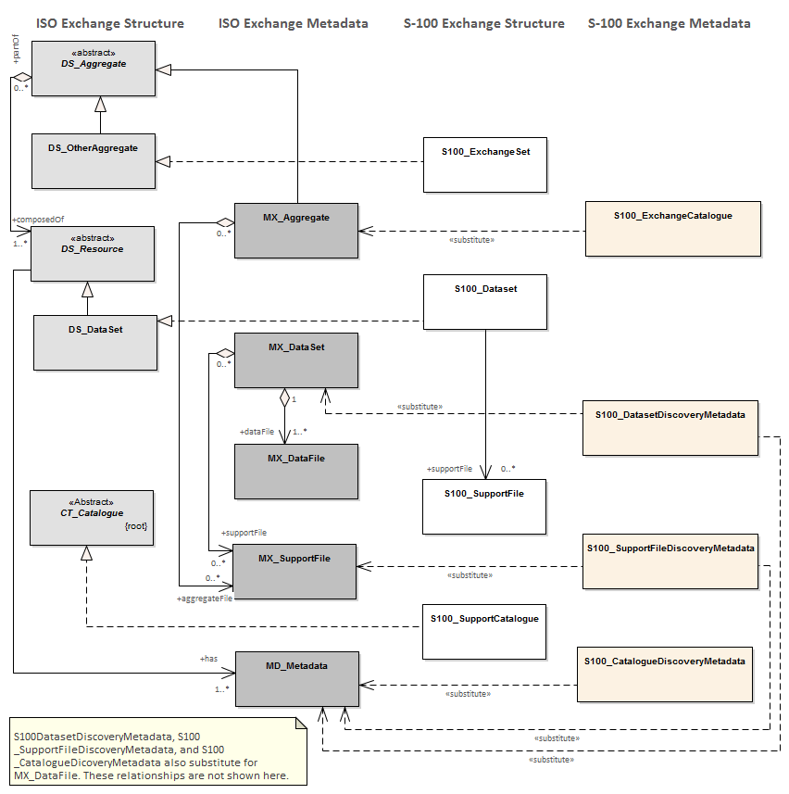
Figure 4a-D-1 Realization of the Exchange Set Classes

The above diagram illustrates the conceptual correspondence between data exchange provisions in ISO-19115 and S-100 standards. At an implementation level, the S-100 Exchange Set may include a combination of S-100 datasets, support files, and catalogue files along with the metadata information for all such resources in the form of the S-100 Exchange Set Catalogue. Conceptually this leads to the more detailed model of the S-100 exchange set, as shown in figure 4a-D-2.
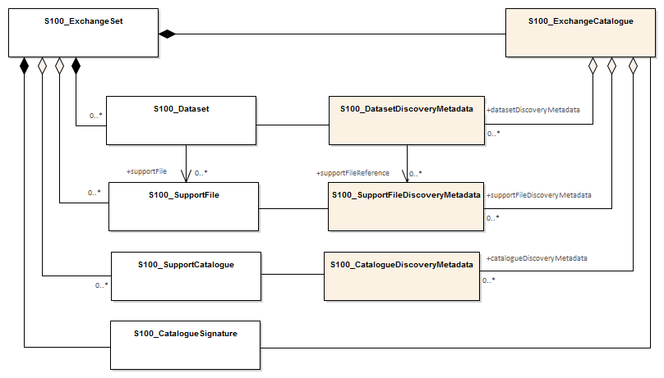
Figure 4a-D-2 – S-100 Exchange Set

The conceptual model depicted in Figure 4a-D-2 is very flexible and can be implemented in a variety of ways as virtually all components, except for the S-100_ExchangeCatalogue, are optional. This level of flexibility is essential to properly support the mainstream use case of exchanging geospatial data, as well as the use cases for releasing dataset cancellation notices or new catalogue releases without any data files present.
This approach ensures that an exchange set catalogue is always included in any S-100 conformant exchange set, providing the essential discovery metadata about any included resources and their intended use.
Preparation of an exchange set consists of packaging its components using a predefined file folder structure shown in figure 4a-D-3.

S-100 Exchange Set Folder Structure.
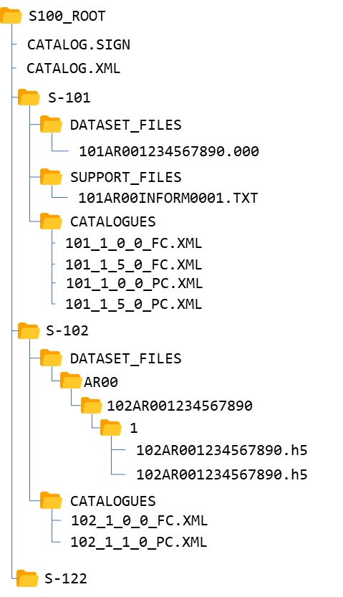
Figure 4a-D-3 – An S-100 Exchange Set Folder Structure

- An S-100 exchange set must contain an exchange set catalogue, CATALOG.XML, its digital signature CATALOG.SIGN and may contain any number of S-100 conformant dataset files, support files and catalogue files.
- All S-100 content must be placed inside a top root folder named S100_ROOT. This is the only top level root folder in an exchange set containing only S-100 products.
- The S100_ROOT folder must contain a subfolder for each specific S-100 product specification data type included in the exchange set, e.g. S-101, S-104, S-102 (names defined in the IHO product specification register). These subfolders hold S-100 content specific to an individual product specification, all other exchange set files must be located in the S100_ROOT folder.
- Each product subfolder must contain subfolders for the component dataset files (DATASET_FILES), support files (SUPPORT_FILES) and catalogues (CATALOGUES) as required.
- Individual data files, such as base dataset, update files or detailed ISO 19115 metadata may be optionally placed in their own subfolders or grouped together.
- Support files, on the other hand, may be grouped together in one folder to prevent duplication across multiple dataset folders. Similarly, when needed, an exchange set may carry additional catalogues and/or their different versions which should also be grouped together in one folder.
- The required exchange set catalogue XML document instance must be named CATALOG.XML and placed in the S100_ROOT folder, together with its digital signature (CATALOG.SIGN) file. All other digital signatures are included within their corresponding resource metadata records in the CATALOG.XML.
An S-100 exchange set can be optionally defined alongside S-57 datasets with their own ENC_ROOT and INFO root folders as required by the S-57 ENC product specification and (optionally) S-63. In this case there are three top level folders: ENC_ROOT and INFO for S-57, and S100_ROOT with two separate catalogues covering their respective content (CATALOG.031 and CATALOG.XML). Figure 4a-D-4 shows one of these use cases with S-57 and multiple S-100 products included..
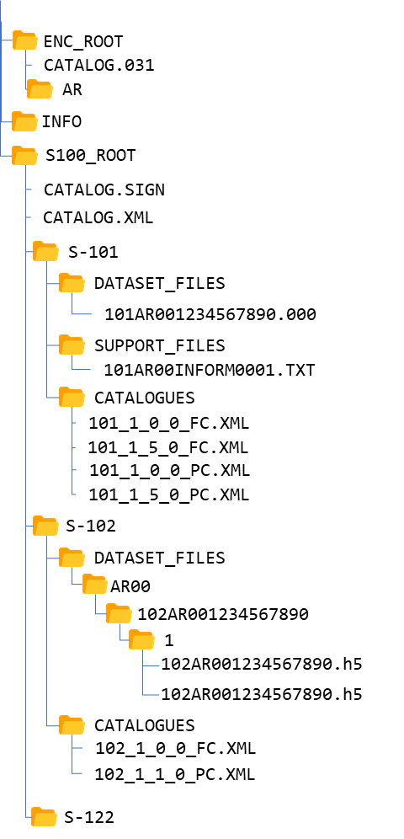
Figure 4a-D-4 – Combined S-100 and S-57 Exchange Sets Folder Structure

In addition to the folder structure, it is important to align the exchange set creation workflow with the data integrity and security provisions outlined in S-100 Part 15. These provisions cover digital signing, compression, and encryption of exchange set resources. All resources within an S-100 Exchange Set must be digitally signed and their signatures included in the exchange set catalogue. Data compression and encryption are optional operations.
Exchange set creation, therefore, consists of:
- The creation of a suitable exchange set folder structure
- The arrangement of all resources in their designated folders.
- Creation of digital signatures for all resources
- Optional compression and encryption of any resources which require it.
- Construction of an Exchange Set Catalogue which records the structure created.
S-100 Part 15 defines the requirements and process for creation and verification of digital signature values and production of compressed/encrypted datasets.

Storage and Management of External Resources
S-100 datasets may refer to a number of externally referenced, supporting resources for content. This content may be textual or graphical and encoded in any of a number of formats (defined by the XXXX enumeration in the exchange catalogue Schema). Datasets hold a reference to the external resource as an attribute value. This value may be updated as any other attribute and updates the reference to the external resource.

The S-100 exchange catalogue provides:
- A normative definition of the location of each supporting resource. Where these are physical files this is a physical location within the SUPPORT/FILES/<S-100 Product> subdirectory in the exchange catalogue file structure.
- For every reference to an external resource within a dataset, a unique map (by reference) in that dataset’s metadata to the definition of the resource.
All content relating to such external resources should be validated and must be consistent with the dataset content to form a valid S-100 exchange set.
Datasets refer to external resources using S-100 attributes with a URI primitive type. Such references can be in any supported S-100 URI form and must be uniquely resolvable by the implementing system without requiring any supplementary information within the exchange catalogue metadata entries.

Examples of such URI definitions are:

URI type | Example URI
File reference | file::101GB00400797.000
MRN (S-100 Digital Signature Value) | urn:mrn:iho:s100:dsig:dsa:302C021421EF1102A1BA0416FC  6A8F916114FBB991F94A2E02146C4D87E83D4AEEBC15A  C23B2A6F2A7301A681A7C
MRN (File Hash) | urn:mrn:iho:s100:hash:sha256:a948904f2f0f479b8f8197694b30184b  0d2ed1c1cd2a1ec0fb85d299a192a447

Full specification of file URIs and MRNs supported by S-100 are contained in S-100 Part 1 and Part 15 15-8.10

As long as the mapping from the dataset metadata to the metadata of the external resource is unique it is valid, so multiple datasets are able to “share” common external resources within an exchange catalogue without ambiguity.

As all resources are digitally signed to preserve data integrity and authenticity the digital signature provides an ideal unique map to the supporting resource. When using digital signatures in a file based exchange catalogue the file name of the resource is therefore not used and thus can conform to any naming convention.

Use of the file name in a file URI allows an exchange set producer to maintain a single, up-to-date version of any supporting file resource without necessitating dataset updates when the content of the resource changes. There is, however, an attendant responsibility on the producer of maintaining unique file names across all resources to ensure identifiers are unique.

S-100 Exchange Set Catalogue
The S100 Exchange Set Catalogue is an XML document instance, which provides the metadata information needed to discover and use the resources contained in the S-100 Exchange Set. It must be named CATALOG.XML. This mandatory, central component of S-100 exchange sets consists of several components which capture suitable metadata records for each resource type. These components cover metadata for the exchange set catalogue, dataset discovery, support file discovery, any references to ISO 19115 dataset metadata, and additional catalogues as depicted in figure Figure 4a-D-4.
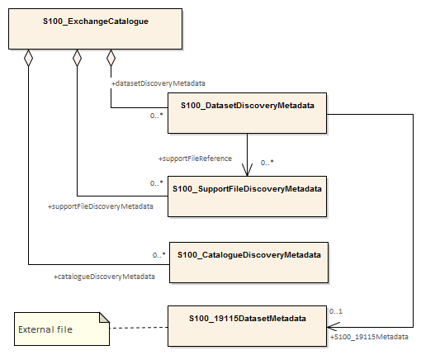
Figure 4a-D-5 – S-100 Exchange Set Catalogue

The discovery metadata subsections have attributes which enable important information about the datasets and accompanying support files to be examined without the need to process the data, for example encryption/compression flags. Similarly, other catalogues can be included in the S-100 Exchange Set, in support of the datasets, such as feature, portrayal, coordinate reference systems, codelists etc. Additionally, the S100 Exchange Set Catalogue provides mechanisms for managing the life cycle of datasets and support files. For example, the S-100 Support File Purpose enumeration within support file metadata provides revision control for support files.
More detailed information about the various elements of the catalogue is shown in Figure 4a-D-5 and in the textual description in the tables at clause 3.

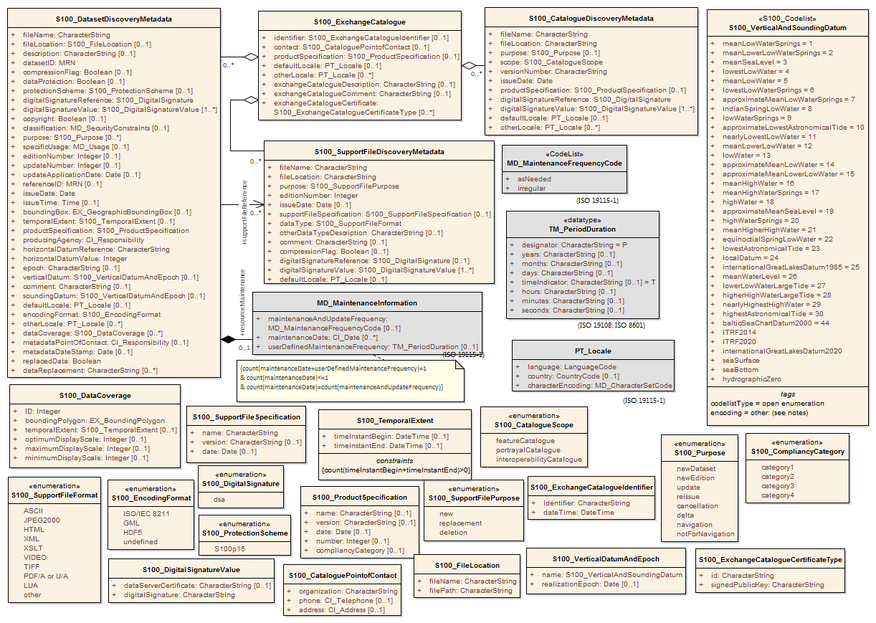
Figure 4a-D-6 – S-100 Exchange Set Catalogue - class details

Page intentionally left blank

Elements of the exchange set

S100_ExchangeCatalogue
Each exchange set has a single S100_ExchangeCatalogue which contains meta information for the data and support files in the exchange set.
Role Name | Name | Description | Mult | Type | Remarks
Class | S100_ExchangeCatalogue | An exchange catalogue contains the discovery metadata about the exchange datasets and support files | - | - | -
Attribute | identifier | Uniquely identifies this exchange catalogue | 0..1 | S100_CatalogueIdentifier
Attribute | contact | Details about the issuer of this exchange catalogue | 0..1 | S100_CataloguePointOfContact
Attribute | productSpecification | Details about the product specifications used for the datasets contained in the exchange catalogue | 0..* | S100_ProductSpecification
Attribute | defaultLocale | Default language and character set used for all metadata records in this exchange catalogue | 0..1 | PT_Locale | Default is English and UTF-8.
Attribute | otherLocale | Other languages and character sets used for the localized metadata records in this exchange catalogue | 0..* | PT_Locale | Required if any localized entries are present in the exchange catalogue.
Attribute | exchangeCatalogueDescription | Description of what the exchange catalogue contains | 0..1 | CharacterString
Attribute | exchangeCatalogueComment | Any additional Information | 0..1 | CharacterString
Attribute | exchangeCatalogueCertificate | Signed public key certificates referred to by digital signatures in the exchange set | 0..* | S100_ExchangeCatalogueCertificateType | Content defined in S-100 Part 15. All certificates used, except the SA root certificate (installed separately by the implementing system) shall be included.
Role | datasetDiscoveryMetadata | Exchange catalogues may include or reference discovery metadata for the datasets in the exchange set | 0..* | Aggregation S100_DatasetDiscoveryMetadata
Role | catalogueDiscoveryMetadata-- | Metadata for catalogue | 0..* | Aggregation S100_CatalogueDiscoveryMetadata | Metadata for the feature, portrayal, and interoperability catalogues, if any
Role | supportFileDiscoveryMetadata | Exchange catalogues may include or reference discovery metadata for the support files in the exchange set | 0..* | Aggregation S100_SupportFileDiscoveryMetadata

S100_ExchangeCatalogueIdentifier
Role Name | Name | Description | Mult | Type | Remarks
Class | S100_ExchangeCatalogueIdentifier | An identifier for an exchange catalogue . | - | - | The concatenation of identifier, editionNumber and dateTime form the unique name
Attribute | identifier | Uniquely identifies this exchange catalogue | 1 | CharacterString | <S100XC:identifier>US_101_20200101_120101_01</S100XC:identifier>
Attribute | dateTime | Creation date and time of the exchange catalogue, including time zone | 1 | DateTime | Format: yyyymmddThhmmssZ

S100_CataloguePointofContact
Role Name | Name | Description | Mult | Type | Remarks
Class | S100_CataloguePointOfContact | Contact details of the issuer of this exchange catalogue | - | - | -
Attribute | organization | The organization distributing this exchange catalogue | 1 | CharacterString | This could be an individual producer, value added reseller, etc.
Attribute | phone | The phone number of the organization | 0..1 | CI_Telephone
Attribute | address | The address of the organization | 0..1 | CI_Address

S100_ ExchangeCatalogueCertificateType
Role Name | Name | Description | Code | Remarks | Data
Enumeration | S100_ExchangeCatalogueCertificateTType | Certificate for digital signature | - | -
Attribute | id | The data server id | - |  | e.g. “UKHO”, “PRIMAR”
Attribute | signedPublicKey | The data server’s public key | 1 | CharacterString

S100_DatasetDiscoveryMetadata
Role Name | Name | Description | Mult | Type | Remarks
Class | S100_DatasetDiscoveryMetadata | Metadata about the individual datasets in the exchange catalogue | - | - | -
Attribute | fileName | Dataset file name | 1 | CharacterString
Attribute | fileLocation | Full location from the exchange set root directory | 0..1 | S100_FileLocation | Without fileLocation the exchange set is unpacked into directory <ROOT>/S100_ROOT/DATASET_FILES/<fileName>
Attribute | description | Short description giving the area or location covered by the dataset | 0..1 | CharacterString | For example, a harbour or port name, between two named locations etc.
Attribute | datasetID | Dataset ID expressed as a Marine Resource Name | 1 | mrn | urn:mrn…
Attribute | compressionFlag | Is the data compressed | 1 | Boolean
Attribute | dataProtection | Indicates if the data is encrypted | 1 | Boolean | 0 indicates an unencrypted dataset  1 indicates an encrypted dataset
Attribute | protectionScheme | Specification or method used for data protection | 0..1 | S100_ProtectionScheme
Attribute | digitalSignatureReference | Digital Signature of the file | 1 | S100_DigitalSignature | Specifies the algorithm used to compute digitalSignatureValue
Attribute | digitalSignatureValue | Value derived from the digital signature | 1..* | S100_DigitalSignatureValue | The value resulting from application of digitalSignatureReference  Implemented as the digital signature format specified in Part 15
Attribute | copyright | Indicates if the dataset is copyrighted | 0..1 | Boolean
Attribute | classification | Indicates the security classification of the dataset | 0..1 | Class MD_SecurityConstraints>MD_ClassificationCode (codelist) | 1. unclassified  2. restricted  3. confidential  4. secret  5. top secret  6. sensitive but unclassified  7. for official use only  8. protected  9. limited distribution
Attribute | purpose | The purpose for which the dataset has been issued | 0..* | S100_Purpose  (codelist)
Attribute | specificUsage | The use for which the dataset is intended | 0..1 | MD_USAGE>specificUsage (character string) | For example, in the case of ENCs this would be a Navigational Purpose classification. This is strictly for discovery catalogue purposes
Attribute | editionNumber | The edition number of the dataset | 0..1 | Integer | When a data set is initially created, the edition number 1 is assigned to it. The edition number is increased by 1 at each new edition. Edition number remains the same for a re-issue.
Attribute | updateNumber | Update number assigned to the dataset and increased by one for each subsequent update | 0..1 | Integer | Update number 0 is assigned to a new dataset
Attribute | updateApplicationDate | This date is only used for the base cell files (that is new data set, re-issue and new edition), not update cell files. All updates dated on or before this date must have been applied by the producer | 0..1 | Date
Attribute | referenceID | Reference back to the datasetID | 0..1 | Urn | Update metadata refers to the datasetID of the dataset metadata. This is used if and only if the dataset is an update.  The URN must be an MRN
Attribute | issueDate | Date on which the data was made available by the data producer | 1 | Date
Attribute | issueTime | Time of day at which the data was made available by the data producer | 0..1 | Time | The S-100 datatype Time
Attribute | boundingBox | The extent of the dataset limits | 0..1 | EX_GeographicBoundingBox | -
Attribute | temporalExtent | Specification of the temporal extent of the dataset. | 0..1 | S100_TemporalExtent | The temporal extent is encoded as the date/time of the earliest and latest data records (in coverage datasets) or date/time ranges (in vector datasets).  If there is more than one feature in a dataset, the earliest and latest time values of records in all features are used, which means the earliest and latest values may be from different features.  If date/time information for a feature is not encoded in the dataset, it is treated for the purposes of this attribute as extending indefinitely in the appropriate direction on the time axis, limited by the issue date/time or the cancellation or supersession of the dataset.  This attribute is encoded if and only if at least one of the start and end of the temporal extent is known.
Attribute | productSpecification | The product specification used to create this dataset | 1 | S100_ProductSpecification
Attribute | producingAgency | Agency responsible for producing the data | 1 | CI_Responsibility>CI_Organisation | See Tables 4a-2
Attribute | horizontalDatumReference | Reference to the register from which the horizontal datum value is taken | 1 | characterString | For example, EPSG
Attribute | horizontalDatumValue | Horizontal Datum of the entire dataset | 1 | Integer | For example, 4326
Attribute | epoch | Code denoting the epoch of the geodetic datum used by the CRS | 0..1 | CharacterString | For example, G1762 for the 2013-10-16 realization of the geodetic datum for WGS84
Attribute | verticalCRS | Vertical CRS of the entire dataset | 0..1 | S100_VerticalCRS
Attribute | soundingCRS | Sounding CRS of the entire dataset | 0..1 | S100_VerticalCRS
Attribute | encodingFormat | The encoding format of the dataset | 1 | S100_EncodingFormat
Attribute | dataCoverage | Provides information about data coverages within the dataset | 0..* | S100_DataCoverage
Attribute | comment | Any additional information | 0..1 | CharacterString
Attribute | defaultLocale | Default language and character set used in the dataset | 0..1 | PT_Locale | In absence of defaultLocale the language is English, UTF-8
Attribute | otherLocale | Other languages and character sets used in the dataset | 0..* | PT_Locale
Attribute | metadataPointOfContact | Point of contact for metadata | 0..1 | CI_Responsibility>CI_Individual or  CI_Responsibility>CI_Organisation | Only if metadataPointOfContact is different to producingAgency
Attribute | metadataDateStamp | Date stamp for metadata | 0..1 | Date | May or may not be the issue date
Attribute | replacedData | If a data file is cancelled is it replaced by another data file | 0..1 | Boolean
Attribute | dataReplacement | Cell name | 0..* | CharacterString | A dataset may be replaced by 1 or more datasets
Attribute | navigationPurpose | Classification of intended navigation purpose (for catalogue indexing purposes). | 0..3 | Enumerate | - Port  For port and near shore operations.  - Transit  For coast and planning purposes.  - Overview  For ocean crossing and planning purposes.  * See note
Role | supportFileReference | Reference to discovery metadata for the support files referenced in the dataset | 0..* | <Reference>S100_SupportFileDiscoveryMetadata | See clause 4a-4.3.
Role | S100_19115Metadata | Reference to ISO-format metadata file | 0..1 | FileName (ISO 19115-3) | Reference to external ISO-format file (ISO gcx:FileName).
Role | resourceMaintenance | Information about the frequency of resource updates, and the scope of those updates | 0..1 | MD_MaintenanceInformation | S-100 restricts the multiplicity to 0..1 and adds specific restrictions on the ISO 19115 structure and content. See clause MD_MaintenanceInformation later in this Part.  Format: PnYnMnDTnHnMnS (XML built-in type for ISO 8601 duration). See Notes.

NOTE:
navigationPurpose: If product specification is intended for creation of navigational products this attribute should be mandatory.

S100_DataCoverage
Role Name | Name | Description | Mult | Type | Remarks
Class | S100_DataCoverage | A spatial extent where data is provided; and the display scale information for the provided data | - | - | This field is used by user systems as part of the data loading and unloading algorithms and it is strongly encouraged that product specifications mandate the use of one or more of the displayScale provided as part of S100_DataCoverage
Attribute | ID | Uniquely identifies the coverage | 1 | Integer | -
Attribute | boundingPolygon | A polygon which defines the actual data limit | 1..1 | EX_BoundingPolygon
Attribute | temporalExtent | Specification of the temporal extent of the coverage. | 0..1 | S100_TemporalExtent | The remarks for temporalExtent in the dataset discovery block (S100_DatasetDiscoveryMetadata) block apply, except that their scope is the individual coverage and not the dataset as a whole.
Attribute | optimumDisplayScale | The scale with which the data is optimally displayed | 0..1 | Integer | Example: A scale of 1:25000 is encoded as 25000
Attribute | maximumDisplayScale | The maximum scale with which the data is displayed | 0..1 | Integer
Attribute | minimumDisplayScale | The minimum scale with which the data is displayed | 0..1 | Integer
Attribute | approximateGridResolution | The resolution of gridded or georeferenced data (in metres). | 0..* | Real | A single value may be provided when all axes have a common resolution.  For multiple value provision, use axis order as specified in dataset.  May be approximate for ungeorectified data.  E.g., for 5 metre resolution, the value 5 must be encoded.  * See note

NOTE:
approximateGridResolution: If the grid cell size varies over the extent of the grid, an approximated value based on model parameters or production metadata should be used.

S100_DigitalSignature
Role Name | Name | Description | Code | Remarks
Enumeration | S100_DigitalSignature | Algorithm used to compute the digital signature | - | -
Value | dsa | Digital Signature Algorithm | - | FIPS 186-4 (2013)

S100_DigitalSignatureValue
Role Name | Name | Description | Mult | Type | Remarks
Class | S100_DigitalSignatureValue | Signed Public Key plus the digital signature | - | - | Data type for encoding digital signature values
Attribute | dataServerCertificate | Data Server Certificate as defined in S-100 Part 15 | 0..1 | CharacterString | A certificate will be encoded in PEM format as a character string as defined in S-100 Part 15. Optional. digitalSignature can use a reference to refer to certificates defined in S100_ExchangeCatalogue to avoid repetition.
Attribute | digitalSignature | Digital signature as defined in S-100 Part 15 | 1 | CharacterString | As defined in S-100 Part 15.

S100_FileLocation
Role Name | Name | Description | Mult | Type | Remarks
Class | S100_FileLocation | Full location relative to the exchange set root directory |  | - | -
Attribute | fileName | Name of the dataset file | 1 | CharacterString
Attribute | filePath | Path Relative to the root directory | 1 | CharacterString | Path relative to the root directory of the exchange set. The location of the file after the exchange set is unpacked into directory <ROOT> will be <ROOT>/<fileLocation>/<fileName>.  If fileLocation is undefined the file is located in the appropriate directory as per the folder structure defined in 4a-4.2

S100_Purpose
Role Name | Name | Description | Code | Remarks
Enumeration | S100_Purpose | The Purpose of the Dataset | -
Value | newDataset | Brand New dataset | - | -
Value | newEdition | New edition of the dataset | - | -
Value | update | Dataset update |  | -
Value | reissue | Dataset that has been re-issued | -
Value | cancellation | Dataset that has been cancelled
Value | delta | Dataset difference
Value | navigation | Dataset Intended for navigation
Value | notForNavigation | Dataset not intended for navigation

S100_TemporalExtent
Role Name | Name | Description | Mult | Type | Remarks
Class | S100_TemporalExtent | Temporal extent | -- |  | At least one of the timeInstantBegin and timeInstantEnd attributes must be populated; if both are known, both must be populated. The absence of either begin or end indicates indefinite validity in the corresponding direction, limited by the issue date/time or the cancellation or supersession of the dataset.
Attribute | timeInstantBegin | The instant at which the temporal extent begins. | 0..1 | DateTime
Attribute | timeInstantEnd | The instant at which the temporal extent ends. | 0..1 | DateTime

NOTES:
- In case of overlap in temporal extent between predecessor and successor datasets, the successor dataset prevails. For example, water level or weather forecast datasets may have a temporal extent of N days or hours, but be replaced by new forecast at N - X.
- Precedence and succession can be determined from information in dataset discovery metadata (e.g., attributes for dataReplacement, edition and update numbers, issue data and time).

EXAMPLE 1: An S-104 (Water Level Information for Surface Navigation) predictions dataset has the following data for temporalExtent encoded in the dataset discovery block in the exchange catalogue:
<temporalExtent>
<timeInstantBegin>2021-07-03T06:00:00Z</timeInstantBegin>
<timeInstantEnd>2021-07-10T18:00:00Z</timeInstantEnd>
</temporalExtent>
indicating that the temporal extent of the predictions in the dataset is the period beginning at exactly 6 a.m. on 3 July 2021 (UTC) and ending at exactly 6 p.m. on 10 July 2021 (UTC).
EXAMPLE 2: The successor dataset to Example 1 has the following data for temporalExtent:
<temporalExtent>
<timeInstantBegin>2021-07-03T12:00:00Z</timeInstantBegin>
<timeInstantEnd>2021-07-10T24:00:00Z</timeInstantEnd>
</temporalExtent>
indicating that the temporal extent of the predictions in the dataset is the period beginning at exactly noon on 3 July 2021 (UTC) and ending at exactly midnight at the end of 10 July 2021 (UTC). Since this temporal extent overlaps the temporal extent of Example 1 from noon UTC on 3 July 2021, it supersedes the dataset in Example 1 at and after noon UTC on 3 July 2021.

S100_VerticalCRS
Role Name | Name | Description | Mult | Type | Remarks
Class | S100_VerticalCRS | Identification of a vertical datum and its coordinate system. | -- | --
Attribute | name | Identifier for the datum | 1 | S100_VerticalAndSoundingDatum
Attribute | realizationEpoch | The time after which this datum definition is valid. | 0..1 | Date
Attribute | axis | The axis of the coordinate system | 1 | CS_CoordinateSystemAxis | rangeMeaning must be “exact” if present.  axisDirection must be either “up” or “down”.

NOTES:
S100_VerticalCRS is derived from, but not a specialisation of, the ISO 19111:2007 type SC_VerticalCRS. The differences are:
- Most ISO attributes are not realized.
- The name and realizationEpoch attributes of CD_VerticalDatum are provided as attributes of this class.
- The name attribute (datatype RS_Identifier in the ISO model), is assigned the datatype S100_VerticalAndSoundingDatum.
- The realizationEpoch attribute carries the same significance and datatype as in ISO 19111:2007, except that it must always be coded as the date after which it is valid.
This time may be precise (e.g. 1997.0 for IRTF97) or merely a year (e.g. 1986 for NAD83(86)). In the latter case, the epoch usually refers to the year in which a major recalculation of the geodetic control network underlying the datum, was executed or initiated. An old datum may remain valid after a new datum is defined. Alternatively, a datum may be replaced by a later datum, in which case the realization epoch for the new datum defines the upper limit for the validity of the replaced datum. [ISO 19111:2007]

S100_VerticalAndSoundingDatum
Role Name | Name | Description | Code | Remarks
S100_Codelist | S100_VerticalAndSoundingDatum | Allowable vertical and sounding datums | - | Open enumeration.
Value | meanLowWaterSprings |  | 1 | (MLWS)
Value | meanLowerLowWaterSprings |  | 2 | -
Value | meanSeaLevel |  | 3 | (MSL)
Value | lowestLowWater |  | 4 | -
Value | meanLowWater |  | 5 | (MLW)
Value | lowestLowWaterSprings |  | 6 | -
Value | approximateMeanLowWaterSprings |  | 7 | -
Value | indianSpringLowWater |  | 8 | -
Value | lowWaterSprings |  | 9 | -
Value | approximateLowestAstronomicalTide |  | 10 | -
Value | nearlyLowestLowWater |  | 11 | -
Value | meanLowerLowWater |  | 12 | (MLLW)
Value | lowWater |  | 13 | (LW)
Value | approximateMeanLowWater |  | 14 | -
Value | approximateMeanLowerLowWater |  | 15 | -
Value | meanHighWater |  | 16 | (MHW)
Value | meanHighWaterSprings |  | 17 | (MHWS)
Value | highWater |  | 18 | (HW)
Value | approximateMeanSeaLevel |  | 19 | -
Value | highWaterSprings |  | 20 | -
Value | meanHigherHighWater |  | 21 | (MHHW)
Value | equinoctialSpringLowWater |  | 22 | -
Value | lowestAstronomicalTide |  | 23 | (LAT)
Value | localDatum |  | 24 | -
Value | internationalGreatLakesDatum1985 |  | 25 | -
Value | meanWaterLevel |  | 26 | -
Value | lowerLowWaterLargeTide |  | 27 | -
Value | higherHighWaterLargeTide |  | 28 | -
Value | nearlyHighestHighWater |  | 29 | -
Value | highestAstronomicalTide |  | 30 | (HAT)
Value | balticSeaChartDatum2000 | Baltic Sea Chart Datum 2000 | 44
Value | ITRF2014 | International Terrestrial Reference Frame 2014 | TBD
Value | ITRF2020 | International Terrestrial Reference Frame 2020 | TBD
Value | internationalGreatLakesDatum2020 | International Great Lakes Datum 2020 | TBD
Value | seaSurface | Sea surface | TBD | Local sea bottom
Value | seaBottom | Sea bottom | TBD | Local sea bottom reference
Value | hydrographicZero | Hydrographic Zero | TBD | A vertical reference near the lowest astronomical tide (LAT, following IHO recommendation), below which the sea level falls only very exceptionally. The origin of the deviation between LAT and hydrographic zero may be due to a strong anticyclonic atmospheric condition, adding weight to the water column that may exceptionally cause the lowest sea level to fall below the astronomical low water level.  The deviation between hydrographic zero and LAT must be less than 0.50 m.

NOTE: The numeric codes are the codes specified in the IHO GI Registry for the equivalent listed values of the IHO Hydro domain attribute Vertical datum, since the registry does not at present (20 June 2018) contain entries for exchange set metadata and dataset metadata attributes.

Datums not included in the S-100 enumeration must be encoded using the “other: …” form. If the datum in question is listed in the IHO GI registry (as one of the standard listed values for attribute “Vertical Datum” in the “IHO Hydro” domain), the “camel case code” in the registry must be used in the “other: …” element. For datums from the EPSG registry but not listed in the IHO GI registry, the form should be “other: EPSG_NNNN”.

EXAMPLE 1: “Local Low Water Reference Level” is in the GI registry but not listed in the S-100 standard. It must be encoded with the camel case in the GI registry as: “other: localLowWaterReferenceLevel”.

EXAMPLE 2: “European Vertical Reference Frame 2019 mean tide” is in the EPSG registry list of vertical datums (EPSG 1287) but not in the IHO GI registry list. It must be encoded as: “other: EPSG_1287”.

If the datum is not listed in any the table above, the IHO GI registry, or the EPSG registry, producers should determine a suitable special code in consultation with the IHO working group(s) and the IHO GI registry authority.

The use of datums that are neither in the enumeration above, nor in the IHO GI registry, nor the EPSG registry is discouraged. Producers who need to use a datum not listed in the S-100 enumeration should propose its addition to the IHO GI registry and/or this enumeration by means of an S-100 maintenance proposal.

Note that application software is not required to process information encoded in “other: …” form, meaning that ECDIS software, for example, is not required to recognise any datum encoded as “other: …” and will therefore be unable to adjust ENC depth information with water level data from the corresponding S-104 dataset, and may warn or reject the S-104 dataset as being incompatible with S-101 ENCs.

S100_EncodingFormat
Role Name | Name | Description | Code | Remarks
Enumeration | S100_DataFormat | The encoding format | - | -
Value | ISO/IEC 8211 | The ISO 8211 data format as defined in Part 10a | - | -
Value | GML | The GML data format as defined in Part 10b | - | -
Value | HDF5 | The HDF5 data format as defined in Part 10c |  | -
Value | undefined | The encoding is defined in the Product Specification | - | Use product specification specific encoding means the data product and product specification is not intended for an IHO S-100 compliant system.

S100_ProductSpecification
Role Name | Name | Description | Mult | Type | Remarks
Class | S100_ProductSpecification | The Product Specification contains the information needed to build the specified product | - | - | -
Attribute | name | The name of the product specification used to create the datasets | 0..1 | CharacterString | The name in the GI Registry should be used for this field
Attribute | version | The version number of the Product Specification | 0..1 | CharacterString | TR 2/2007 specifies versioning of product specifications.
Attribute | date | The version date of the product specification | 0..1 | Date
Attribute | number | The number used to lookup the product in the Product Specification Register of the IHO GI registry | 1 | Integer | For IHO Product Specifications these should be taken from the IHO Product Specification Register, in the IHO Geospatial Information Registry.
Attribute | compliancyCategory | The level of compliance of the Product Specification to S-100 | 0..1 | S100_CompliancyCategory | See clause Part 4a-5.5

S100_CompliancyCategory
Role Name | Name | Description | Code | Remarks
Enumeration | S100_CompliancyCategory |  | - | -
Value | category1 | IHO S-100 object model compliant
Value | category2 | IHO S-100 compliant with non-standard encoding
Value | category3 | IHO S-100 compliant with standard encoding
Value | category4 | IHO S-100 and IMO harmonized display compliant

S100_ProtectionScheme
Role Name | Name | Description | Code | Remarks
Enumeration | S100_ProtectionScheme | Data protection schemes | - | -
Value | S100p15 | IHO S-100 Part 15 | - | See Part 15

S100_SupportFile
Role Name | Name | Description | Mult | Type | Remarks
Class | S100_SupportFile |  | - | - | -
Role | aggregateFile | Collection of support files | 0..* | -
Role | supportFile | File which has information about a dataset | 0..* | -

S100_SupportFileDiscoveryMetadata
Role Name | Name | Description | Mult | Type | Remarks
Class | S100_SupportFileDiscoveryMetadata | Metadata about the individual support files in the exchange catalogue | - | - | -
Attribute | fileName | Name of the support file | 1 | CharacterString
Attribute | fileLocation | Full location from the exchange set root directory | 1 | S100_FileLocation | Path relative to the root directory of the exchange set. The location of the file after the exchange set is unpacked into a directory <ROOT> will be <ROOT>/S100_ROOT/<fileLocation>/<filename>.  If fileLocation is undefined the file is located in <ROOT>/S100_ROOT/SUPPORT_FILES/fileName
Attribute | purpose | The purpose for which the support file has been issued | 1 | S100_SupportFilePurpose | For example new, re-issue, new edition, update etc.
Attribute | editionNumber | The edition number of the support file | 1 | Integer | When a data set is initially created, the edition number 1 is assigned to it. The edition number is increased by 1 at each new edition. Edition number remains the same for a re-issue
Attribute | issueDate | Date on which the data was made available by the data producer | 0..1 | Date
Attribute | supportFileSpecification | The specification used to create this file | 0..1 | S100_SupportFileSpecification
Attribute | dataType | The format of the support file | 1 | S100_SupportFileFormat
Attribute | otherDataTypeDescription | Support file format other than those listed | 0..1 | CharacterString
Attribute | comment | Optional comment | 0..1 | CharacterString
Attribute | compressionFlag | Is the data compressed | 0..1 | Boolean | Yes or No
Attribute | digitalSignatureReference | Digital Signature of the file | 0..1 | CharacterString | Reference to the appropriate digital signature algorithm
Attribute | digitalSignatureValue | Value derived from the digital signature | 1..* | S100_DigitalSignatureValue | The value resulting from application of digitalSignatureReference  Implemented as the digital signature format specified in Part 15
Attribute | defaultLocale | Default language and character set used in the support file | 0..1 | PT_Locale | In absence of defaultLocale the language is English in UTF-8.  A support file is expected to use only one as locale. Additional support files can be created for other locales.

S100_SupportFileFormat
Role Name | Name | Description | Code | Remarks
Enumeration | S100_SupportFileFormat | The format used for the support file | - | -
Value | ASCII | UTF-8 text excluding control codes | - | Many files use UTF-8
Value | JPEG2000 | JPEG2000 format | - | ISO 15444
Value | HTML | Hypertext Markup Language | -
Value | XML | Extensible Markup Language | -
Value | XSLT | Extensible Stylesheet Language Transformations | -
Value | VIDEO | Representation of moving images in unspecified format | -
Value | TIFF | Tagged Image File Format | -
Value | PDF/AorUA | Portable Document Format | - | ISO 19005, ISO 32000  Product Specification developers should take careful consideration in using PDF as a support file format. It is recommended that PDF never be used in products that will be used on a navigation system as it may impair night vision  Must be PDF/A or UA
Value | LUA | Lua programming language | -
Value | other | Other format | -

S100_SupportFilePurpose
Role Name | Name | Description | Code | Remarks
Enumeration | S100_SupportFilePurpose | The reason for inclusion of the support file in this exchange set | - | -
Value | new | A file which is new | - | Signifies a new file
Value | replacement | A file which replaces an existing file | - | Signifies a replacement for a file of the same name
Value | deletion | Deletes an existing file | - | Signifies deletion of a file of that name

S100_SupportFileSpecification
Role Name | Name | Description | Mult | Type | Remarks
Class | S100_SupportFileSpecification | The standard or specification to which a support file conforms | - | - | -
Attribute | name | The name of the specification used to create the support file | 1 | CharacterString
Attribute | version | The version number of the specification | 0..1 | CharacterString
Attribute | date | The version date of the specification | 0..1 | Date

S100_CatalogueDiscoveryMetadata
Role Name | Name | Description | Mult | Type | Remarks
Class | S100_CatalogueDiscoveryMetadata | Class for S-100 catalogue metadata | - | - | -
Attribute | fileName | The name for the catalogue | 1 | S100_FileLocation
Attribute | purpose | The purpose for which the dataset has been issued | 0..1 | S100_Purpose  (codelist) | 2. new edition  5. cancellation  Default is value 2:new edition
Attribute | fileLocation | Full location from the exchange set root directory | 1 | CharacterString | Path relative to the root directory of the exchange set. The location of the file after the exchange set is located in a directory <ROOT> will be <ROOT>/<fileLocation>/<fileName>  If fileLocation is undefined then the file will be located in <ROOT>/S100_ROOT/CATALOGUES/<fileName>
Attribute | scope | Subject domain of the catalogue | 1 | S100_CatalogueScope
Attribute | versionNumber | The version number of the product specification | 1 | CharacterString
Attribute | issueDate | The version date of the product specification | 1 | Date
Attribute | productSpecification | The product specification used to create this file | 0..1 | S100_ProductSpecification
Attribute | digitalSignatureReference | Digital Signature of the file | 1 | S100_DigitalSignature | Reference to the appropriate digital signature algorithm
Attribute | digitalSignatureValue | Value derived from the digital signature | 1..* | S100_DigitalSignatureValue | The value resulting from application of digitalSignatureReference  Implemented as the digital signature format specified in Part 15
Attribute | defaultLocale | Default language and character set used in the catalogue | 0..1 | PT_Locale | In absence of defaultLocale the language is English in UTF-8
Attribute | otherLocale | Other languages and character sets used in the catalogue | 0..* | PT_Locale

S100_CatalogueScope
Role Name | Name | Description | Code | Remarks
Enumeration | S100_CatalogueScope | The scope of the catalogue | - | -
Value | featureCatalogue | S-100 feature catalogue
Value | portrayalCatalogue | S-100 portrayal catalogue
Value | interoperabilityCatalogue | S-100 interoperability information

S100_SV_ServiceIdentification
Role Name | Name | Description | Mult | Type | Remarks
Class | S100_SV_ServiceIdentitification | Identification of capabilities which a service provider makes available to a service user through a set of interfaces which define a behaviour | - | - | Specialization of SV_ServiceIdentification (ISO 19115-1) and thereby a specialization of MD_Identification  (The ISO attributes coupledResource and couplingType are not used.)
(Inherited properties) | (Inherited from SV_ServiceIdentification.)
Attribute | serviceType | A service type name | 1 | Class GenericName | GenericName is an abstract class for all names in a NameSpace. Each instance of a GenericName is either a LocalName or a ScopedName. A LocalName references a local object directly accessible from the NameSpace. A ScopedName is a composite of a LocalName for locating another NameSpace and a GenericName valid in the NameSpace. (ISO 19103). In short: A name that is defined in a namespace.  For S-100 services, the recommended namespace is the IALA/IMO/IHO list of Maritime Services (TBD as of May 2018)
Attribute | serviceTypeVersion | The version of the service, supports searching based on the version of serviceType | 0..* | CharacterString
Attribute | accessProperties | Information about the availability of the service, including fees, planned available date and time, ordering instructions, turnaround | 0..1 | MD_StandardOrderProcess | ISO 19115-1 B.11.5
Attribute | operatedDataset | Provides a reference to the resource on which the service operates | 0..* | CI_Citation | For any single resource referenced, only one of operatedDataset or operatesOn is allowed to be documented (not both for the same resource)
Attribute | profile | Profile to which the service adheres | 0..* | CI_Citation | profile of the standard cited in serviceStandard  The specification for the data product can be identified here
Attribute | serviceStandard | Standard to which the service adheres | 0..* | CI_Citation | For example, citation for OGC WFS, WMS, etc.
Role | operatesOn |  | 0..* | MD_DataIdentification | For any single resource referenced, only one of operatedDataset or operatesOn is allowed to be documented (not both for the same resource)
(Inherited properties) | (Inherited from MD_Identification.) (not shown)

MD_MaintenanceInformation
Role Name | Name | Description | Mult | Type | Remarks
Class | MD_MaintenanceInformation | Information about the scope and frequency of updating. | -- | -- | S-100 restricts the ISO 19115-class to:  - prohibit maintenanceScope, maintenanceNote, and contact attributes;  - define restrictions on maintenanceAndUpdate‌Frequency, maintenanceDate, and userDefinedMaintenance‌Frequency attributes.
Attribute | maintenanceAndUpdateFrequency | frequency with which changes and additions are made to the resource after the initial resource is completed | 0..1 | MD_MaintenanceFrequencyCode (codelist) | Must be populated if userDefined‌MaintenanceFrequency is not present, otherwise optional. See table MD_Maintenance‌Frequency‌Code in this Part for values allowed in S-100 metadata.
Attribute | maintenanceDate | date information associated with maintenance of resource | 0..1 | CI_Date | Exactly one of maintenanceDate and userDefinedMaintenanceFrequency must be populated.  Allowed value for dateType: nextUpdate
Attribute | userDefinedMaintenanceFrequency | maintenance period other than those defined | 0..1 | TM_PeriodDuration | Exactly one of maintenanceDate and userDefinedMaintenanceFrequency must be populated.  Only positive durations allowed.

See clause 4a-4.9 for more information about encoding maintenance information.

MD_MaintenanceFrequencyCode
S-100 uses a subset of the values allowed in ISO 19115-1.

Role Name | Name | Description | Code | Remarks
Enumeration | MD_MaintenanceFrequencyCode | frequency with which modifications and deletions are made to the data after it is first produced | - | S-100 is restricted to only the following values from the ISO 19115-1 codelist. The conditions for the use of a particular value are described in its Remarks.
Value | asNeeded | resource is updated as deemed necessary | - | Use only for datasets which normally use a regular interval for update or supersession, but will have the next update issued at an interval different from the usual.  Allowed if and only if userDefinedMaintenanceFrequency is not populated.
Value | irregular | resource is updated in intervals that are uneven in duration | - | Use only for datasets which do not use a regular schedule for update or supersession.  Allowed if and only if userDefinedMaintenanceFrequency is not populated.

CI_DateTypeCode
This codelist is documented in the ISO schemas documentation, available in the S-100 schemas distribution. It is used in several places in S-100 metadata.

PT_Locale
Role Name | Name | Description | Mult | Type | Remarks
Class | PT_Locale | Description of a locale | - | - | From ISO 19115-1
Attribute | language | Designation of the locale language | 1 | LanguageCode | ISO 639-2 3-letter language codes.
Attribute | country | Designation of the specific country of the locale language | 0..1 | CountryCode | ISO 3166-2 2-letter country codes
Attribute | characterEncoding | Designation of the character set to be used to encode the textual value of the locale | 1 | MD_CharacterSetCode | Use (the “Name” from the) IANA Character Set register: http://www.iana.org/assignments/character-sets. (ISO 19115-1 B.3.14)  For example, UTF-8

Overview of multilingual support in S-100 Exchange Set Catalogue
The S100 Exchange Set Catalogue provides the necessary multilingual support by directly reusing the localization framework present in ISO 19115-1:2014 metadata standard. This effectively adds two localization elements: defaultLocale and otherLocale to various classes within the model. These elements are intended to consistently identify the languages used in both the metadata records and within the geospatial resources, such as datasets, support files and other catalogues included in an exchange set. The defaultLocale element is intended to identify the default language and character set while the otherLocale element is intended to provide the same for any alternatively used localized character strings. Both elements are defined as PT_Locale type defined as illustrated in Figure 4a-D-6.

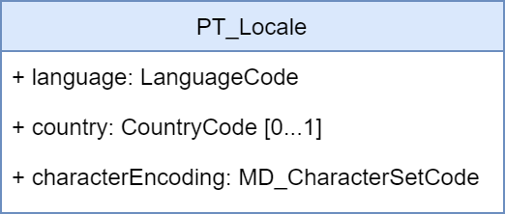
Figure 4a-D-6 – ISO 19115-1:2014 PT_Locale class.

The PT_Locale class as defined in ISO 19115-1:2014 has the following members:
- LanguageCode – required ISO 639-2, 3-letter code in lowercase i.e. “fra”
- CountryCode – optional ISO 3166-1 2-letter code in uppercase i.e. “CA” intended to be used when the national language differences can impact the interpretation or processing of localized content
- MD_CharacterSetCode – required MD_CharacterSetCode in lowercase i.e. “utf8”

The implementation of the PT_Locale type provides the necessary structure to consistently define and communicate the key language characteristics within metadata or other geospatial resources.

Additionally, the localization framework provides the support for using multiple languages in the metadata records by extending CharacterString simple type with PT_FreeText and LocalisedCharacterString subtypes as illustrated in Figure 4a-D-7.

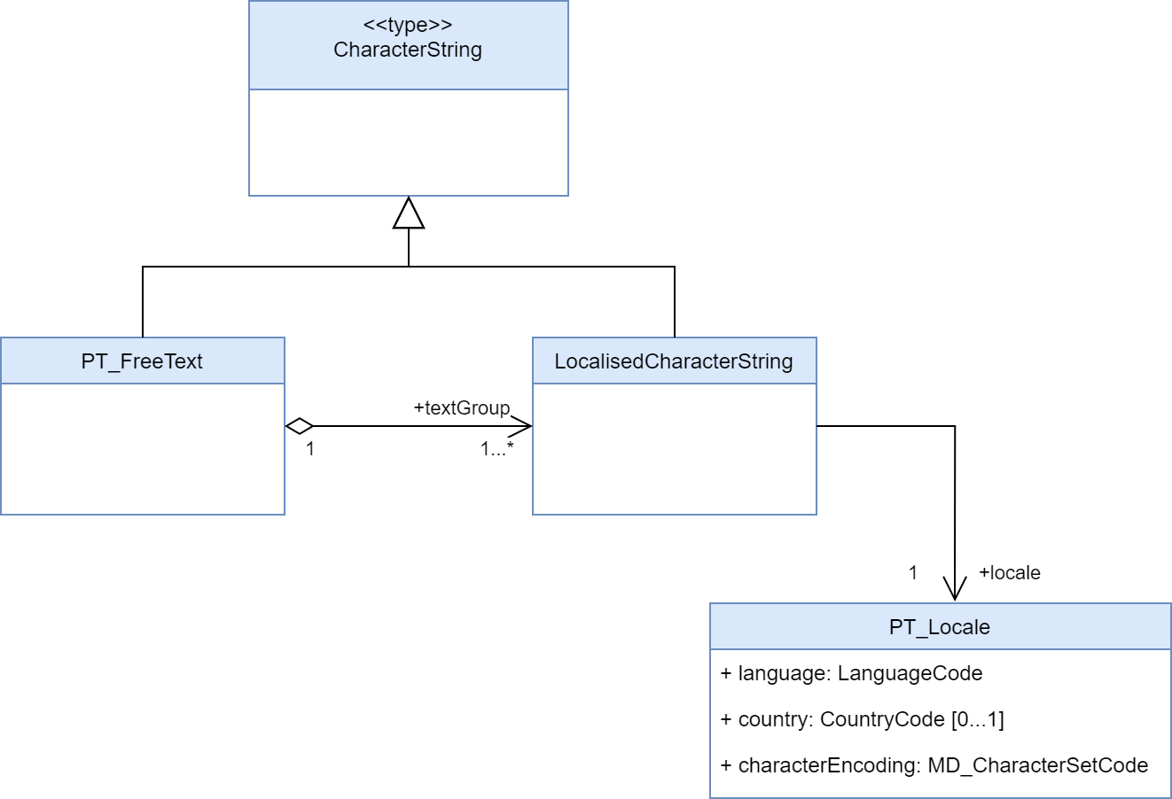
Figure 4a-D-7 – ISO 19115-1:2014 PT_FreeText and LocalisedCharacterString subtypes.

This allows any free text metadata record instances expressed in the default metadata language to also be expressed in other languages by aggregating the corresponding localized translations using LocalisedCharacterString and adding a reference to the underlying otherLocale definition. The diagram below shows a pseudo-XML implementation example illustrating how such aggregations should be constructed.

Encoding of S-100 Exchange Set Catalogue elements in multiple languages
The S100 Exchange Set Catalogue model provides two elements: defaultLocale and otherLocale to define and indicate the languages used for all metadata records within an instance of an exchange catalogue. Only one defaultLocale is permitted within the core section of the S100 Exchange Set Catalogue (within S100_ExchangeCatalogue) and it is intended to communicate the default language used for all catalogue records. Since the expected default language is English and the default character set is UTF-8 the defaultLocale element is optional and can be omitted. In most situations, however, it is prudent to explicitly define defaultLocale to prevent any confusion and more readily support data sharing with other user communities that might not be fully aware of S-100 conventions. This can be achieved as illustrated below.

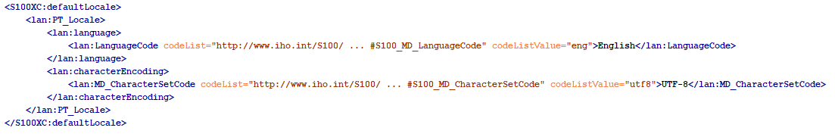

Data producing agencies wishing to provide addional localized translations of any of the catalogue records can achieve so by first defining otherLocale and then referring to it when required. The first step can be achieved as illustrated below and, similarly to defaultLocale, this only needs to be defined once within the core section of the S100 Exchange Set Catalogue (within S100_ExchangeCatalogue) for each addional language used in a catalogue instance. This approach is intended to communicate any additional language used for localized catalogue records.

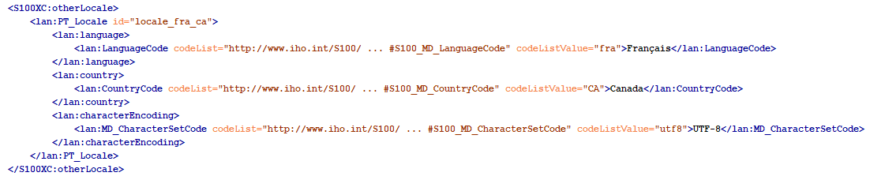

Of note is the id attribute of PT_Locale. When used in otherLocale definition, it needs to be a unique, ideally descriptive identification of a specific language which can be used as a reference by localized records. With the otherLocale element defined, any free text instances captured using the default language can also provide corresponding localized translations using PT_FreeText and LocalisedCharacterString subtypes as illustrated below.

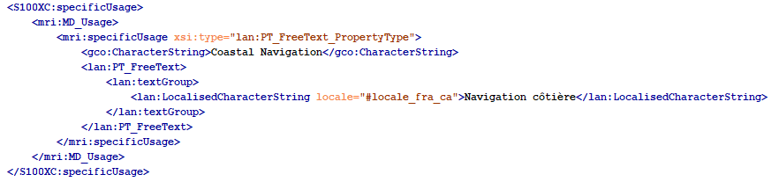

Indicating languages used inside geospatial resources described in S-100 Exchange Set Catalogue
Data producing agencies using multiple languages in their products or other resources, who wish to explicitly indicate the languages used can use the same localization framework. In contrast to the metadata records, where language definitions are applicable to all records in an exchange catalogue instance, the default and other language definitions are individual resource specific. This is accomplished by defining default and/or other languages in the same way as before but placing them inside specific resource records. For example, a data producing agency wishing to communicate that a specific dataset includes features encoded using multiple languages can add the defaultLocale and otherLocale definitions inside the corresponding dataset discovery metadata record. At the resource level, both of these elements are optional and English UTF-8 encoding is considered to be the default therefore there is generally no need to capture this fact explicitly.

S-100 support file resources are a special case, as the textual information inside them is intended to be in a single language. As with all other resources, English UTF-8 encoding is the default therefore there is no need to capture this fact explicitly. It would be prudent, however, to define support file specific defaultLocale when the language used for the content is other than English. Both the S-100 Exchange Set Catalogue and S-100 Datasets can reference any number of support resources. The diagram below shows a pseudo-XML version with examples of MRN-based identifiers used as references between datasets and support resources. This illustrates the mechanism for using a predefined referencing system to interconnect the independently captured metadata records for datasets and support resources.

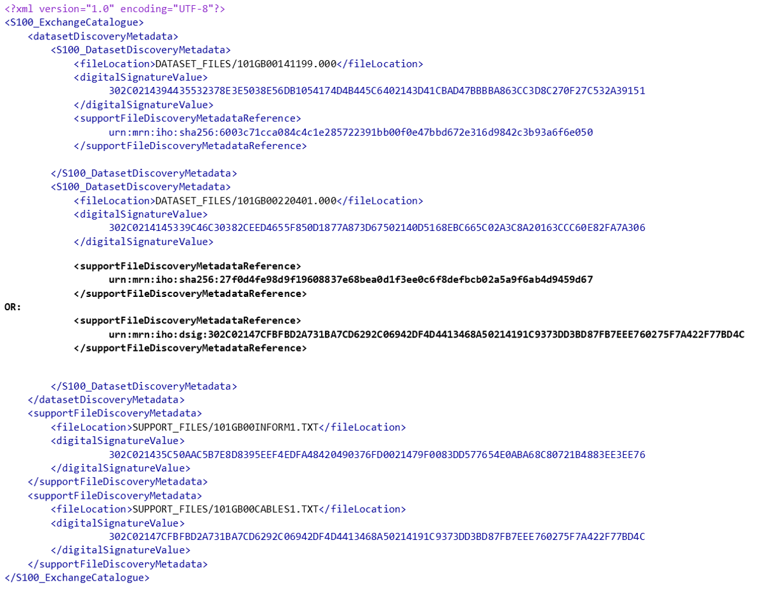

The above diagram also illustrates the optional defaultLocale fully omitted for any resources encoded using English UTF-8 thus simplifying the related metadata content. At the same time, data producers wishing to supply support resources in other languages can achieve this by capturing them independently and adding the corresponding metadata records, including defining their defaultLocale, as appropriate. The diagram below shows a pseudo-XML metadata example of a support resource supplied as two individual files one in English and the other in French.

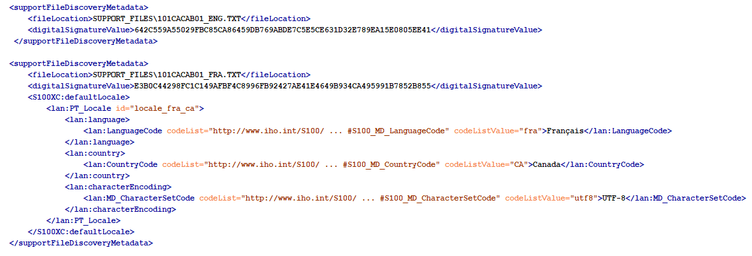

While the localization framework currently allows a high degree of flexibility, data producers are strongly encouraged to apply one consistent multilanguage support approach across their entire S-100 product portfolios to ensure a consistent user experience. The recommended approach is to provide all support resources in any other officially supported language in addition to English.

Encoding of maintenance information
The interval described by userDefinedMaintenanceFrequency is with respect to the issue date and time of the dataset described by this dataset discovery metadata block. End-user’s and distributor’s systems should use this interval for planning any automated operations to obtain the successor dataset, but must allow for delays or variations in the actual availability of successor dataset(s).
The format for userDefinedMaintenanceFrequency is given by the XML built-in datatype duration, which can be validated by off-the-shelf XML parsers. See “XML Schema Part 2: Datatypes (2nd edition) - Clause 3.2.6 duration” (relevant extracts below):
The lexical representation for duration is the ISO 8601 extended format PnYnMnDTnHnMnS, where nY represents the number of years, nM the number of months, nD the number of days, ‘T’ is the date/time separator, nH the number of hours, nM the number of minutes and nS the number of seconds. The number of seconds can include decimal digits to arbitrary precision.
The values of the Year, Month, Day, Hour and Minutes components are not restricted but allow an arbitrary unsigned integer, i.e., an integer that conforms to the pattern [0-9]+.. Similarly, the value of the Seconds component allows an arbitrary unsigned decimal. Following ISO 8601, at least one digit must follow the decimal point if it appears.
Reduced precision and truncated representations of this format are allowed provided they conform to the following:
- If the number of years, months, days, hours, minutes, or seconds in any expression equals zero, the number and its corresponding designator ·may· be omitted. However, at least one number and its designator ·must· be present.
- The seconds part ·may· have a decimal fraction.
- The designator ‘T’ must be absent if and only if all of the time items are absent. The designator ‘P’ must always be present.

Encoding and interpretation rules in S-100 metadata
- Restriction to non-negative durations: S-100 restricts the duration type by prohibiting zero or negative values of duration in userDefinedMaintenanceFrequency.
- Number of digits: S-100 recommends (but does not require) using 2 digits for the months, days, hours, minutes, components, when they are present. If the seconds component is encoded, two digits are recommended for the number of whole seconds (for example, encode 0.5 seconds as PT00.5S; encode 100 seconds as PT01M40S).
- Start and end instants: The start and end instants of the interval calculated by combining userDefinedMaintenanceFrequency with the issue date/time must be interpreted according to Part 3 Clause 3-8. The value must be encoded appropriately; this means that smaller date/time components must not be encoded unless the availability of the successor dataset is known to the corresponding level of precision. Smaller units should be used when the availability is known to the corresponding precision, such as “48 hours” instead of “2 days” when the successor dataset availability is planned to the hour.
- Encoding of zero components: Zero components must be encoded if and only if they are significant for indicating the granularity of the start/end instants of the interval.
- Variability: A variation of ±X should be allowed for, where X is the component of smallest granularity; if the value of the smallest component is 1, variability is unspecified.
- Stability for successive datasets, and exceptions: The value of this attribute will normally be stable over a sequence of predecessor/successor datasets. The alternate encoding using maintenanceDate should be used for known exceptional circumstances affecting the release of a successor, such as an office closure at the end of the intervening period, reverting to normal encoding with userDefinedMaintenanceFrequency when the normal update schedule is restored.
- Off-schedule updates: Communication of exceptional, unforeseeable off-schedule issues of data such as emergency hurricane forecasts should be provided for by other means than userDefinedMaintenanceFrequency or maintenanceDate attributes, since they are by definition unforeseeable.
- Supersession: If both userDefinedMaintenanceFrequency and maintenanceDate are encoded in the same discovery metadata block, the maintenanceDate supersedes the userDefinedMaintenanceFrequency.
EXAMPLES
No. | maintenanceAnd‌UpdateFrequency | maintenanceDate | userDefined‌Maintenance‌Frequency | Remarks
1 | -- | -- | P3DT10H30M | An interval of 3 days, 10 hours, and 30 minutes. Variability +/-1 minute.
2 | -- | -- | PT6H | An interval of exactly 6 hours, with a variability of +/1 hour.
3 | -- | -- | P30M | an interval of 30 months.
4 | -- | -- | PT30M | an interval of 30 minutes.
5 | -- | -- | P6H  P30S  P30M10S | invalid (they contain time components but lack the ‘T’ designator)
6 | -- | -- | PT30m | Invalid (‘m’ should be upper-case).
7 | -- | -- | PT12:30  P3DT10H 30M | Invalid (the ‘:’ or space separators are not allowed, only the separators specified by the XML Schema datatypes specification for duration are allowed)
8 | -- | -- | P1M | One month, variability unknown. According to the “Start and end instants” rule, will be interpreted as the same day in the following month, or the nearest preceding day if there is no such date in the following month.  If the issue date of the current dataset is 30 August, the successor dataset can be expected to be issued between midnight at the beginning of 30 September and midnight at the end of 30 September.
9 | -- | -- | P1M00D | One month, with a variability of +/- 1 day. With a dataset issued on January 31 2021, the next dataset is expected on February 28, 2021; with a dataset issued on January 31, 2024 means the next dataset is expected February 29, 2024. A 1-day variation before after those dates should be anticipated.
10 | -- | -- | P30D | 30 days, variability +/- 1 day. With a dataset issued on January 31, 2021 it means the next dataset is expected on March 2, 2021; with a dataset issued on January 31, 2024 it means the next dataset is expected on March 1, 2024. A 1-day variation should be allowed for in both cases.
11 | irregular | cit:CI_Date >  cit:dateType=nextUpdate  cit:date=2021-10-25 | -- | On 25 October 2021, at an unspecified time on that date.
12 | irregular | cit:CI_Date >  cit:dateType=nextUpdate  cit:date=2021-10-25T14:00:00Z | -- | On 25 October 2021, at 2 p.m. UTC.
13 | asNeeded | cit:CI_Date >  cit:dateType=nextUpdate  cit:date=2021-10-25T14:00:00Z | -- | To encode an exception to a dataset sequence normally on a regular schedule. Next dataset will be available on 25 October 2021, at 2 p.m. UTC.

XML encoding examples:
EXAMPLE 1: Dataset is updated at an interval of 6 hours:
<mri:resourceMaintenance>
<mmi:MD_MaintenanceInformation>
<mmi:userDefinedMaintenanceFrequency>
<gco:TM_PeriodDuration>PT06H</gco:TM_PeriodDuration>
</mmi:userDefinedMaintenanceFrequency>
</mmi:MD_MaintenanceInformation>
</mri:resourceMaintenance>

EXAMPLE 2: Dataset is normally updated on a regular schedule, but the next update will be on 1 January 2022 at 5 a.m. local time in the time zone with UTC offset -5 hours (e.g., 5 a.m. US Eastern Standard Time). The codeList attributes must be populated with the URL of the appropriate codelist, which will be in the ISO or S-100 schema distribution package.
<mri:resourceMaintenance>
<mmi:MD_MaintenanceInformation>
<mmi:maintenanceAndUpdateFrequency>
<mmi:MD_MaintenanceFrequencyCode codeList="http://...." codeListValue="asNeeded">
empty, or any text in any single language
</mmi:MD_MaintenanceFrequencyCode>
</mmi:maintenanceAndUpdateFrequency>
<mmi:maintenanceDate>
<cit:CI_Date>
<cit:date>
<gco:DateTime>2022-01-01T05:00:00-05:00</gco:DateTime>
</cit:date>
<cit:dateType>
<cit:CI_DateTypeCode codeList="http://..." codeListValue="nextUpdate">
empty, or any text in any single language
</cit:CI_DateTypeCode>
</cit:dateType>
</cit:CI_Date>
</mmi:maintenanceDate>
</mmi:MD_MaintenanceInformation>
</mri:resourceMaintenance>
EXAMPLE 3: Dataset has no consistent update schedule. The next update will be on 1 January 2022 at an unspecified time.
<mri:resourceMaintenance>
<mmi:MD_MaintenanceInformation>
<mmi:maintenanceAndUpdateFrequency>
<mmi:MD_MaintenanceFrequencyCode codeList="http://...." codeListValue="irregular"/>
</mmi:maintenanceAndUpdateFrequency>
<mmi:maintenanceDate>
<cit:CI_Date>
<cit:date>
<gco:Date>2022-01-01</gco:Date>
</cit:date>
<cit:dateType>
<cit:CI_DateTypeCode codeList="http://...." codeListValue="nextUpdate"/>
</cit:dateType>
</cit:CI_Date>
</mmi:maintenanceDate>
</mmi:MD_MaintenanceInformation>
</mri:resourceMaintenance>

