User Manual for the S-100 Producer Code Register

  - draft-Edtion 0.1.0 2022
This document provides guidance on How to register a new Producer Code or modify the information in the Producer Code Register.
INTERNATIONAL HYDROGRAHIC ORGANIZATION
Tel +377 93 10 81 00 | 4b quai Antoine 1er  MC 98011 MONACO CEDEX | www.iho.int  info@iho.int

Contents
Introduction 1
Who is the data producer? 2
How to get the producer code 3
Procedures to S-100 codes 5

Introduction
Introduction

IHO Geospatial Information Registry
A Registry is the information system on which a Register or series of Registers is maintained. A Register is simply a managed list. It is easier to maintain than a fixed document, because new items can be added as needed to the Register; and existing items in the Register can be clarified, superseded or retired. Each Register item has one or more dates associated with it that indicate when changes in its status occurred. This means that a Product Specification, defined at a given date, may reference an item in the Register at a specific point in time.

The following Registers have been implemented within the IHO Geospatial Information (GI) Registry structure. A full description of these Registers is included in the accompanying references:
- Concept Register
- Data Dictionary Register
- Portrayal Register
- Metadata Register
- Product Specification Register
- Producer Code Register

A description of the operational and management procedures for the IHO GI Registry, expanding further on the general concepts described in the following clauses, is included in IHO Publication S-99 – Operational Procedures for the Organization and Management of the IHO Geospatial Information (GI) Registry.

- This document covers only the operational procedures for the Producer Code Register.

Produce Code Register
A list of Electronic Navigational Chart (ENC) Producer Agency Codes was originally published in November 1996 as Annex A to S-57 Appendix A, under the title "IHO Codes for Producing Agencies". Because the list of Producer Codes is liable to revision more frequently than the S-57 standard, it was subsequently decided to publish the list of ENC Producer Codes in a stand-alone IHO publication S-62 - List of Data Producer Codes. After the publication of IHO S-100 and establishment of the associated IHO Geospatial Information Registry, it was decided to manage and maintain all Producer Codes in a Data Producer Code Register within the Registry. The Data Producer Code Register is partitioned into “Official” Producer Codes allocated to States or groups of States for the production of officially authorized nautical products meeting the requirements of marine navigation as laid down in the Convention on the Safety of Life at Sea (SOLAS) Chapter V; and ‘Non-Official” Producer Codes allocated to other organizations and entities. Most of the “Non-Official” Producer Codes were previously maintained on the Open ECDIS Forum and extended to meet the requirements of various domains.
The Producer Code Register is a system to store and maintain information of data producer for S-57 and S-100 data products.

Acknowledgement
The producer code register has been developed with support of Korea Hydrographic and Oceanographic Agency (KHOA), IHO S-100 Working Group, and IHO secretariat.
August 25, 2022

Who is the Data Producer?
User types
It has been under consideration and will be fulfilled later.

How to obtain/amend Producer Codes
Requests for new or changes

Producer Code Register - Overview
The Producer Code Register is subdivided into three different tabs: Introduction; Codes (S-100); and Codes (S-57).
- Introduction: Information about the different categories of Producer Codes. This tab also includes a link to a document containing a cumulative summary list of changes to the list of Producer Codes.
- Codes (S-100): The list of S-100 Data Producers and corresponding Producer Codes.
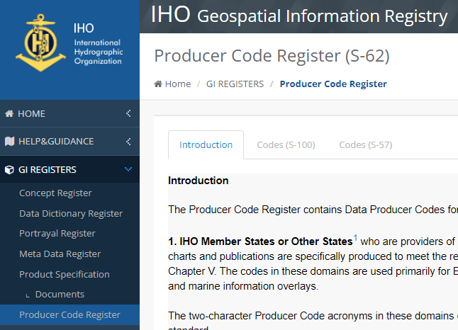
- Codes (S-57): The list of S-57 Data Producers and corresponding Producer Codes.

S-57 Codes
Requests for new Data Producer Codes; deletion of an existing Data Producer Code; or changes to an existing Data producer Code (for example change of Agency Name or contact details) should be sent by email to the Producer Code Register Manager. A link to generate this email is included on the IHO GI Registry Home page.
The email request should include the following information:
- For a new Data Producer Code:
  - Category of Producer Code (IHO Member State, Other State¹ or Other Organization/Entity
  - Full Agency name
  - Brief summary of the area(s) covered and the purpose for the ENCs as produced by the Agency
  - Justification for issuance of a Data Producer Code
  - Web site (if applicable)
  - Contact name
  - Contact email
- For changes to an existing Data Producer Code:
  - Summary of the change(s) to be applied based on the above criteria for a new Data Producer Code.

S-100 Codes
Guidance for applying for a S-100 Data Producer Code is found in the Codes (S-100) tab in the Producer Code Register.
- Move to the Code (S-100) tab;
- Click the Application button in the lower right of the window
  - Initiates a pop-up window Instructions for Requesting a Producer Code
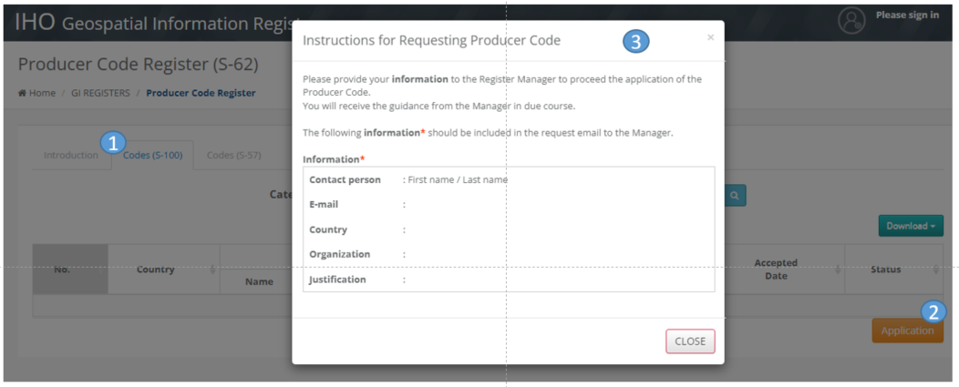
- Provide your information, as indicated in the instructions, by email to the Producer Code Register Manager
  - You will receive guidance in following days, by return email, as referenced below.
- Open the online application form clicking the link in the instruction, then the online application is now available to be processed.
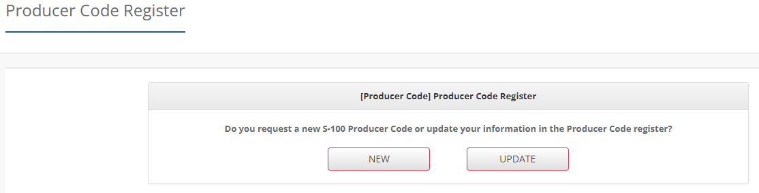

Procedures to S-100 codes
Application steps

Application steps
Please follow the steps below to obtain a new S-100 Data Producer Code or update a Data Producer Code in the Register.
- Please keep in mind that the application must be authenticated with a Validation Code prior to submission, which is supplied for single-use only.
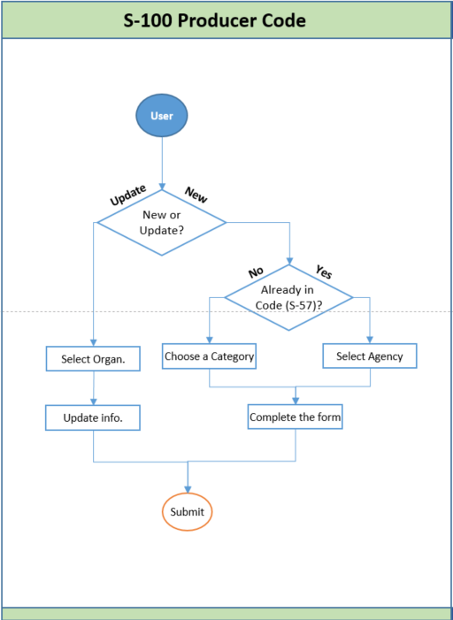
The Register Manager will process the application at the earliest opportunity and may contact you to get more information. You will receive an e-mail confirming the application result. If accepted, the allocated code will be listed under the Codes (S-100) tab.

Figure 1_Example of the notification letter
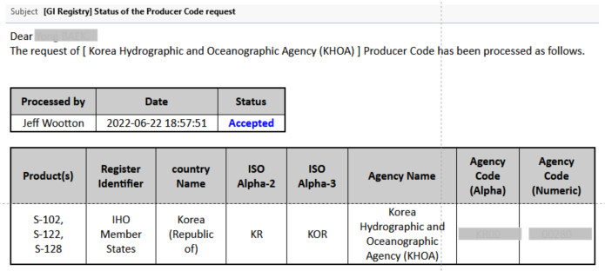

***

These categories must only be indicated if the Datasets to be produced are to be considered to be “official” Datasets produced by or on behalf of a recognized Government hydrographic institution.

