**IEC TC80/MT7 Meeting**

**(S-98 Annex C)**

Meeting Times 0900-1700 18th – 20th September, BSI London

[ Map: <https://iho.int/uploads/user/Services%20and%20Standards/S-100WG/S-164SG/S-98_2024_0_EN_Travel%20to%20BSI_%20Chiswick%20office%20in%20London.pdf> ]

1. Introductions [All]
2. Welcome and Background – S-98 Annex C [ chair]
   1. Welcome
   2. Agenda overview and Ground rules
   3. S-98 Annex C
   4. S-164
   5. IHO timelines
3. Description of documents supplied [Chair]
   1. S-98 Draft 1.4.1
   2. Supplementary papers
   3. GitHub issue inputs
4. Objectives [Chair]
   1. New Draft S-98 Annex C and proposed timelines for completion of updates/actions.
   2. Timelines in respect of S-164 and other IHO WG activities.
   3. Specific S-164 inputs, new tests and test scenarios
5. Meeting Order:
   1. Finish reviewing document starting from last VTC review meeting point.
      1. The last VTC reached Section C-16.
      2. Continue with review from C-16 to end of document noting updates received.

**[All – Day 1 will begin from this point]**

* 1. Breakout topics. Review of specific parts of document and new inputs not dealt with in 5a. This includes papers and feedback received. **[TBD when this takes place, likely morning Day 2 or Day 3]**
     1. Manual Updates
     2. Loading/Unloading
     3. Taking into account data quality
     4. Others?
  2. GitHub Issues
  3. Any Other Business relevant to S-98 Annex C.
  4. Assembly of new edition, actions for completion **[pm - last day]**

1. Timetable and forward plan for completion.
2. Meeting close.

**How to get in to BSI**

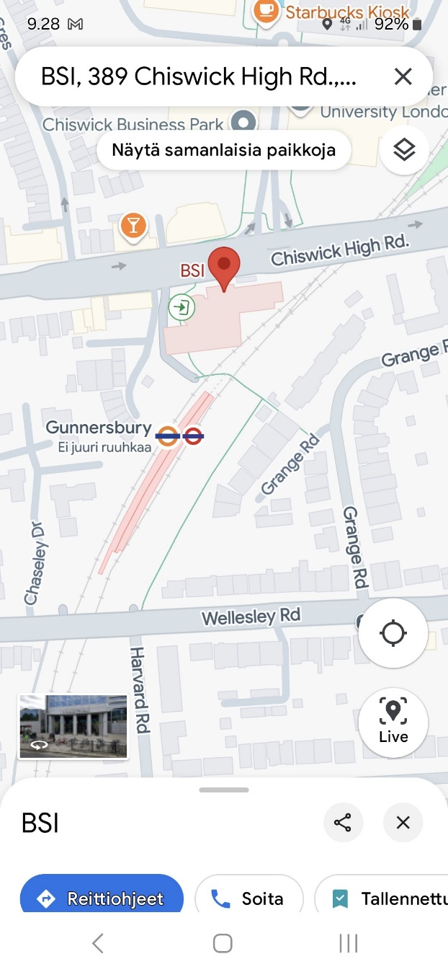

* Enter from the street side, Address is 389 Chiswick High Road
* It’s a big building - there is a general reception desk for all visitors.
* Inform the receptionist that you are for the IEC TC80 meeting.
* The receptionist will open a gate, and you can proceed one floor up by stairs or by elevator.
* Next is another reception desk, this is for BSI.
* Inform the receptionist that you are for IEC TC80/MT7 meeting.
* The receptionist will search for the signing paper for the use of the room reserved for IEC TC80/MT7 meeting
* Write your name, signature and the number of the badge given to you.
* The receptionist will give you an electronic badge to operate gates and doors.
* Use the elevator and go to the floor pointed out by the receptionist
* In the meeting room floor, use your badge to open the door for the meeting room